**Lab 1**

The purpose of this lab is to get your student machine setup.

**Setup**

Please ensure you have the following installed:

* Your preferred version of Visual Studio
* SFML (I suggest we use at least version 2.5.0)
* Doxygen (www.doxygen.org)

**Exercise**

Create a simple C++ / SFML program which will draw two sprites/characters on the screen.

The two objects should begin moving in any direction (but then continue in that direction indefinitely). One of the characters should respond to player inputs as follows: Up Arrow velocity increases, Down Arrow velocity decreases.

Note: The world in which they are moving is to be wrap-around.

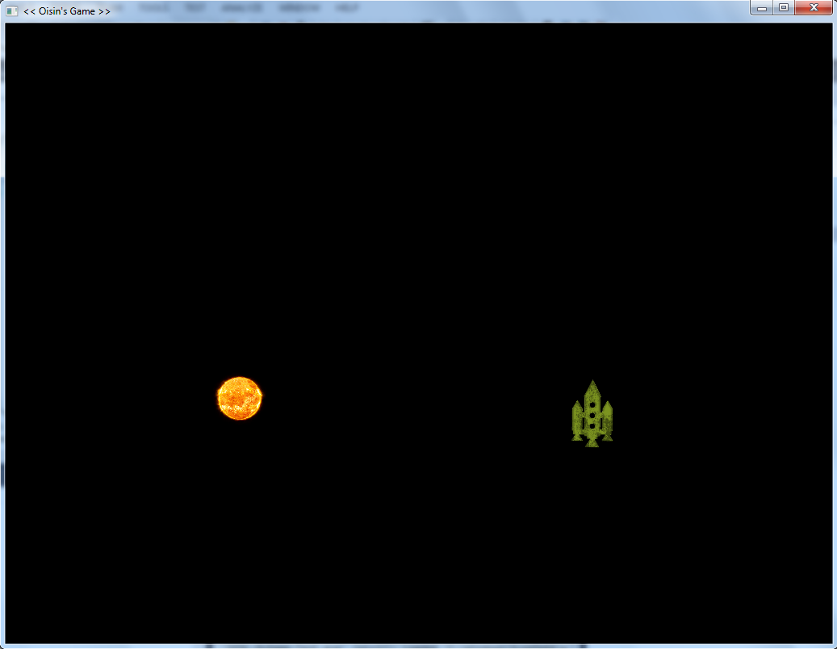

Show me when you have it complete.