**Lab 2a**

**Exercise**

Extend the simple two character program from lab1 as follows.

One character will be designated the player ship and the other the alien ship.

The alien ship stays moving as before.

The player ship must respond to the left and right arrow keys and change its direction of motion accordingly.

The ship should have a maximum speed which it cannot exceed.

Additionally the player character should always point in the direction that it is travelling.

At this stage your Player and NPC classes should be keeping track of the necessary movement attributes as mentioned in the notes.

Note: The world in which they are moving is to be wrap-around.

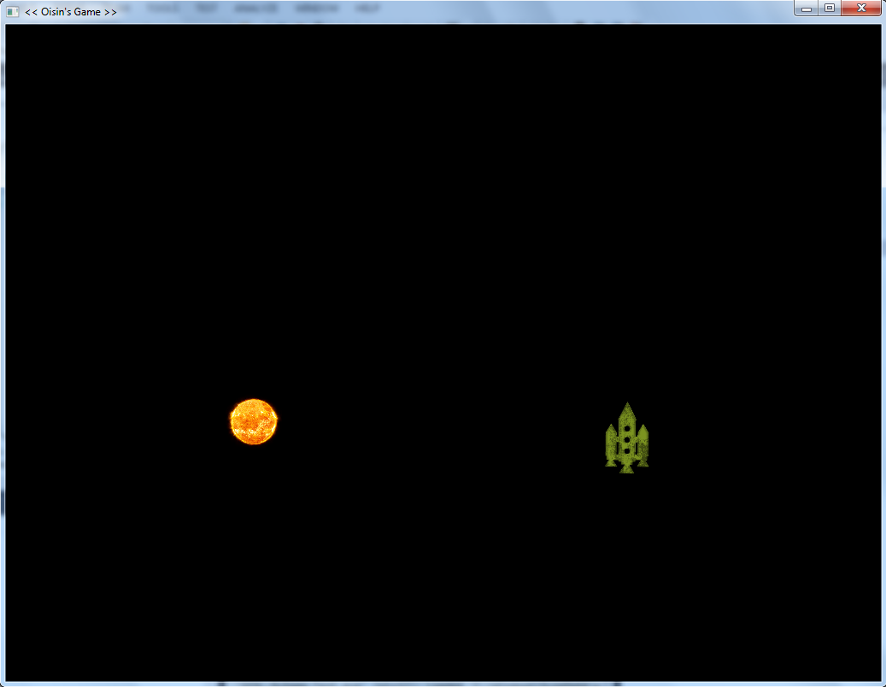

Show me when you have it complete.