3.1 Background
DNA yield is the total mass of DNA obtained after polymerase chain reaction (PCR). It can be calculated by multiplying the concentration by the total volume of the purified sample. DNA yield plays an important role in calculating the amount of DNA in the sample and is measured in µg. High yield, however, does not mean that the material is clean - that is what is evaluated by DNA purity, which usually uses UV absorbance ratios as a measurement. Virtual PCR simulator, created by Fellermann et al. (2019), addresses both of these points. In the simulator, yield is reported as product concentration (ng/µl), and purity as the percentage of DNA in the reaction that is the intended amplicon. This differs from spectrophotometric purity (A260/A280, A260/A230), which measures contamination by protein or salts rather than non-specific products.

3.2 Baseline and screening
The default settings on the virtual PCR simulator (1 unit of Taq polymerase, 15 cycles with denaturation at 80°C for 10 seconds, annealing at 68°C for 10 seconds, extension at 54°C for 20 seconds, plasmid at 50ng, primers at 1 µl (from 10.0 uM stock) and dNTP at 0.5 µl from 10.0mM stock) produced 0.1 ng/µl yield and 10.5% purity. These settings were changed to produce a new baseline:
- Phusion polymerase was chosen due to higher efficiency. When running the default parameters, swapping Taq polymerase for Phusion raised yield from 0.1 to 0.2 ng/µl, and purity from 10.5% to 13.4%. Moreover, New England Biolabs (NEB) quotes Phusion to have much higher fidelity than Taq;
- The number of cycles was changed from 15 to 35, raising the yield from 0.2 to 1.2 ng/µl and purity from 13.4% to 34.5%;
- Denaturation temperature was increased from 80 °C to 98 °C for 10 seconds (NEB Phusion protocol recommendation), increasing yield (2.1 → 95.0 ng/µl) and purity (~46% -> ~82%);
- Annealing was first set to the NEB-calculated 61 °C, then raised to 65 °C (yield 96.5 → 102.5 ng/µl; purity 82.8 → 88.2%), and the annealing time was extended from 20 to 25 s (106.2 ng/µl; 89.8%).
- Extension temperature was changed to 72°C (NEB Phusion protocol recommendations), and the extension time was changed from 20 to 30 s;
- dNTPs volume was increased from 0.5 µl to 1 µl, raising yield from 106 to 124 ng/µl and purity from 89.8% to 96.8%.
Since no final volume was given by the simulation, it was assumed that the final reaction has a volume of 50 µl. From this, using c1v1=c2v2, the concentration of primers present in the default settings has been worked out to be 200 nM (10 µM × 1 µl ÷ 50 µl = 0.2 µM = 200 nM). We also tried to increase the primer concentration to 500 nM (recommended by the NEB Phusion protocol) from 200 nM (default settings). This caused an increase in yield (from 124.2 to 177.7 ng/µl), but at the expense of purity (which dropped from 96.8% to 71.9%), and therefore was kept the same (at 200 nM).
Using the NEB Tm calculator, we also calculated the optimal annealing temperature for both primers (selecting Phusion as product group, primer concentration at 200 nM, and inserting both primer sequences - FWD1 (GCAACGTGCTGGTTATTGTG) and REV1 (AGCGGATAACAATTTCACACAGG)), which, according to NEB’s calculations, was 61 °C. 61 °C initially gave lower purity than 65 °C during screening, when dNTPs were limiting (100 µM). Once dNTPs were raised to 200 µM, 61 °C and 65 °C gave indistinguishable results (conditions F and G, Table 1), so the NEB-calculated value was retained for the final plan.

3.3 Our design
Once the baseline has been defined, we have run three runs of the baseline parameters, which gave us a mean +- SD of 122.3+-1.8 ng/µl yield and 96.8+-0.3 % purity. Then, the number of cycles (25 for low and 35 for high) and annealing temperature (58°C for low and 68°C for high) were selected as two adjustable factors. We have decided to run the simulation thrice per condition, resulting in 12 results that have been produced. Prior to running, we predicted that more cycles should raise yield in both temperatures, and a lower annealing temperature should cause less purity due to increased amplification of misprimed products.

3.4 Results
Table 1 illustrates the means of 2x2 runs (A-D), proposed condition (E), proposed condition with more cycles (F) and the baseline reaction (G), which was run first. In total, 21 reportable results have been produced (the screening results can be found in the supplementary material). For the replicates, the standard deviation (SD) ranged from 0.7-3.7ng/µl for yield and below 1.3 points for purity. Differences involving 68 °C (conditions B and D) far exceed this variation, whereas conditions A, C, E, F and G fall within each other.
At 58°C annealing temperature, the overall PCR reaction seems to plateau by 25 cycles, and adding additional cycles did not affect the yield or purity (condition A versus condition C in Table 1). However, at 68°C annealing temperature (Ta), the increased number of cycles aided in both yield (69.7 → 109.4 ng/µl) and purity (77.5 → 92.4%), as seen in Table 1 (conditions B and D). The interaction effect, calculated from conditions A-D, was +19.9 ng/µl for yield and +7.5 points for purity, as large as the main effect of cycles (+19.9 ng/µl; +7.4 points), so the effect of cycle number depends on annealing temperature. The main effect of annealing temperature (−29.6 ng/µl; −11.8 points) shows that raising Ta to 68 °C reduced both yield and purity overall, with the loss largest at 25 cycles. This differs substantially from the predictions we have made before running the model. 58°C is only ~3°C below the recommended Ta for this set of primers, and likely is not low enough to cause substantial mispriming. The simulator also seems to be penalising low annealing temperatures much less than high ones. The dominant effect seemed to be inefficient primer binding at 68°C, which slowed the amplification substantially, and 25 cycles were not enough to reach plateau.
Following the discoveries found while using the simulator, a PCR plan has been produced, which, in silico, maximises both yield and purity. It uses an annealing temperature of 61°C over 58°C. Primarily, because this is the NEB Tm calculator’s suggestion, and both temperatures produce almost identical results (as seen in Figure 1). E and F conditions are indistinguishable (118.6 ± 2.7 vs 120.2 ± 1.5 ng/µl), so 25 cycles give the same result in a shorter run, with less risk of late-cycle non-specific product, which is why 25 cycles were used instead of 35.
Reagents:
- 1U Phusion polymerase;
- 200 µM each dNTP;
- 200 nM each primer;
- 50 ng plasmid;
- 10µl of 5× Phusion HF buffer;
- Nuclease-free water to 50 µl.
The proposed PCR reaction:
- Initial denaturation (98°C for 30s);
- 25 cycles of;
  - Denaturation (98°C for 10 s);
  - Annealing (61°C for 25s);
  - Extension (72°C for 30s);
- Final extension (72 °C for 5–10 min);
- 4 °C hold in the thermocycler.
The proposed condition (condition E, Table 1) has been replicated three times, resulting in mean ± SD results of 118.6 ± 2.7 ng/µl for yield and 96.6 ± 0.7% for purity.
Condition | Role | Cycles | Annealing (°C) | Yield mean (ng/µL) | Yield SD | Purity mean (%) | Purity SD
A | Low/low | 25 | 58 | 119.1 | 2.9 | 96.8 | 0.2
B | Low/high | 25 | 68 | 69.7 | 3.7 | 77.5 | 1.2
C | High/low | 35 | 58 | 119.1 | 0.7 | 96.7 | 0.3
D | High/high | 35 | 68 | 109.4 | 1.9 | 92.4 | 0.8
E | Proposed condition | 25 | 61 | 118.6 | 2.7 | 96.6 | 0.7
F | NEB Ta, more cycles | 35 | 61 | 120.2 | 1.5 | 96.9 | 0.1
G | Baseline check | 35 | 65 | 122.3 | 1.8 | 96.8 | 0.3
Table 1. The mean and standard deviation of all of the conditions tested. Mean ± SD, n = 3. 98 °C 10 s; 25 s annealing; 72 °C 30 s; 200 µM each dNTP; 200 nM each primer; 50 ng plasmid; 1 U Phusion; 50 µl assumed.

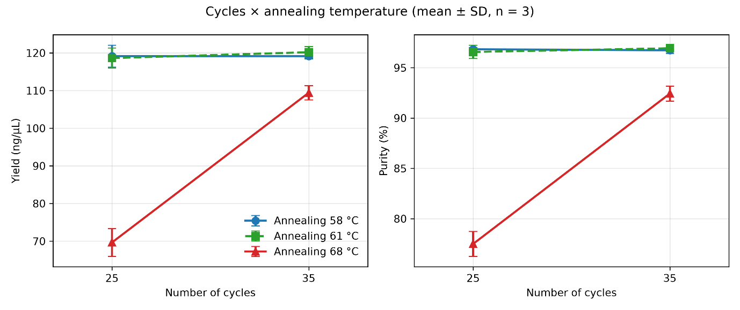
Figure 1. The figure shows the trends in yield and purity at three different annealing temperatures and two different cycle amount selections. Mean ± SD, n = 3; fixed settings as in Table 1.

3.5 Limitations and next steps
The main limitation of this simulator is that not all features, typically available to choose when running PCR, are available. The initial denaturation and final extension temperatures are not specified. Therefore, they were not included in the simulator, and their effect could not be tested. Moreover, the volume of the final reaction was also not mentioned anywhere and was not an option to choose from, making the overall concentrations of the reagents rather ambiguous. Other reagents, also impacting the yield and purity of the PCR reaction, e.g., Mg²⁺ concentration, buffer type, or additional additives (DMSO, GC enhancers), were also unavailable to choose from.
The simulator does add a simulated gel image of the product size next to the molecular weight ladder, which allows us to see whether the right product formed (1kb amplicon). However, the simulator seems to be penalising low annealing temperatures very little (with no purity loss at 58°C ), perhaps because it was too close to the annealing temperature recommended by NEB.
The next suggestions for this project would be a cycle titration (15-35 cycles, checking every 5 cycles), lower plasmid input (1-10ng) and a gradient PCR in the lab at 58- 66 °C, which would aid in determining the optimal annealing temperature for these primers. Lower plasmid input, however, would possibly require more cycles, which increases the risk of more non-specific products and errors. NEB protocol recommends 1pg-10ng of plasmid template per 50 µl; hence, 50 ng was well above the range - this was kept from the simulator, but would have to be reduced in a real reaction. Phusion polymerase has been chosen for high fidelity, but the simulator’s output cannot show sequence errors, and fidelity cannot be tested. A final product, produced in a real reaction, must be checked on a gel, by sequencing, or both, to ensure that the correct product is formed, even if yield and purity are high.
It is important to remember that this simulator runs on a stochastic model and produces slightly different results every time; hence, it mimics experimental variability between the replicates. This in silico experiment highlights the importance of designing the experiments in factorial with replicates, rather than a one-factor-at-a-time test, which costs more time and retrieves less information. For us, the screening phase to determine the baseline took over 20 runs; the factorial answered the interaction question in 12.

References
Fellermann, H., Shirt-Ediss, B., Kozyra, J.W., Linsley, M., Lendrem, D.W., Isaacs, J. and Howard, T.P. (2019) ‘Design of experiments and the virtual PCR simulator: An online game for pharmaceutical scientists and biotechnologists’, Pharmaceutical Statistics, 18(4), pp. 402–406. doi:10.1002/pst.1932.
New England Biolabs (n.d.) PCR protocol for Phusion® High-Fidelity DNA Polymerase (M0530). Available at: https://www.neb.com/en-gb/protocols/pcr-protocol-m0530?srsltid=AU7gw4Uq9UG1N4ntbAJUanTrCuqixn9IbnPJYrMEJJQFREkOL6RVLo59 (Accessed: 22 October 2026).
New England Biolabs (n.d.) NEB Tm Calculator. Available at: https://tmcalculator.neb.com (Accessed: 22 October 2026).

