Using the BMC Tool to update a UCD module:

1. Python setup. The following is required to run the bmc\_tool.py script:
   1. Python **2.7.5 (NOT version 3.3)** – available at <http://www.python.org/download/>
      1. Download the appropriate installer:
         1. Windows: Choose the Windows installer (32 or 64 bit systems) or X86-64 installer (64 bit systems only).
         2. Linux: Choose the compressed source tarball.
      2. Run the installer:
         1. Windows: Double click the .msi file and follow the installer instructions.
         2. Linux:
            1. Extract the tarball:

tar xvfz Python-2.7.5-tgz

* + - * 1. Change to the Python-2.7.5 directory:

cd Python-2.7.5

* + - * 1. Run the following command:

make install

* 1. PySerial **2.6** – available at <https://pypi.python.org/pypi/pyserial>
     1. To install:
        1. Extract the contents of tarball:
           1. Windows: Use a tool such as winzip to extract the contents to another folder.
           2. Linux:

tar xvfz pyserial-2.6.tar.gz

* + - 1. Change to the extracted folder:

cd [DOWNLOAD\_LOCATION]/pyseral-2.6

* + - 1. Run the Following command:
         1. Windows:

C:\Python27\python.exe setup.py install

* + - * 1. Linux:

python setup.py install

**NOTE: For windows the command is python.exe and will likely not be included in the default PATH (you will need to either add C:\Python27 or use the full path when executing the command). When the command ‘python’ is given in this document, windows users will have to replace it with ‘C:\Python27\python.exe’.**

1. Make sure that no other program is connected to the BMC serial port.
2. Launch the BMC Tool. From the directory of the bmc\_tool.py file, give the following command:

python bmc\_tool.py

1. Select the appropriate COM port from the drop down list. If you are connected to the EVM by USB, the appropriate COM port is the greater of the two values.

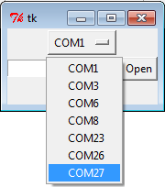

1. Click the **Get Versions** button to view the current UCD module versions (they will print out on the command line). Compare these versions against those used in the names of the provided text file. In the example below, UCD module at address 78 is out of date. Complete steps 5 -7 for all text files for the modules with out of date versions.

**NOTE: This step is not required to update the UCD modules, It is simply a tool available to the user to determine the versions currently stored in the UCD modules.**

**NOTE: BMC versions 1.0.1.3a and earlier have a bug which cause this feature to fail. Please upgrade to the latest BMC or do not use this feature with earlier versions.**

ver_output.png 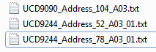

1. Click the open button and select one of the UCD text files. 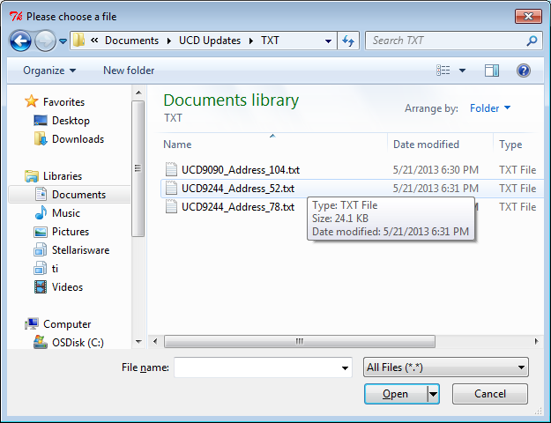
2. Click the execute button.

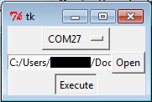

1. Upon successful completion, the message shown below will appear. Power cycle the board before executing another text file. It is also recommended that you restart the program as well (close the window and start at step 3).

