Exporting an XML file to a TXT file in the Fusion software:

1. Download and install the latest version of TI Digital Power Designer from <http://www.ti.com/tool/fusion_digital_power_designer>
2. Start Fusion Digital Designer in Offline mode.
3. Select **“Open Existing Project”**

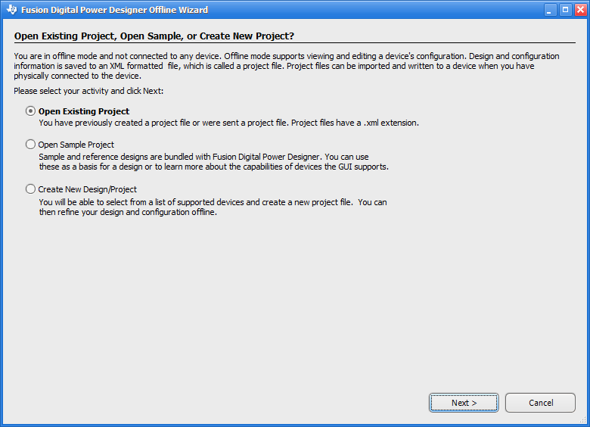

1. Select the XML file you would like to export.
2. Once the project has loaded, go to **File->Export**.
3. In the **Device Export** window, select the **PMBus Write Script** tab.
4. Select the options listed below:
   * Script Style – I2C
   * Write Validation – Do not validate command writes
   * PEC – Uncheck **Add PEC byte**
   * File Format – Tab Separated
   * Hex Format – AA
   * Comment Style – Proceed with # (Shell style)
   * How to Handle Multiple Data Bytes – Break apart into separate fields
   * Block Length Byte – Check **Add block length byte to read block commands in SMBus mode**
   * The filename can be altered as desired. Be sure to include the revision in the filename.

A screenshot below shows all options selected correctly:

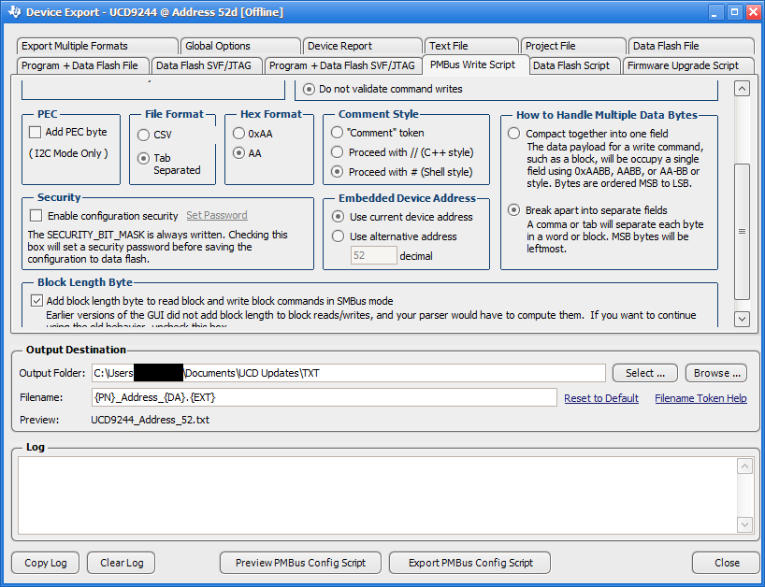

1. Click the **Export PMBus Config Script** button. The file will be stored in the location indicated by the **Output Folder** option.

**NOTE:** For the UCD9090 at address 104d, please comment out (place ‘#’ at the beginning of the line) or delete the following lines found toward the beginning of the file. They cause errors to occur when updating through the BMC.

# I2CWrite D0 00 00

# I2CWrite D0 F6 0C 96 01 00 00 00 00 00 00 00 02 00 00