

data collection methods

Project- 02



**Submitted By: Anu Bala(c0718191)**

**Abstract**

In this paper I will discuss the steps that are done on twitter and fetch the tweets from streaming API by using python language and store this streaming in any database after that I will perform sentimental analysis.

**Introduction**

**Step 1**: First of all, create an application in which you fulfill the details that is shown in below figure

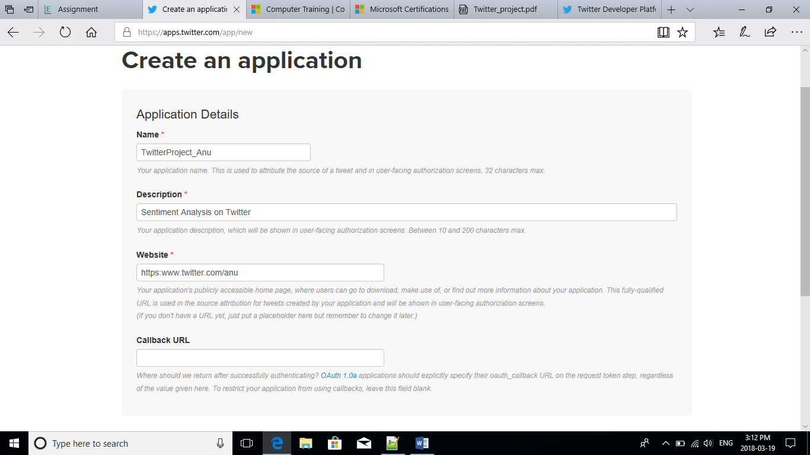

**Step 2** : On application settings you will find the details that will use in a project to perform analysis.

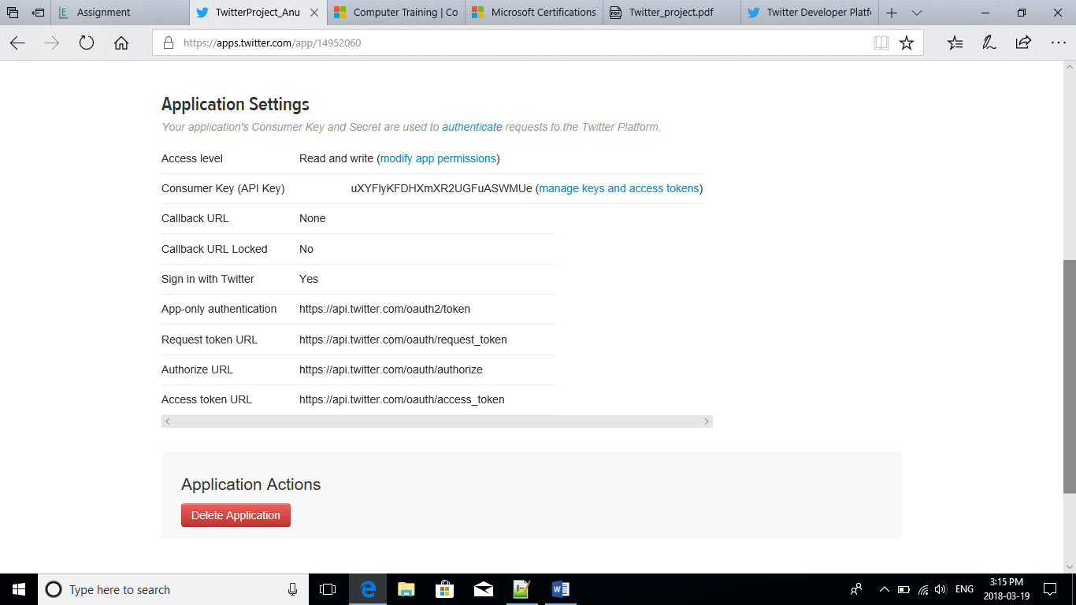

**Step 3**: In this step you see your own name that you give in a first figure and get a consumer key, consumer server (API Secret) and all other details

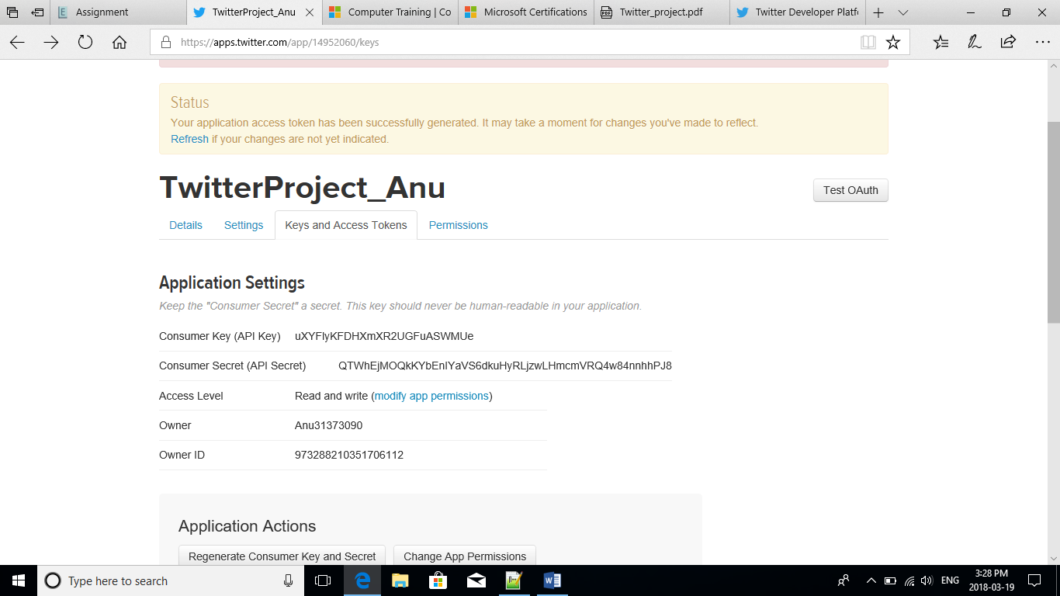

**Step4**: In this figure it shows your Access token that will help later and use in a program in python

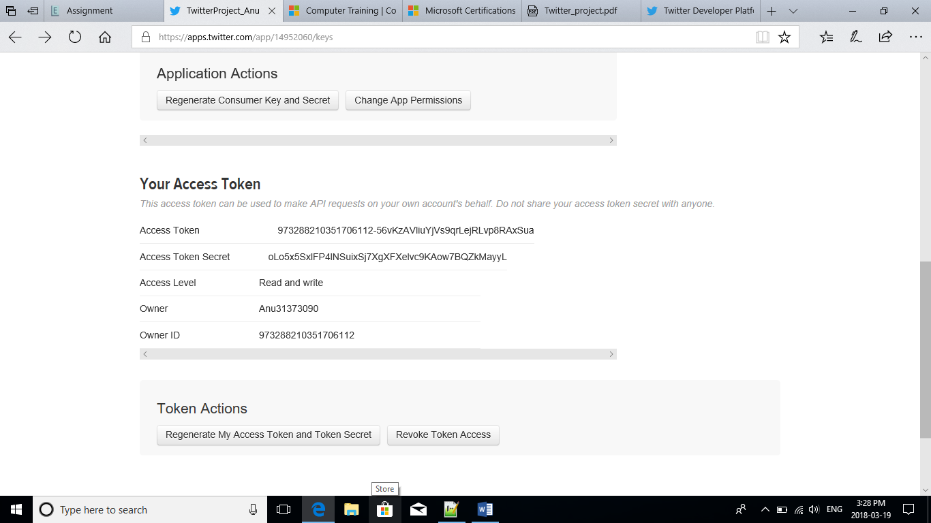

**Step 5:** In this step write a program and get results by using the token, consumer key, access token or all steps that discussed earlier.

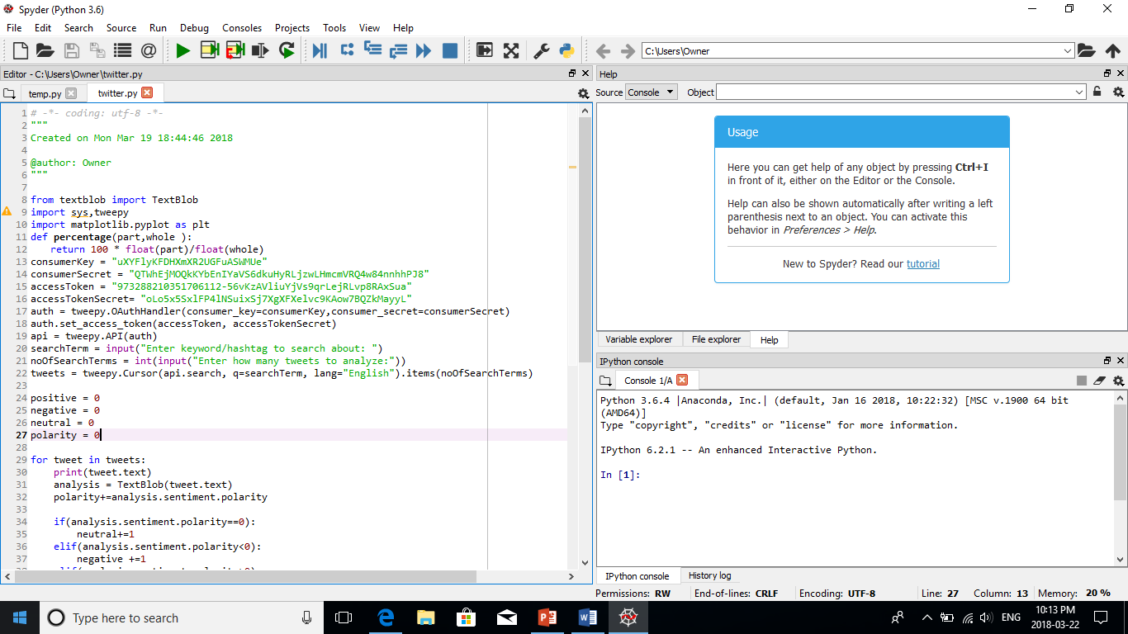

**Step 6**: continue the program for sentimental analysis

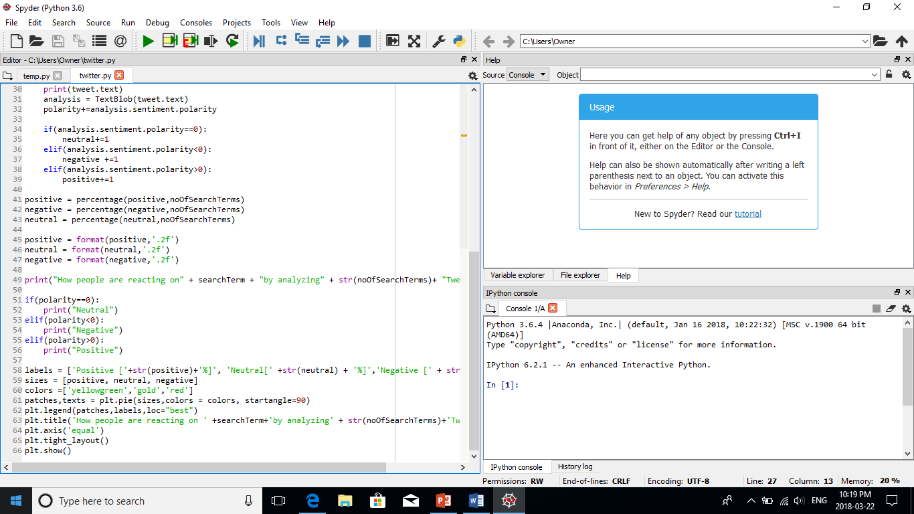

**Step 7:** Output can be show in this figure

