**IAM Groups**

* Allow you to assign IAM permission policies to more than one user at a time
* This ability allows for easier access management to AWS resources

For example, you could have a group called *Admins* and give that group the types of permissions that administrators typically need. Any user in that group automatically has the permissions that are assigned to the group. If a new user joins your organization and needs administrator privileges, you can assign the appropriate permissions by adding the user to that group.

Similarly, if a person changes jobs in your organization, instead of editing that user's permissions, you can remove him or her from the old groups and add him or her to the appropriate new groups.

Important characteristics of groups:

* A group can contain many users, and a user can belong to multiple groups.
* Groups can't be nested; they can contain only users, not other groups.
* There's a limit to the number of groups you can have, and a limit to how many groups a user can be in.

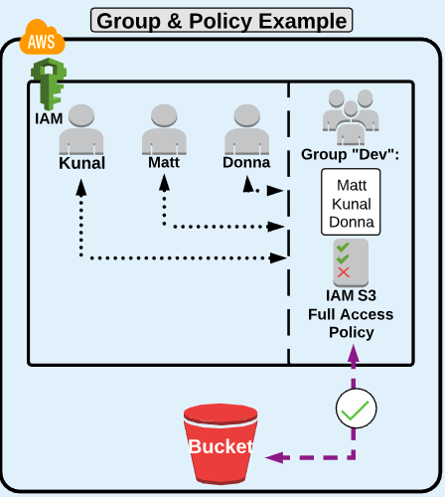

<https://docs.aws.amazon.com/IAM/latest/UserGuide/id_groups.html>