***Lambton College at Queen’s College of Business, Technology and Public Safety***

**Program: Big Data Analytics (DSMM)**

**Project Name:**

**US Developer Salary Prediction using Stack Overflow 2023 Data**

**Course:  Advanced Python AI and ML Tools  01 (AML 2203)**

**Professor: Sagara Samarawickrama**

**Group Members:**

**Jennylynne Dominguez (C0929140)**

**Joyce Ann Murillo (C0927648)**

**Chaw Su Su Thinn (C0916347)**

**Hazel Portia Elaine Santos (C0915982)**

# Project Overview

This project aims to build a machine learning model that predicts the annual salary of U.S.-based software developers using the Stack Overflow 2023 Developer Survey. By analyzing developer demographics, professional background, technology usage, and job satisfaction, the model provides insights into the factors that influence compensation in the U.S. tech industry.

The original Stack Overflow 2023 dataset contained over 89,000 global responses and 84 features. After filtering for U.S.-based respondents and valid salary entries, we retained over 18,000 rows, which provided a large and consistent sample for modeling.

### Why Focus Only on U.S. Respondents?

To ensure consistency and comparability in salary values, this project limits its scope to U.S.-based respondents only. The global dataset includes compensation reported in dozens of local currencies, making direct modeling difficult without introducing exchange rates, inflation adjustments, or cost-of-living normalization — all of which can introduce noise or bias. By focusing on the U.S. subset:

Currency is standardized (USD), eliminating the need for conversion.

Data volume is sufficient, with over 18,000 respondents, providing a robust sample size for modelling.

Based on the chart of the Top 15 Countries by Number of Respondents, it's evident that the United States has the highest number of survey participants, with 18,026 respondents, which is more than double the second highest (Germany, 7,129).

This large representation makes the US data more statistically robust and reliable for modelling.

The U.S. represents one of the largest and most mature tech markets, making it a valuable benchmark for salary trends in software development. According to U.S. Bureau of Labor Statistics (BLS), the employment of software developers is projected to grow 17% from 2023 to 2033, which is much faster than the average for all occupations.

## **Dataset Summary**

**Source**: Stack Overflow Developer Survey 2023 (public release)

**Filtered for**: U.S. respondents only

**Format**: Tabular CSV with ~80 structured survey features (free-text responses excluded)

**Target** : CompTotal

## **Data Cleaning and Preprocessing**

**Convert  to Numeric and Drop all NA of CompTotal (Target)**

* We dropped rows where the target (CompTotal) is missing using dropna()
* We converted the target feature to numeric by using pd.to_numeric

**Drop all rows where the Currency column does NOT contain "USD"**

* We filtered the dataset to retain only respondents who are located in the United States and whose Currency includes "USD", ensuring a consistent basis for salary analysis.
* The conditions use .**str.contains() with na=False** to handle missing values safely.

**Removing Irrelevant Columns**

* This step removes columns considered irrelevant, non-predictive, or intention-based (like tool preferences or browsing habits) using df.drop() with a filtered list.
* It ensures only meaningful, modeling-relevant features are retained for analysis.

**Dropping Columns with Excessive Missing Values - 70%**

* We dropped any column where 70% or more of its values are missing, using a calculated threshold based on the dataset length.
* If more than 70% of a column is missing, imputing or interpreting it becomes unreliable and introduces noise.

**Dropping rows with more than 50% values missing**

* We dropped row with more than 50% missing values which often lack enough information for accurate imputation or analysis.
* This threshold is a common practice to maintain data integrity without being too aggressive in data loss.

**Checking for Duplicate Columns**

* This step checks for duplicate column names using .duplicated() on df.columns to ensure no redundancy or confusion during analysis or modeling. The result confirms that no duplicate columns exist in the dataset, maintaining data integrity.

**Standardizing Age Group Format**

* This step standardizes the Age column by removing the extra text " years old" using .str.replace() and .str.strip(), leaving clean age ranges like '25-34'.

**Standardizing EdLevel Values**

* This step standardizes the EdLevel column by removing the text inside parentheses using .str.replace() with a regex pattern, leaving clean values like 'Bachelor’s degree'.
* It ensures consistent and simplified education labels for easier grouping, filtering, and analysis.

**Convert OrgSize Ranges to Numeric Midpoints**

* This step standardizes the OrgSize column by removing the word "employees" and replacing " to " with "-" using .str.replace() and .str.strip(), resulting in a cleaner format like '100-499'.
* This transformation helps normalize company size ranges for downstream processing such as converting to numeric midpoints or group-based analysis

**Standardizing YearsCode and YearsCodePro**

* This step standardizes the YearsCode and YearsCodePro columns by replacing special string values like "Less than 1 year" and "More than 50 years" *using a mapping dictionary and .replace().*
* It then converts all values to numeric *format with pd.to_numeric(errors='coerce'*) to enable accurate analysis and plotting of coding experience.

**Standardizing Frequency_1, Frequency_2, and Frequency_3**

* This step cleans the Frequency_1, Frequency_2, and Frequency_3 columns by removing the text " times a week" using .str.replace(), leaving only the numeric frequency ranges like '1-2', '6-10', etc.
* It ensures uniform string values for easier parsing, grouping, or conversion to numeric bins later.

## **Exploratory Data Analysis**

**Age Distribution of Stack Overflow Respondents**

**Interpretation:**

**Dominant Age Group:** The 25–34 age group is the largest demographic among Stack Overflow respondents, with 4,626 people, making up 40.8% of the total.

**Young Professionals Make Up the Majority:** Combined, the 18–24 and 25–34 age groups account for 48.5% of respondents, suggesting the platform is heavily used by younger developers or those early in their careers.

**Mid-career Representation:** The 35–44 age group follows with 31.2% (3,540 respondents), indicating a solid presence of experienced professionals as well.

**Sharp Decline in Older Age Groups**: There's a steep drop in representation after age 44:

* 45–54: 12.8%
* 55–64: 5.9%
* 65+: Only 1.4%

This shows that older demographics are much less active or represented on Stack Overflow.

**Minimal Responses from Youth and Non-disclosure:** Very few respondents are under 18 (0.1%) or prefer not to disclose their age (0.1%), suggesting age transparency is common.

**Working Arrangement Distribution**

**Interpretation**:

Most Stack Overflow respondents work remotely, highlighting a strong shift toward remote work in the tech industry. Hybrid models are also common, while fully in-person roles are now the minority. This suggests remote-friendly roles are the norm among developers and tech professional’s post-pandemic.

**Education Level Distribution of Developers**

**Interpretation**:

Most developers hold formal post-secondary education, with nearly 60% holding a bachelor’s degree and an additional 18% holding a master’s degree. This highlights that traditional academic paths remain the most common route into the developer profession. However, the presence of developers with non-degree education (including self-taught and partial university) — making up over 17% — suggests there is still considerable room for alternative pathways into tech.

**Understanding the Salary Distribution by Age Group**

**Interpretation**:

Salaries tend to increase with age and experience up to a point, with the **35–44** and **45–54** age groups showing the highest median and upper salary ranges. The **18–24** and **Under 18** groups have noticeably lower median salaries, reflecting entry-level positions or internships. Interestingly, the **65+** and **prefer not to say** groups also report relatively competitive salaries, possibly due to senior consulting or niche roles. Overall, the chart underscores a correlation between age and earning potential, with mid-career developers earning the most.

**Top 10 Developer Types**

**Interpretation**:

Full-stack development dominates the profession, indicating high demand for developers with end-to-end skills.

Back-end and front-end specializations also form a large portion of the workforce, but niche and emerging roles like data science, mobile, and cloud engineering still lag in numbers.

This suggests that while full-stack skills are widespread and sought after, there may be growth opportunities in specialized or underrepresented domains.

**Total Years of Coding Experience by Age Group**

**Interpretation**:

* There is a strong positive correlation between age and coding experience, especially up to the 55–64 group.
* Median experience increases steadily from 18–24 through 55–64.
* The 65+ and ‘Prefer not to say’ groups show more variance but fewer data points.

The boxplots are consistent with expected career progression: older developers typically have more experience.

Outliers (small dots) show that some people in younger age brackets already have considerable experience, and vice versa.

**Education Level vs. Salary**

**Interpretation:**

* Higher education generally correlates with higher compensation, though there are exceptions.
* Some lower education levels (e.g., primary school, something else) have high variance—likely due to individuals with exceptional skills, seniority, or entrepreneurship.
* Wide box and whisker ranges in all groups suggest salary is influenced by factors beyond education (e.g., role, experience, location).

**Salary vs. Remote Work Status**

**Interpretation:**

**Median Salary:**

Remote and Hybrid workers both have higher median salaries than In-person workers.

The median for Remote and Hybrid appears around $140k–$150k, while In-person is closer to $100k–$110k.

**Spread (IQR - Interquartile Range):**

Remote and Hybrid jobs show wider salary ranges, indicating greater variability.

In-person roles are more compressed, suggesting more consistent but generally lower salaries.

**Outliers:**

All groups show outliers at the high end, but Remote and Hybrid include more extreme high earners (some near or over $300k).

The lower end of all three includes some near-zero salaries, possibly due to students, part-timers, or data entry errors.

**Heatmap of Salary Correlation (numeric fields)**

**Interpretation:**

Strong positive correlations between experience variables:

YearsCode, YearsCodePro, and WorkExp are highly correlated (0.86 to 0.92).

These features are redundant, meaning they capture overlapping information.

**Near-zero correlation with CompTotal:**

CompTotal (salary) has no linear correlation with any of the experience-related variables:

YearsCode: 0.00

YearsCodePro: -0.01

WorkExp: ~0.00

**Most Common Languages**

**Interpretation**:

JavaScript is the most commonly used language among U.S. respondents, with nearly 8,000 developers reporting working with it.

Other widely used languages include SQL, HTML/CSS, and Python, each with over 5,000 users.

Languages like C++, PowerShell, and Java are still popular but have smaller user bases (around 2,000–3,000 respondents).

This reflects the dominance of web development and scripting tools in the U.S. developer landscape.

**Top 10 Most Common Databases Worked With**

**Interpretation**:

PostgreSQL is the most popular database, with close to 5,000 respondents using it.

MySQL and Microsoft SQL Server follow closely, showing strong usage in both open-source and enterprise environments.

SQLite, Redis, and MongoDB are also commonly used, reflecting a mix of lightweight, in-memory, and NoSQL solutions.

Less common but still notable are Elasticsearch, DynamoDB, MariaDB, and Oracle — often used in specialized or enterprise contexts.

### Handling Target Outliers

**Addressing Outliers in CompTotal (Target Variable) by using below :**

The *describe()* function with high percentiles (.90 to .999) is used to examine the upper distribution of the target variable CompTotal, helping identify extreme salary values that may skew model training.



**Outlier Removal:**

To reduce the influence of unrealistic salaries, only data points with CompTotal between $5,000 and $500,000 are retained—effectively filtering out noise and ensuring more stable regression performance.



**Compare skewness of raw and log-transformed salary values**

The left plot shows the skewed distribution of raw `CompTotal` values.

The right plot shows the normalized shape after applying `log1p()`.

This comparison supports our decision to model both and evaluate performance.

## **Feature Engineering**

Our cleaned dataset contains **11,111 rows and 188 features**. In preparing the dataset for salary prediction, we applied one-hot encoding only to a selected set of categorical features. Rather than encoding all categorical columns (many of which had dozens of values or weak links to salary), we focused only on the most relevant ones. *This helped us reduce noise, keep the dataset manageable, and avoid unnecessary complexity that could affect model performance*. By targeting features that truly influence pay, we aimed to build a more efficient and accurate prediction model.

**Encoding EdLevel**

Rather than one-hot encoding EdLevel, we chose to apply ordinal mapping, assigning increasing numerical values to education levels based on their progression (e.g., from "Primary school" to "Doctoral degree"). This method reflects the natural order of education and preserves that structure for the model to learn from.

We also cleaned the column by stripping whitespace and handling missing or ambiguous values (e.g., "Something else"). This approach kept the data compact and interpretable, while still capturing the educational progression that may influence salary.

**Ordinal mapping:**

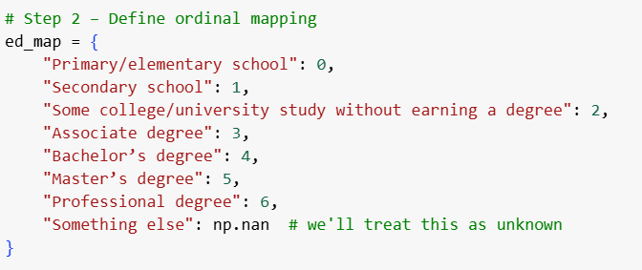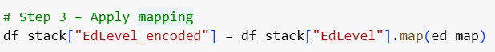

**Output**:

**Encoding Employment Status**

The Employment column in the dataset allowed multiple selections (e.g., “Employed full-time; Self-employed”), so we needed a way to handle and represent these multi-label responses in a machine-learning-friendly format. To handle this, we applied the following steps:

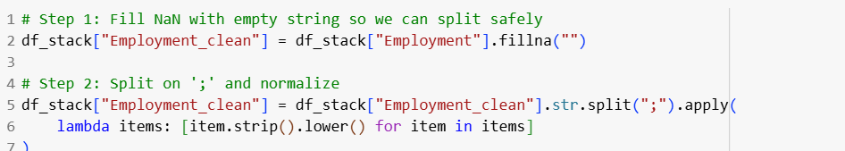

Cleaning & Normalization

Multi-Label Binary Encoding

**Encoding Remote Work Preferences**

The RemoteWork column includes three types of responses: ***Remote, Hybrid, and In-person***. Since these responses are categorical and mutually exclusive, we transformed them into binary flags to make them usable in modeling. To handle this, we applied the following steps:

**Cleaning and Standardization** - We filled missing values with empty strings and normalized the text by converting all entries to lowercase and removing whitespace

**Binary Feature Creation** - We created three new binary columns:

* is_remote: True if the respondent works fully remotely.
* is_hybrid: True if the respondent works partly remotely and partly in person.
* is_inperson: True if the respondent works entirely in person.

**Encoding Developer Roles (DevType)**

The DevType column in the Stack Overflow dataset contains multiple roles per respondent (e.g., “Developer, full-stack; Developer, back-end”), making it a multi-label categorical feature. To handle this, we applied the following steps:

Cleaning and Splitting

* We filled missing values with empty strings and split the entries on semicolons to extract individual roles. Each entry was also normalized (stripped and lowercased) to ensure consistency.

Top 10 Role Selection

* Since the dataset includes over 20 unique roles, we selected the top 10 most common developer roles based on EDA insights. This reduced dimensionality while still preserving the most impactful data.

Multi-Label Binary Encoding

* We performed manual multi-label one-hot encoding for the DevType column by first splitting roles into lists, then creating binary columns for the top 10 most frequent roles identified during EDA. This allowed us to capture relevant role information while keeping the feature space compact.

Cleaning and Splitting using fillna and .strip and .split

Put the top 10 roles in a list. These roles are based on the EDA

Multi-Label Binary Encoding using lambda function

**Encoding Organization Size**

The OrgSize column indicates the size of the respondent's organization, using predefined size ranges. Since these ranges follow a natural increasing order, we applied ordinal encoding to convert them into meaningful numeric values.

Mapping Ranges to Ordered Integers - We created a custom dictionary to map each size category (e.g., "1-9", "100-499") to an increasing integer, starting from 0 for the smallest (freelancers) up to 8 for the largest (10,000 or more). The category "I don’t know" was treated as missing (NaN).

Applying the Mapping - We used the .map() function to apply this mapping directly to the OrgSize column and stored the result in a new column called OrgSize_encoded.

Mapping Ranges to Ordered Integers

We used the .map() function to apply the mapping

**One-Hot Encoding Multi-Select Tech Stack Columns**

The columns such as LanguageHaveWorkedWith, DatabaseHaveWorkedWith, and related technologies contain multiselect categorical data—respondents could select multiple tools or platforms they've used. While we did not include full visual EDA for each of these columns, we made use of domain knowledge and general industry trends to guide our preprocessing decisions.

For example, we know from industry experience and prior Stack Overflow reports that certain technologies (e.g., SQL, Python, PostgreSQL, Docker) consistently rank among the most used. We used this context to extract and encode only the top N most relevant tools from each category using a consistent processing function.

**This approach allowed us to:**

* Focus on technologies with high practical importance or adoption
* Avoid over-encoding rare or outdated tools
* Keep the feature set manageable and relevant for modelling

**Step 1: Clean and Split**

* Replaces NaN with empty strings
* Splits the string on ; (since multiple values are semicolon-separated)
* Strips whitespace from each item
* Result: a list of selected tech tools per respondent

**Step 2: Count Top N Items**

* Flattens all responses into a single list of tech items
* Uses Counter from Python's collections module to get the **top N most frequent tools**
* You control top_n (default = 10)

**Step 3: Create Binary Columns**

For each of the top N tools:

* Creates a new column like LanguageHaveWorkedWith_python
* Sets it to True or False depending on whether the respondent used that tool

## **Regression Modeling Roadmap: From Baseline to Boosted Models**

To predict developer compensation (CompTotal), we implemented a staged regression modeling pipeline—starting with basic models and progressing to more complex, tuned variants. Our process involved five main steps:

**Justification for Model Choices**

We selected **Random Forest** as one of our core models due to its strong performance on tabular, structured datasets like the Stack Overflow survey data. It offers several advantages:

* Handles non-linear relationships and complex feature interactions well
* Robust to outliers and noise in the data
* Performs automatic feature selection by assessing feature importance
* Low risk of overfitting due to averaging across multiple decision trees
* No need for scaling or strict assumptions about data distribution

Random Forest served as an effective baseline for tuned ensemble models and provided interpretability through feature importance scores.

We introduced **Gradient Boosting** as an advanced model due to its ability to incrementally correct errors made by previous models, resulting in higher accuracy when tuned well. It is particularly suitable because:

* It captures subtle patterns and non-linear relationships
* It often outperforms bagging methods (like Random Forest) when tuned properly
* It supports regularization techniques (e.g., learning rate, tree depth) to reduce overfitting
* It provides fine-grained control over model complexity and performance

Gradient Boosting is widely used in winning solutions for structured prediction tasks and offers a strong benchmark for high-performing models.

### Baseline Regression with Raw Target (No Hyperparameter Tuning)

We began with simple regression models using the untransformed compensation values and a small set of baseline features. This established a performance benchmark for comparison.

**Features Used:**

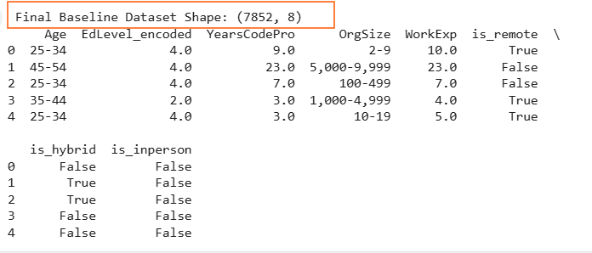

For our baseline Random Forest regression model (using the raw CompTotal target), we selected a compact set of features that are:

* Numerical or ordinal (no further encoding required)
* Available early in the survey
* Likely to influence compensation based on domain knowledge and EDA

This baseline setup allows us to measure how much value is added when additional features (like tech stacks, developer roles, etc.) are incorporated later in the pipeline.

**Model Evaluation (Raw Target, Baseline Features)**

After training the Random Forest model on the baseline feature set with the raw CompTotal target, we evaluated performance using three standard regression metrics

MAE (Mean Absolute Error)

RMSE (Root Mean Squared Error)

R² Score (Coefficient of Determination)

|  |  |  |
| --- | --- | --- |
| **Metric** | **Value** | **Interpretation** |
| MAE (Mean Absolute Error) | $ 53,151.00 | On average, the model’s salary predictions are off by about $53,000. |
| RMSE (Root Mean Squared Error) | $ 72627.84 | A $72K error suggests that the model occasionally makes very large prediction errors — especially for high-salary earners, where it can under- or overestimate significantly |
| R² Score | 0.0693 | The model explains only about 7% of the variation in salaries.  That’s quite low — meaning other important factors (like job title, industry, or location) are probably missing from the data.  It shows that the model is not very reliable at capturing what drives compensation. |

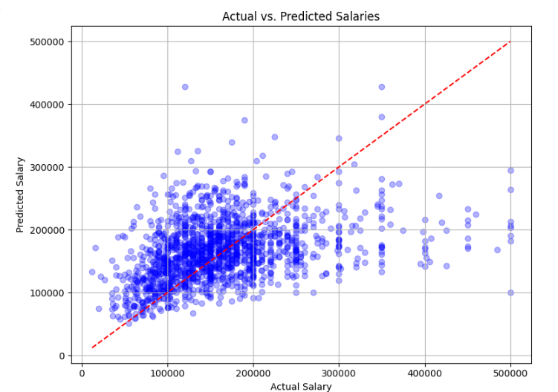**Actual vs Predicted Salaries**

**Interpretation:**

The model generally captures the upward trend — higher actual salaries tend to correspond with higher predictions.

However, predictions are compressed toward the center, especially for higher salary ranges, indicating:

* Underestimation of high salaries
* Limited ability to model extreme values with the current feature set

The scatter's spread and deviation from the diagonal suggest there’s room to improve accuracy, particularly for outlier compensation cases

This visualization supports the numerical metrics (MAE, RMSE, R²) and highlights the need for further improvements, such as target transformation and feature expansion.

**Feature Importance :**

The chart shows how much each baseline feature contributed to the Random Forest model’s salary predictions.

Years of professional coding experience (**YearsCodePro**) and overall work experience (**WorkExp**) were the most influential factors, strongly impacting predicted compensation.

**Org size and education** level also had moderate importance, while age played a smaller role.

**Remote work status** (is_remote, is_hybrid, is_inperson) had the least influence on predictions in the baseline model.

Experience-related features (especially YearsCodePro and WorkExp) were the most powerful predictors of salary in our baseline model. In contrast, remote work arrangement had minimal predictive value on its own.

### Hyperparameter Tuning for Random Forest (Same Baseline Feature)

To improve the performance of our baseline Random Forest model, we applied hyperparameter tuning using a grid search strategy. The parameter grid included combinations of:

* *n_estimators:* Number of trees in the forest (100, 200)
* *max_depth:* Maximum depth of each tree (None = unlimited, or fixed at 10 or 20)
* *min_samples_split:* Minimum number of samples required to split an internal node (2 or 5)
* *min_samples_leaf:* Minimum number of samples required to be at a leaf node (1 or 2)
* *max_features:* Number of features to consider when looking for the best split ('sqrt', 'log2', or all features)

This grid allowed the model to explore a variety of complexity levels, from shallow and regularized trees to fully grown ones, and to optimize how features are selected at each decision node.

**Model Evaluation:**

|  |  |  |
| --- | --- | --- |
| **Metric** | **Value** | **Interpretation** |
| MAE | $ 47,972.72 | On average, the model’s salary predictions are off by around $48,000 |
| RMSE | $ 66,790.65 | This means the model still makes some large errors, especially for higher salaries. |
| R² Score | 0.2129 | The model explains about 21% of the variation in salaries using the input data. |

**Actual vs Predicted Salaries**

**Interpretation:**

Most points are clustered around the line, especially in the lower and mid salary ranges — this means the model is making reasonable predictions in these areas.

For higher salaries (right side), the dots fall below the red line — this suggests the model tends to underpredict high salaries.

Overall, the predictions follow the right trend but still leave room for improvement, especially at the higher end.

**Feature Importance**

**Interpretation:**

Years of professional coding experience (YearsCodePro) was by far the most important factor — the model uses it heavily to estimate salary.

Overall work experience (WorkExp) and organization size (OrgSize_encoded) also played major roles.

Education level and age had moderate influence, while the work format (remote, hybrid, in-person) had very little impact.

This suggests that experience and workplace context matter more for salary prediction than whether someone works remotely or not.

### RandomForrest Regression with Logarithmic Transformation of Target (with Tuning)

To address the skewness in salary distribution, we applied a logarithmic transformation to the CompTotal target variable using **np.log1p()**. *This stabilizes variance and helps the model focus on relative differences rather than extreme salary outliers*.

After model training and prediction in the log scale, we used np.expm1() to revert predictions and targets back to the original salary scale for evaluation.

**Model Evaluation:**

|  |  |  |
| --- | --- | --- |
| **Metric** | **Value** | **Interpretation** |
| MAE | $ 46,383.52 | On average, predictions are off by about $51.1K |
| RMSE | $ 67,480.40 | The model still makes some big mistakes, especially for people on the high or low ends of the salary range. |
| R² Score | 0.1966 | The model explains only 9% of what affects salary. That means 91% of the variation in salaries is due to other factors that the model didn’t capture (e.g., role, seniority, company, etc.). |

**Actual vs Predicted**

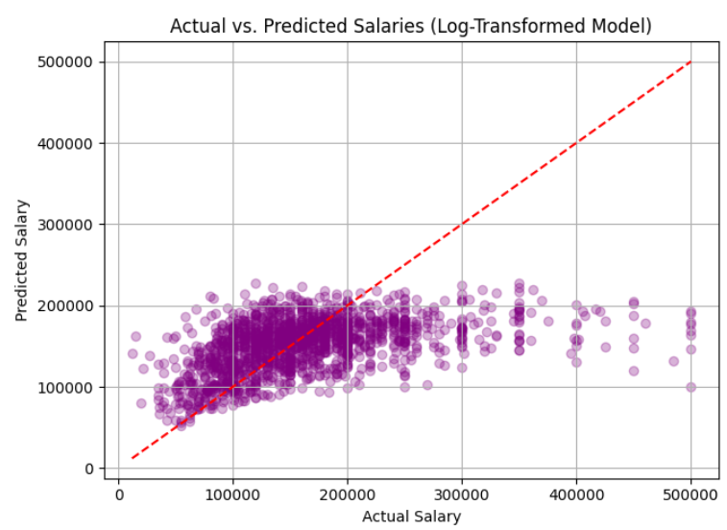**Interpretation:**

The predictions are more tightly clustered along the ideal line compared to the untransformed model — a sign of improved stability and better fit.

The model performs especially well for mid-range salaries, where most points are close to the red line.

Some underprediction is still visible for higher salaries, but overall, the spread is more consistent and less extreme than before.

This confirms that applying a log transformation to the target helped the model handle salary variability better and make more accurate predictions across most of the range.

**Feature Importance:**

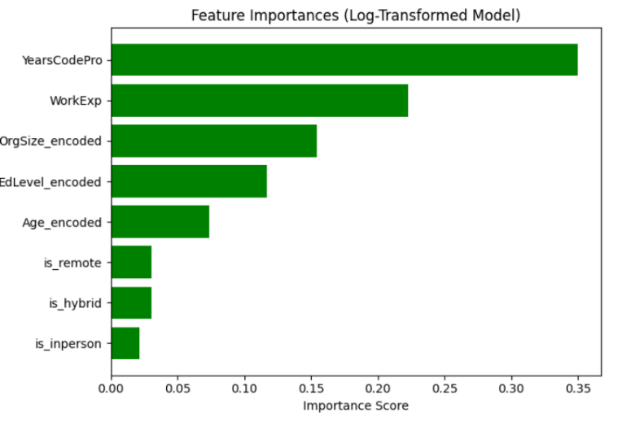**Interpretation:**

YearsCodePro remains the most important feature, contributing over 35% to the model’s predictive power. This suggests that more professional coding experience strongly correlates with higher salaries.

WorkExp and OrgSize_encoded also contribute meaningfully, indicating that total work experience and company size affect salary levels.

Education level (EdLevel_encoded) and Age have moderate impact, while remote/hybrid/in-person status play smaller roles.

### Feature Expansion with Tuning

After establishing a tuned Random Forest model using a compact baseline feature set, we proceeded to evaluate whether adding more features could improve model performance. To improve performance, we expanded our feature set by adding key technology indicators, especially the top databases developers reported working with:

*Examples include:*

DatabaseHaveWorkedWith_PostgreSQL, MySQL, MongoDB, SQLite, Redis, and others.

We then applied Random Forest Regressor with GridSearchCV for hyperparameter tuning to better capture non-linear relationships and improve prediction accuracy.

**Model Evaluation:**

|  |  |  |
| --- | --- | --- |
| **Metric** | **Value** | **Interpretation** |
| MAE | $ 44,557.68 | On average, the model's predictions are off by $44.5K |
| RMSE | $ 62,605.76 | It shows that the model still struggles especially with very high or very low salaries. |
| R2 | 0.2839 | The model can explain about 23% of the salary differences between developers. That means it’s picking up on some important factors, but most of what affects salary is still not captured. |

**Actual vs Predicted**

**Interpretation:**

Most predictions are clustered below the red line, especially for higher salaries.

This means the model tends to underpredict high salaries.

For mid-range salaries (around $100K–$200K), predictions are fairly close to actual values.

The model performs best in this range.

For very high salaries (>$300K), predictions are much lower than actual.

The model struggles to capture top-end compensation accurately.

**Feature Importance:**

**Interpretation**:

**Top Predictors:**

YearsCodePro (years coding professionally) is by far the most influential factor in predicting salary.

WorkExp (total work experience) and OrgSize_encoded (company size) are also strong indicators, showing that experience and organization context heavily influence pay.

**Moderate Impact Features:**

Technologies like DatabaseHaveWorkedWith_Microsoft_SQL_Server and Redis, as well as demographics like Age_encoded and EdLevel_encoded, have noticeable but smaller influence.

Being a full-stack developer (is_developer_full_stack) adds some predictive value.

**Low Impact Features:**

Some database tools (like SQLite, MongoDB, MariaDB) and work arrangement indicators (is_remote, is_hybrid, is_full_time) have minimal impact in this model.

### Gradient Boosting

To further improve prediction accuracy, we applied a Gradient Boosting Regressor (GBR) using the same enhanced feature set. Gradient Boosting builds an ensemble of decision trees sequentially, where each tree corrects the errors of the one before it. This makes it well-suited for capturing complex, non-linear relationships in structured data. By incorporating both developer demographics and technical experience—including database tools and employment type—GBR offers a more refined approach to modeling salary compared to baseline methods.

**Model Evaluation:**

|  |  |  |
| --- | --- | --- |
| **Metric** | **Value** | **Interpretation** |
| MAE | $ 44,394.30 | On average, the model’s salary predictions are off by around $44K, which is a moderate error given the wide range of tech salaries. |
| RMSE | $ 62,115.12 | his shows that while many predictions are close, there are still some larger errors—especially for very high or very low salaries. |
| R2 | 0.2951 | The model explains about 29.5% of the differences in developer salaries. This is an improvement over earlier models, suggesting the added features helped the model better understand what affects compensation |

**Actual vs Predicted :**

**Interpretation:**

Most points are clustered below the red line, indicating that the model tends to underestimate salaries, especially for higher earners.

The predictions are close for many mid-range salaries (around $100k–$200k), where the model performs best.

There's more spread and underprediction in the higher salary ranges (above $250k), which is common in salary data due to high variability and fewer examples.

**Feature Importance:**

**Interpretation**:

YearsCodePro (professional coding experience) was by far the most important predictor — the more experience, the more it influenced the predicted salary.

OrgSize_encoded (organization size) also played a strong role, likely because larger companies often offer higher pay.

DatabaseHaveWorkedWith_Microsoft_SQL_Server and EdLevel_encoded (education level) contributed noticeably, suggesting experience with enterprise tools and higher education matter.

Technical traits like full-stack developer and experience with databases like Redis and DynamoDB had moderate influence.

On the other hand, features like is_hybrid, is_remote, or working with SQLite had very low impact on salary prediction in this model.

## **Conclusion**

|  |  |  |  |
| --- | --- | --- | --- |
| **Model** | **MAE** | **RMSE** | **R2** |
| Gradient Boosting | **$44,394.30** | **$62,115.12** | **0.2951** |
| Feature Expansion with Tuning | $44,557.68 | $62,605.76 | 0.2839 |
| RandomForrest Regression with Logarithmic Transformation of Target | $46,383.52 | $ 67,480.40 | 0.1966 |
| Hyperparameter Tuning for Random Forest | $47,972.72 | $66,790.65 | 0.2129 |
| Baseline Random Forest | $53,151.00 | $72,627.00 | 0.0693 |

Among all the models tested, Gradient Boosting delivered the best overall performance. It achieved the lowest prediction errors (MAE: ~$44K, RMSE: ~$62K) and the highest explanatory power (R² = 0.2951), capturing nearly 30% of the variation in developer salaries.

The Feature Expansion model using Random Forest with Tuning closely followed, demonstrating that incorporating database-related and developer-type features can substantially improve predictive accuracy.

By contrast, both the log-transformed model without tuning and the baseline random forest performed significantly worse, showing lower R² values (0.1966 and 0.0693, respectively) and higher error rates.

Notably, even applying hyperparameter tuning alone (without additional feature engineering) led to moderate gains. This suggests that both careful model tuning and the inclusion of more relevant features are key drivers of improved salary prediction.

## **Future Enhancements**

While our current models provide a strong foundation for salary prediction, there are several opportunities to improve both performance and interpretability. In future iterations, we plan to explore advanced modeling techniques such as feature interaction engineering and more powerful gradient boosting libraries like XGBoost. We also aim to make predictions more practical by estimating salary ranges instead of exact values. Finally, integrating model explainability tools like SHAP will help users understand the key factors driving predictions, making the model more transparent and trustworthy.

**Resources :**

Software Developers, Quality Assurance Analysts, and Testers. (2025, April 18). Bureau of Labor Statistics. <https://www.bls.gov/ooh/computer-and-information-technology/software-developers.htm>