ReactJS – User List Workshop
This is application was created as a workshop for the ReactJS Course @ Software University

Task Requirements
Use the provided html structure and styles to create a page with the following functionalities:

Create user
Clicking on the Add new user button should display a form for creating users.
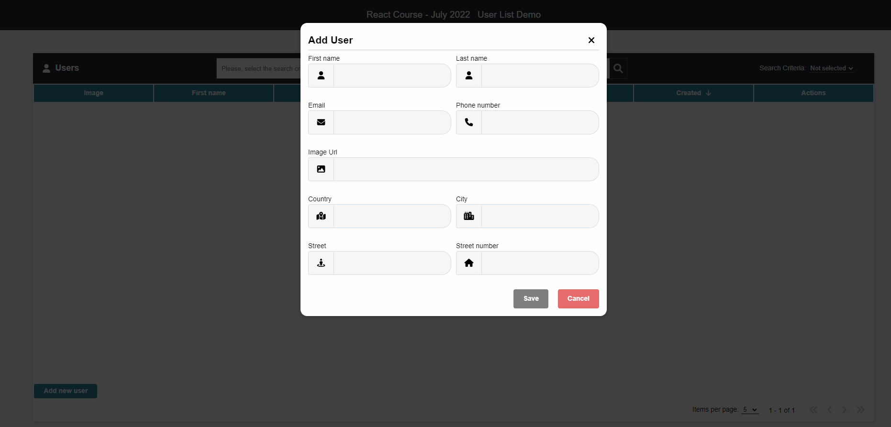
All fields must be filled correctly before sending the request. If any of the fields is not filled or it does not meet its requirements, the [Save] button should be disabled and their error messages should be visible.
Keep in mid that there are server validations while creating or editing a user:
- The First Name should be at least three characters
- The Last name should be at least three characters
- The Email should contain @ with atleast 3 character after it
- The ImageUrl should should start with https://.
- The Phone nubmer should start with 0 and be 10 characters
- The Country should be at least two characters
- The City should be at least three characters
- The Street should be at least three characters
- The Street number must be a number larger than 0

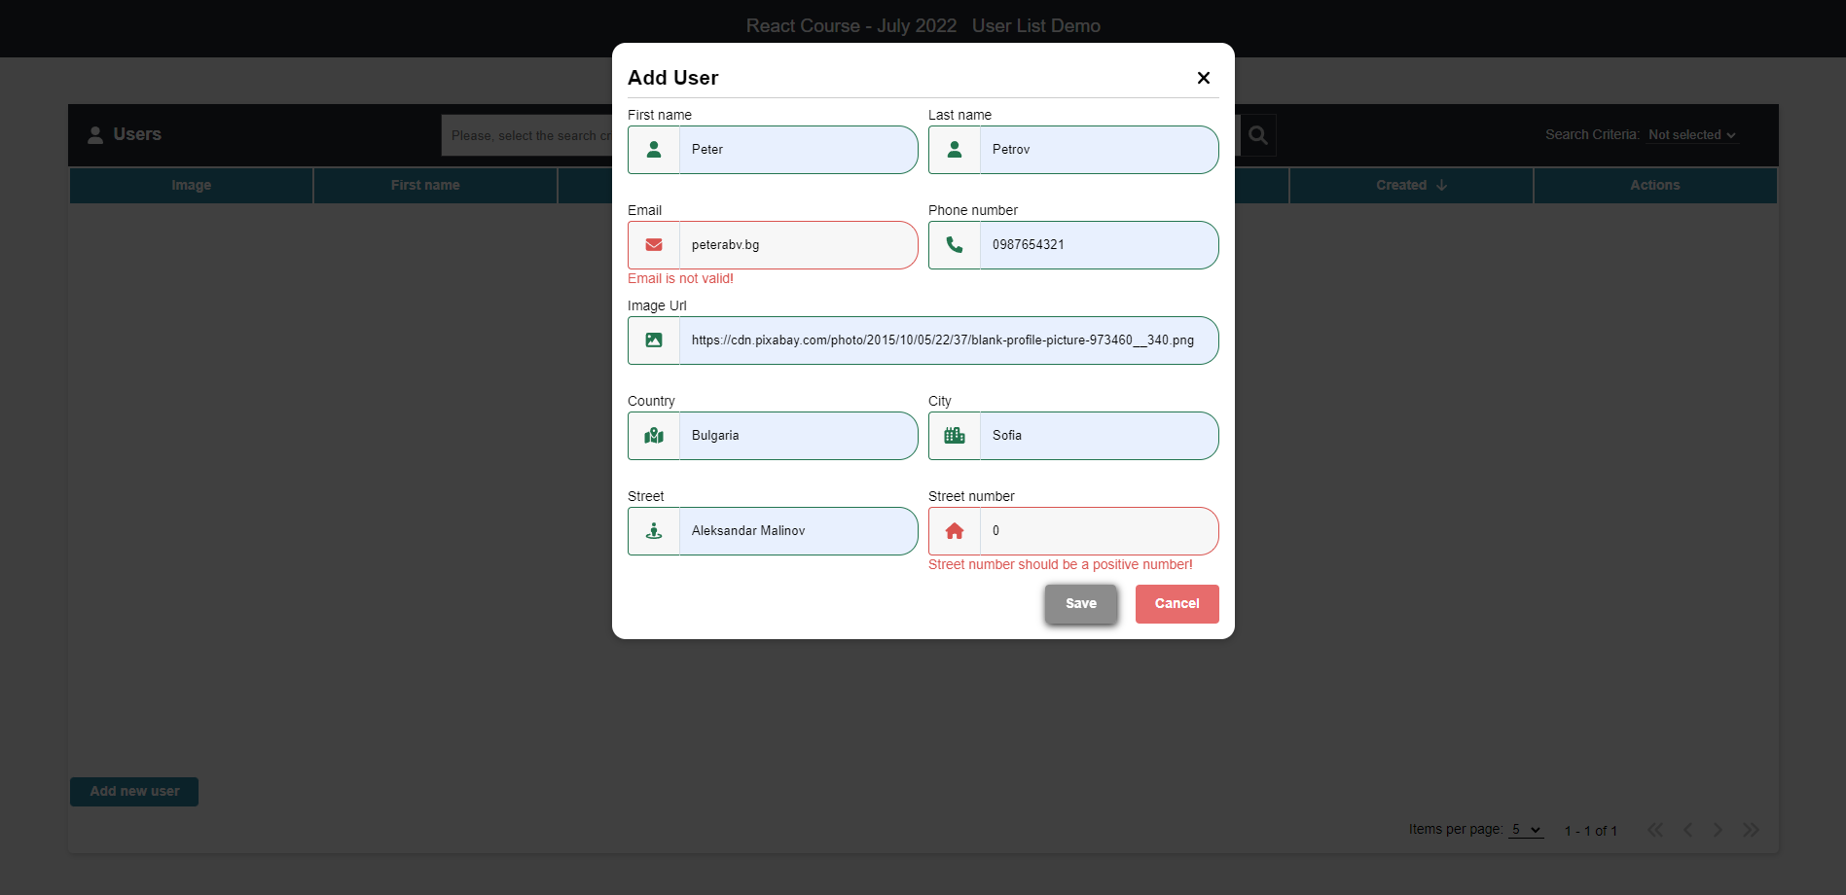
Otherwise send the following request:
Method: POST
URL: /users
The service expects a body with the following shape:
{
firstName,
lastName,
email,
imageUrl,
phoneNumber,
address: {
country,
city,
street,
streetNumber
}
}
Then the service will return the newly created record.
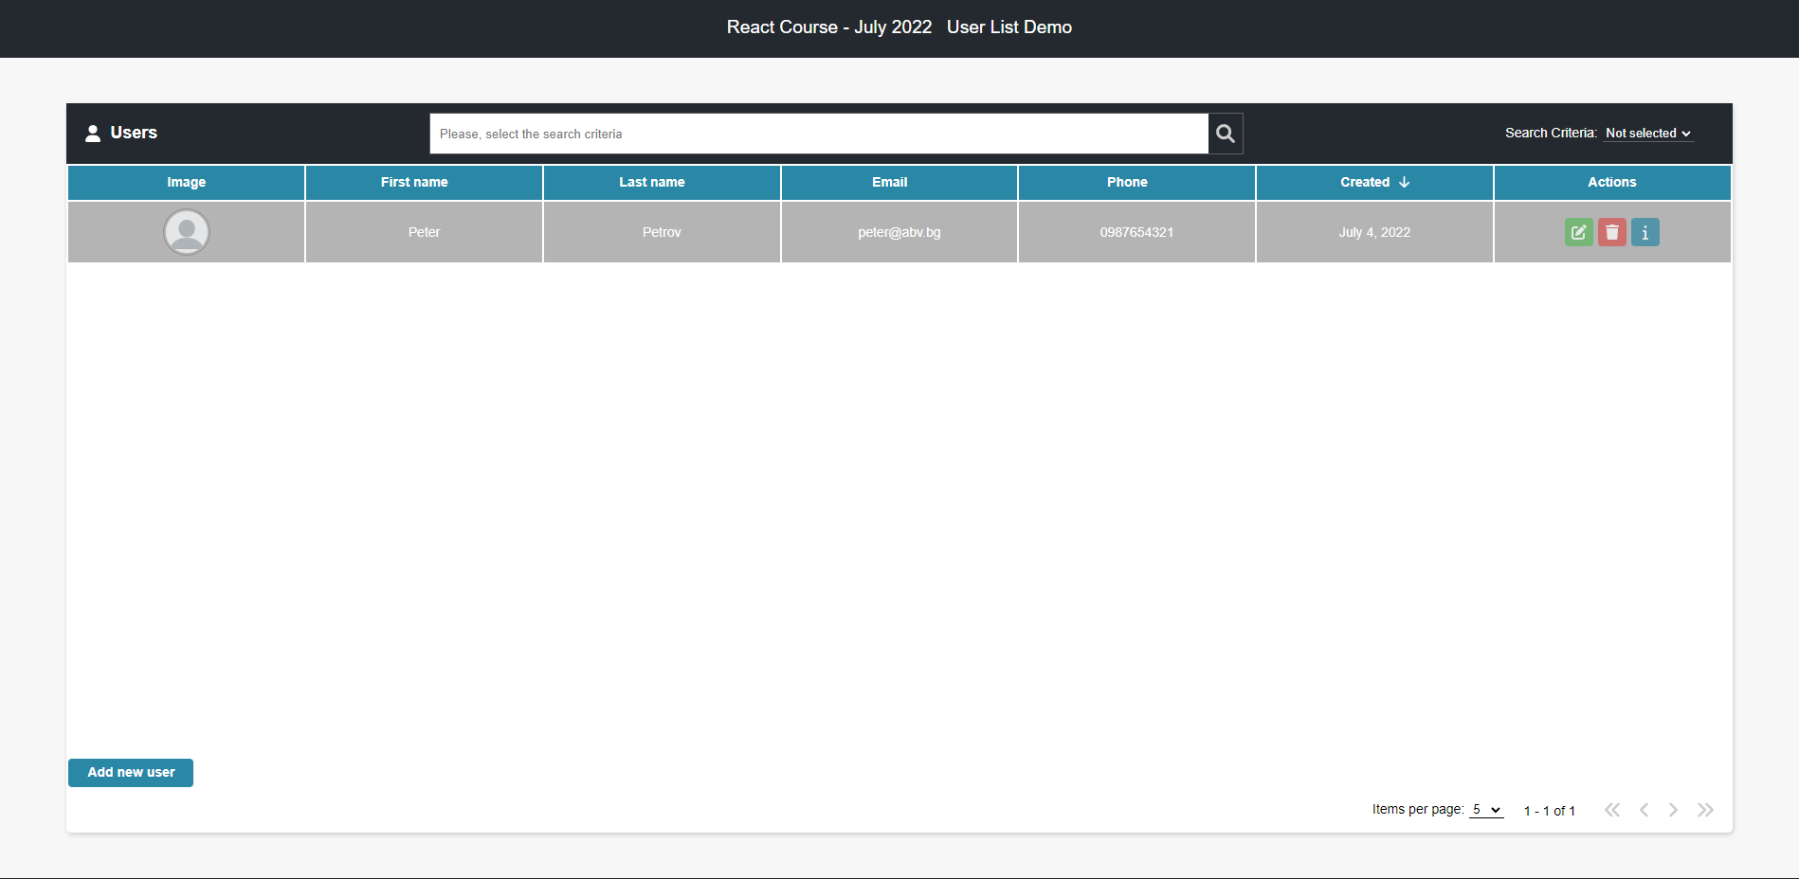

User info
Clicking the [ i ] button in the Actions section should display a window containing the information for the selected user.
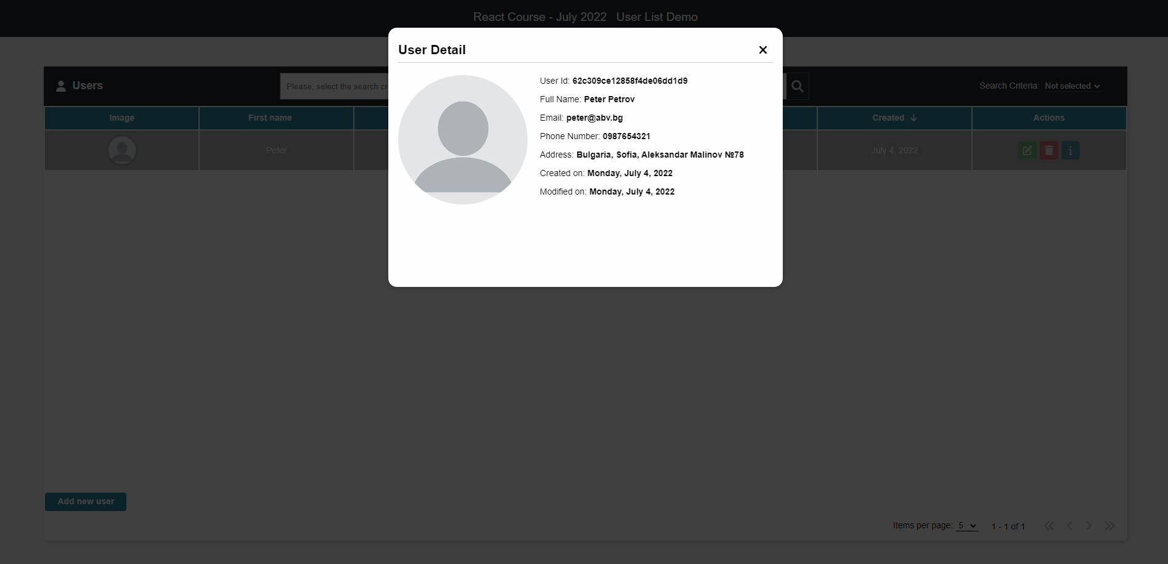
To retrieve the information, send the following request:
Method: GET
URL: /users/{userId}

Edit user
Clicking the [ Edit ] button in the Actions section should display a form for editing the user information. 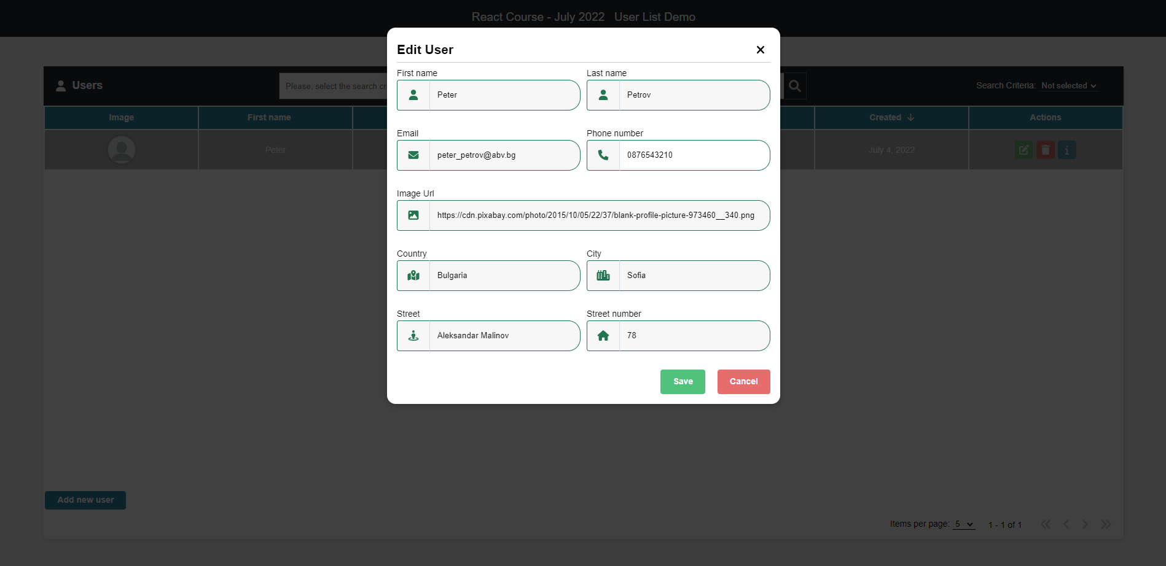
If the form is filled correctly send the following request:
Method: PUT
URL: /users/{userId}
The service expects a body with the following shape:
{
firstName,
lastName,
email,
imageUrl,
phoneNumber,
address: {
country,
city,
street,
streetNumber
}
}
Then the service will return the newly modified record.

Delete user
Clicking the [ Delete ] button in the Actions section should display a confirmation window. 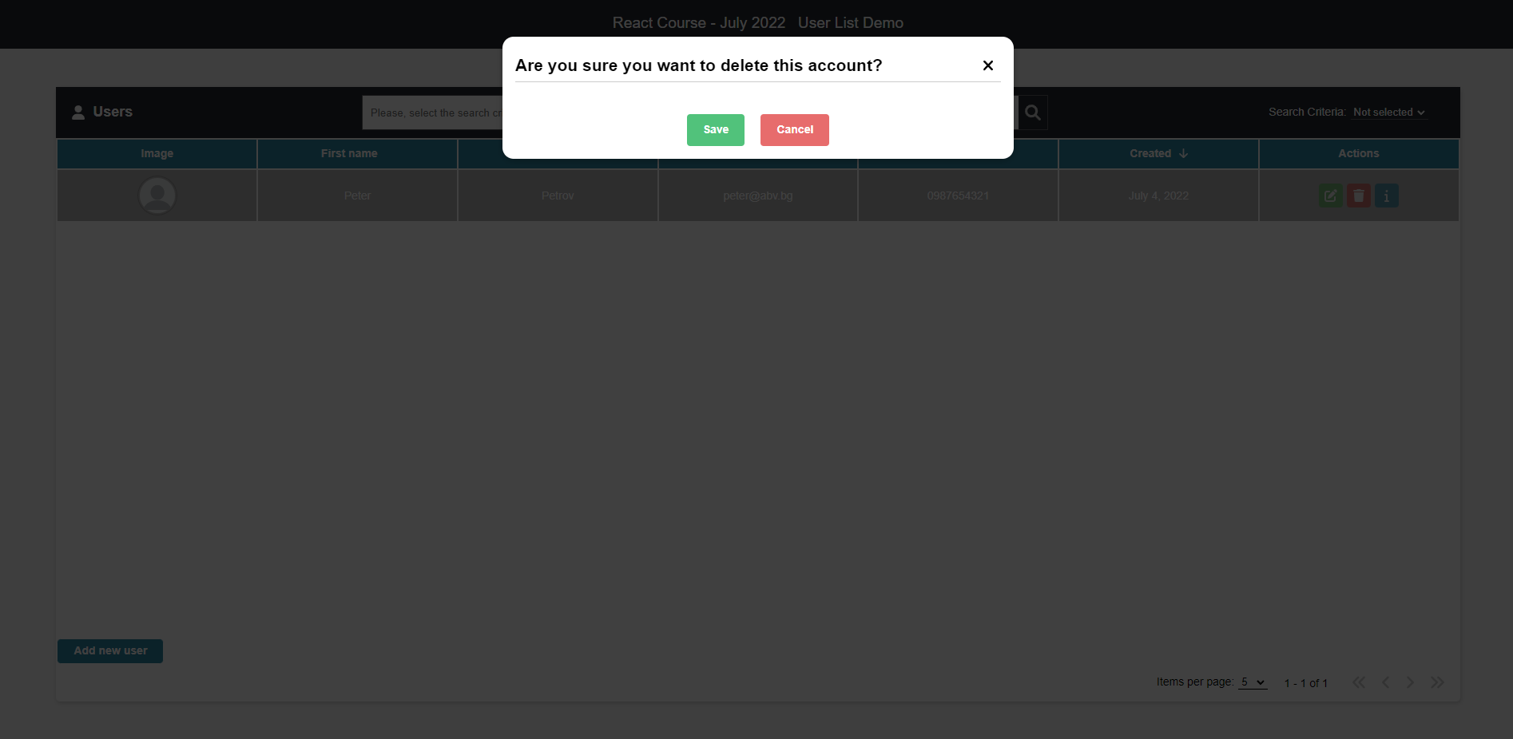
Clicking the [ Save ] button should send the following request:
Method: DELETE
URL: /users/{userId}
Then the record with the given id will be deleted.

Search
By selecting a search criterion and typing in the search bar the criteria, only the matching records should be visible
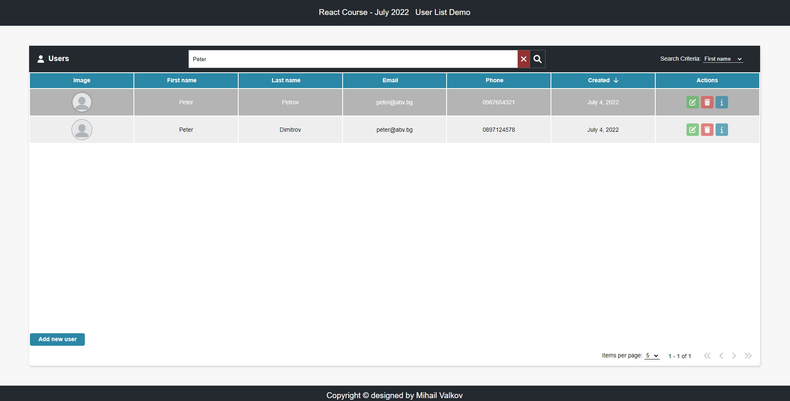

Pagination
Selecting how many items a page must include, implement a pagination
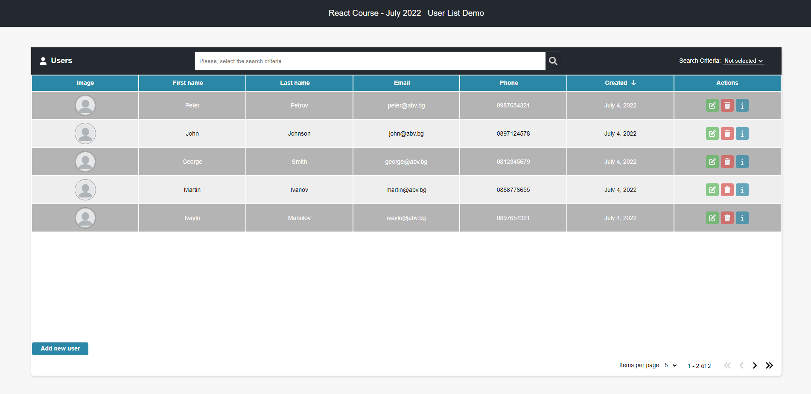
If there are more records than the maximum items per page, a second page must become active.
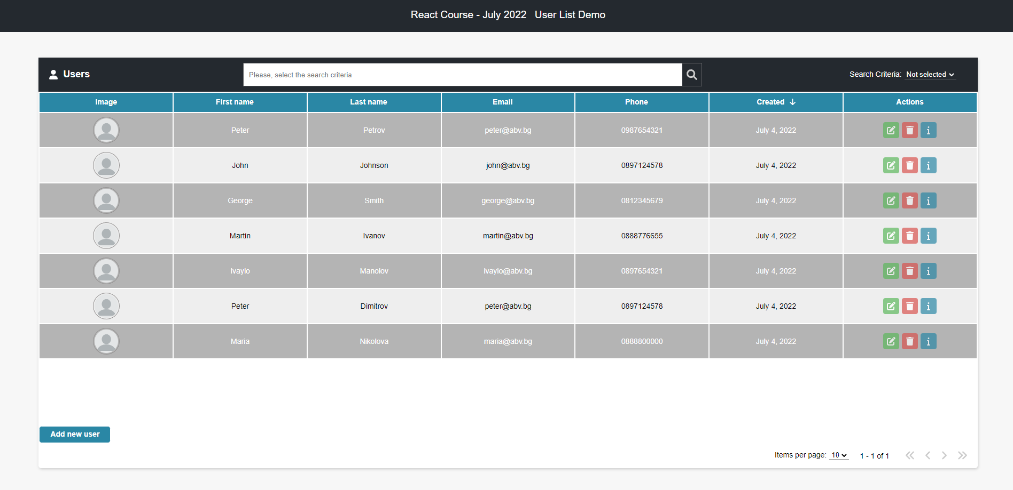

Sorting
Clicking on some of the main fields should sort the records in an ascending or descending order, depending on how many times it is clicked.
Ascending by ‘Last name’:
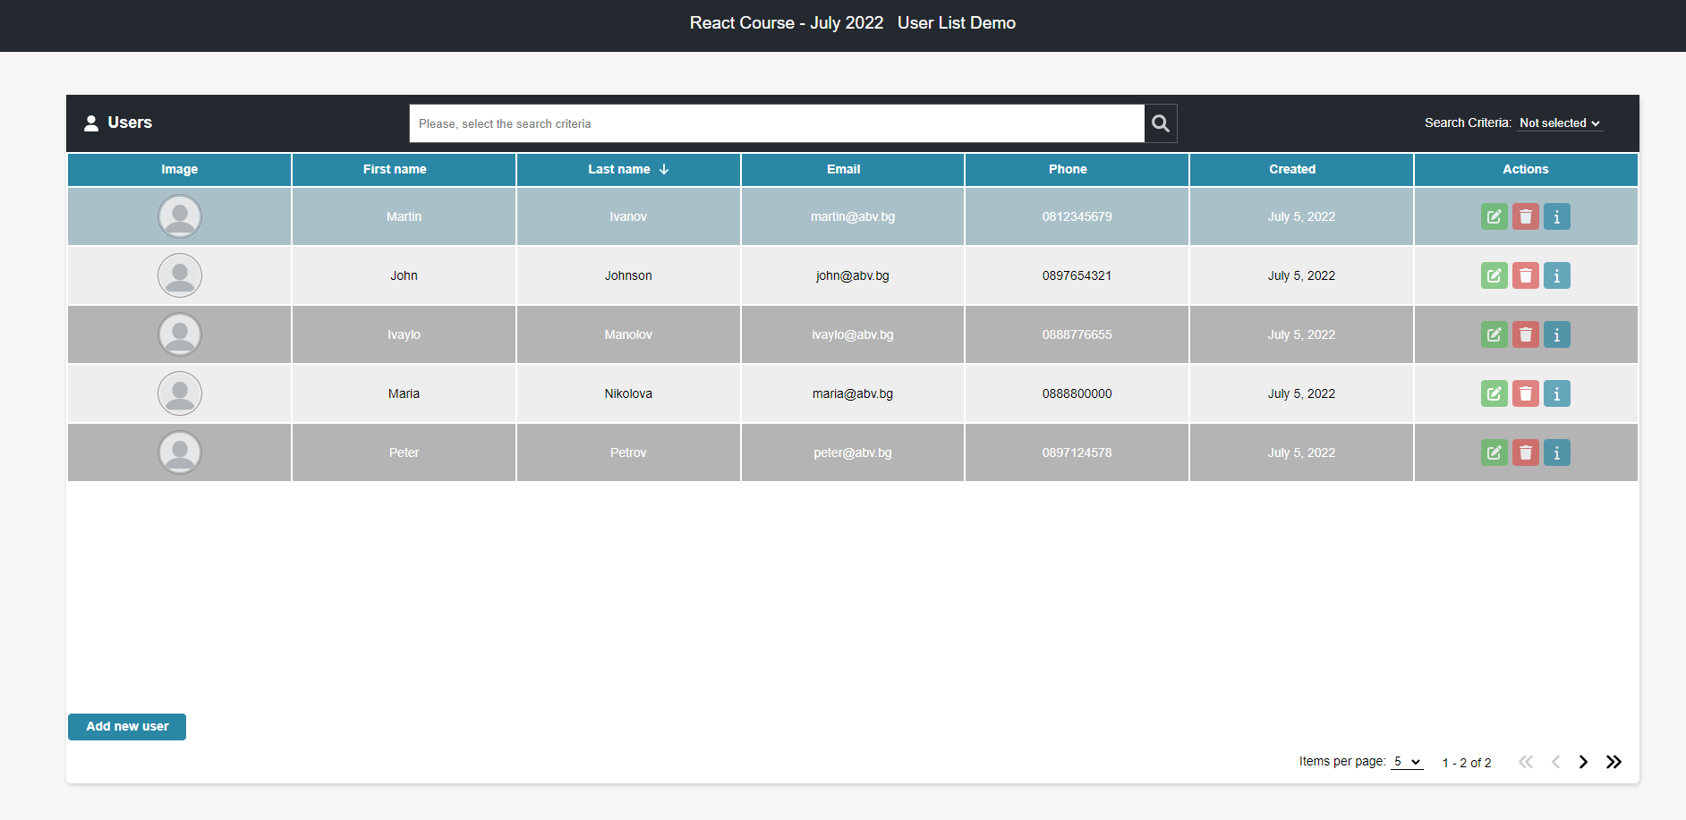
Descending by ‘Last name’:
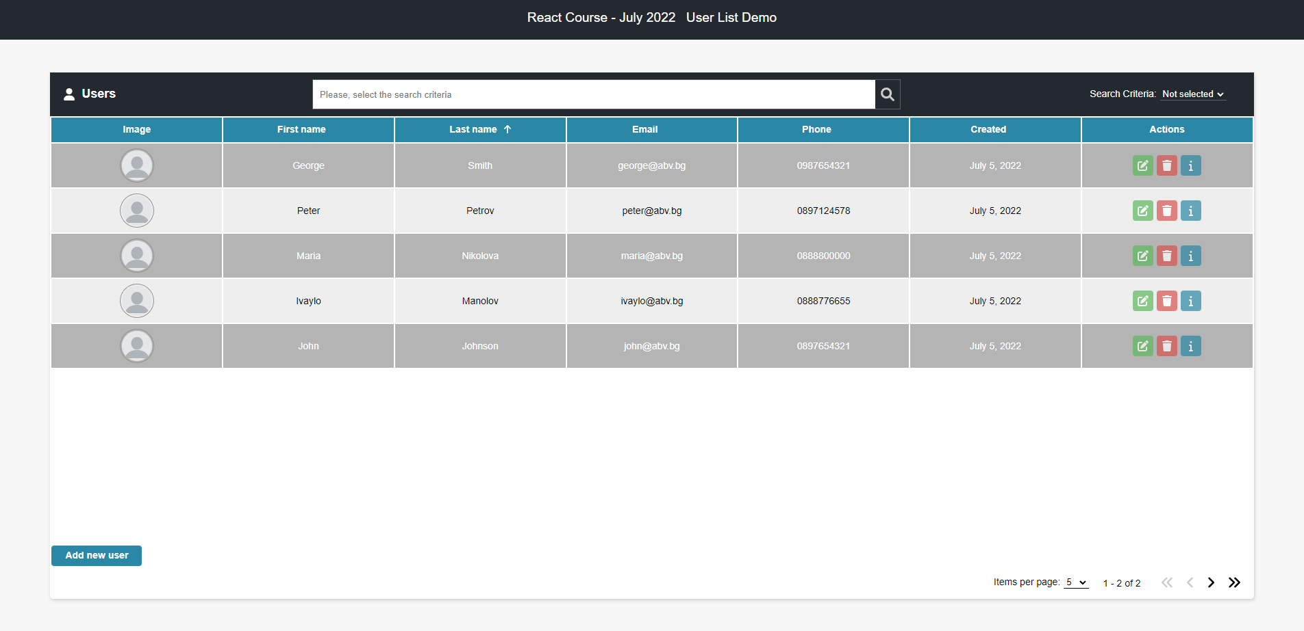

Spinner
While waiting a response from a request, a spinner should be displayed:
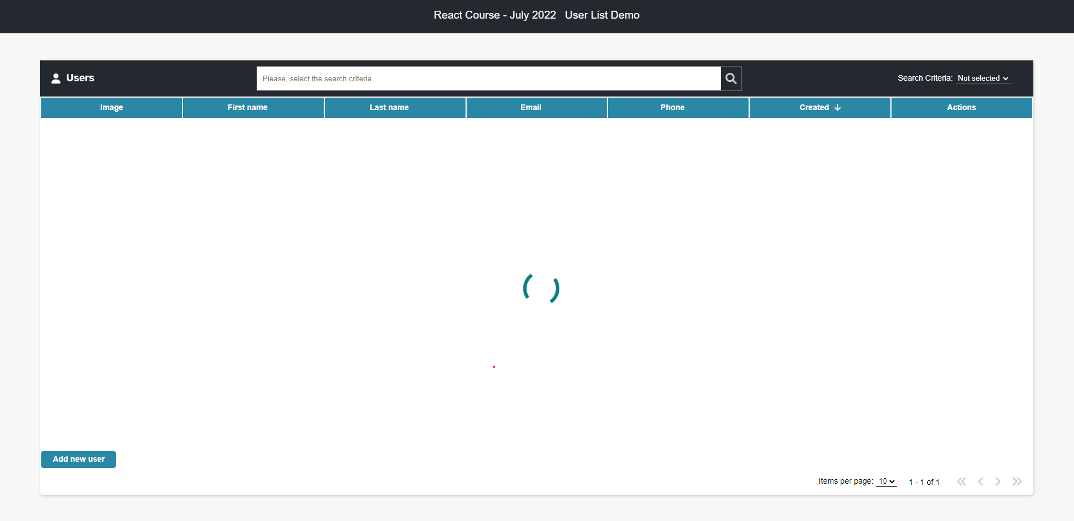

Errors
If a request failed, the following error should be displayed:
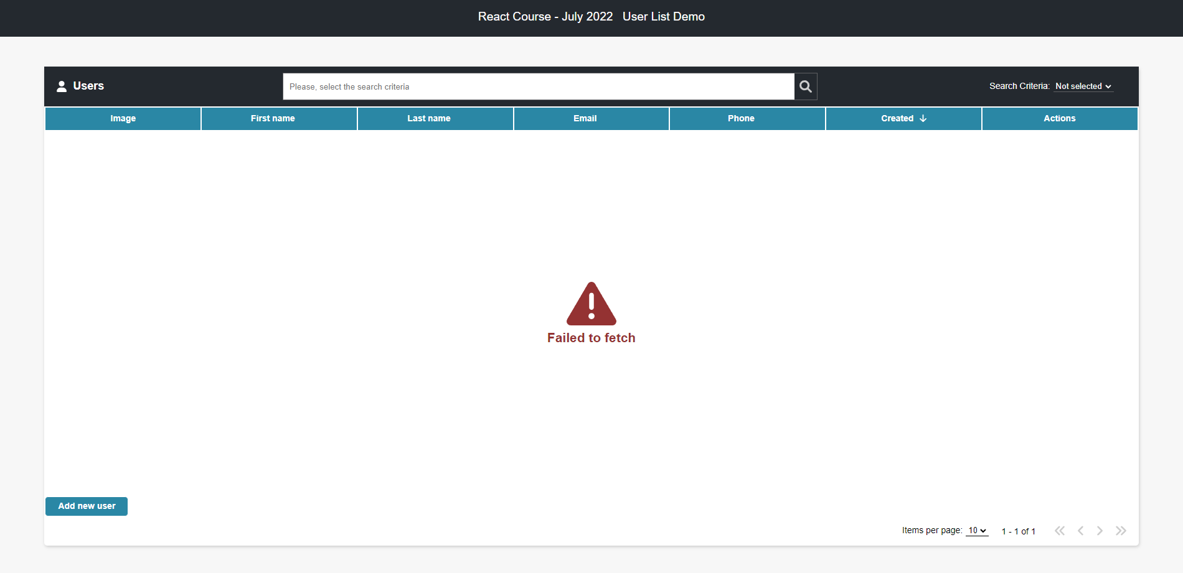
If there are no records yet, the following error should be displayed:
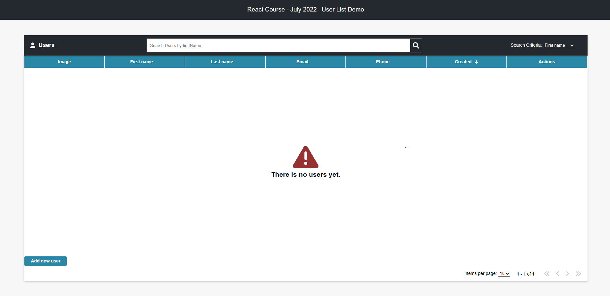
If there is no record matching the given search criterion the following error should be displayed:
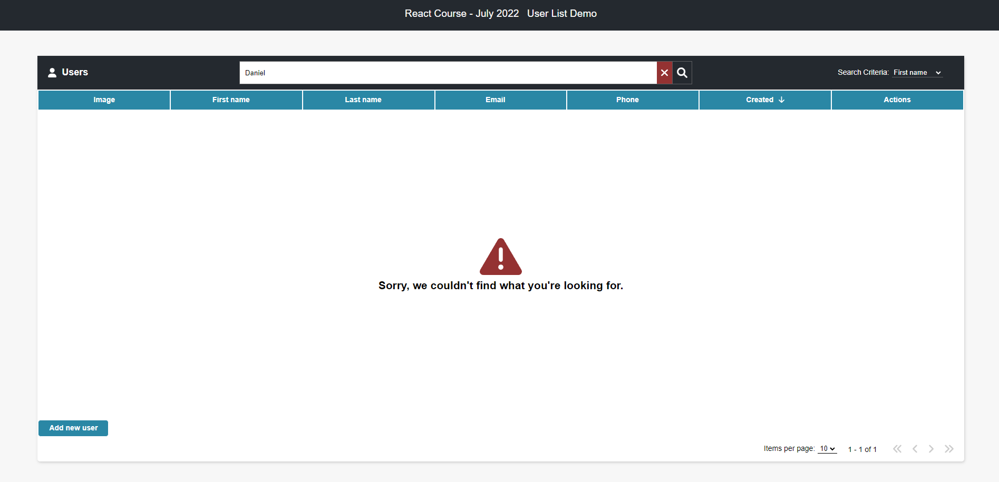

Initialize the App
Use the "npx create-react-app user-list-demo" command to create a new React App.
If you face any trouble, check the following link:
https://github.com/facebook/create-react-app#create-react-app--

Server
Use the provided server to make the needed requests so you can visualize their results into the front-end. If you are experiencing difficulties starting the server, need the right endpoints or see the expected request bodies, make sure to check its documentation: https://github.com/MihailValkov/user-list-demo/blob/main/server/README.md

Implementation
Make sure you assign every required attribute to each Component, so the result is the same as the example. If at some point something is not right, be free to check the structure for each element style for each element from the provided github link for the demo.

