Data Structures Laboratory
Assignment-2

Polynomial Manipulation using ListADT
Name: Sai Shashaank R
Register No: 205001086
Class: CSE-B
adt.h
struct polyADT
{
int coeff;
int exp;
struct polyADT *next;
};

struct polyADT* insertEnd(struct polyADT *p, int coeff, int exp); //To create polynomial through insertion at the end
struct polyADT* polyAdd(struct polyADT *p1, struct polyADT *p2); //To add two polynomials and return the pointer to the resulting polynomial
struct polyADT* polyMul(struct polyADT *p1, struct polyADT *p2); //To multiply two polynomials and return the pointer to the resulting polynomial
struct polyADT* polySimplify(struct polyADT *p); //To simplify a polynomial
int polyEvaluate(struct polyADT *p, int x); //To evaluate a polynomial
int polyDegree(struct polyADT *p); //To find the degree of a polynomial

void display(struct polyADT *p); //To display a listADT implementation of polynomial
int isZero(struct polyADT *p); //To check if a polynomial is zero
int item_in(int arr[],int size,int item); //To check if an item exists in an array; used in polySimplify()
struct polyADT* polyInp(struct polyADT *p); //To take input for a polynomial
impl.h
#include "adt.h"
#include <stdlib.h>
#include <stdio.h>
#include <math.h>

struct polyADT* insertEnd(struct polyADT *p, int c, int e)
{
struct polyADT *temp;
temp = (struct polyADT *) malloc(sizeof(struct polyADT));
temp->coeff = c;
temp->exp = e;
temp->next = NULL;

if(p==NULL)
{
p=temp;
}
else
{
struct polyADT *i = p;
while(i->next!=NULL)
i=i->next;
i->next = temp;
}
return p;

}

struct polyADT* polyAdd(struct polyADT *p1, struct polyADT *p2)
{
if(isZero(p1))
return p2;

else if(isZero(p2))
return p1;

struct polyADT *p = NULL;

while(p1!=NULL && p2!=NULL)
{
if((p1->exp) > (p2->exp))
{
p = insertEnd(p,p1->coeff,p1->exp);
p1=p1->next;
}

else if((p1->exp) == (p2->exp))
{
p = insertEnd(p,(p1->coeff + p2->coeff),p1->exp);
p1 = p1->next;
p2 = p2->next;
}

else if((p1->exp) < (p2->exp))
{
p = insertEnd(p,p2->coeff,p2->exp);
p2=p2->next;
}
}

if(p1 == NULL)
{
while(p2!=NULL)
{
p = insertEnd(p,p2->coeff,p2->exp);
p2 = p2->next;
}
}

if(p2==NULL)
{
while(p1!=NULL)
{
p = insertEnd(p,p1->coeff,p1->exp);
p1 = p1->next;
}
}
return p;
}

struct polyADT* polyMul(struct polyADT *p1, struct polyADT *p2)
{
if(isZero(p1)||isZero(p2))
return NULL;

struct polyADT *p = NULL,*t;

while(p1!=NULL)
{
t = p2;
while(t!=NULL)
{
p = insertEnd(p,(p1->coeff * t->coeff),(p1->exp + t->exp));
t = t->next;
}

p1=p1->next;
}

return p;
}

struct polyADT* polySimplify(struct polyADT *p)
{
struct polyADT *temp;
struct polyADT *p1 = NULL;

int c[50];
int e[50];

int k=0;
int result;

while(p!=NULL)
{
result = 0;
if(!item_in(e,k,p->exp))
{
result += p->coeff;
temp = p->next;

while(temp!=NULL)
{
if(temp->exp == p->exp)
result += temp->coeff;
temp = temp -> next;
}

e[k] = p->exp;
c[k++] = result;
}

p = p->next;
}

for(int i=0; i<k ; i++)
{
p1 = insertEnd(p1,c[i],e[i]);
}

return p1;
}

int polyEvaluate(struct polyADT *p, int x)
{
int result=0;
while(p!=NULL)
{
result += p->coeff * (int)pow(x,p->exp);
p = p->next;
}

return result;
}

int polyDegree(struct polyADT *p)
{
int largest = p->exp;
while(p!=NULL)
{
if(largest < p->exp)
largest = p->exp;
p = p->next;
}

return largest;
}

int item_in(int arr[],int size,int item)
{
int flag=0;
for(int i=0;i<size;i++)
{
if(arr[i] == item)
{
flag = 1;
break;
}
}

return flag;
}

int isZero(struct polyADT *p)
{
int flag=0;
int onlyZero = (p->next == NULL)&&(p->coeff == 0);

if(p == NULL || onlyZero)
flag=1;

return flag;
}

struct polyADT* polyInp(struct polyADT *p)
{
char choice;
int term =1;
int c,e;
do
{
printf("\nEnter coeff and exp for term %d: ",term++);
scanf("%d %d",&c,&e);
p = insertEnd(p,c,e);

printf("\nDo you want to add another term?(y/n): ");
scanf(" %c",&choice);

}while(choice == 'y');

return p;
}

void display(struct polyADT *p)
{
struct polyADT *ptr = p;
while(ptr!=NULL)
{
printf("%dx^%d + ",ptr->coeff,ptr->exp);
ptr=ptr->next;

}
printf("\b\b");
}

appl.c
#include "impl.h"
#include <stdio.h>
#include <stdlib.h>

void main()
{
int choice;
int poly_option;
int x;

char option;

struct polyADT *p1 = NULL;
struct polyADT *p2 = NULL;
struct polyADT *p = NULL;

printf("\nEnter polynomial 1: ");
p1 = polyInp(p1);

printf("\nEnter polynomial 2: ");
p2 = polyInp(p2);

do
{
printf("\nMAIN MENU");
printf("\n1)Add two polynomials. ");
printf("\n2)Multiply two polynomials. ");
printf("\n3)Print the degree of the polynomials. ");
printf("\n4)Evaluate a polynomial. ");
printf("\n5)Exit");
printf("\nEnter your choice: ");
scanf("%d",&choice);

switch(choice)
{
case 1: p = polyAdd(p1,p2);
printf ("\nAddition result: ");
display(p);
break;

case 2: p = polyMul(p1,p2);
p = polySimplify(p); //Using polySimplify() to simplify the multiplication result

/*polyMul returns NULL if the result is 0. We need to check for that.*/
if(p == NULL)
printf("\nMultiplication result = 0");

else
{
printf ("\nMultiplication result: ");
display(p);
}

break;

case 3: printf("\nDegree of poly1 = %d",polyDegree(p1));
printf("\nDegree of poly2 = %d",polyDegree(p2));
break;

case 4: printf("\nEnter the polynomial to be evaluated (1/2): ");
scanf("%d",&poly_option);

printf("\nEnter the value of x: ");
scanf("%d",&x);

if(poly_option == 1)
printf("\nValue of poly 1 at x = %d is %d",x,polyEvaluate(p1,x));

else if(poly_option == 2)
printf("\nValue of poly 2 at x = %d is %d",x,polyEvaluate(p2,x));

else
{
printf("\nERROR: Wrong choice. Try again.");
continue;
}

break;

case 5: exit(0);

default: printf("\nERROR. Wrong choice. Try again.");

}

printf("\nDo you want to continue? (y/n): ");
scanf(" %c",&option);

}while(option == 'y');
}
Screenshots(general cases)
1) Taking input for the two polynomials.
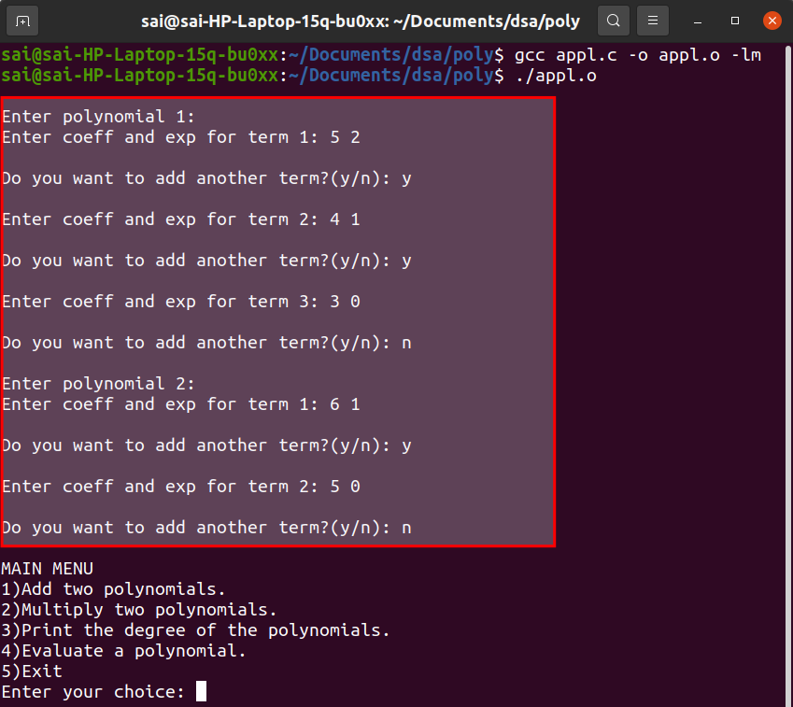
2) Addition
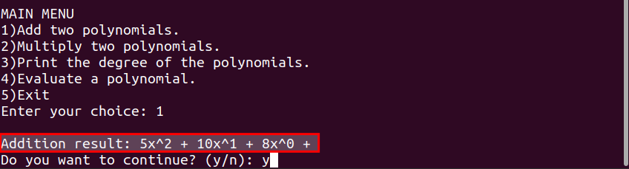

3)Multiplication
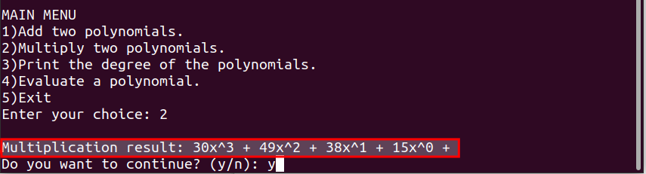

4) Printing degree of the two polynomials.
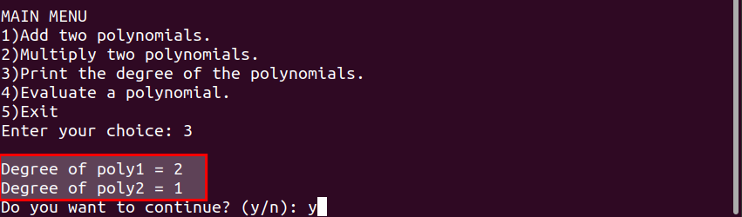
4)Evaluation of a polynomial.
a) First polynomial 5x² + 4x +3 at x=2.
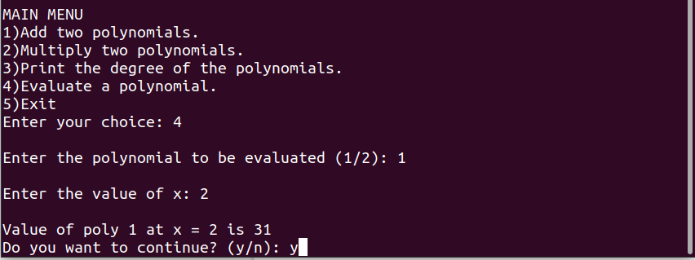
b) Second polynomial 6x + 5 at x=4.
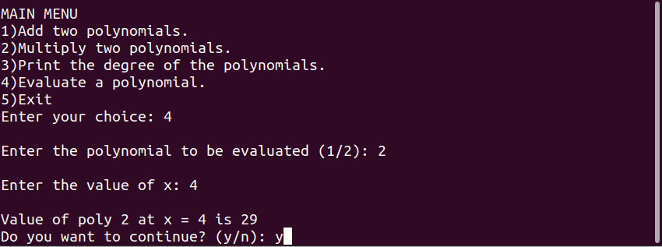
c) Wrong option
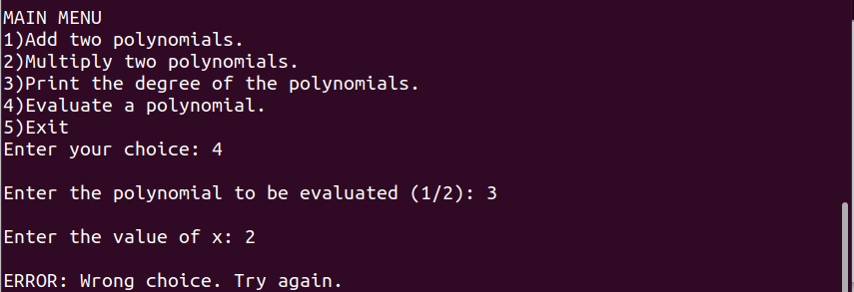

Screenshots(when polynomial 1 = 0)
1) Taking input for the two polynomials.

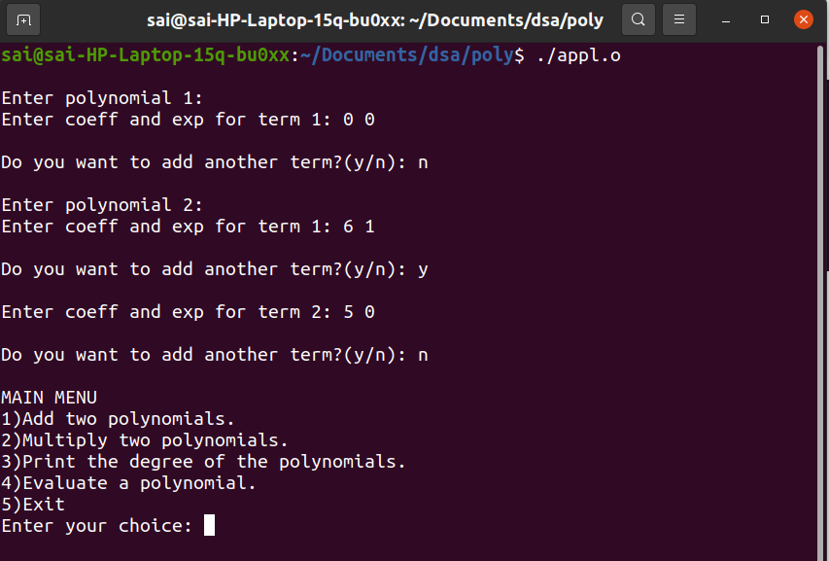

2) Addition
The second polynomial is printed as the result.
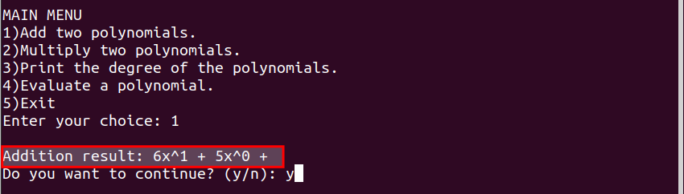
3) Multiplication
The result is printed as zero.
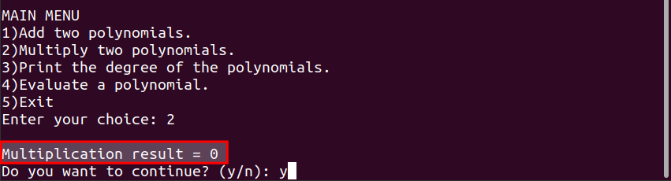

4) Degree of the two polynomials
