Healthcare Claims Analysis
Where Is the Money Going?
Tools: SQL Server · Excel (PivotTables) · Power BI

1. Business Problem
The business is losing money on health insurance claims, but nobody knows which parts of the claims portfolio drive the cost. The goal of this project was to find where the money goes by looking at claim type, procedure (CPT) and diagnosis (ICD) codes, individual members, and the gap between billed and paid amounts.

2. Dashboard Overview
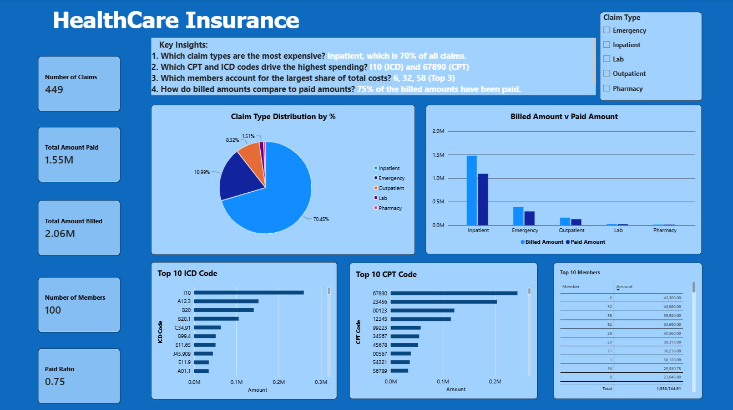
KPI | Value | Meaning
Number of claims | 449 | One row per claim
Number of members | 100 | Unique members with claims
Total amount billed | $2.06M | What providers charged
Total amount paid | $1.55M | What the insurer actually paid
Paid ratio | 0.75 | Paid ÷ billed

3. Tools and Data
- SQL Server: querying and aggregating the claims and members tables.
- Excel (PivotTables): cross-checking SQL results and exploring slices of the data.
- Power BI: the final dashboard with KPI cards, a claim type filter and charts.
Data: claims table (claim_id, member_id, provider_id, claim_type, cpt_code, icd_code, billed_amount, paid_amount) and members table (member_id). Grain: one row per claim.

4. Workflow
- Understand the data. Reviewed the claims and members tables and confirmed the grain.
- Break down cost by claim type. Grouped by claim_type for claim counts, total billed and total paid.
- Find the cost drivers. Ranked the top 10 CPT and ICD codes by total paid, and calculated average paid per claim by CPT to separate frequent cheap procedures from rare expensive ones.
- Analyse members. Summed paid amount per member and pulled the top 10. A CTE then broke each top member’s cost down by claim type, with each type’s percentage of that member’s total.
- Compare billed vs. paid. Calculated the overall paid ratio, then repeated it by claim type, CPT code and provider. HAVING COUNT(*) >= 30 was applied to the CPT and provider cuts to avoid ratios based on very few claims.
- Validate in Excel. Rebuilt the key totals with PivotTables to confirm the SQL results.
- Visualise. Built the Power BI dashboard.

5. Findings

Finding 1: Inpatient claims are the most expensive claim type
Inpatient accounts for about 70.5% of total spend, followed by Emergency (19.0%), Outpatient (8.3%), Lab (1.5%) and Pharmacy (under 1%). Inpatient and Emergency together make up roughly 89% of cost, so that is where the money is going.
Claim type | Share of total paid | Priority
Inpatient | 70.5% | High
Emergency | 19.0% | High
Outpatient | 8.3% | Medium
Lab | 1.5% | Low
Pharmacy | <1% | Low

Finding 2: A few codes drive spending
- ICD: I10 (essential hypertension) is the top diagnosis at about $0.26M, followed by A12.3, B20 and B20.1.
- CPT: 67890 leads at about $0.24M, followed by 23456, 00123 and 12345.
- The top 4 codes in each list account for a large share of spend, so a small set of conditions and procedures drives the cost.

Finding 3: Member costs are spread out, not concentrated
The top 3 members are 6 ($43,300), 32 ($40,080) and 58 ($35,920), about $119K combined or 7.7% of total paid. The top 10 members total about $320K, or 20.6% of spend. Roughly 10% of members drive about a fifth of cost, so cost control should focus on service types and codes more than on a few individuals.
Rank | Member ID | Total paid | Share of total
1 | 6 | $43,300 | 2.8%
2 | 32 | $40,080 | 2.6%
3 | 58 | $35,920 | 2.3%
Top 10 | combined | ~$320K | 20.6%

Finding 4: About 75% of billed dollars are paid
The paid ratio is 0.75: $1.55M paid against $2.06M billed. The gap of roughly $0.51M is the amount reduced or denied before payment, and it is worth investigating by provider and CPT code.

6. Recommendations
- Target Inpatient and Emergency spend with utilization review, pre-authorization for high-cost admissions, and care management to reduce avoidable ER visits.
- Review the top CPT/ICD codes (67890, 23456, I10) for pricing, coding accuracy and medical necessity.
- Invest in chronic condition management, since hypertension (I10) is the top diagnosis and preventive care is cheaper than acute care.
- Monitor high-cost members (6, 32, 58 and the rest of the top 10) with case management.
- Audit the billed-to-paid gap by provider and CPT code to find outliers, and renegotiate contracts where the gap is too wide or too narrow.

7. Limitations and Next Steps
- The dashboard shows costs only. To confirm the business is losing money, add premium revenue data and calculate a loss ratio (claims paid ÷ premiums collected).
- With only 449 claims, the >= 30 claim threshold may exclude many CPT codes and providers, so treat those ratios with caution.
- A time dimension (monthly or quarterly trends) would show whether costs are rising.
- Inpatient share is of total paid cost, not of claim count; claim count by type should be reported separately.

