Domain Description

3x3 maze

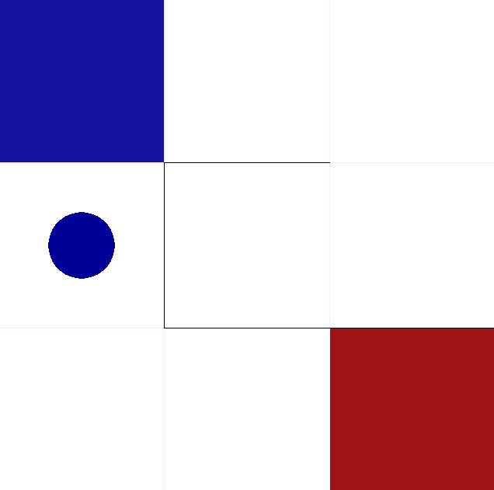

All actions are deterministic and reward is -0.011 for all transitions and +1 for reaching goal

Reference:

Github: https://github.com/MattChanTK/gym-maze