Amit Malik (DouBle_Zer0)
E-Mail: M.amit30@gmail.com
Member Garage4hackers and SecurityXploded

Analysis of a malicious PDF file
Yesterday, I downloaded a malicious pdf file for analysis. I found something strange in the PDF file. The file was using a different kind of technique and i was not aware about it. But after some googling i found that the same technique was exposed in 2010 so it was not a new technique. But in this article i want to discuss the same technique and analysis of the file.
Analysis:
When i opened the file in PDFStreamDumper , i got this structure:
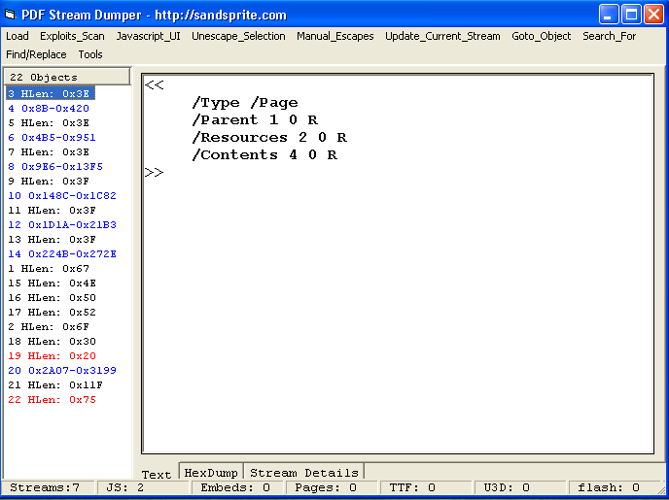

So we can clearly say that object 19 and 22 contains some javascript (because in PDFStreamDumper if any object contains javascript it will be displayed with red colour. )
If we look into object 19 we get this:
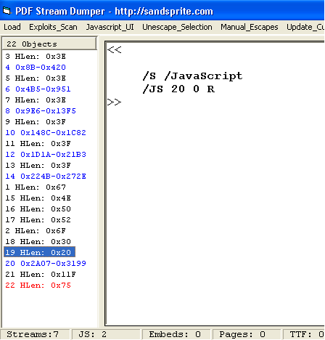

We can say that object 20 contains actual javascript stream.
So if we look into object 20 we get this:
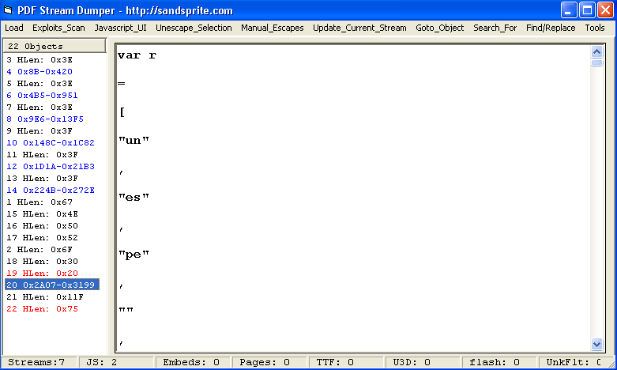

As we can see from the figure that it is a big mangled javascript. So i copied it and formatted it, after that script look like:
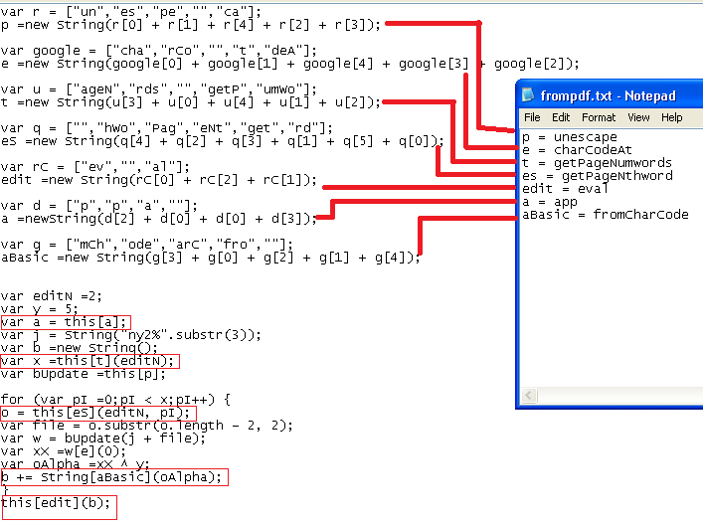

As we can see that the code is not providing much information about vulnerability and exploit used in this pdf file. But because it was a malicious pdf so i was sure that it is using some exploits. But the question was how to retrieve that part. I searched for getPageNthword and getPageNumwords because these were the only keywords that creating some confusion to me. Hopefully i found some details that getPageNumwords will return the number of words in a page and getPageNthword is used to loop through the words and manipulate them based on parameters passed.

So from the above computation we can say that b variable store the results and this[edit](b) = eval(b) is used to execute the javascript expression inside b. We can display b via console functions (console.show() and console.println()). So by replacing this[edit](b) with console.show();console.println(b) we can get the value of b. PDFStreamDumper provide a Update_Stream feature to update the pdf stream so we can easily make this change and can save it into a another pdf file and after that pdf file should display content of b when opened.
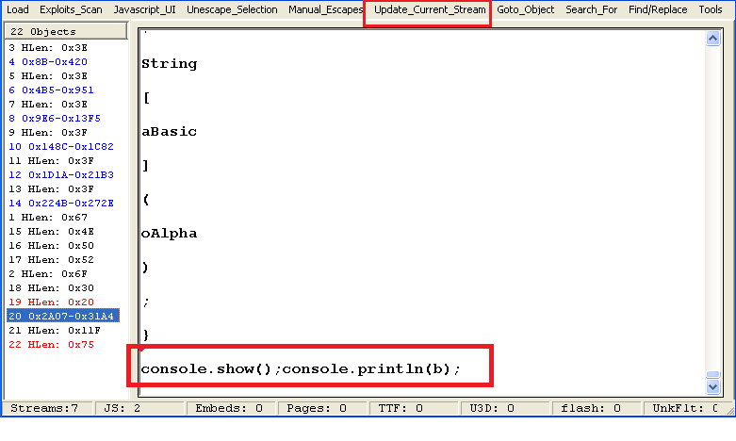
b contents:
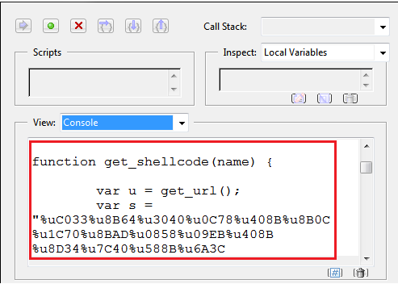
The full script is
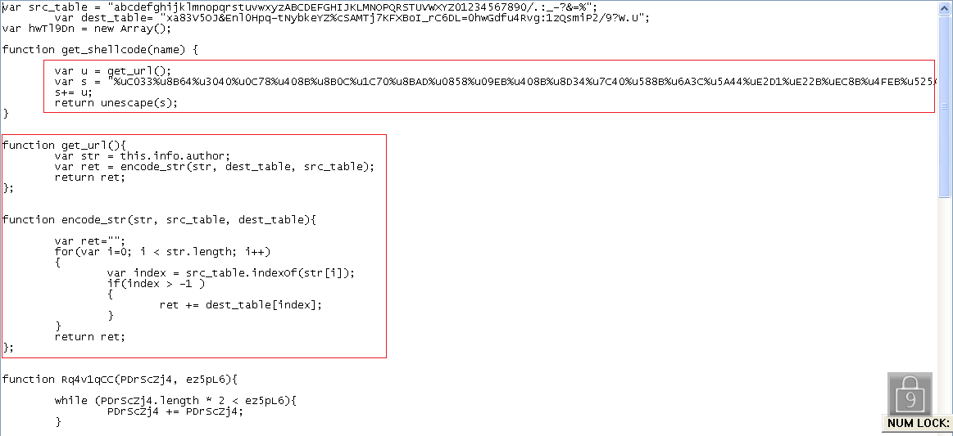
As we can see in the above picture that get_shellcode function first calling get_url() function. so if we take a look to get_url() function we see that it is using author name as a key to decode the url. But variable s is also seems to contain some shellcode. During my analysis i found that shellcode try to execute a file named “e.exe” from temp folder. So we can say that the actual script first exploit the vulnerability and then download the “e.exe” from the decoded url and then execute the file. So actual stuff is in “e.exe” ☺. But right now i am not in mood to go for “e.exe” ☺. Btw the script was exploiting 4 vulnerabilities. 