**Codelab 1.2 (phần A và B)**

*Họ và tên: Bùi Quốc Khánh*

*MSSV: 20183773*

*Github: https://github.com/c0lydxMas/Android-Codelabs*

Part A

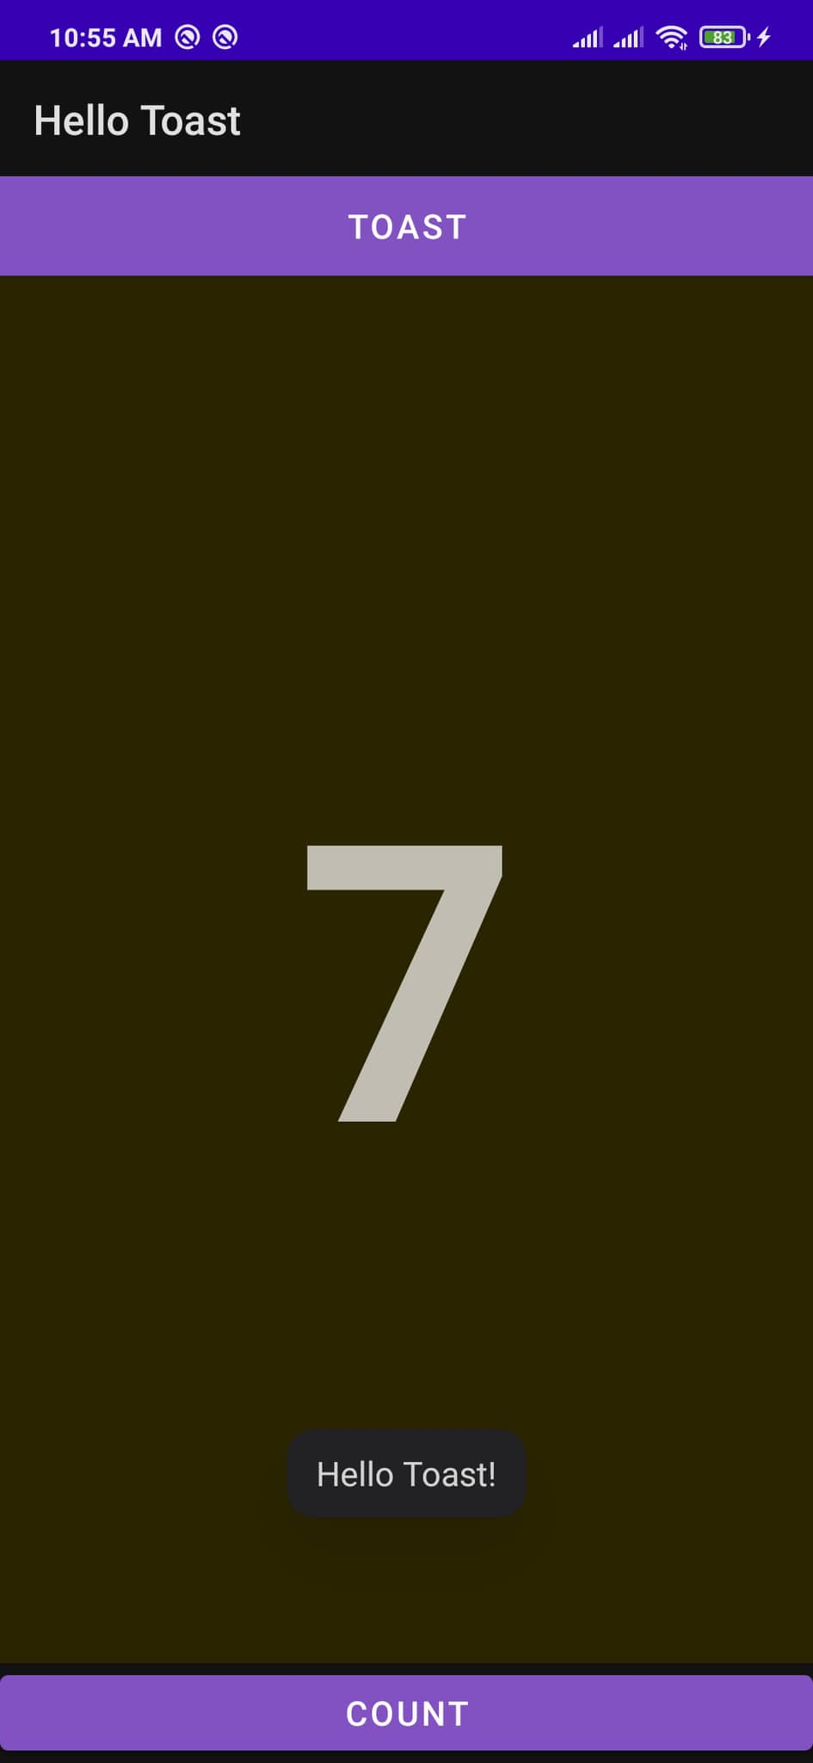

Part B

LinearLayout

RelativeLayout