MAT 243 Project Three Summary Report
Heath Davis
heath.davis1@snhu.edu
Southern New Hampshire University

1. Introduction
This project analyzes NBA team performance data from the 1995-2015 seasons (618 total team seasons) to identify which performance metrics best predict regular season wins. The analysis uses correlation and regression analysis to examine relationships between team performance indicators and total wins. These results will help identify the key drivers of winning records and enable predictions of team performance based on measurable metrics. The analyses performed include Pearson correlation coefficients to measure relationship strength, simple linear regression using average relative skill as a predictor, and multiple regression incorporating additional performance variables to build comprehensive predictive models.

2. Data Preparation
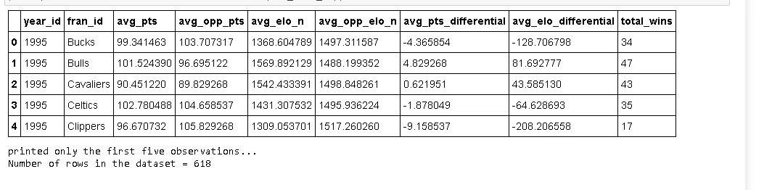
The variable avg_pts_differential represents the average point differential per game, calculated as the difference between points scored by a team and points allowed. This metric provides a comprehensive measure of overall team performance, combining offensive and defensive effectiveness into a single number. A positive differential indicates a team scores more than it allows, which is a strong indicator of team quality.
The variable avg_elo_n represents the average ELO rating, a skill rating system that measures team relative strength based on game outcomes. ELO ratings adjust after each game based on the probability of winning versus the actual result. Higher ELO ratings indicate stronger teams. This metric provides a probabilistic assessment of team quality independent of point scoring patterns.

3. Simple Linear Regression: Scatterplot and Correlation for Total Wins and Average Relative Skill
Data visualization techniques are essential for studying relationship trends between two variables. Scatterplots display each observation as a point on a two-dimensional plane, allowing visual identification of patterns, trends, and outliers. The placement of points reveals whether variables move together (positive relationship), move opposite (negative relationship), or show no pattern (no relationship). This visual representation provides immediate insight that numerical summaries alone cannot convey.
The correlation coefficient quantifies the strength and direction of association between two variables. Pearson correlation coefficients range from -1 to +1, where -1 indicates a perfect negative relationship, +1 indicates a perfect positive relationship, and 0 indicates no linear relationship. Values close to ±1 indicate strong relationships, while values near 0 indicate weak relationships.
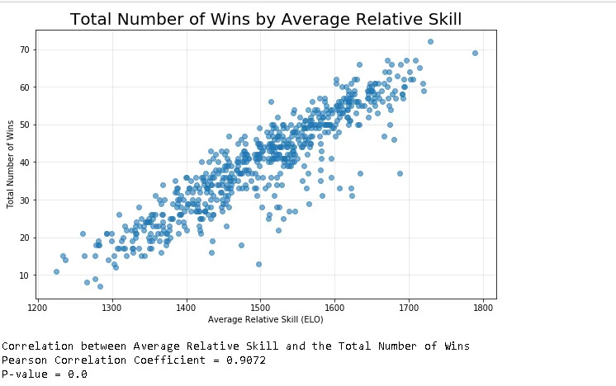
The scatterplot clearly demonstrates a strong positive linear relationship between average relative skill (ELO rating) and total wins. Points are tightly clustered around an upward-sloping line, indicating that teams with higher ELO ratings consistently win more games. The Pearson correlation coefficient of 0.9072 confirms this is an extremely strong positive correlation. At the 1% level of significance, the p-value of 0.0 is far below the significance threshold, indicating this correlation is highly statistically significant and not attributable to random chance.

4. Simple Linear Regression: Predicting Total Wins Using Average Relative Skill
A simple linear regression model uses a single predictor variable to estimate the response variable through a linear equation of the form: ŷ = b₀ + b₁(x). The model fits a regression line that minimizes the sum of squared residuals, providing the best linear fit to the data. This allows us to make predictions for new observations and to quantify the relationship between the variables.
Regression Equation: total_wins = -128.2475 + 0.1121(avg_elo_n)
This equation indicates that for each one-unit increase in average ELO rating, total wins increases by approximately 0.1121 wins on average.
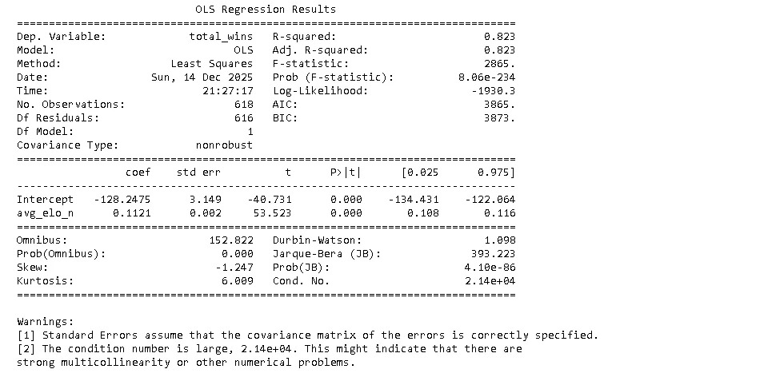
Hypothesis Test Results for Overall F-Test:
Component | Value
Test Statistic | 2865.00
P-value | 8.06e-234

Null Hypothesis (H₀): β₁ = 0 - Average relative skill does not predict total wins in a regular season.
Alternative Hypothesis (H₁): β₁ ≠ 0 - Average relative skill does predict total wins in a regular season.
Level of Significance: α = 0.05
The F-statistic of 2865.00 with a p-value of 8.06e-234 is vastly smaller than the 0.05 significance level. We reject the null hypothesis and conclude that average relative skill is a statistically significant predictor of total wins. The p-value indicates virtually zero probability that this result occurred by chance.
Based on the regression results, average relative skill is a highly effective predictor of total wins. The R² value of 0.823 indicates that 82.3% of the variation in wins can be explained by team ELO rating alone.
Predicted Wins at avg_elo_n = 1550: -128.2475 + 0.1121(1550) = 45 wins
Predicted Wins at avg_elo_n = 1450: -128.2475 + 0.1121(1450) = 34 wins

5. Multiple Regression: Scatterplot and Correlation for Total Wins and Average Points Scored
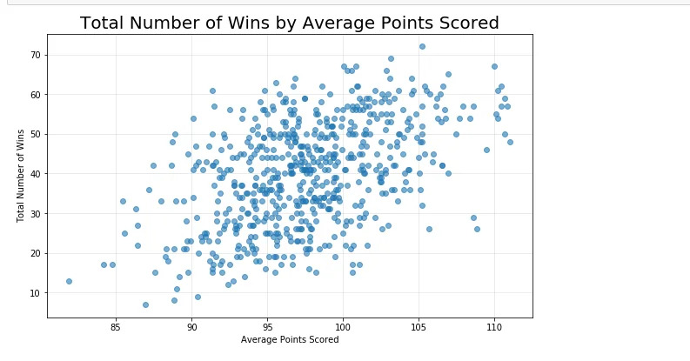
The scatterplot demonstrates a moderate positive relationship between average points scored and total wins. The points show greater vertical scatter around any potential trend line compared to the skill scatterplot, indicating a weaker relationship. The Pearson correlation coefficient of 0.4777 quantifies this moderate association. While the relationship is positive—teams that score more points tend to win more—the relationship is noticeably weaker than the skill-wins relationship. The p-value of 0.0 indicates the correlation is statistically significant at the 1% level of significance.

6. Multiple Regression: Predicting Total Wins Using Average Points and Average Relative Skill
A multiple linear regression model extends simple regression by incorporating two or more predictor variables into the equation: ŷ = b₀ + b₁(x₁) + b₂(x₂) + ... + bₖ(xₖ). This approach captures more of the complexity in predicting the response variable and often results in improved predictions compared to simple regression.
Regression Equation: total_wins = -152.5736 + 0.3497(avg_pts) + 0.1055(avg_elo_n)
This equation shows both average points scored and average ELO rating contribute to predicting wins. Average points has a coefficient of 0.3497, and average ELO rating has a coefficient of 0.1055.
Hypothesis Test Results for Overall F-Test:
Component | Value
Test Statistic | 1580.00
P-value | 4.41e-243

Null Hypothesis (H₀): β₁ = β₂ = 0 - Neither average points nor average skill predict total wins.
Alternative Hypothesis (H₁): At least one βᵢ ≠ 0 - At least one predictor significantly predicts total wins.
Level of Significance: α = 0.05
The F-statistic of 1580.00 with a p-value of 4.41e-243 is far below the 0.05 significance level. We reject the null hypothesis and conclude that the multiple regression model is statistically significant. The model with both predictors explains 83.7% of the variation in wins (R² = 0.837), an improvement over the simple regression model which explained 82.3%.

7. Multiple Regression: Full Model with Four Predictors
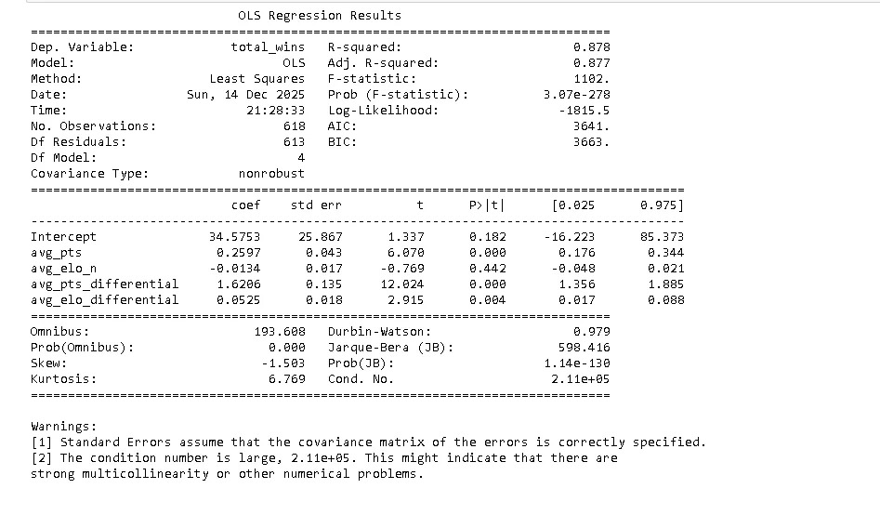
The complete regression model incorporates all four predictor variables: average points scored, average ELO rating, average points differential, and average ELO differential. The model equation is:
total_wins = 34.5753 + 0.2597(avg_pts) - 0.0134(avg_elo_n) + 1.6206(avg_pts_differential) + 0.0525(avg_elo_differential)
This full model achieves an R² of 0.878, meaning it explains 87.8% of the variation in total wins. The F-statistic of 1102 with a p-value of 3.07e-278 indicates the overall model is highly statistically significant. Adding the differential variables improved the model from the two-predictor R² of 0.837 to 0.878, a 4.1 percentage point improvement, demonstrating that performance differentials provide additional predictive value beyond just average points and skill ratings.

