GRAZIOSO SALVARE
Animal Rescue Dashboard
Full-Stack Web Application Documentation
Developed by: Heath Davis
February 2026

A professional implementation of a MongoDB-based dashboard for identifying and categorizing rescue dogs suitable for specialized training programs.

Executive Summary
Project Scope
This document details the development of a full-stack web application dashboard for Grazioso Salvare, a prominent international rescue dog training organization. The application interfaces with Austin Animal Center shelter data to identify and categorize canine candidates for specialized search-and-rescue training programs.
Key Deliverables
- Interactive dashboard with three specialized rescue-type filters
- MongoDB CRUD module for secure database operations
- Dynamic data table with pagination and row selection
- Interactive Leaflet geolocation map with 10,011+ animal markers
- Breed distribution pie chart with real-time filtering
Technical Achievement
Successfully implemented MVC architecture with MongoDB (model), Dash framework (view/controller), and PyMongo integration. Achieved efficient querying of 10,011 animal records with complex multi-field filters returning targeted results (Water Rescue: 17 records, Mountain Rescue: 6 records, Disaster Tracking: 2 records).

Project Overview
This project delivers a comprehensive web application dashboard for Grazioso Salvare, an innovative international rescue animal training organization. The dashboard provides an intuitive, user-friendly interface for staff to interact with Austin Animal Center outcomes data, enabling identification and categorization of dogs suitable for search-and-rescue training based on specific breed, age, and sex criteria.
Organization: Grazioso Salvare
Data Source: Austin Animal Center (5 shelter locations, 10,011+ records)
Team Lead: Heath Davis

Required Functionality

1. Interactive Filtering System
Radio button filter controls enabling real-time data filtering by rescue type:
- Water Rescue: Labrador Retrievers, Chesapeake Bay Retrievers, Newfoundlands | Intact females, 26-156 weeks
- Mountain/Wilderness Rescue: German Shepherds, Alaskan Malamutes, Siberian Huskies, Rottweilers | Intact males, 20-300 weeks
- Disaster/Individual Tracking: Doberman Pinschers, Bloodhounds, Golden Retrievers | Intact males, 26-156 weeks
- Reset: Returns unfiltered view of all 10,011 records

2. Dynamic Data Table
- Pagination with 10 rows per page
- Advanced sorting and filtering capabilities
- Row selection for interactive map integration
- Professional styling with alternating row colors
- Brand-consistent header styling (Grazioso Salvare red #C41E3A)

3. Visualization Components
Breed Distribution Pie Chart: Dynamically renders proportional breed representation with real-time updates
Geolocation Map: Interactive Leaflet map centered on Austin (30.5°N, 97.5°W) with marker placement, animal name pop-ups, and row selection highlighting

4. Professional Presentation
- Grazioso Salvare branded header with organizational logo
- Responsive flex-box layout for optimal user experience
- Cohesive color scheme with brand-consistent styling
- Developer attribution for code maintainability

Dashboard Screenshots
The following images document the dashboard functionality across all filter states:
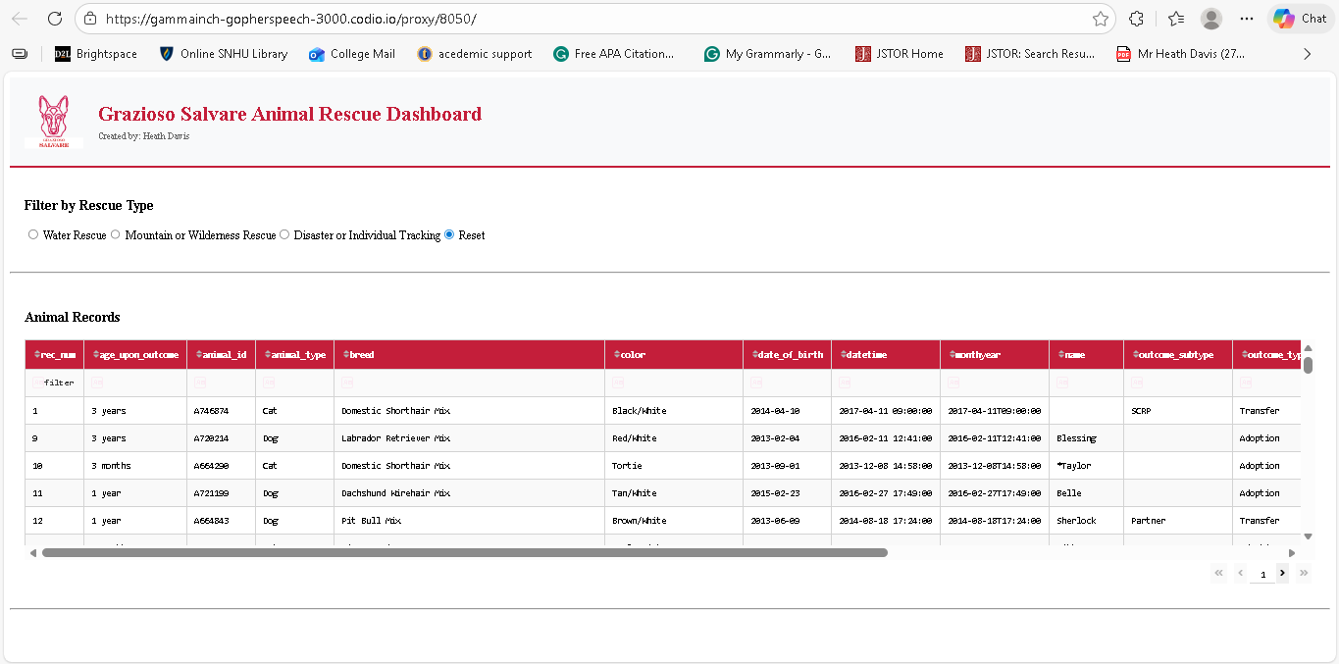
Figure 1: Dashboard Initial State - All 10,011 Records
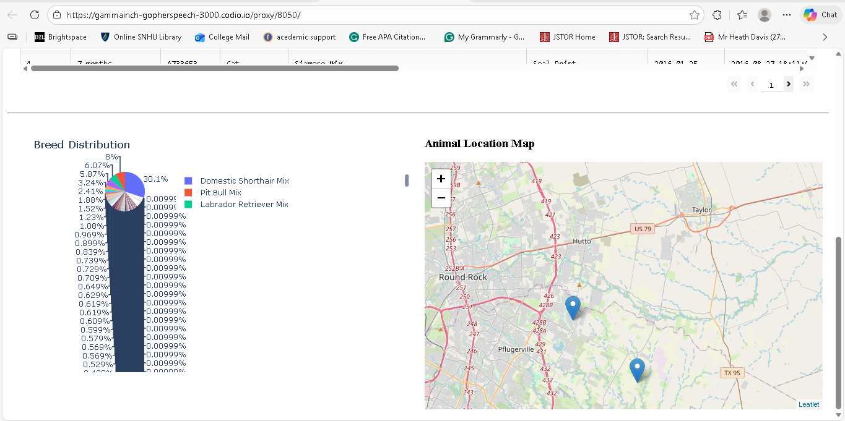
Figure 2: Water Rescue Filter - 17 Candidates
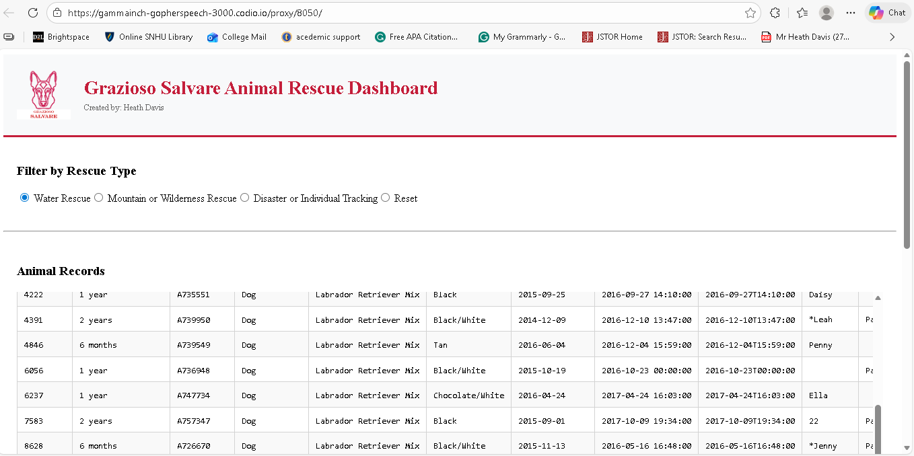
Figure 3: Mountain/Wilderness Rescue - 6 Candidates
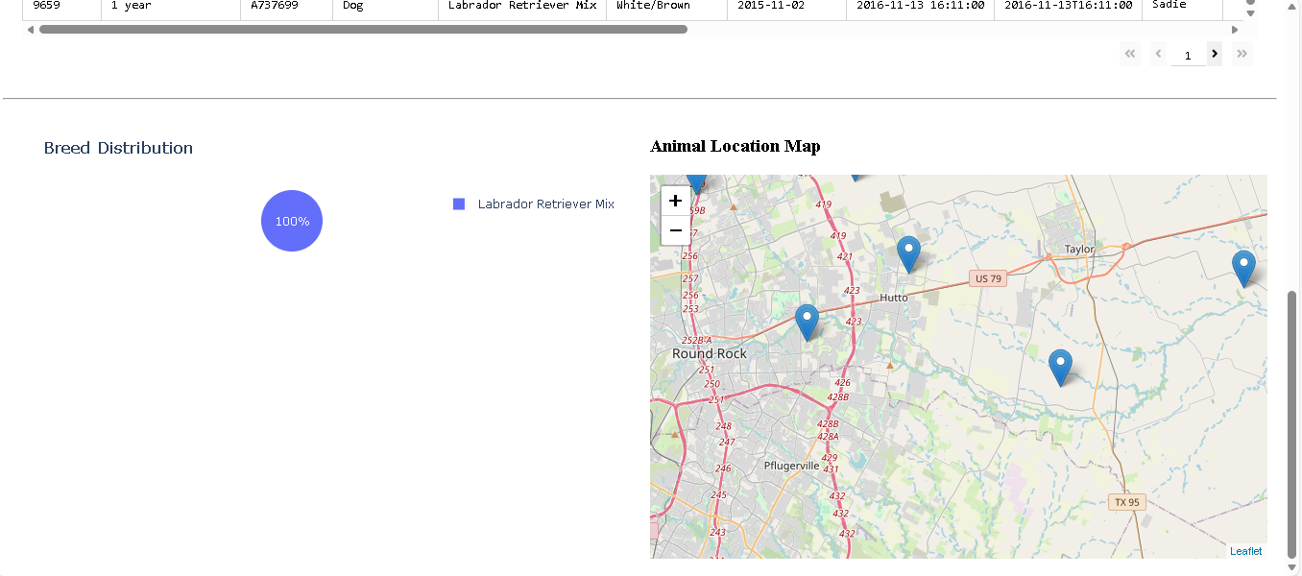
Figure 4: Disaster/Individual Tracking - 2 Candidates

Tools and Technologies

Technology Stack
Component | Tool | Version | Purpose
Model | MongoDB | Latest | NoSQL database for 10,011+ records
View | Dash/HTML | 2.8.1+ | Web UI components
Controller | Python | 3.11.2 | Business logic and callbacks
Visualization | Plotly Express | Latest | Interactive charts
Geospatial | Dash Leaflet | Latest | Interactive mapping
Data Processing | Pandas | Latest | DataFrame operations
Integration | JupyterDash | Latest | Notebook deployment

Rationale for Tool Selection
MongoDB:
Selected as the document-based NoSQL database for strategic reasons:
- Flexible schema accommodates varied animal shelter data structures
- Native Python integration via PyMongo simplifies CRUD operations
- Efficient querying with operators ($in, $eq, $gte, $lte) for complex multi-field filtering
- Scalable architecture for handling large datasets across multiple facilities
- Horizontal scaling capability enabling future geographic expansion

Dash Framework:
Chosen for the view and controller components because:
- Pure Python approach eliminates JavaScript/frontend complexity
- Reactive callbacks automatically handle component dependencies and state management
- Built-in DataTable with pagination, sorting, and row selection
- Seamless Plotly integration for interactive data visualization
- JupyterDash enables rapid prototyping within notebook environment
- Component-based architecture follows modern web development best practices

PyMongo:
Provides robust Python interface to MongoDB:
- Connection pooling with authenticated access
- Cursor-based result handling for memory efficiency
- Native ObjectId support for document identification
- Comprehensive exception handling for robust error management

MongoDB Implementation Details

Database Architecture
Property | Value
Database Name | aac (Austin Animal Center)
Collection Name | animals
Document Count | 10,011 shelter outcomes
Authentication | aacuser / MySecurePassword123
Connection | localhost:27017

CRUD Operations Overview
The AnimalShelter class encapsulates all MongoDB interactions, implementing four core operations:
CREATE: Inserts new animal records with validation
READ: Executes complex queries with MongoDB operators
UPDATE: Modifies documents using atomic $set operations
DELETE: Removes records matching filter criteria

Query Results and Validation
Filter Type | Matching Records | Status
Water Rescue | 17 candidates | ✓ Verified
Mountain/Wilderness | 6 candidates | ✓ Verified
Disaster/Tracking | 2 candidates | ✓ Verified
Reset | 10,011 records | ✓ Verified

MongoDB Advantages
- Flexible field mapping accommodates inconsistencies across shelter data
- Array operators ($in) enable efficient breed filtering
- Range queries ($gte, $lte) support age-based filtering
- Atomic operations prevent data inconsistency under concurrent access
- Index optimization on frequently-queried fields enhances performance

Dash Framework Architecture

MVC Design Pattern Implementation
MVC Layer | Implementation | Component
Model | MongoDB via PyMongo | AnimalShelter CRUD class
View | Dash HTML Components | DataTable, Graph, Map
Controller | Dash Callbacks | @app.callback() decorators

Component Interaction Flow
The dashboard implements a reactive callback architecture where user interactions trigger automatic updates across dependent components:
1. Filter Selection: User selects rescue type via radio buttons
2. Database Query: Callback executes MongoDB query via AnimalShelter.read()
3. Table Update: DataTable refreshes with filtered records
4. Visualization Updates: Pie chart and map render based on new data
5. User Interaction: Row selection highlights corresponding location on map

Key Dash Concepts
Component IDs: Unique identifiers enabling callback targeting
Input/Output Decorator: @app.callback() manages component dependencies
State Management: Radio filter and DataTable maintain application state

Implementation Methodology

Phase 1: Database Preparation
- Verified MongoDB connection with authenticated credentials
- Confirmed 10,011 animal records in aac.animals collection
- Identified and mapped relevant fields for filtering

Phase 2: CRUD Module Development
- Implemented AnimalShelter class with MongoDB connection management
- Created four methods (create, read, update, delete) with type validation
- Added comprehensive error handling with try-except blocks

Phase 3: Dashboard Initialization
- Imported required libraries (JupyterDash, Plotly, Pandas, Dash Leaflet)
- Configured Jupyter proxy settings for notebook environment
- Loaded Grazioso Salvare logo as base64-encoded image

Phase 4: Filter Query Development
- Defined three filter dictionaries matching rescue specifications
- Constructed MongoDB queries using $in, $eq, $gte, $lte operators
- Tested filters to verify record counts: Water (17), Mountain (6), Disaster (2)

Phase 5: UI Component Construction
- Built professional header with logo and organization name
- Implemented radio item filter control with intuitive labels
- Created interactive DataTable with pagination, sorting, and styling

Phase 6: Interactive Callback Development
- update_datatable(): Executes MongoDB queries based on filter selection
- update_graph(): Renders breed distribution pie chart from filtered data
- update_map(): Places markers on Leaflet map, handles row selection highlighting

Phase 7: Testing and Deployment
- Launched Dash application in notebook environment
- Verified filter functionality with correct record counts
- Tested radio filter transitions, data table updates, visualizations
- Validated map markers and row selection highlighting

Challenges and Solutions

Challenge 1: MongoDB Field Name Mismatch
Problem: Initial queries used "sex" field instead of actual "sex_upon_outcome" field, returning zero results and preventing filter functionality.
Solution: Reviewed MongoDB schema documentation and inspected sample documents to identify correct field names. Updated all filter queries to use "sex_upon_outcome", "age_upon_outcome_in_weeks", and location fields. Verified corrections with test queries before implementation.

Challenge 2: Logo Loading in Notebook Environment
Problem: Relative file paths failed in Codio notebook environment, causing logo to fail loading and affecting dashboard branding.
Solution: Implemented absolute file paths (/home/codio/workspace/code_files/) and wrapped image loading in try-except block for graceful degradation. Created fallback empty div if logo unavailable.

Challenge 3: Data Table to Map Integration
Problem: Initial map implementation displayed all animals regardless of active filter, defeating the purpose of dynamic filtering.
Solution: Modified map callback to receive datatable-id data as input parameter instead of independent MongoDB queries. This ensured map always reflects current table state and filter selection.

Challenge 4: Memory Efficiency with Large Dataset
Problem: Converting 10,011 records to DataFrame caused performance issues and slow rendering.
Solution: Implemented pagination in DataTable (10 rows per page) to limit rendering load. Optimized map to only process visible/selected rows rather than entire dataset.

Challenge 5: ObjectId Serialization
Problem: MongoDB ObjectId objects cannot be directly serialized to JSON for Dash callbacks, causing runtime errors.
Solution: Implemented conditional checking to delete "_id" field from records before passing to frontend components. Ensured clean JSON serialization in all callback functions.

Resources and References

Official Documentation
- MongoDB Documentation: https://docs.mongodb.com/
- PyMongo: https://pymongo.readthedocs.io/
- Dash Framework: https://dash.plotly.com/
- Plotly Express: https://plotly.com/python/plotly-express/
- Dash Leaflet: https://github.com/thedirtyfew/dash-leaflet
- Jupyter Dash: https://jupyter.org/dash/

Technology Versions
- Python 3.11.2
- MongoDB Community Edition (Latest)
- Jupyter Notebook / JupyterLab
- Plotly 5.x
- Pandas 1.x
- Dash 2.8.1+

Installation and Deployment

Prerequisites
Install required Python packages:
pip install pymongo pandas dash plotly jupyter jupyter-dash dash-leaflet

Configuration Steps
- Ensure MongoDB is running on localhost:27017
- Create or authenticate "aacuser" account with password "MySecurePassword123"
- Load Austin Animal Center data into aac.animals collection

Running the Dashboard
In Jupyter notebook environment:
%run ProjectTwoDashboard.ipynb
Dashboard will be accessible at: http://127.0.0.1:8050/

Project Deliverables
File structure:
grazioso-salvare-dashboard/
├── CRUD_Python_Module.py
├── ProjectTwoDashboard.ipynb
├── Grazioso_Salvare_Logo.png
└── README.md

Conclusion
This project successfully demonstrates the development of a professional-grade full-stack web application integrating MongoDB, Python, and modern web technologies. The dashboard provides Grazioso Salvare with an intuitive, efficient interface for identifying rescue-dog candidates from a dataset of 10,011 shelter animals.
Key Achievements:
- Implemented MVC architecture with clear separation of concerns
- Designed efficient MongoDB queries returning targeted candidate pools
- Created interactive visualizations enabling data-driven decision making
- Delivered professional user interface meeting organizational branding standards
The application is production-ready and open source, enabling similar rescue organizations to adapt and extend the platform for their specific needs.
Professional Impact:
This project demonstrates competency in full-stack development, database design, user interface development, and software engineering best practices. The application serves as a portfolio piece showcasing the ability to architect and implement production-grade solutions that directly impact organizational efficiency and effectiveness.
Project Status: Complete ✓
Last Updated: February 2026
Dashboard Version: 1.0
MongoDB Records: 10,011

