AERO1005 MATLAB Coursework 2

Author: Yao Liang
Student ID: 20718529
Date of report: 6th, May, 2026

Task 0
My remote repo address: https://github.com/c0nn3r-ly/AE1005_CW2_ws/tree/main
Task1
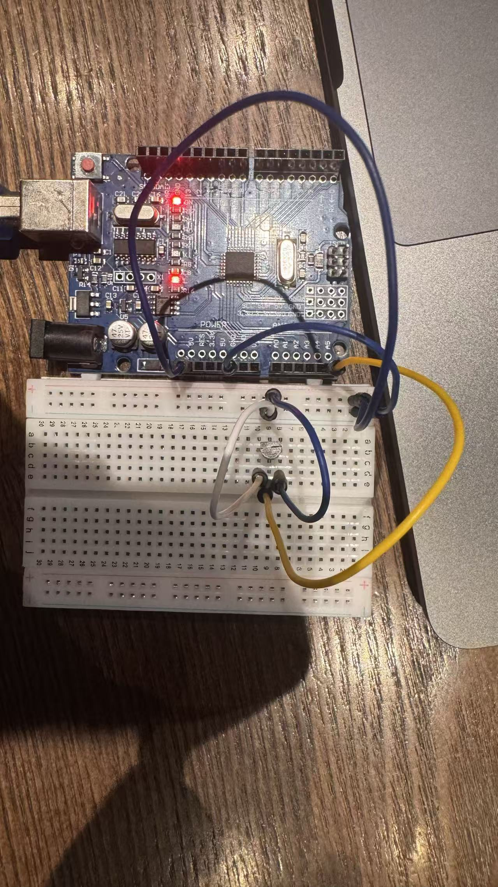
At first, no resistor was used to stabilize the noise caused by the microchip power supply. The result was like this:
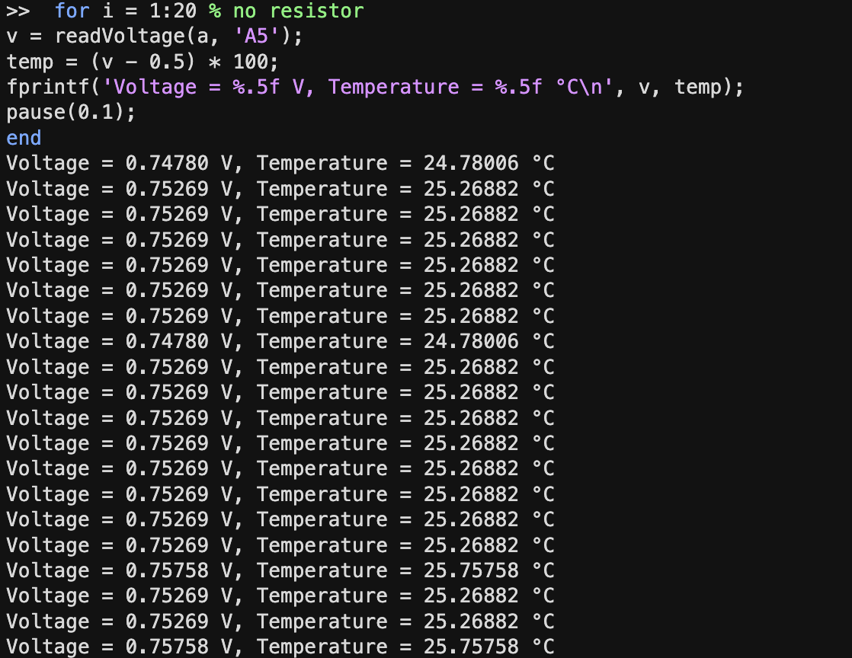
Then, one and three resistors wers applied and connected in series with the thermistor.
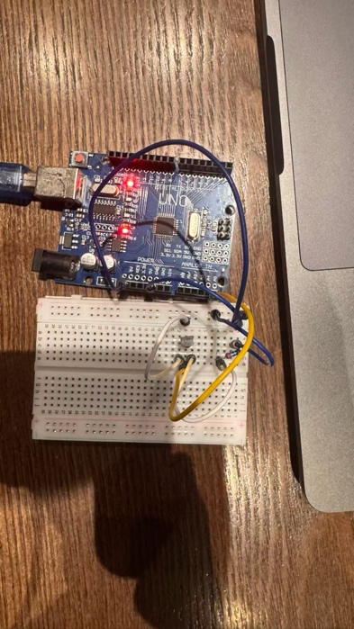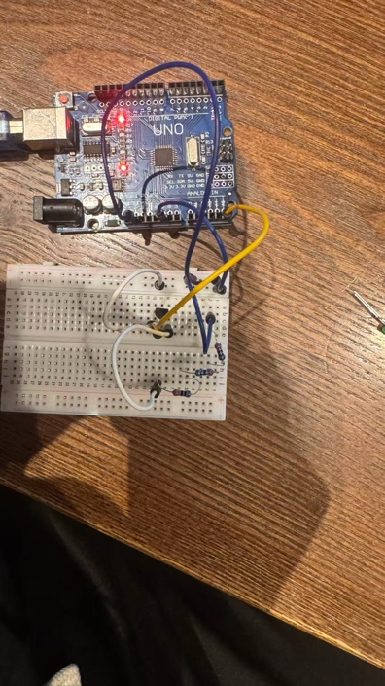
And the results are as shown:
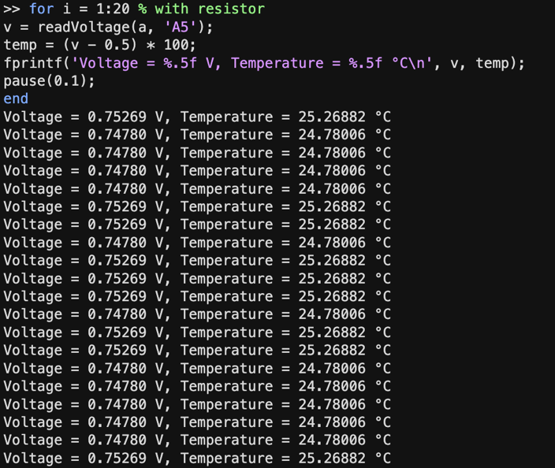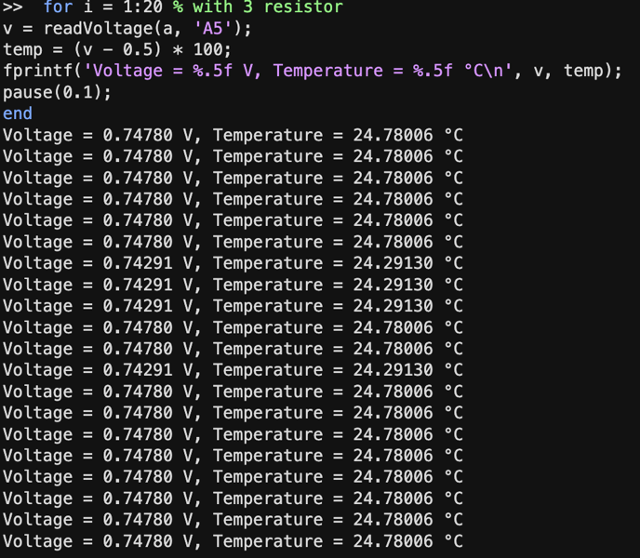
I will be discussing them in the Task4.
The temperature/time plot:
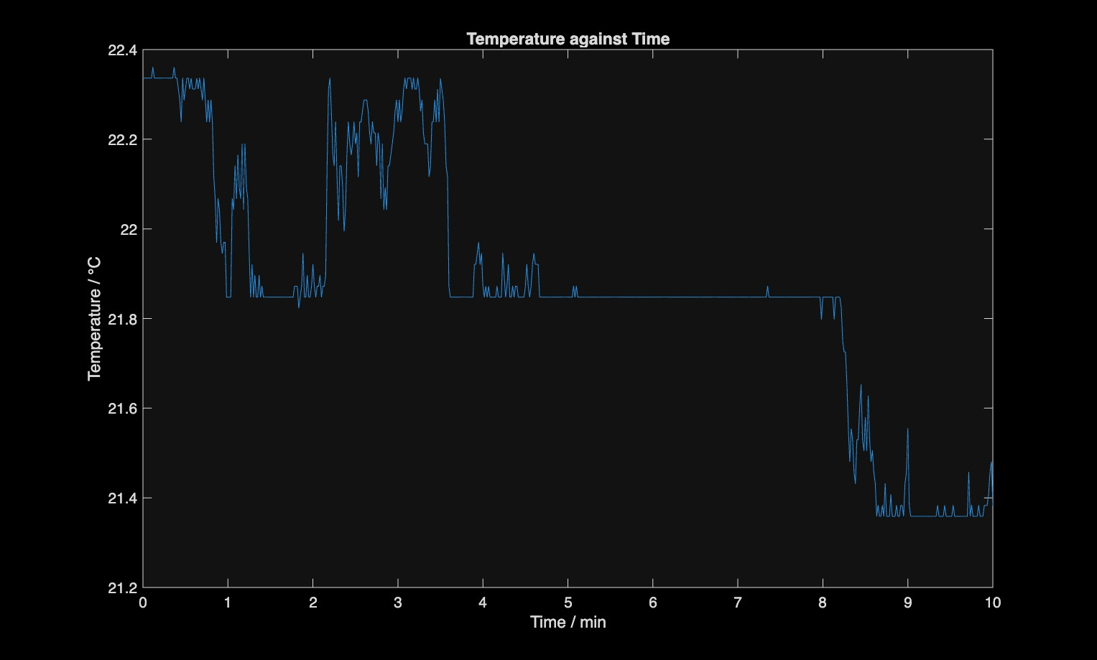

Task 2
The flowchart before start coding:
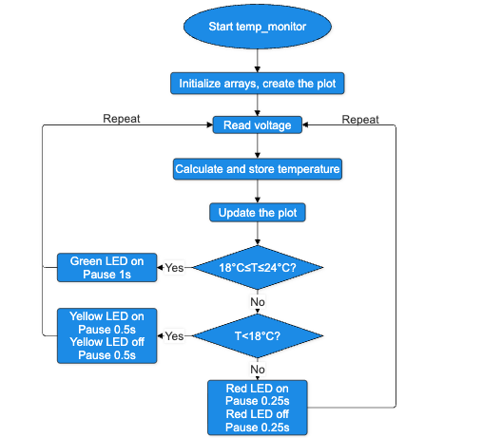

The live temperature graphs:
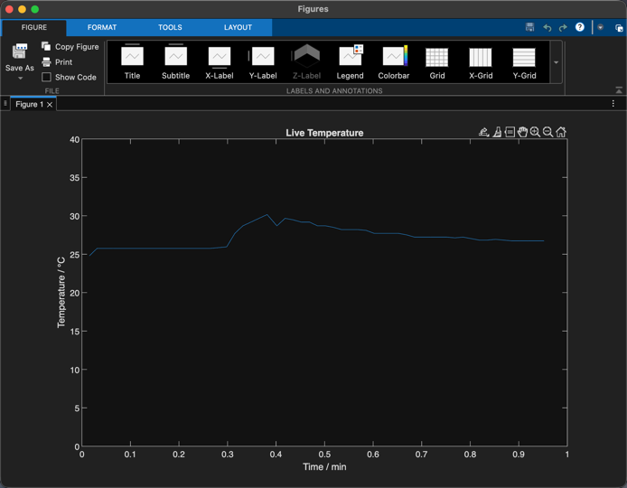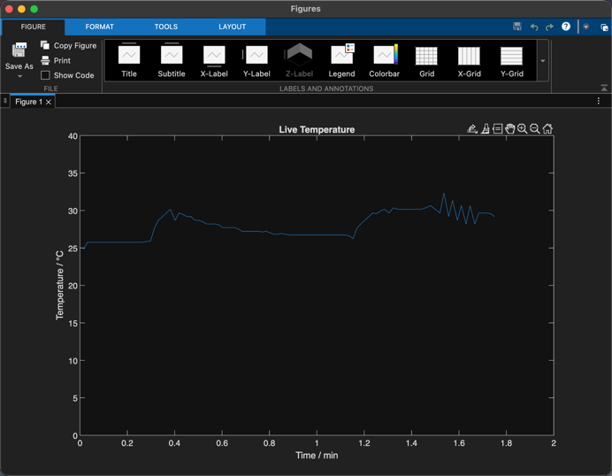
The two charts showed the data were updated and the axis are updated as time went by.

The flowchart of the code:
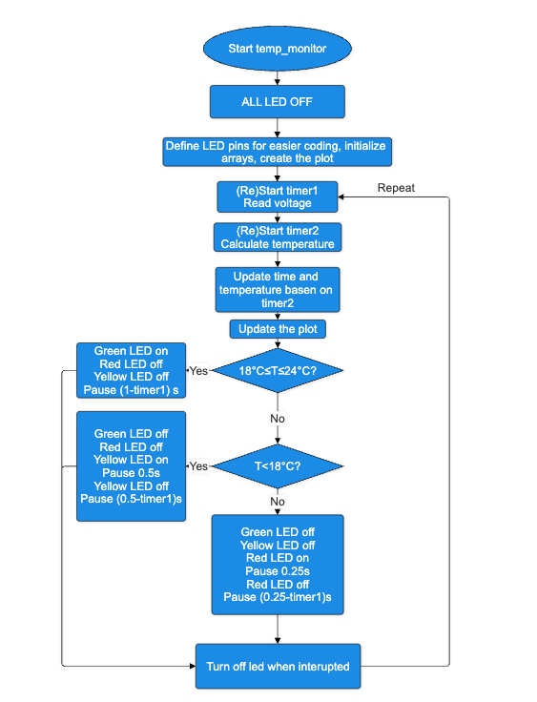

Task 3
The flowchart:
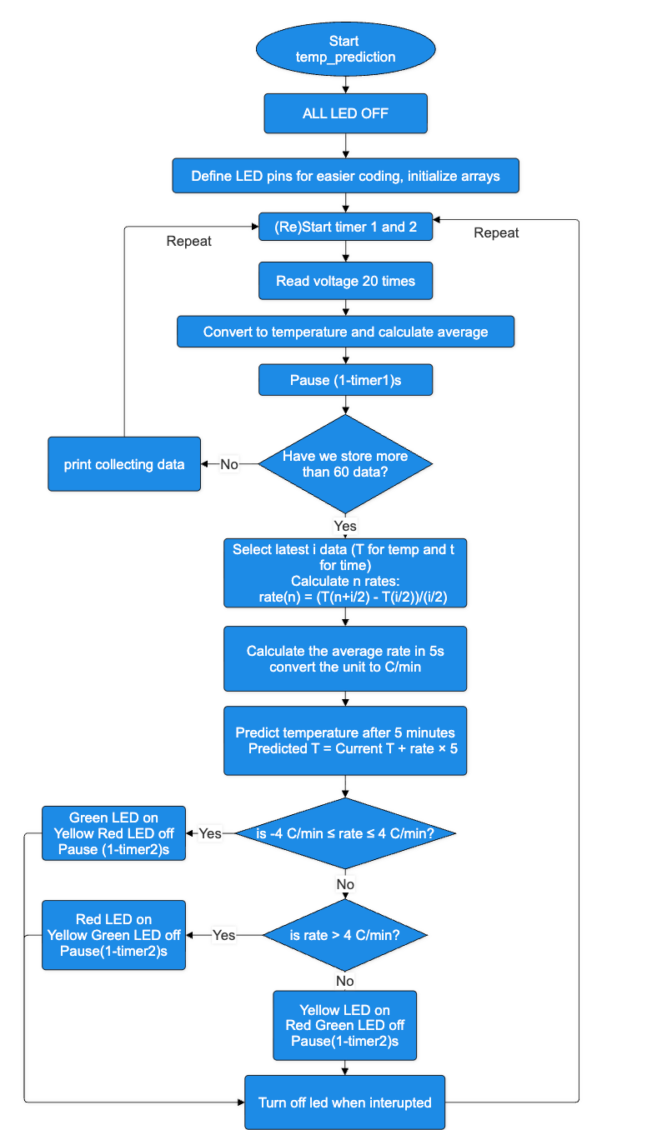
Task 4 Reflective statement
For the coursework, the first challenge was reducing the noise of the temperature (voltage) readings. I tried to use one resistor and three resistors to reduce the noise, and the results were compared with one without any resistors. Improvements were not significant.
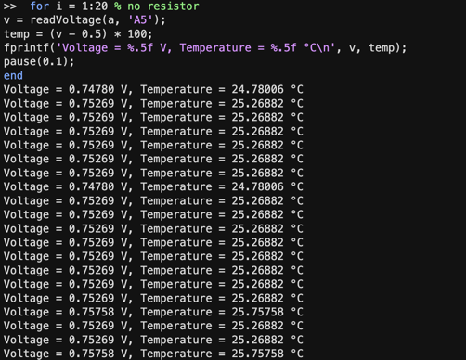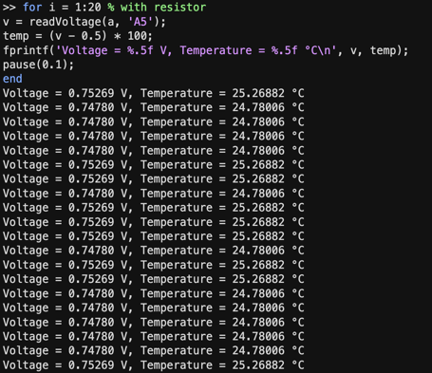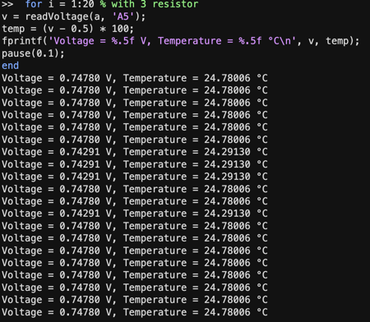
But I think it’s reasonable because the thermistors used works in small current. So using only resistors cannot stabilize the voltage significantly. Also I notice that the 3 leds need 3 resistors later, so I decided not to use the resistor for noise reduction.

To solve this problem, I used an averaging method. For all of the tasks, I read the voltage several times in each cycle of one second and use the average value as the measured data for the second. I start a timer when the cycle begins, store voltage data several times and read the time of the timer. Then the program was paused 1s minus the time of data collection. In this case I can make sure that each cycle is very close to one second. This was important because all tasks required correct timing.

Another challenge was managing the LED pins. During the coding, it was easy to forger which LED was connected to which port, and every control command require me to write the corresponding Arduino pin. Therefore, I defined variable such as greenLED, redLED and yellowLED at the start to make coding easier. I can also change the code very fast when changes are made to the circuit.

I also found that when I interrupted the program, the LEDs didn’t always turn off.To solve this, I found and used a cleanup function, which allow me to run a function defined by myself before the program stops. The leds are turned off in the function.

For my prediction algorithm, I didn’t calculate the rate from only two different points. Instead, I used multiple newest data points to calculate several rates and average them. It makes the changes and the prediction more stable. I also used a variable that can be changed to represent how many seconds of newest data the program will consider when calculate the rate. It can be adjusted during testing and fit into different environment.
For future improvement, I would consider adding a capacitor or even using Kalman filter. Capacitor could be a good solution but Kalman filter is just overpowered for this kind of task.

