Join a call that uses dial-in conferencing
If you received a request for a meeting that supports dial-in conferencing, access information is included in the meeting request.
To dial in from your phone as the leader or an authenticated caller, note the following access information from the meeting request: dial-in phone number, conference ID, your PIN (see “Set your PIN”), and your phone number.
Set your PIN
The Lync dial-in conferencing PIN identifies and authenticates you as someone with access to your organization’s network. A PIN is required if you are dialing in by phone or device, when you are outside your organization’s network, and on some networks.
- In the Lync main window, click the Show Menu arrow, click Tools, and then click Dial-in Conferencing Settings.
- On the home page, under Personal Identification Number (PIN), click Sign In.
- In the Language list, click your preferred language, type your username and password, and then click Sign In.
- On the Create New PIN page, click PIN or Change PIN, type a number that meets the PIN requirements in the PIN text box, and then retype your new PIN in the Confirm PIN box.
Have Lync 2010 call you
You can have Lync call you and automatically connect you to the meeting audio (for example, if you have to leave your computer but want to continue the call on your mobile device). You do not have to remember the dial-in phone number and conference ID.
- When you join the meeting, in the Meeting Audio dialog box, click Call me at.
- Click a number already in the list, or type the phone number you want to be called at, and then click OK.

PRINT SETTINGS For best results, set printer options to: Paper Size: Letter (8.5x11”); Orientation: Landscape; 2-sided printing options: Two-sided, flip on short side.

© 2011 Microsoft. All Rights Reserved. This document is provided “as-is”. Information and views expressed in this document, including URL and other Internet Web site references, may change without notice. You bear the risk of using it. Some examples are for illustration only and are fictitious. No real association is intended or inferred.

Conferencing Quick Reference
Schedule an online meeting
You can schedule Microsoft® Lync™ 2010 meetings and conference calls from Microsoft® Outlook®. One meeting request is used for both purposes.
- Open your Outlook Calendar.
- On the Home tab, click New Online Meeting (in Microsoft Outlook 2010) or Online Meeting (in Microsoft Outlook 2007).
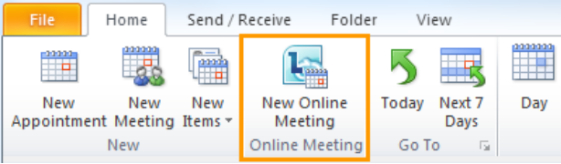
A new meeting request opens, to which you add recipients, a subject line, and other meeting details.
Set meeting options
The meeting request contains the dial-in information that the participant can use to join the audio part of the meeting or conference call. During the Lync meeting, dial-in information is available in the Invite by Phone dialog box (click the People Options menu, and then click Invite by Phone).
You can customize the dial-in information in the Outlook meeting request. You can also customize access and presenters.
- In the meeting request, on the Meeting tab, click Meeting Options.
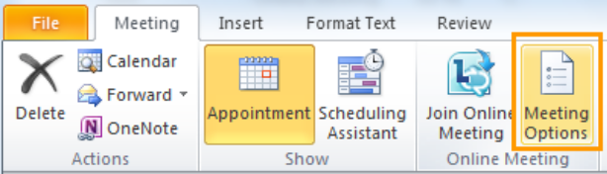
- In the Online Meeting Options dialog box:
- To control meeting access and presenter options, click Access and Presenters.
- To customize dial-in information, click Audio and Phone.
Meet now
With the Meet Now option, you can quickly start a meeting or conference call with people inside or outside your organization.
- In the Lync main window, click the arrow to the right of the Options button, and then click Meet Now.
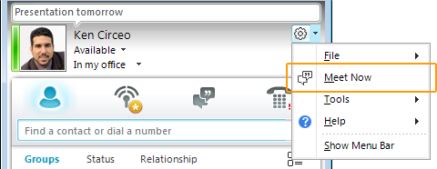
- In the conversation window, do any of the following:
- To invite someone inside your organization, click the People Options menu, click Invite by Name or Phone Number, and then select a contact.
- To invite someone outside your organization by email, click the People Options menu, and then click Invite by Email. An email message opens in Outlook. (If you do not have Outlook, copy the invitation text, and paste it into your email program.)
- You can also add contacts to the meeting by dragging the contact from the Contacts list into the conversation window.
Join a schedule online meeting
In the Outlook meeting request, click Join online meeting or click the meeting link.
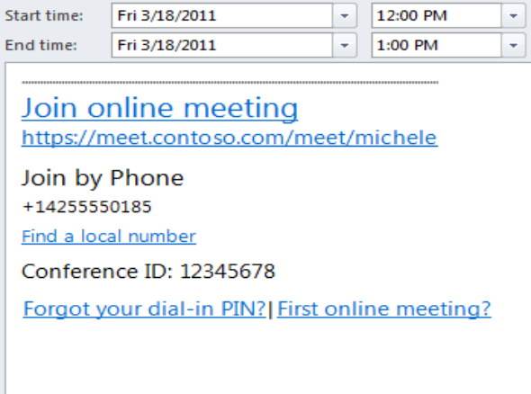
Start a group IM conversation
You can start a group instant messaging (IM) conversation by selecting multiple contacts or a contact group from your Contacts list, or you can turn an IM conversation with one person into a group conversation.
To start a group conversation from the Contacts list:
- Hold down the Ctrl key, and click each contact that you want to invite.
- Right-click the last contact, and then click Send an Instant Message.
- Type your message in the message input area, and then press Enter.
To start a group conversation from a conversation window:
- Click the People Options menu, click Invite by Name or Phone Number, and then select the contacts that you want to invite.
Enhance your IM conversations
With Lync 2010, you can add communication modes to your IM conversation. For example, you can start an IM conversation with a single contact, add more contacts, and then add audio and video. If you need to share documents or slides, you can share your desktop.
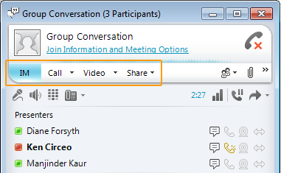
To add voice or video, in the conversation window, do any of the following:
- To add voice, click Call.
- To add video, click Video to add video.
To invite others, in the conversation window, click the arrow to the right of People Options, and then select the contacts that you want to invite.
To share your desktop or a program, in the conversation window, click the Share menu, and then select your desktop, monitor, or a program to share.

