
Call Someone
Quick Start for Microsoft® Communicator Phone Edition for Polycom CX600
With Communicator Phone Edition, all your contacts are at your fingertips. It’s easy to call anyone in your Contacts list or your corporate directory without having to remember numbers or extensions.
- To connect with someone in your Contact Groups, select the Contact Group that the contact is in. Then, use the up and down arrow buttons to find them. When you find the contact, select Call to call them.
- To search for someone in your company directory, use the keypad to enter their name. When you see the person that you want to contact, select their name, and then select Call. Use the backspace key to correct an entry.
- To call a number, pick up the receiver and dial as usual. To dial a number with the handset in the cradle, dial the number and select Call.
Hook it up
PRINT SETTINGS For best results, set printer options to: Paper Size: Letter (8.5x11”); Orientation: Landscape; 2-sided printing options: Two-sided, flip on short side.

This document is provided “as-is”. Information and views expressed in this document, including URL and other Internet Web site references, may change without notice. You bear the risk of using it.

© 2011 Microsoft. All Rights Reserved
- Attach the handset cord to the handset.
- Using the phone jack, attach the phone cord to the base unit.
- Using the network jack, connect the RJ-45 network cable to the base unit.
- Connect the other end of the RJ-45 network cable to a live RJ-45 network jack.
- Connect the power supply to the base unit.
- Plug the other end of the power supply into a wall power outlet. The display screen lights up and the phone starts.
Connect the USB
You can connect Microsoft® Communicator Phone Edition to your computer by using the provided USB cable for simplified desk phone sign in from Communicator. Additionally, you can use Communicator to place and receive calls using Communicator Phone Edition.
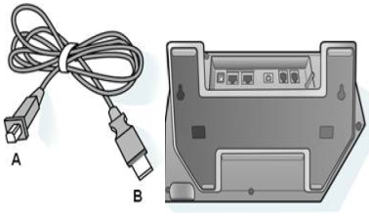
- Sign in to Communicator on your computer.
- Using the cable, connect the Type A USB connector (smaller cable end connector) to the back of the phone, as shown here.
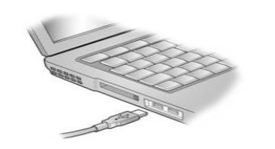
- Connect the Type B connector (larger cable end connector) to your computer’s USB port. When both ends of the cable are secured, the connection between Communicator and your Communicator Phone Edition is detected.
- On your computer, you are prompted to enter your Account, User name, and Password. After you have entered your credentials, Communicator Phone Edition begins to sign in.
- To help secure access to your phone, the phone will lock automatically after a period of inactivity. To create a PIN to unlock the device:
  - Enter a PIN twice
  - Select OK
Sign In
When you have signed in, the presence icon lights up and you’re connected to Communicator Phone Edition. Your contacts appear on the phone, synchronized with Communicator.
- On the Sign In screen, use the keypad to enter your sign-in name (for example, andreash@contoso.com).
- Enter your network domain and user name (for example, contoso\andreash) and your network password, and then select Sign In.

