Call Someone

PRINT SETTINGS For best results, set printer options to: Paper Size: Letter (8.5x11”); Orientation: Landscape; 2-sided printing options: Two-sided, flip on short side.

© 2011 Microsoft. All Rights Reserved

With Communicator Phone Edition, all your contacts are at your fingertips. It’s easy to call anyone in your Contacts List or your corporate directory without having to remember numbers or extensions.
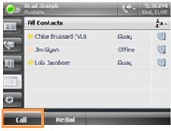
- To connect with someone in your Contact List, simply use the scroll wheel to find them, and then touch the Call button.
- To search for someone in your company directory, use the keypad to enter their name. When you see the person that you want to contact, press their name to place the call. Use the backspace key to correct an entry.
- To call a number, pick up the receiver and dial as usual. To dial a number with the handset in the cradle, dial the number and tap Call on the screen.
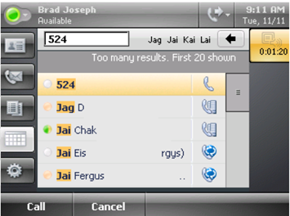
Quick Start for Microsoft® Communicator Phone Edition for Polycom CX700
Hook it up
- Attach the phone cord to the handset.
- Using the phone jack, attach the phone cord to the base unit.
- Using the network jack, connect the RJ-45 network cable to the base unit.
- Connect the other end of the RJ-45 network cable to a live RJ-45 network jack.
- Connect the power supply to the base unit.
- Plug the other end of the power supply into a wall power outlet. The display screen lights up and the phone starts.
- Press the button on the back of the base unit to tilt the touch screen for better viewing.
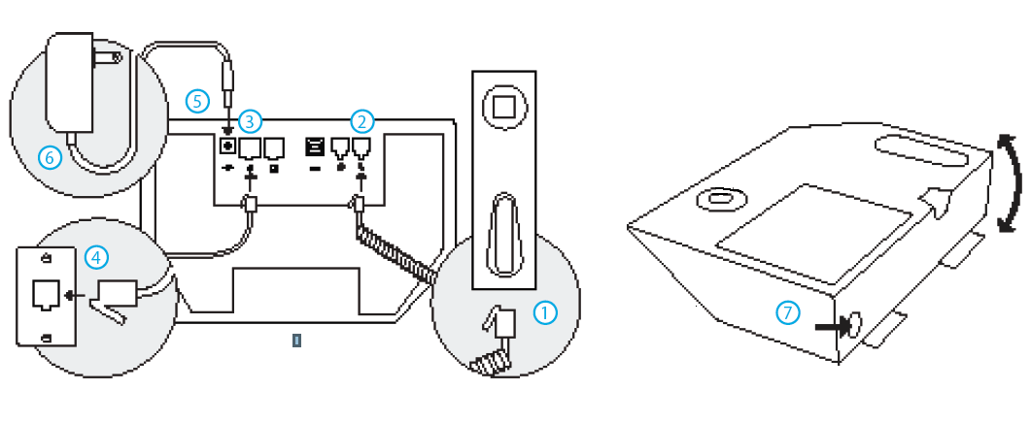
Connect the USB
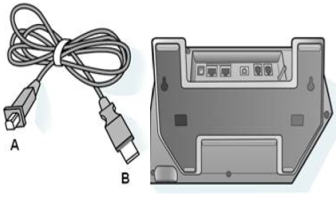
You can connect Communicator Phone Edition to your computer by using the provided USB cable for simplified desk phone sign in from Communicator. Additionally, you can use Communicator to place and receive calls using Communicator Phone Edition.
- Sign in to Communicator on your computer.
- Using the cable, connect the Type A USB connector (smaller cable end connector) to the back of the phone, as shown here.
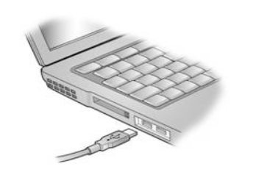
- Connect the Type B connector (larger cable end connector) to your computer’s USB port. When both ends of the cable are secured, the connection between Communicator and your Communicator Phone Edition is detected.
- You can sign in from Communicator, or by using the desk phone by tapping Sign in on the phone instead. Either way, you are prompted to enter your Account, User name, and Password. After you have entered your credentials, Communicator Phone Edition begins to sign in.
Sign In
When you have signed in, the presence icon lights up and you’re connected to Microsoft Communicator Phone Edition. Your contacts appear on the phone, synchronized with Communicator Phone Edition.
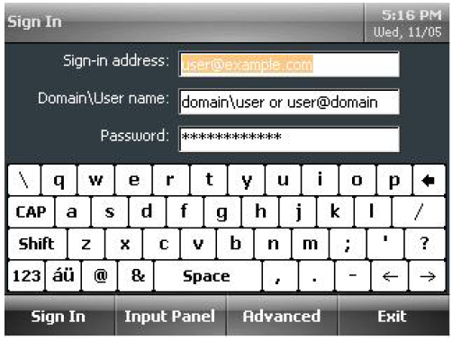
- On the Sign In screen, use the touch screen to enter your sign-in name (for example, andreash@contoso.com).
- Enter your network domain and user name (for example, contoso\andreash) and your network password, and then tap Sign In on the touch screen.
- To help secure access to your personal contacts, your phone will lock automatically after a period of inactivity. You can choose to use either a personal identifier number (PIN) or your fingerprint to unlock the phone.
- To use a PIN to unlock the device, enter the PIN (two times) that you want to use, and then touch OK.
- To use your fingerprint to unlock the device, select Switch to Fingerprint and swipe your finger on the fingerprint reader until the device recognizes your print (four times).

