What’s New with Microsoft Communicator Phone Edition for Polycom CX700
The following new features are available on Microsoft® Communicator Phone Edition for Polycom CX700.
Calendar
Phone Location
Agent Anonymity
Private Line Support
Improved Conferencing
Delegate Support Desktop Alert
Frequent Contact
Delete Voicemails
Report Malicious Call
Call Forwarding
Direct Transfer
Calendar
You can view your meetings and join a meeting directly from the phone.
- View your Microsoft Outlook Calendar items on your phone.
- Select the meeting that you want to join, and tap Join.
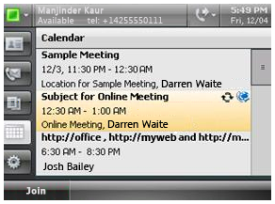
Note You can only join a Communicator online meeting that has been created by using Communicator Conferencing Add-in.

Phone Location
The phone location assists emergency responders in locating distressed callers.
To view or set your phone location:
- Tap Settings, and then tap Phone Location.
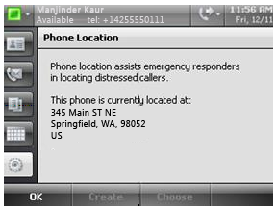
Anonymous Agent Support
When you are part of a Response Group and you receive a group call, the call is answered anonymously as part of your Response Group.
Private Line Support
Private Line Support allows you to have a second line for your private calls.
- If you have delegate’s set-up, where your incoming calls are answered by your assistant, now you can also have a private line where the calls to the private line come directly to you.
Improved Conferencing
The following new features have been added to provide a better conferencing experience.
- The conference leader can mute everyone else in the conference except for themselves by pressing the Mute All But Me button.
- When you join a conference, the call ribbon displays your current state. For example, if you are in the Meeting Lobby, it will state you are in Meeting Lobby.
- You can admit users from the Meeting Lobby to the conference from Communicator Phone Edition.
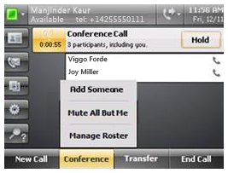
Delegate Support Desktop Alert
When you have delegates configured to answer calls on your behalf, both you and your delegate receive a desktop alert of the incoming call.
- The desktop alert informs you that you have an incoming call.
- You are notified that your delegate is receiving the incoming call.
- You are notified when your delegate answers the call.
If you have more than one delegate set up, both delegates will receive a desktop alert of the call.
Frequent Contact
You can now view your Frequent Contacts on your phone.
- The Frequent Contacts group has been added to Contact Groups to let you easily find the people you contact the most.
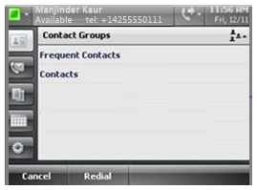
Delete Voicemails
In the Voicemail menu there is a new Delete Voicemail button that lets you delete voice mail messages individually without having to listen to them.
Report Malicious Calls
Now you can report a malicious call to your administrator after the call has ended. You can report the last call that was received or placed since the last sign-in.
To report a malicious call:
- Tap Settings, tap Report a Malicious Call, and then tap Submit.
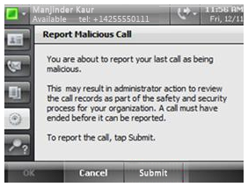
Call Forwarding
You can set call forwarding options to, Simultaneously ring a contact or any phone number, from Communicator Phone Edition. This option enables you to specify a contact or another phone number to ring at the same time as your phone number rings.
To set call forwarding options to, Simultaneously ring a contact or any phone number:
- In the upper right corner of Communicator Phone Edition, tap the Call Forwarding icon.
- Tap Simultaneously ring a contact or any phone number, select a contact or choose a phone number, and then tap OK.
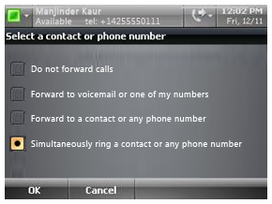
Direct Transfer
Now you can directly transfer a call from Communicator Phone Edition to another phone number without interrupting the call.
To transfer a call to another phone number:
- Tap the Transfer button and tap Transfer Directly To, and then choose the number to which you want to transfer the call.
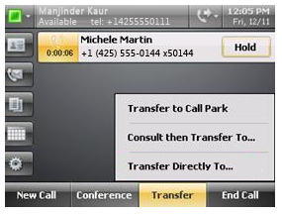
This document is provided “as-is”. Information and views expressed in this document, including URL and other Internet Web site references, may change without notice. You bear the risk of using it.
© 2011 Microsoft. All Rights Reserved

