Troubleshooting
Why does the display show “Sign in…” or “Please Upgrade” when the phone is already connected to my computer?
When the phone is not connected to Communicator (because the computer does not have Communicator installed, or has a version of Communicator that does not support the phone), the “Sign in” or “Please Upgrade” messages are displayed, and you can use the phone as an audio device only.
- Make sure that the correct version of Communicator is installed on your computer. See “System Requirements” on this card.
- Make sure that your network connection is active.
- Make sure that you are signed in to Communicator.
Why can’t I make outgoing calls from my phone when my computer is locked?
Your system administrator controls management settings for Communicator. See your system administrator about how to modify the rules for your phone’s functionality.
Why isn’t the phone playing any sounds from Communicator?
No sound may mean that the phone is not physically set up. Make sure that the handset is on the cradle if you are trying to hear sounds through the speakerphone. Check that the speaker volume is high enough to be audible. Use the volume keys on the keypad to adjust.

Additionally, verify that the phone is selected as the speaker and microphone device. To do this, in Communicator, go to Tools, select Set Up Audio and Video, and then select the USB phone from the applicable drop-down menus.
PRINT SETTINGS For best results, set printer options to: Paper Size: Letter (8.5x11”); Orientation: Landscape; 2-sided printing options: Two-sided, flip on short side.
This document is provided “as-is”. Information and views expressed in this document, including URL and other Internet Web site references, may change without notice. You bear the risk of using it.
© 2011 Microsoft. All Rights Reserved
Quick Start for Communicator USB Phone

System Requirements
The following are the minimum software and hardware requirements:
- Windows Vista® Service Pack 1 or Windows® XP Professional Service Pack 3
- System requirements for Microsoft® Communicator
  - Communicator
  - A powered USB port
Assembling the phone
- Attach one end of the phone cord (B) to the handset phone jack at the back of the phone (C). A “click” sound indicates that the phone cord is inserted correctly in the computer.
- Attach the other end of the Phone cord (B) to the handset (A). A “click” sound indicates that the phone cord is connected correctly to the handset.
- Connect the USB cable from the phone (C) to the computer that is running Communicator.
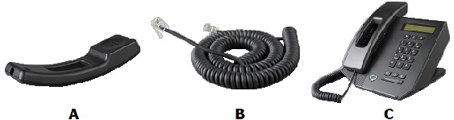

Main Features

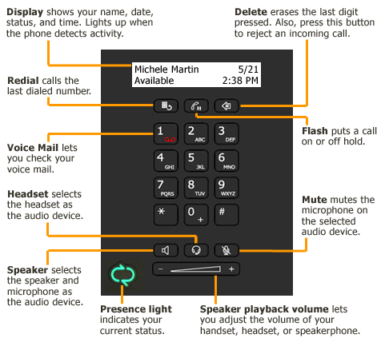
Tips
- Voice Mail “1” – Press 1 for 1.5 seconds to access your voice mail.
- Device Settings “5” – Press 5 during startup to change your phone settings.
- International “0” – When placing an international call, press 0 for 1.5 seconds (must be the first number pressed) to add the “+” sign to the number that you’re dialing. Communicator replaces the “+” with the access numbers required to dial an international phone number.

