8 Reasons to Use your PC as a Phone
With Microsoft® Communicator, you can save time, work efficiently, and get what you’ve always wanted from your PC — for example, using it as a telephone. Here are eight reasons you might want to use your PC as a phone.
Say goodbye to phone tag
Make a call with one click
Answer a call with one click
Control calls
Forward calls with one click
Show co-workers your cell phone number
Listen to voice mail
Say goodbye to phone tag
Presence status in the Communicator Contacts list lets you know when a contact is available for a conversation so you don’t waste time calling people who aren’t there. Here are a few tips.
Before making a call, check presence status
- If the contact’s presence status is Available, go ahead and call them.
- Tips: Communicator can notify you of changes in a contact’s status by displaying an alert whenever the contact’s status changes to Available or Offline. In the Contacts list, just right-click a name, and then click Tag for status change alerts. A star next to their name indicates that you have tagged them. You can tag as many contacts as you want.

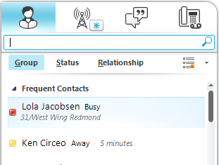

Check the contact card for free/busy status
There are several ways to view someone’s contact card. For example, you can click their Presence button in the Contacts list, the Search Results box, or in the Communicator Conversation window.
To view a contact card
- Click the Presence icon in the Contacts list to the left of the contact’s name.
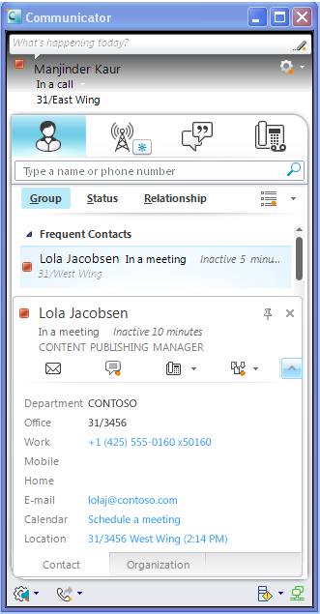
Make a call with one click
Use Office Communicator to make one-click phone calls to people in your Contacts list. You can also call optional numbers by clicking the Calling options arrow to the right of the Call button.
Make a one-click call
- In the Contacts list, click the person’s Call button.
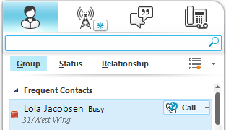
Call an alternate phone number
- In the Contacts list, click the Calling options arrow to the right of the Call button, and then click the number you want to call.
Enter a phone number to call
- Type the number in the Search box, and then click the Call button next to the number as it appears in the Search Results box. You can enter an internal phone extension, an external number, an alphanumeric number such as 425-555-TAXI, or a contact’s name.
Copy and paste to call
- From an Outlook e-mail, Web page, or document, copy the number, paste it into the Search box, and then click the Call button next to the number as it appears in the Search Results box.
Invite someone to a call
- In the Conversation window, click Invite, and then select a contact, enter a name, or enter a number to call.
Answer a call with one click
When you receive a phone call, the call invitation alert appears in the bottom-right of your computer screen. You can answer the call the old-fashioned way by picking up the handset of your USB phone or Communicator Phone Edition desk phone, or you can click the call alert that appears in the bottom-right of your computer screen.
Answer a phone call
- In the phone call invitation alert, click the left pane. The alert appears in the bottom-right of your computer screen. If you have a Communicator Phone Edition desk phone or USB audio phone attached, lift the handset or press Answer.
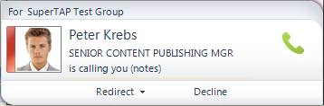
Redirect a call
When you receive a call you can answer the call or you can redirect the call another number, an instant, or reject the call.
- Click Redirect, and then select an option from the menu. If you choose to redirect a call to an instant message, a call rejection message is sent to the caller and the Conversation window opens so that you can send the caller an instant message.
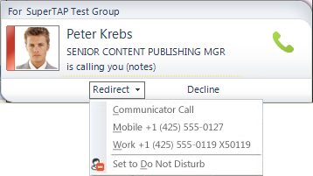
Control calls
Call controls are icons in your Conversation window that enable you to easily manage your phone call. For example, you can put the caller on hold, transfer them to another user or phone, or mute a speaker or microphone.
The following table describes each call control function.
Control | Description
 | End a call  In the Conversation Window, Click the End Call icon.
Put a call on hold
In the Conversation window, click the Hold icon.
 | Transfer an incoming call to another person  Click the call alert invitation to accept the call. In the Conversation window, click the Transfer icon, click Another Person, and then select the contact to whom you want to transfer the call.
Transfer an incoming call to another phone
Click the call alert invitation to accept the call. In the Conversation window, click the Transfer icon, click Another Person, and then select the phone that you want to transfer the call.
 | Display Dial pad  Click the Dial pad icon. This control is often used when prompted for Voice Mail PIN or Access Codes.
Mute speaker or adjust speaker volume
In the Conversation window, click the Mute speaker icon to turn off the speaker on your USB phone device. Click the arrow and use the slider to adjust the speaker volume.
Mute microphone
In the Conversation window, click the Mute microphone icon to mute the microphone.
Forward calls with one click
Communicator offers several options for automatically forwarding incoming calls. For example, you can forward calls to voice mail, one of your other phone numbers, or another person. When calls are forwarded, your phone does not ring. Instead, calls are automatically forwarded to the specified destination.
To forward calls to voice mail, another phone, or a contact
- Click the Options button, and point to Tools, ad then Call-Forwarding Settings.
- Select a phone number, Voice Mail, New Number, or Contact.
To ring another number at the same time your number rings
- Click the Call Forwarding button.
- Point to Simultaneously Ring.
- Select a number, or click New Number and enter a number.
The numbers available on the Simultaneously Ring menu are based on the numbers you published on the Phone Options tab (see Control Access to Information). Any new number you enter overwrites an existing number on the Simultaneously Ring menu.
To redirect unanswered calls to voice mail, another number, or a contact
- Click the Options button, click Tools, and then click Call-Forwarding settings.
- In the Forward calls to list, click a number, or click Voice Mail, New Number, or New Contact, and then enter the number or select a contact.
- To specify the time period before redirecting the call, in the Ring for this many seconds before redirecting box, use the arrows to increase or decrease the time interval.
Show co-workers your cell phone number
You can assign levels of access to your contacts to control their access to your Presence information. Different attributes are exposed for each presence level, such as Block, Public, Company, Team, and Personal. For example, Mobile Phone is available at the Team level, but not at the Company level.
To edit and publish your phone numbers
- Click the Options icon.
- Point to Tools, click Options, and then click Phones.
- Click the button for the number you want to add or edit.
- After you have entered the number, select the Publish this phone number box for those numbers that you want to make visible to other Communicator users.
Assign access to your phone numbers
After you publish your phone numbers, you must assign privacy relationships to those contacts who you want to see your phone numbers. If you want a contact to see your Home and Mobile phone numbers, assign the contact to the Friends and Family level. If you want them to see only your Work and Mobile numbers, assign them to the Colleagues level.
- To assign a privacy relationship to a contact, right-click the contact, point to Change Privacy Relationship, and then select the relationship.
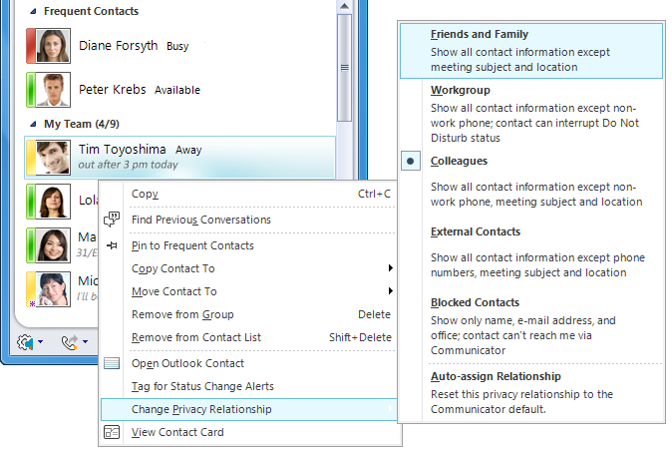

About phone number formats
When specifying phone numbers, enter the country code, an area code, and the local number, using only the digits 0123456789 and optionally the + symbol. Do not use alphanumeric numbers. Thus, a U.S. number might look like: 4255550101, 14255550101, or +14255550101. An international number dialed from the U.S. might look like: +441223479818 or 011441223479818. See your system administrator for dialing requirements (such as adding 9 for outside calls) that may be specific to your organization.
Listen to voice mail
Did you miss a call? The Phone tab lets you know, and also holds your voice mail messages. The tab glows and displays the number of missed calls.
- Point to a voice mail message and click the green arrow to hear it, or if you want to, call the person back.
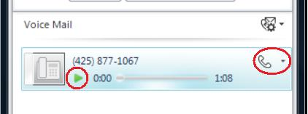
- You can also set voice mail options such as your recorded greeting.
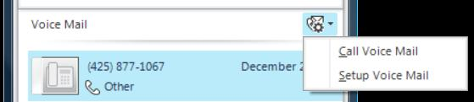
This document is provided “as is”. Information and views expressed in this document, including URL and other Internet Web site references, may change without notice. You bear the risk of using it.
© 2010 Microsoft. All Rights Reserved.
This document is provided “as is”. Information and views expressed in this document, including URL and other Internet Web site references, may change without notice. You bear the risk of using it.
© 2010 Microsoft. All Rights Reserved.
This document is provided “as is”. Information and views expressed in this document, including URL and other Internet Web site references, may change without notice. You bear the risk of using it.
© 2011 Microsoft. All Rights Reserved.

