Finding Familiar Features in Lync 2010
If you’re used to using Microsoft Office Communicator 2007 R2, this side-by-side comparison guide will help you find familiar features and tasks in Microsoft Lync 2010.
Presence and Search Features
Sharing Features
Phone and Video Features

Presence and Search Features
Where do I… | In Communicator 2007 R2 | in Lync 2010
Set my status | 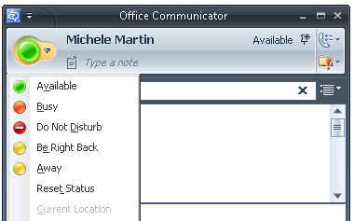 | 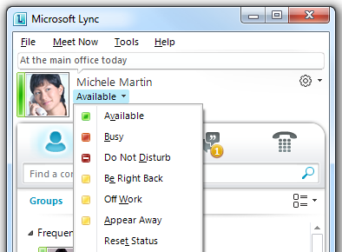
Search for someone | 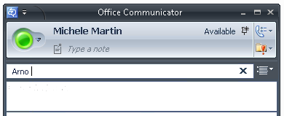 | 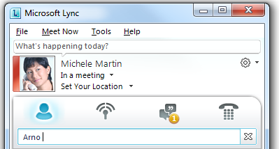
Type a note about myself that others can see | 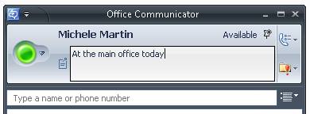 | 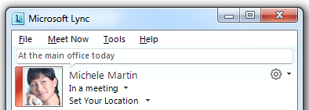
Change the view of my Contacts list | 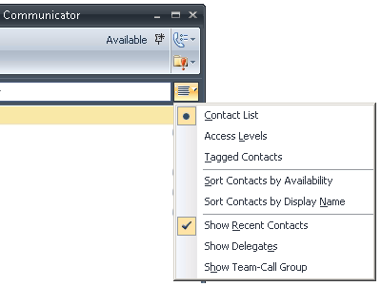 | 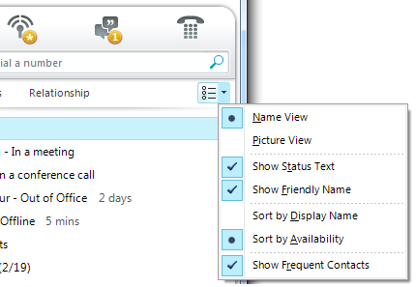
Set my options | 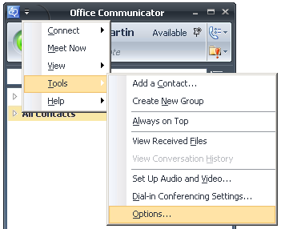

Sharing Features
Where do I… | In Communicator 2007 R2 | In Lync 2010
Start sharing during an instant messaging (IM) conversation or meeting | 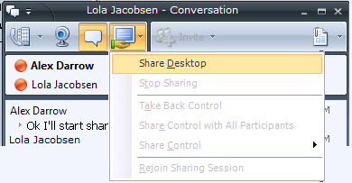 | 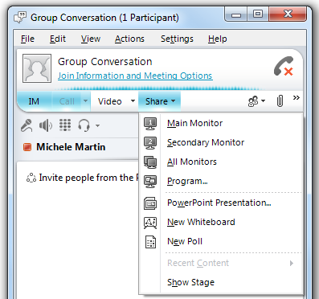
Give control of a shared desktop or program to another participant | 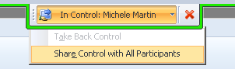 | 

Phone and Video Features
Where do I… | In Communicator 2007 R2 | In Lync 2010
Make a call by dialing a number | 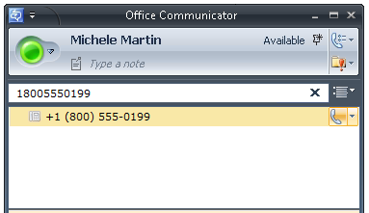 | 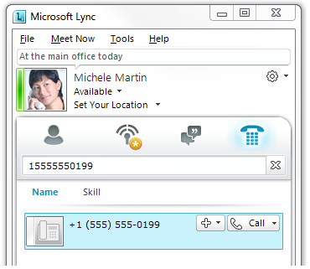
Switch between active conversations | 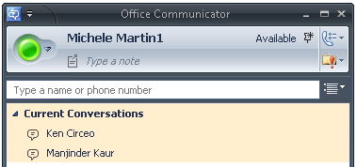 | 
Use call controls during a call | 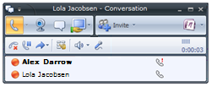  End the call  Put the call on hold  Transfer the call to another person or phone  Display the dial pad  Mute speaker, or adjust speaker volume  Mute microphone |   End the call  Mute microphone  Mute speaker, or adjust speaker volume  Display the dial pad  Change the device I’m using  View the status of my network connectivity  Put the call on hold  Transfer the call to another person or phone
Set up ringing options, such as call forwarding and simultaneous ring | 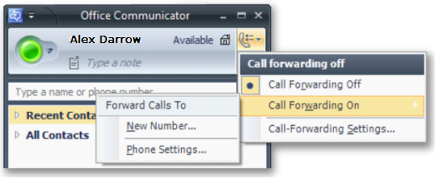 | 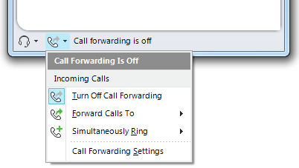
Continue a conversation on another phone (for example, on a home or mobile phone) | 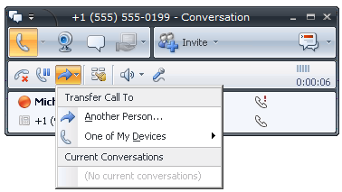 | 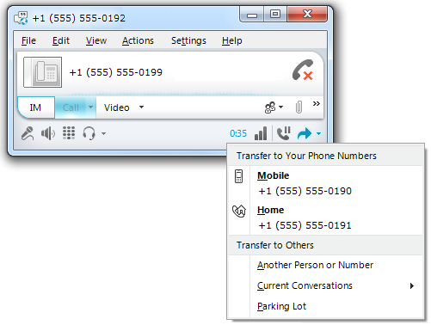
Switch to a different audio device (for example, from a computer microphone and speakers to a headset) | From the Communicator main window  when not in a call:  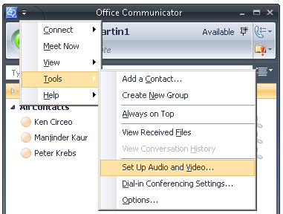 | From the Lync main window  when not in a call:  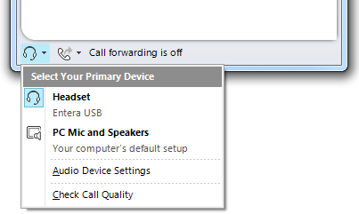  From the conversation window  during a call:  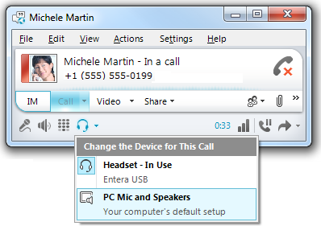
Check my voice mail | 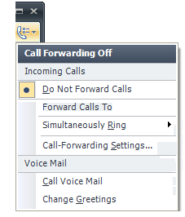 | 

©2011 Microsoft Corporation. All rights reserved. This material is provided for your informational purposes only. Microsoft makes no warranties, express or implied. Some examples depicted herein are provided for illustration only and are fictitious. No real association or connection is intended or should be inferred.

