

Lync™ 2010 Scenario Spotlight
September 2010, Issue #2

This newsletter is produced every few weeks and is sent to all current participants of the Lync rollout. We hope you find it informative and useful and that you share it with others.
NEW Product featureS: CONTACT ENHANCEMENTS
Quickly identify the right teammates. Now you can see your contacts’ corporate or custom pictures for quick identification, and change the way you display them, such as by status or group.
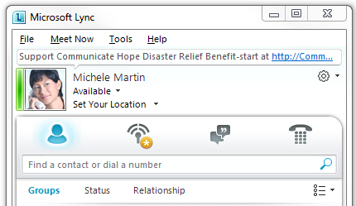

Easily contact frequent contacts. The Frequent Contacts group shows the 10 contacts you most frequently have conversations with (not necessarily the most recent). Lync 2010 pre-populates the group with your team members. You can “pin” important contacts to the top of Frequent Contacts by right-clicking a contact and then clicking Pin to Frequent Contacts.

Get more from search. Searching for contacts is even more powerful in Lync if you have Microsoft SharePoint services because in addition to searching for names or phone numbers, you can search for items such as job title, department, or skills and expertise from a SharePoint profile.

Get details about your contacts. Point to a contact, and get rich information about that person or distribution group. You can start communicating from the contact card as well as from the Contacts list. When you expand the card, you can even see the contact’s place in the organization.
SCENARIO SPOTLIGHT: RECORD AND PLAYBACK CALLS AND MEETINGS
Record a conversation, call, or meeting. When you’re in a meeting, conversation, or a call, you can start recording. Click the More options button, and then click Start Recording.

Play a recording. You can play recordings from the Microsoft Lync 2010 Recording Manager.
- Open Lync Recording Manager, by doing one of the following:
- Click Start, click All Programs, click Microsoft Lync, and then click Microsoft Lync Recording Manager.
- In Lync, next to the Options button, click the Show Menu arrow, click Tools, and then click Recording Manager.
- In Recording Manager, click a recording, and then click Play.
news you CAN use: changes to OFFICE live meeting AND Record- ing MEETINGS
Microsoft Office Live Meeting is replaced by the new, integrated online meeting service in Lync. Be sure to check out the Conferencing FAQ and Training Index for additional information about changes to online meetings in Lync.

What do I do with my existing Office Live Meetings? Most existing Live Meetings do not need to be rescheduled (guidance here), however, you cannot create new Live Meetings in Lync. Lync replaces Live Meeting for scheduled or impromptu meetings. Find a brief description of service changes here.

You can still record meetings in Lync, but you need to exit and restart Lync to make the recording icon available.

The Microsoft IT Lync Rollout Team
We would really like you to continue to receive our newsletter; however, you can opt-out here.

©2011 Microsoft Corporation. All rights reserved. This material is provided for your informational purposes only. Microsoft makes no warranties, express or implied.

