Use the call controls
To put the call on hold, click Hold.

To send the call to another phone or to merge the call with another conversation, click Transfer.
When you’re finished, just click End Call.
Add video
If you have a webcam set up, you can choose to allow your contact to see you during your conversation.
To add video to your IM conversation or audio call, click Video in the conversation window. If you accept someone’s incoming video call, they won’t see you until you add video from your side of the conversation.
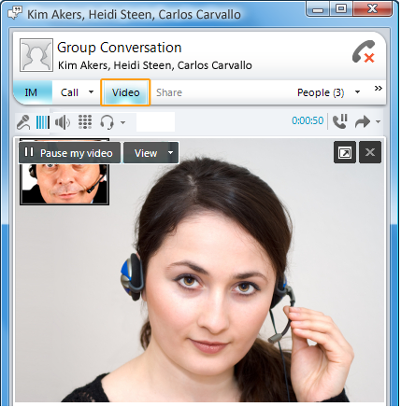

PRINT SETTINGS For best results, set printer options to: Paper Size: Letter (8.5x11”); Orientation: Landscape; 2-sided printing options: Two-sided, flip on short side.

© 2011 Microsoft. All Rights Reserved. This document is provided “as-is”. Information and views expressed in this document, including URL and other Internet Web site references, may change without notice. You bear the risk of using it. Some examples are for illustration only and are fictitious. No real association is intended or inferred.

Voice and Video Quick Reference
Set up your audio devices
If you have a microphone and speakers, you’re ready to use Microsoft® Lync™ 2010 for voice calls. You can also plug in any device recommended by your company, such as a USB headset, USB phone, or handset, and Lync 2010 will automatically configure your settings. To check your audio settings, click the Options button, and then click Audio Device.
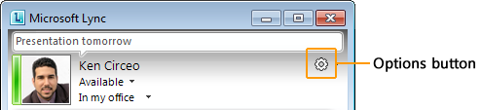
For information about the phones and devices supported by Lync, see Phones and Devices Qualified for Microsoft Lync at http://go.microsoft.com/fwlink/?LinkId=214003.
Plug in a webcam
When you connect a webcam to your computer, Lync automatically detects it and uses it for your next video call. To see your webcam settings, click the Options button, and then click Video Device.
Find the right person
Just start typing a person’s name in the search box, and results will appear below the box. If you see who you’re looking for, double-click to send an instant message. Right-click the person’s name if you want to add him or her to your Contacts list.
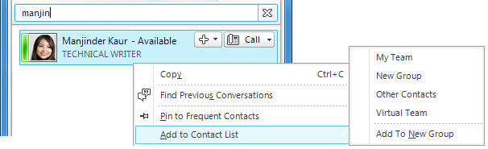
Make a voice call
You can start a phone call with one simple click.
- Point to the contact in your Contacts list.
- Click the Call button. (Or click the arrow next to it, and then click the specific number you want. You can also add a new number.)
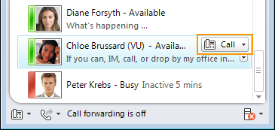
Start a conference call
To select multiple contacts, press and hold the Ctrl key, and click the contacts you want. Then right-click a selected contact, and click Start a Conference Call.
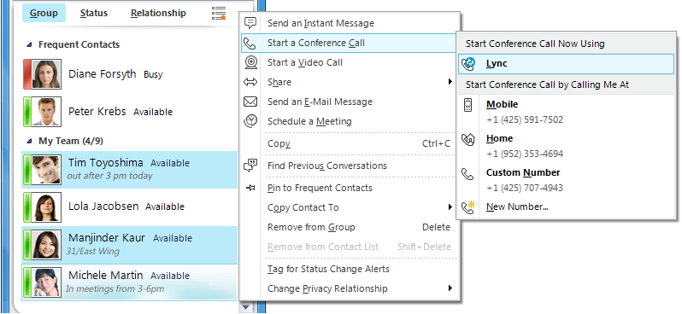
Answer a call
When a call alert appears on your screen, do one of the following:
- To answer the call, click the alert.
- To send the call to voice mail, click Decline.
- To redirect the call to a different number, click Redirect, and then select a number.

Invite other people to the conversation
- In the conversation window, click the People Options menu.
- Click Invite by Name or Phone Number, click the contact you want or search for that person, and then click OK.
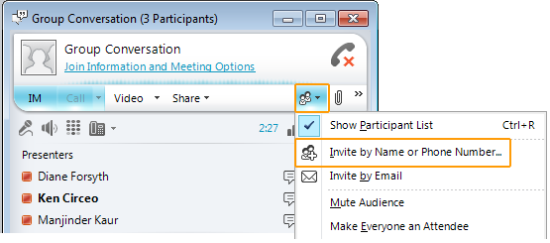
If someone is available only by phone, click Invite by phone, and then type the phone number. You can also drag contacts from your Contacts list into the conversation window.
Add voice to an IM conversation
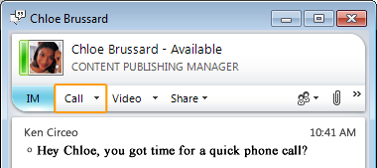
You can add voice to an instant messaging (IM) conversation by just clicking the Call button. You can continue to type while talking.

