SCHOOL OF COMPUTING
ST1507 Data Structures and Algorithms (AI)
Lab 02 Submission Worksheet

Instructions:
- Submit this at Brightspace under the appropriate submission folder.
- Name your file “Name_StudentID.docx”
(for example ‘JohnTan_12345.docx”)
- You may need to expand the answer boxes below accordingly.

Name
Student ID | P2518507
Class | DAAA/FT/2A/19

Lab Two - Task Submission 1

Task 6: Implementing a Deque class

Copy and paste the Python code that you have written for this task in this area

class Deque:
def __init__(self):
self.__list = []

def isEmpty(self):
return self.__list == []

def size(self):
return len(self.__list)

def clear(self):
self.__list.clear()

def addHead(self, item):
self.__list.insert(0, item)

def addTail(self, item):
self.__list.append(item)

def removeHead(self):
if self.isEmpty():
return None
else:
return self.__list.pop(0)

def removeTail(self):
if self.isEmpty():
return None
else:
return self.__list.pop()

def getHead(self):
if self.isEmpty():
return None
else:
return self.__list[0]

def getTail(self):
if self.isEmpty():
return None
else:
return self.__list[-1]

def __str__(self):
output = '<'
for i in range(len(self.__list)):
item = self.__list[i]
if i < len(self.__list) - 1:
output += f'{str(item)}, '
else:
output += f'{str(item)}'
output += '>'
return output

# Main program
d = Deque()
print(d.removeHead())
print(d.removeTail())
for i in range(1,6):
d.addTail(i)
print('Content of deque is = ',d)
print('Item at front = ',d.getHead())
print('Item at back = ',d.getTail())
print('Size = ', d.size())
count=0
while not d.isEmpty():
# Alternating remove head and tail
if count % 2 ==0:
print(d.removeHead())
else:
print(d.removeTail())
print(d)
count+=1

Paste screenshot(s) of the output of your program here

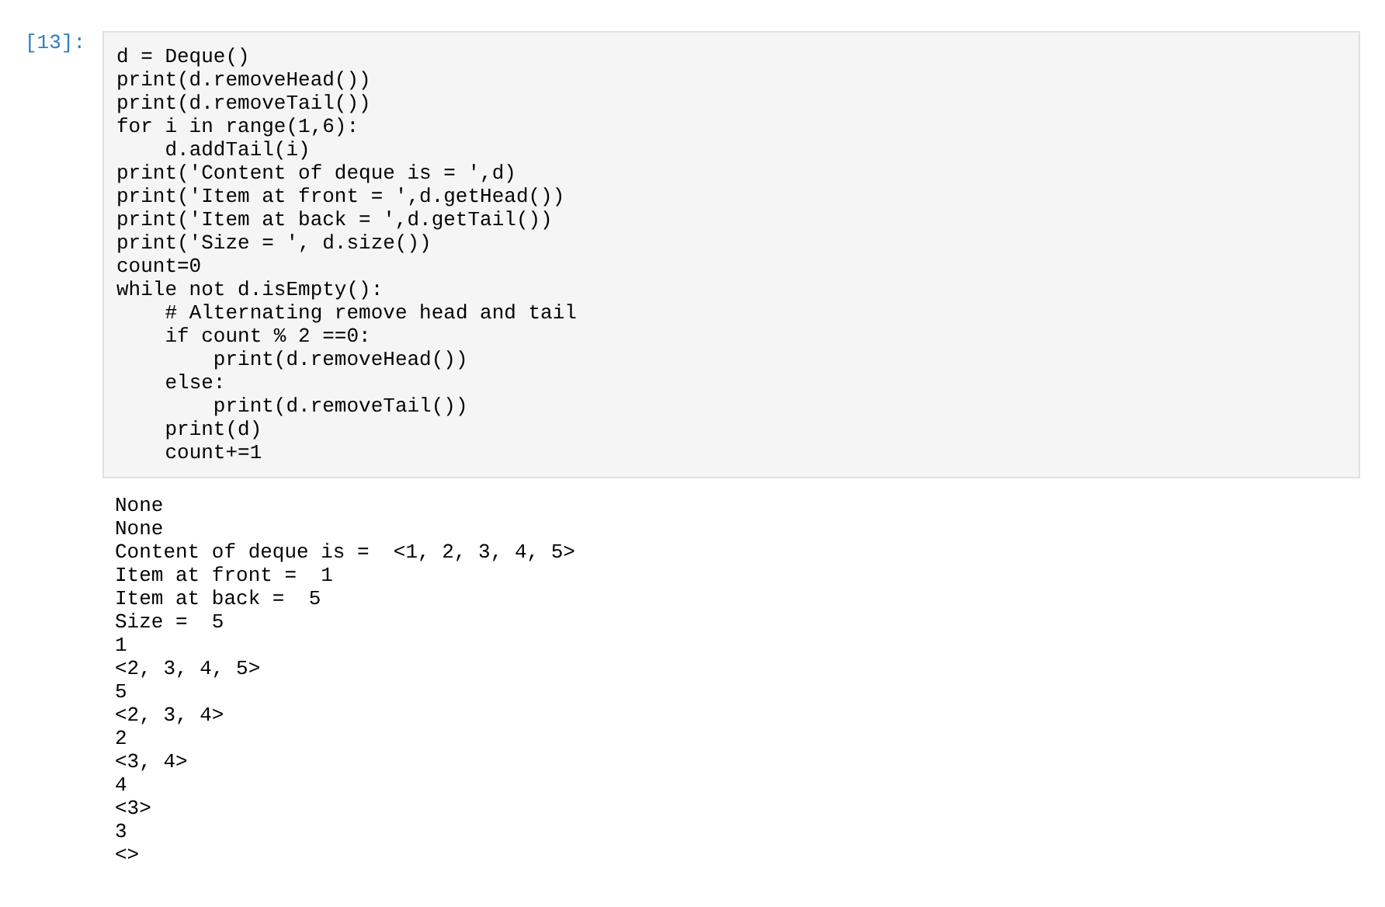

Lab Two - Task Submission 2

Task 8(a): Implementing a Fruit class and use it for a SortedList

Copy and paste the Python code that you have written for this task in this area

class Node:
# Constructor
def __init__(self):
self.nextNode = None

class Fruit(Node):
def __init__(self, name):
self.name = name
super().__init__()

def __eq__(self, otherNode):
if otherNode == None:
return False
else:
return self.name == otherNode.name

def __lt__(self, otherNode):
if otherNode == None:
raise TypeError("'<' not supported between instances of 'Fruit' and 'NoneType'")
if len(self.name) == len(otherNode.name):
return self.name.lower() < otherNode.name.lower() # same length, so alphabetical
return len(self.name) < len(otherNode.name)

def __str__(self):
return f"'{self.name}'"

class SortedList:
def __init__(self):
self.headNode = None
self.currentNode = None
self.length = 0

def __appendToHead(self, newNode):
oldHeadNode = self.headNode
self.headNode = newNode
self.headNode.nextNode = oldHeadNode
self.length += 1

def insert(self, newNode):
# If list is currently empty
if self.headNode == None:
self.headNode = newNode
self.length += 1
return

# Check if it is going to be new head
if newNode < self.headNode:
self.__appendToHead(newNode)
return

self.length += 1
# Check it is going to be inserted
# between any pair of Nodes (left, right)
leftNode = self.headNode
rightNode = self.headNode.nextNode
while rightNode != None:
if newNode < rightNode:
leftNode.nextNode = newNode
newNode.nextNode = rightNode
return
leftNode = rightNode
rightNode = rightNode.nextNode

# Once we reach here it must be added at the tail
leftNode.nextNode = newNode

def __str__(self):
# Show the list like a Python list: [item1, item2, ...]
output = "["
node = self.headNode
firstNode = True
while node != None:
if firstNode:
output += node.__str__()
firstNode = False
else:
output += (', ' + node.__str__())
node = node.nextNode
output += "]"
return output

# Main program
l = SortedList()
# Populate a list with fruit names
fruits = ['Cherry', 'Apricot', 'lime', 'blueberry', 'Apple', 'Date']
print('Before sorting')
print(fruits)
for fruit in fruits:
l.insert(Fruit(fruit))
print('\nAfter sorting')
print(l)

Paste screenshot(s) of the output of your program here



