SCHOOL OF COMPUTING
ST1507 Data Structures and Algorithms (AI)
Lab 01 Submission Worksheet

Instructions:
- Submit this at Brightspace under the appropriate submission folder.
- Name your file “Name_StudentID.docx”
(for example ‘JohnTan_12345.docx”)
- You may need to expand the answer boxes below accordingly.

Name
Student ID
Class

Lab One - Task Submission 1

Task 2: Implementing a Morse code translator

Copy and paste the Python code that you have written for this task in this area

MORSE_CODE = {
'A': '.-', 'B': '-...', 'C': '-.-.', 'D': '-..', 'E': '.',
'F': '..-.', 'G': '--.', 'H': '....', 'I': '..', 'J': '.---',
'K': '-.-', 'L': '.-..', 'M': '--', 'N': '-.', 'O': '---',
'P': '.--.', 'Q': '--.-', 'R': '.-.', 'S': '...', 'T': '-',
'U': '..-', 'V': '...-', 'W': '.--', 'X': '-..-', 'Y': '-.--',
'Z': '--..',
'1': '.----', '2': '..---', '3': '...--', '4': '....-', '5': '.....',
'6': '-....', '7': '--...', '8': '---..', '9': '----.', '0': '-----',
' ': ' ' # a space stays a space (gap between words)
}

# Make the opposite dictionary: Morse -> English
ENGLISH_CODE = {}
for letter in MORSE_CODE:
morse = MORSE_CODE[letter]
ENGLISH_CODE[morse] = letter

def encodeMorse(text):
lines = text.strip().split('\n') # one item per line

result = ""
for line in lines:
morseLine = ""
for ch in line.upper():
morseLine = morseLine + MORSE_CODE[ch] + ","
morseLine = morseLine[:-1] # remove the extra comma at the end
result = result + morseLine + "\n"

return result.strip() # remove the extra newline at the end

def decodeMorse(text):
lines = text.strip().split('\n')

result = ""
for line in lines:
codes = line.split(',') # each item is one letter in Morse
englishLine = ""
for code in codes:
englishLine = englishLine + ENGLISH_CODE[code]
result = result + englishLine + "\n"

return result.strip()

# Translate English to Morse
text = """
SOS SOS OUR SHIP IS SINKING
PLEASE HELP
"""

output = encodeMorse(text)
print(output)

# Translate Morse to English
morse = """
...,---,..., ,...,---,..., ,---,..-,.-., ,...,....,..,.--., ,..,..., ,...,..,-.,-.-,..,-.,--.
.--.,.-..,.,.-,...,., ,....,.,.-..,.--.
"""

output = decodeMorse(morse)
print(output)

Paste screenshot(s) of the output of your program here

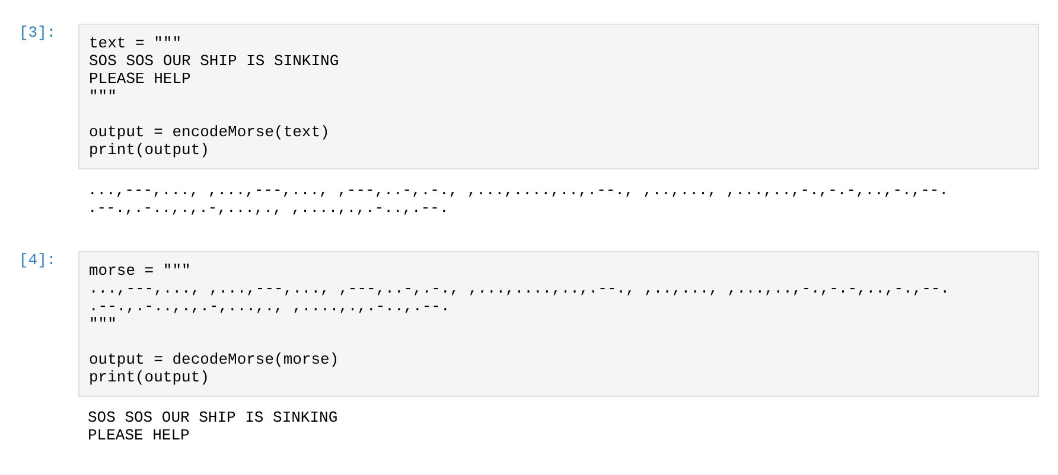

Lab One - Task Submission 2

Task 4: Implementing algorithm D

Copy and paste the Python code that you have written for this task in this area

def guessDivideConquer(maxNum):
# Make a list 1, 2, 3 ... maxNum
candidates = []
for i in range(1, maxNum + 1):
candidates.append(i)

noOfQuestions = 0

# Keep cutting the list in half until only one number is left
while len(candidates) > 1:
middle = len(candidates) // 2
breakpoint = candidates[middle]
noOfQuestions = noOfQuestions + 1

answer = input("Is it smaller than " + str(breakpoint) + ", 'y' or 'n'?")

if answer == 'y':
candidates = candidates[:middle] # keep the left half
else:
candidates = candidates[middle:] # keep the right half

print('Wonderful it took me', noOfQuestions, 'questions to find out that you had the number', candidates[0], 'in mind!')

# Main program
maxNum = int(input('Enter the range: '))
input('Think of a random number between 1 and ' + str(maxNum) + ' and press enter once done!')
guessDivideConquer(maxNum)

Paste screenshot(s) of the output of your program here



