**CA 3: Experiential Learning**

Group Members:

|  |  |  |  |
| --- | --- | --- | --- |
| **Sr. No.** | **PRN** | **Name of Student** | **Mail id** |
| 1 | 22070122198 | Shilpi Biswal | shilpi.biswal.btech2022@sitpune.edu.in |
| 2 | 22070122199 | Shivani Shashidhar | shivani.shashidhar.btech2022@sitpune.edu.in |
| 3 | 22070122249 | Vidhi Binwal | vidhi.binwal.btech2022@sitpune.edu.in |

**Problem Statement:**

Traditional methods of purchasing movie tickets can be difficult and time-consuming, which can often make users frustrated. As a solution to this, our platform seeks to provide a more straightforward, user friendly and convenient method for booking movie tickets and seats, thus enhancing the overall booking experience for the user.

**Explanation:**

**Title**: Online Movie Ticket Booking System

**Description of System:**

Our system is an effective and user-friendly programme created to make the procedure of making movie ticket reservations simpler and less time consuming. Through the provision of a digital platform that enables customers to select movies, choose seats, and make safe payments, it aims to improve the experience of purchasing movie tickets traditionally.

**Key Features:**

* Movie Selection: Users can look through the list of movies and showtimes to decide the movie they want to see.
* Seat Reservation: The system offers a simple interface that enables customers to choose their seat column and row.
* Users have the choice of paying for their tickets either with a credit card or a UPI payment option.
* E-Ticket Generation: Following a successful reservation, the system generates an eye-catching e-ticket that includes a summary of the movie information, showtime and seat details.

**Working Of The System:**

1. User makes decision of selecting desired movie and showtime.
2. They enter the number of tickets they want to buy and choose the row and column in which they want to sit.
3. Users enter payment data, such as credit card information or a UPI phone number.
4. The system creates an electronic ticket containing the movie and showtime information after a successful payment.

**Technology Used:** C++ for code development

**Code Structure:**

The code is organised around classes for tickets and payments, and it includes methods for booking, displaying, and processing payments. Additionally, it uses functions for displaying the seating arrangement and generating electronic tickets.

**Class Diagram:**

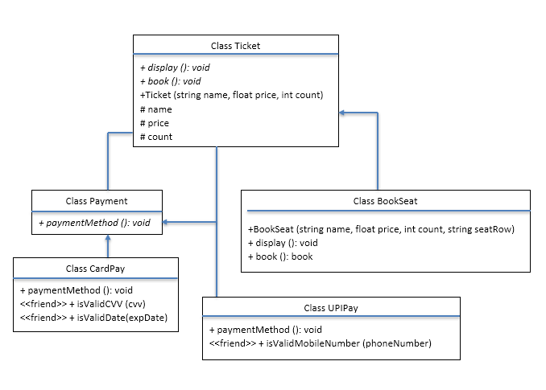

**Code snippets:**

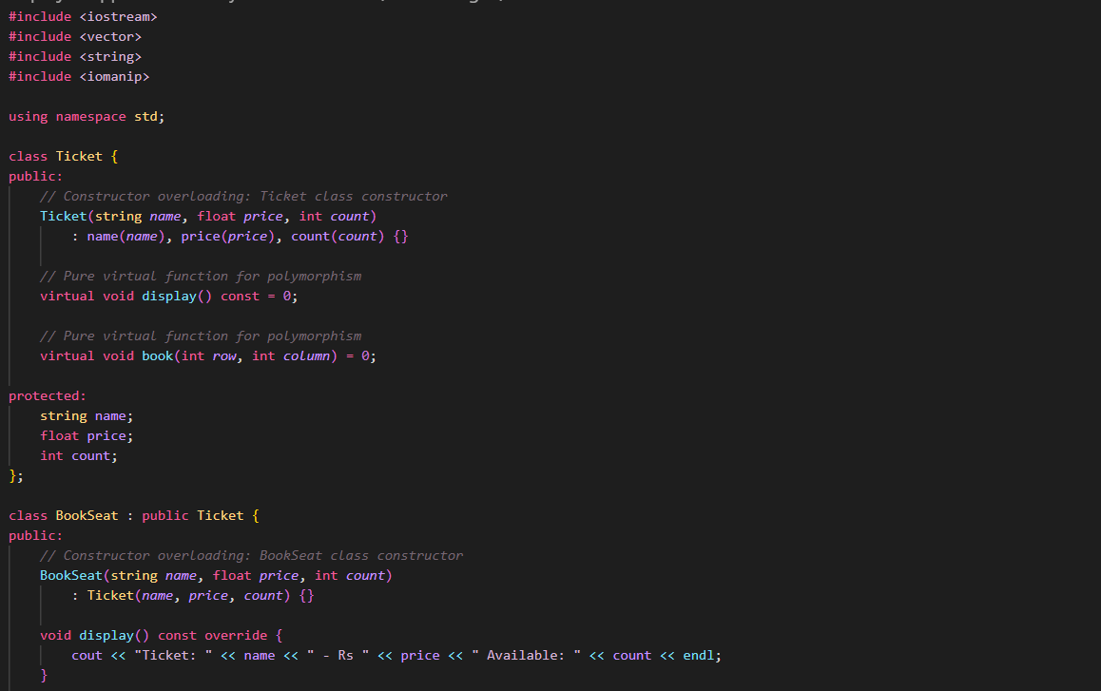

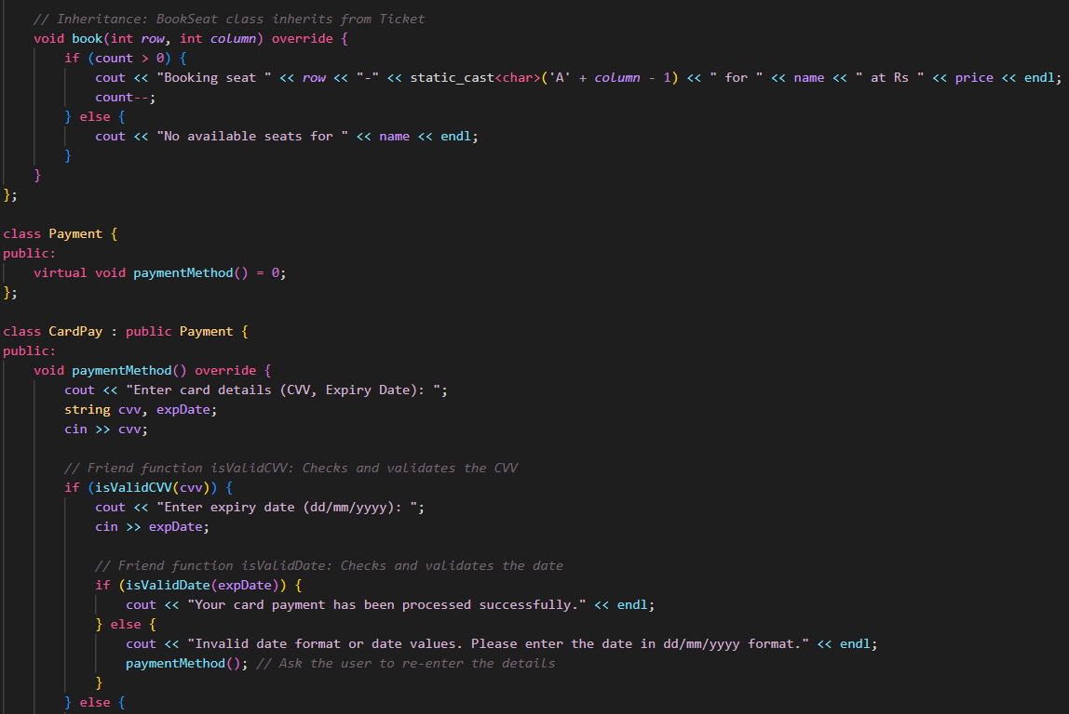

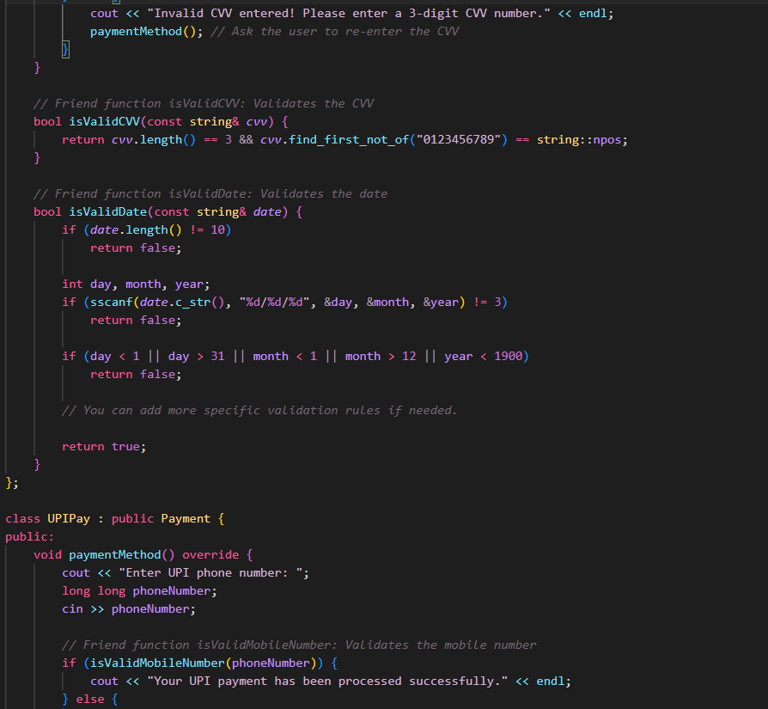

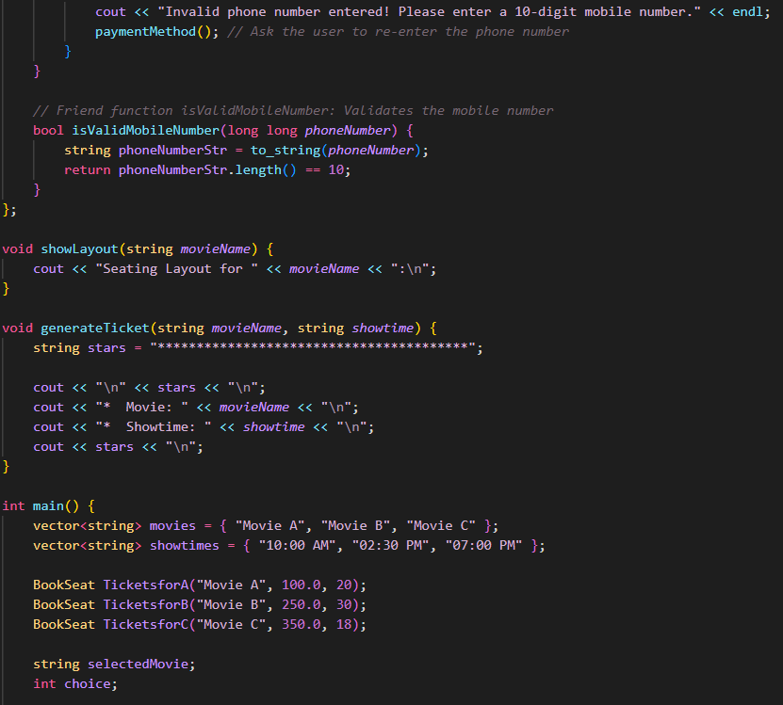

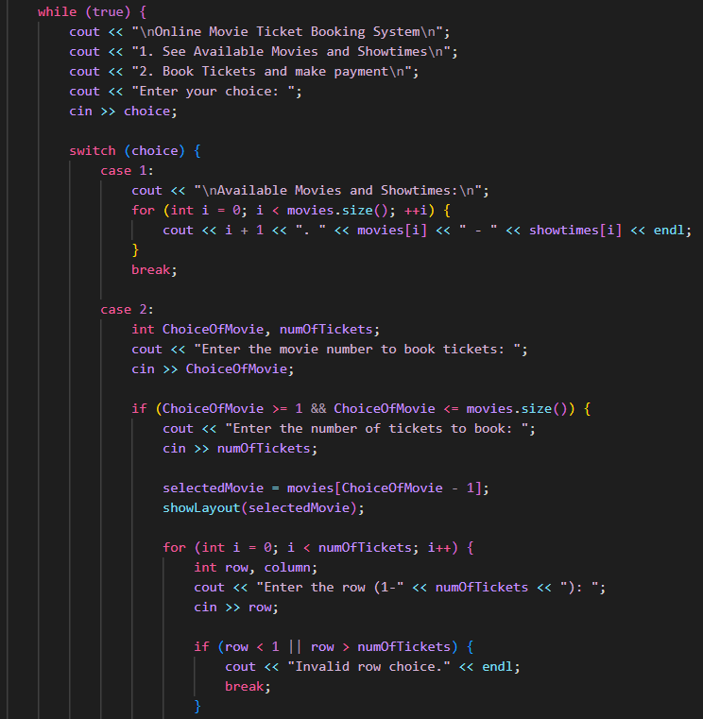

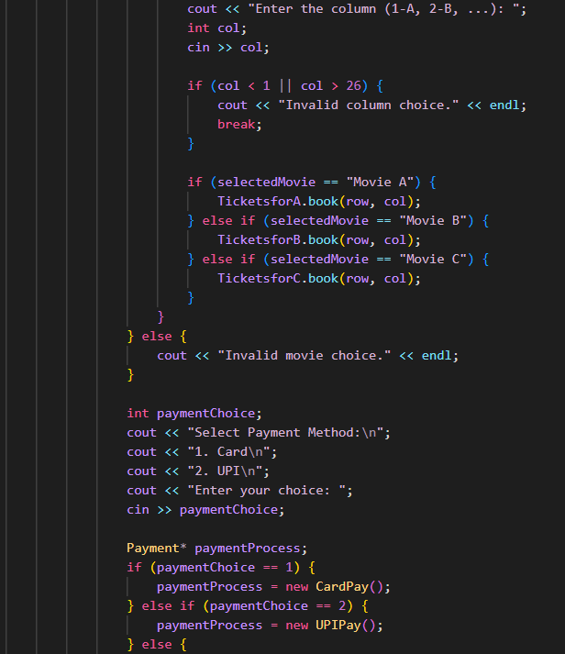

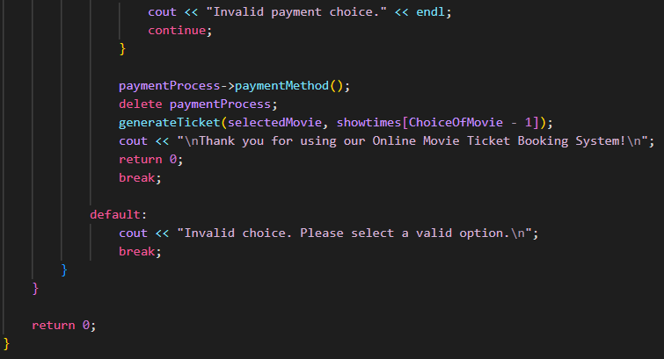

**Input/Output:**

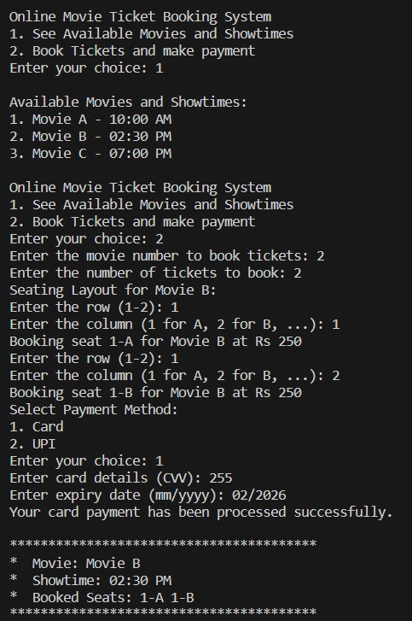

**Github repository link:**