CPE403 – Advanced Embedded Systems

# Design Assignment #5

DO NOT REMOVE THIS PAGE DURING SUBMISSION:

Name: Xianjie Cao

Email: [caox2@unlv.nevada.edu](mailto:caox2@unlv.nevada.edu)

Github Repository link (root): <https://github.com/c1029324620/Flat-White.git>

Youtube Playlist link (root): <https://www.youtube.com/playlist?list=PLY90fbcjLcrnosJGw9U__oC1jxRqwp8w8>

**Follow the submission guideline to be awarded points for this Assignment.**

Submit the following for all Assignments:

1. In the document, for each task submit the modified or included code (from the base code) with highlights and justifications of the modifications. Also include the comments. If no base code is provided, submit the base code for the first task only.
2. Create a private Github repository with a random name (no CPE/403, Lastname, Firstname). Place all labs under the root folder TIVAC, sub-folder named Assignment1, with one document and one video link file for each lab, place modified c files named as asng_taskxx.c.
3. If multiple c files or other libraries are used, create a folder asng1_t01 and place these files inside the folder.
4. The folder should have a) Word document (see template), b) source code file(s) with startup_ccs.c and other include files, c) text file with youtube video links (see template).
5. Submit the doc file in canvas before the due date. The root folder of the github assignment directory should have the documentation and the text file with youtube video links.
6. Organize your youtube videos as playlist under the name “cpe403”. The playlist should have the video sequence arranged as submission or due dates.
7. Only submit pdf documents. Do not forget to upload this document in the github repository and in the canvas submission portal.
8. Code for Tasks. for each task submit the modified or included code (from the base code) with highlights and justifications of the modifications. Also include the comments. If no base code is provided, submit the base code for the first task only. Use separate page for each task.

Collector main.c Code:

*****************************************************************************/

/******************************************************************************

Includes

*****************************************************************************/

**#include** <xdc/std.h>

**#include** <xdc/runtime/Error.h>

**#include** <xdc/runtime/System.h>

**#include** <ti/sysbios/BIOS.h>

**#include** <ti/sysbios/knl/Task.h>

**#include** <ioc.h>

**#include** "sys_ctrl.h"

**#include** "ti_drivers_config.h"

**#include** <inc/hw_ccfg.h>

**#include** <inc/hw_ccfg_simple_struct.h>

/* Header files required for the temporary idle task function */

**#include** <ti/drivers/Power.h>

**#include** <ti/drivers/power/PowerCC26XX.h>

**#include** <aon_rtc.h>

**#include** <prcm.h>

/* Header files required to enable instruction fetch cache */

**#include** <ti/sysbios/hal/Hwi.h>

**#include** "cpu.h"

**#include** "collector.h"

**#ifdef** NV_RESTORE

**#include** "macconfig.h"

**#ifdef** ONE_PAGE_NV

**#include** "nvocop.h"

**#else**

**#include** "nvocmp.h"

**#endif**

**#endif**

**#include** <string.h>

**#ifdef** OSAL_PORT2TIRTOS

**#include** "macTask.h"

**#include**"rom_jt_154.h"

**#else**

**#include** "api_mac.h"

**#include** "icall.h"

**#endif**

**#if** defined(RESET_ASSERT)

**#include** "csf.h"

**#endif**

**#ifndef** USE_DEFAULT_USER_CFG

**#include** "mac_user_config.h"

/* MAC user defined configuration */

macUserCfg_t macUser0Cfg[] = MAC_USER_CFG;

**#endif** /* USE_DEFAULT_USER_CFG */

**#ifndef** CUI_DISABLE

**#include** "cui.h"

**#endif**

**#ifdef** USE_ITM_DBG

**#include** "itm.h"

**#endif**

/******************************************************************************

Constants

*****************************************************************************/

/* Assert Reasons */

**#define** MAIN_ASSERT_MAC 3

**#define** MAIN_ASSERT_HWI_TIRTOS 4

**#define** RFC_MODE_BLE PRCM_RFCMODESEL_CURR_MODE1

**#define** RFC_MODE_IEEE PRCM_RFCMODESEL_CURR_MODE2

**#define** RFC_MODE_ANT PRCM_RFCMODESEL_CURR_MODE4

**#define** RFC_MODE_EVERYTHING_BUT_ANT PRCM_RFCMODESEL_CURR_MODE5

**#define** RFC_MODE_EVERYTHING PRCM_RFCMODESEL_CURR_MODE6

/* Extended Address offset in FCFG (LSB..MSB) */

**#define** EXTADDR_OFFSET 0x2F0

**#if** defined(DeviceFamily_CC13X2) || (DeviceFamily_CC26X2)

**#define** APP_TASK_STACK_SIZE 1536

**#else**

**#define** APP_TASK_STACK_SIZE 960

**#endif**

**#define** APP_TASK_PRIORITY 1

**#define** SET_RFC_MODE(mode) HWREG( PRCM_BASE + PRCM_O_RFCMODESEL ) = (mode)

/******************************************************************************

External Variables

*****************************************************************************/

**extern** ApiMac_sAddrExt_t ApiMac_extAddr;

/******************************************************************************

Global Variables

*****************************************************************************/

Task_Struct appTask; /* not static so you can see in ROV */

**static** uint8_t appTaskStack[APP_TASK_STACK_SIZE];

**#ifdef** OSAL_PORT2TIRTOS

**static** uint8_t _macTaskId;

**#endif**

/*

When assert happens, this field will be filled with the reason:

MAIN_ASSERT_HWI_TIRTOS or MAIN_ASSERT_MAC

*/

uint8 Main_assertReason = 0;

**#ifdef** NV_RESTORE

mac_Config_t Main_user1Cfg =

{ 0 };

**#endif**

/******************************************************************************

Local Variables

*****************************************************************************/

/* Used to check for a valid extended address */

**static** **const** uint8_t dummyExtAddr[] =

{ 0xFF, 0xFF, 0xFF, 0xFF, 0xFF, 0xFF, 0xFF, 0xFF };

**extern** **void** **Board_init**(**void**);

**#ifdef** NV_RESTORE

**#ifdef** ONE_PAGE_NV

/* NVOCOP load API pointers */

**static** **void** NVOCOP_loadApiPtrs(NVINTF_nvFuncts_t *pfn)

{

// Load caller's structure with pointers to the NV API functions

pfn->initNV = &NVOCOP_initNV;

pfn->compactNV = &NVOCOP_compactNV;

pfn->createItem = NULL;

pfn->deleteItem = &NVOCOP_deleteItem;

pfn->readItem = &NVOCOP_readItem;

pfn->writeItem = &NVOCOP_writeItem;

pfn->writeItemEx = NULL;

pfn->getItemLen = NULL;

}

**#endif**

**#endif**

/*!

* @brief Reads the IEEE extended MAC address from the CCFG

* @param addr - Extended address pointer

*/

**static** **inline** **void** **CCFGRead_IEEE_MAC**(ApiMac_sAddrExt_t addr)

{

uint32_t macAddr = (( HWREG(

CCFG_BASE + CCFG_O_IEEE_MAC_0 ) &

CCFG_IEEE_MAC_0_ADDR_M ) >>

CCFG_IEEE_MAC_0_ADDR_S );

**memcpy**(addr, (uint8_t *)&macAddr, (APIMAC_SADDR_EXT_LEN / 2));

macAddr = (( HWREG(

CCFG_BASE + CCFG_O_IEEE_MAC_1 ) &

CCFG_IEEE_MAC_1_ADDR_M ) >>

CCFG_IEEE_MAC_1_ADDR_S );

**memcpy**(addr + (APIMAC_SADDR_EXT_LEN / 2), (uint8_t *)&macAddr,

(APIMAC_SADDR_EXT_LEN / 2));

}

/*!

* @brief Fill in your own assert function.

*

* @param assertReason - reason: MAIN_ASSERT_HWI_TIRTOS or

* MAIN_ASSERT_MAC

*/

**void** **Main_assertHandler**(uint8_t assertReason)

{

Main_assertReason = assertReason;

**#if** defined(RESET_ASSERT)

Csf_assertInd(assertReason);

/* Pull the plug and start over */

SysCtrlSystemReset();

**#else**

Hwi_disable();

**while**(1)

{

/* Put you code here to do something if in assert */

}

**#endif**

}

/*!

* @brief Main task function

*

* @param a0 -

* @param a1 -

*/

Void **appTaskFxn**(UArg a0, UArg a1)

{

/* The following code encapsulated in TI_154STACK_FPGA flag is used for

* internal FPGA evaluation of the 15.4 Stack and should not be used with

* TI hardware platforms. */

**#ifdef** TI_154STACK_FPGA

/* FPGA build disables POWER constraints */

Power_setConstraint(PowerCC26XX_IDLE_PD_DISALLOW);

Power_setConstraint(PowerCC26XX_SB_DISALLOW);

IOCPortConfigureSet(IOID_20, IOC_PORT_RFC_GPO0, IOC_STD_OUTPUT);

IOCPortConfigureSet(IOID_18, IOC_PORT_RFC_GPI0, IOC_STD_INPUT);

// configure RF Core SMI Command Link

IOCPortConfigureSet(IOID_22, IOC_IOCFG0_PORT_ID_RFC_SMI_CL_OUT, IOC_STD_OUTPUT);

IOCPortConfigureSet(IOID_21, IOC_IOCFG0_PORT_ID_RFC_SMI_CL_IN, IOC_STD_INPUT);

**#endif**

**#ifndef** OSAL_PORT2TIRTOS

/* Initialize ICall module */

ICall_init();

**#endif**

/* Copy the extended address from the CCFG area */

CCFGRead_IEEE_MAC(ApiMac_extAddr);

/* Check to see if the CCFG IEEE is valid */

**if**(**memcmp**(ApiMac_extAddr, dummyExtAddr, APIMAC_SADDR_EXT_LEN) == 0)

{

/* No, it isn't valid. Get the Primary IEEE Address */

**memcpy**(ApiMac_extAddr, (uint8_t *)(FCFG1_BASE + EXTADDR_OFFSET),

(APIMAC_SADDR_EXT_LEN));

}

**#ifdef** NV_RESTORE

/* Setup the NV driver */

**#ifdef** ONE_PAGE_NV

NVOCOP_loadApiPtrs(&Main_user1Cfg.nvFps);

**#else**

NVOCMP_loadApiPtrs(&Main_user1Cfg.nvFps);

**#endif**

**if**(Main_user1Cfg.nvFps.initNV)

{

Main_user1Cfg.nvFps.initNV( NULL);

}

**#endif**

**#ifdef** OSAL_PORT2TIRTOS

/* Initialize the application */

Collector_init(_macTaskId);

**#else**

ICall_createRemoteTasks();

/* Initialize the application */

Collector_init();

**#endif**

/* Kick off application - Forever loop */

**while**(1)

{

Collector_process();

}

}

/*!

* @brief TIRTOS HWI Handler. The name of this function is set to

* M3Hwi.excHandlerFunc in app.cfg, you can disable this by

* setting it to null.

*

* @param excStack - TIROS variable

* @param lr - TIROS variable

*/

xdc_Void **Main_excHandler**(UInt *excStack, UInt lr)

{

/* User defined function */

Main_assertHandler(MAIN_ASSERT_HWI_TIRTOS);

}

/*!

* @brief HAL assert handler required by OSAL memory module.

*/

**void** **assertHandler**(**void**)

{

/* User defined function */

Main_assertHandler(MAIN_ASSERT_MAC);

}

/*!

* @brief "main()" function - starting point

*/

**int** **main**(**void**)

{

Task_Params taskParams;

**#ifndef** USE_DEFAULT_USER_CFG

macUser0Cfg[0].pAssertFP = assertHandler;

**#endif**

/*

Initialization for board related stuff such as LEDs

following TI-RTOS convention

*/

Board_init();

**#if** !defined(POWER_MEAS) && !defined(CUI_DISABLE)

/* Initialize CUI UART*/

CUI_params_t cuiParams;

**CUI_paramsInit**(&cuiParams);

**#ifdef** MT_CSF

cuiParams.manageUart = **false**;

**#endif** //MT_CSF

// One-time initialization of the CUI

// All later CUI_* functions will be ignored if this isn't called

**CUI_init**(&cuiParams);

**#endif**

**#ifdef** OSAL_PORT2TIRTOS

_macTaskId = macTaskInit(macUser0Cfg);

**#endif**

/* Configure task. */

Task_Params_init(&taskParams);

taskParams.stack = appTaskStack;

taskParams.stackSize = APP_TASK_STACK_SIZE;

taskParams.priority = APP_TASK_PRIORITY;

Task_construct(&appTask, appTaskFxn, &taskParams, NULL);

**#ifdef** USE_ITM_DBG

ITM_config itm_config =

{

48000000,

ITM_6000000

};

ITM_initModule(itm_config);

ITM_enableModule();

**#endif** /* USE_ITM_DBG */

BIOS_start(); /* enable interrupts and start SYS/BIOS */

**return** (0);

}

1. Block diagram and/or Schematics showing the components, pins used, and interface.

Components used: CC1352R1 Launch Pad and LPSTK, Code composer studio.

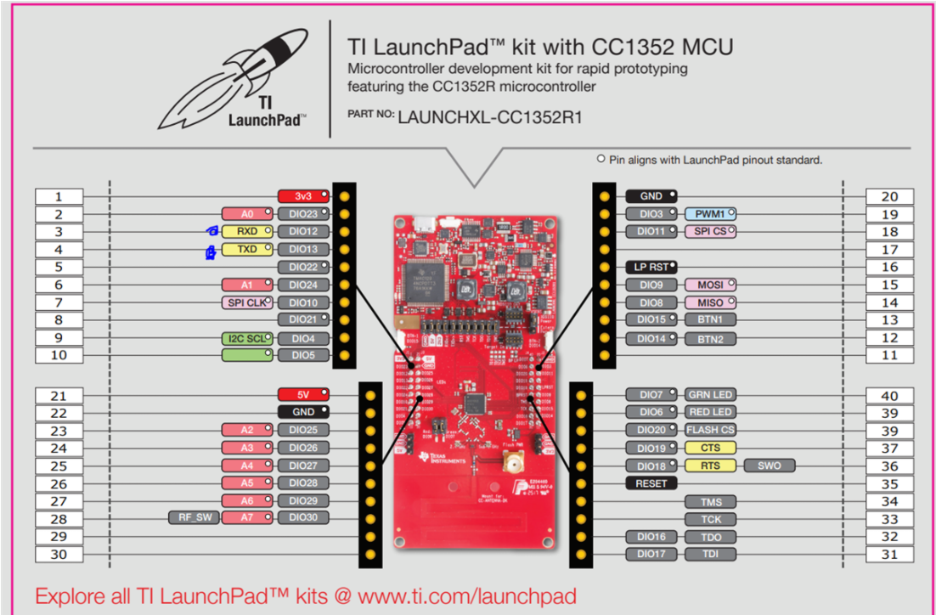

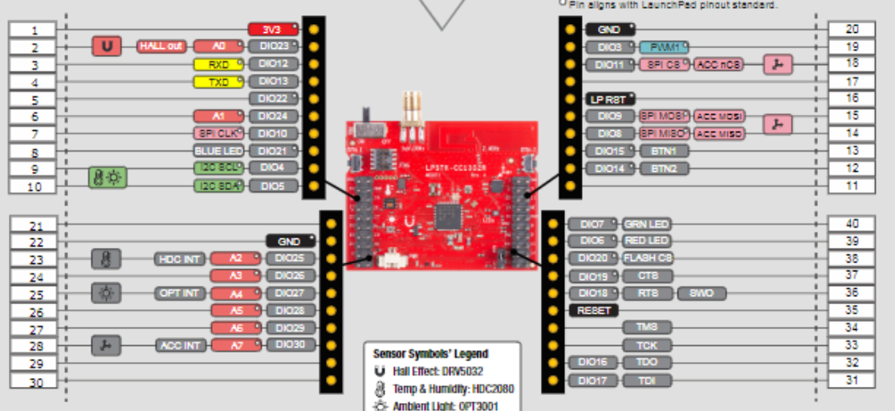

1. Screenshots of the IDE, physical setup, debugging process - Provide screenshot of successful compilation, screenshots of registers, variables, graphs, etc.

**LPSTK TI 15.4:**

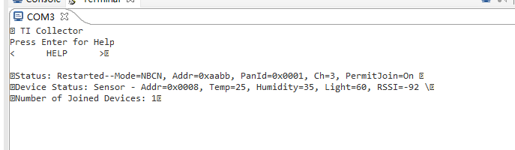

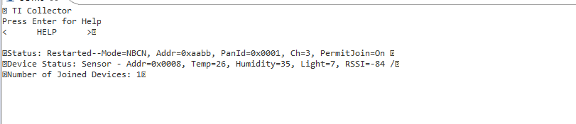

**Sensor and Collector – Project zero:**

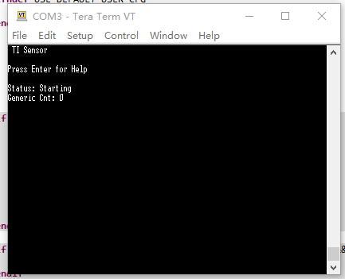

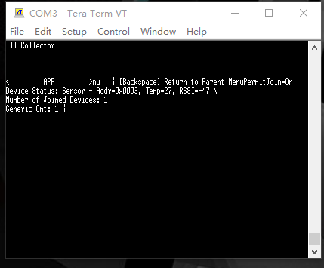

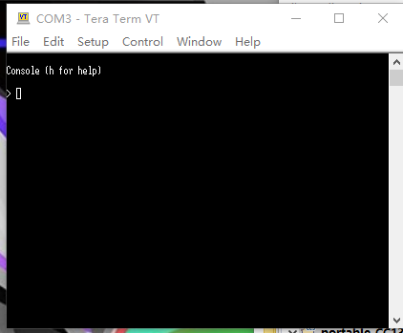

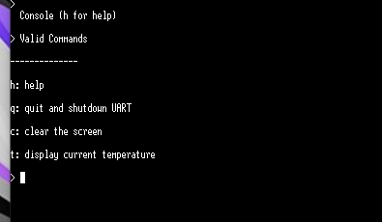

**Adding a New Sensor:**



1. Declaration

I understand the Student Academic Misconduct Policy - http://studentconduct.unlv.edu/misconduct/policy.html

“This assignment submission is my own, original work”.

Xianjie Cao