CPE403 – Advanced Embedded Systems

# Design Assignment 4

DO NOT REMOVE THIS PAGE DURING SUBMISSION:

Name: Xianjie Cao

Email: [Caox2@unlv.nevada.edu](mailto:Caox2@unlv.nevada.edu)

Github Repository link (root): <https://github.com/c1029324620/Flat-White.git>

Youtube Playlist link (root): <https://www.youtube.com/playlist?list=PLY90fbcjLcrnosJGw9U__oC1jxRqwp8w8>

**Follow the submission guideline to be awarded points for this Assignment.**

Submit the following for all Assignments:

1. In the document, for each task submit the modified or included code (from the base code) with highlights and justifications of the modifications. Also include the comments. If no base code is provided, submit the base code for the first task only.
2. Create a private Github repository with a random name (no CPE/403, Lastname, Firstname). Place all labs under the root folder TIVAC, sub-folder named Assignment1, with one document and one video link file for each lab, place modified c files named as asng_taskxx.c.
3. If multiple c files or other libraries are used, create a folder asng1_t01 and place these files inside the folder.
4. The folder should have a) Word document (see template), b) source code file(s) with startup_ccs.c and other include files, c) text file with youtube video links (see template).
5. Submit the doc file in canvas before the due date. The root folder of the github assignment directory should have the documentation and the text file with youtube video links.
6. Organize your youtube videos as playlist under the name “cpe403”. The playlist should have the video sequence arranged as submission or due dates.
7. Only submit pdf documents. Do not forget to upload this document in the github repository and in the canvas submission portal.
8. Code for Tasks. for each task submit the modified or included code (from the base code) with highlights and justifications of the modifications. Also include the comments. If no base code is provided, submit the base code for the first task only. Use separate page for each task.

/* XDC Module Headers */

**#include** <xdc/std.h>

**#include** <xdc/runtime/System.h>

**#include** <xdc/cfg/global.h>

/* BIOS Module Headers */

**#include** <ti/sysbios/BIOS.h>

**#include** <ti/sysbios/knl/Task.h>

**#include** <ti/sysbios/knl/Clock.h>

**#include** <ti/sysbios/knl/Semaphore.h>

**#include** <ti/drivers/Board.h>

**#include** <ti/drivers/GPIO.h>

**#include** <ti/drivers/ADC.h>

**#include** <ti/display/Display.h>

**#include** <ti/drivers/PWM.h>

**#include** <ti/drivers/Timer.h>

/* Driver configuration */

**#include** "ti_drivers_config.h"

uint16_t timerCNT = 0;

uint16_t adcValue;

ADC_Handle adc;

**static** Display_Handle display;

uint16_t pwmPeriod = 4096;

uint16_t duty = 0;

PWM_Handle pwm1 = NULL;

**void** **timerCallback**(Timer_Handle myHandle, int_fast16_t status)

{

timerCNT++;

**if**(timerCNT == 5)

{

Semaphore_post(semHandle);

}

**if**(timerCNT == 10)

{

Semaphore_post(semHandle1);

}

**if**(timerCNT == 15)

{

Semaphore_post(semHandle2);

timerCNT = 0;

}

}

**void** **heartBeatFxN**(UArg arg0, UArg arg1)

{

**while**(1)

{

**GPIO_write**(CONFIG_GPIO_LED_0, CONFIG_LED_OFF);

Task_sleep(500*(1000/Clock_tickPeriod));

**GPIO_write**(CONFIG_GPIO_LED_0, CONFIG_LED_ON);

Task_sleep(500*(1000/Clock_tickPeriod));

}

}

**void** **adcFxN**(UArg arg0, UArg arg1)

{

**while**(1){

Semaphore_pend(semHandle, BIOS_WAIT_FOREVER);

**ADC_convert**(adc, &adcValue);

//Semaphore_post(semHandle);

Task_sleep(500*(1000/Clock_tickPeriod));

}

}

**void** **displayFxN**(UArg arg0, UArg arg1)

{

**while**(1){

Semaphore_pend(semHandle1, BIOS_WAIT_FOREVER);

Display_printf(display, 1, 0, "ADC Value: %d\n", adcValue);

// Semaphore_post(semHandle1);

Task_sleep(500*(1000/Clock_tickPeriod));

}

}

**void** **pwmFxN**(UArg arg0, UArg arg1)

{

**while**(1){

Semaphore_pend(semHandle2, BIOS_WAIT_FOREVER);

duty = adcValue;

**PWM_setDuty**(pwm1, duty);

Display_printf(display, 1, 0, "PWM duty cycle: %d\n", duty);

//Semaphore_post(semHandle);

Task_sleep(500*(1000/Clock_tickPeriod));

}

}

/*

* ======== main ========

*/

**int** **main**()

{

/* Call driver init functions */

Board_init();

**GPIO_init**();

**ADC_init**();

**PWM_init**();

Display_init();

**Timer_init**();

Timer_Handle timer0;

Timer_Params timerParams;

/*

* Setting up the timer in continuous callback mode that calls the callback

* function every 1000 microseconds or 1ms.

*/

**Timer_Params_init**(&timerParams);

timerParams.period = 1000;

timerParams.periodUnits = *Timer_PERIOD_US*;

timerParams.timerMode = *Timer_CONTINUOUS_CALLBACK*;

timerParams.timerCallback = timerCallback;

timer0 = **Timer_open**(CONFIG_TIMER_0, &timerParams);

**if** (timer0 == NULL) {

// Failed to initialized timer

Display_printf(display, 0, 0, "Error initializing CONFIG_TIMER_0\n");

**while** (1);

}

**if** (**Timer_start**(timer0) == Timer_STATUS_ERROR) {

// Failed to start timer

Display_printf(display, 0, 0, "Error to start timer\n");

**while** (1);

}

ADC_Params adcParams;

// int_fast16_t res;

**ADC_Params_init**(&adcParams);

adc = **ADC_open**(CONFIG_ADC_0, &adcParams);

**if**(adc == NULL) {

Display_printf(display, 0, 0, "Error initializing CONFIG_ADC_0\n");

**while**(1);

}

display = Display_open(Display_Type_UART, NULL);

**if** (display == NULL) {

/* Failed to open display driver */

**while** (1);

}

PWM_Params pwmParams;

**PWM_Params_init**(&pwmParams);

pwmParams.dutyUnits = *PWM_DUTY_US*;

pwmParams.dutyValue = 0;

pwmParams.periodUnits = *PWM_PERIOD_US*;

pwmParams.periodValue = pwmPeriod;

pwm1 = **PWM_open**(CONFIG_PWM_0, &pwmParams);

**if** (pwm1 == NULL) {

/* CONFIG_PWM_0 did not open */

Display_printf(display, 0, 0, "Error initializing CONFIG_PWM_0\n");

**while** (1);

}

**PWM_start**(pwm1);

/*

* normal BIOS programs, would call BIOS_start() to enable interrupts

* and start the scheduler and kick BIOS into gear. But, this program

* is a simple sanity test and calls BIOS_exit() instead.

*/

BIOS_start(); /* terminates program and dumps SysMin output */

**ADC_close**(adc);

**return**(0);

}

/*

* ======== myDelay ========

* Assembly function to delay. Decrements the count until it is zero

* The exact duration depends on the processor speed.

*/

**__asm**(" .sect \".text:myDelay\"\n"

" .clink\n"

" .thumbfunc myDelay\n"

" .thumb\n"

" .global myDelay\n"

"myDelay:\n"

" subs r0, #1\n"

" bne.n myDelay\n"

" bx lr\n");

1. Block diagram and/or Schematics showing the components, pins used, and interface.

Components used: CC1352R, BoosterPack MKII, jump wires, code composer studio.

Pins used: 3.3V, GND, DIO23 (ADC), DIO7 (green LED), DIO6 (red LED), DIO12 and DIO13 (UART).

Interface: UART, ADC, PWM.

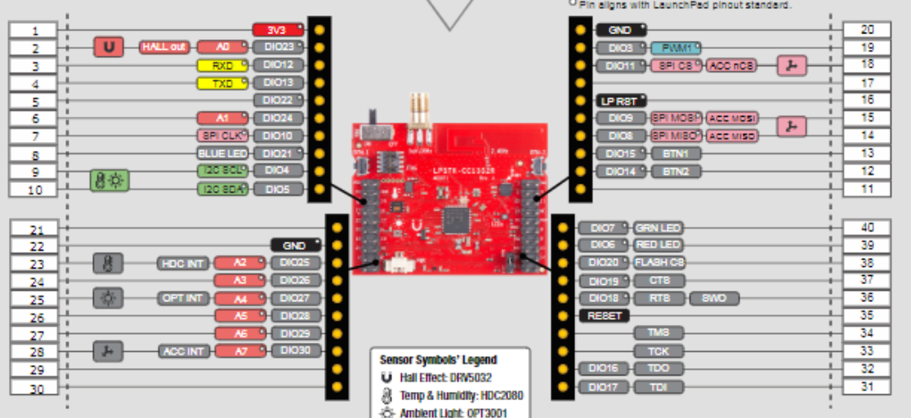

1. Screenshots of the IDE, physical setup, debugging process - Provide screenshot of successful compilation, screenshots of registers, variables, graphs, etc.

Board setup:

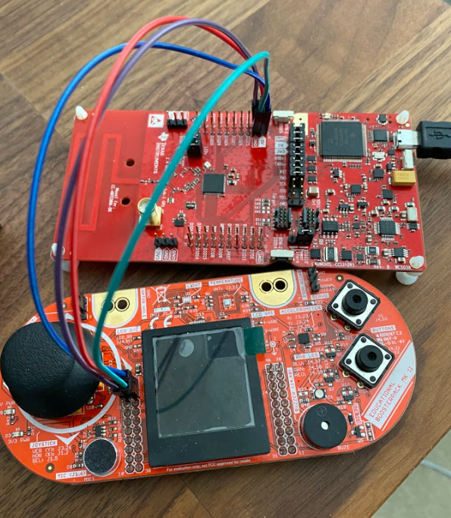

Successful compilation:

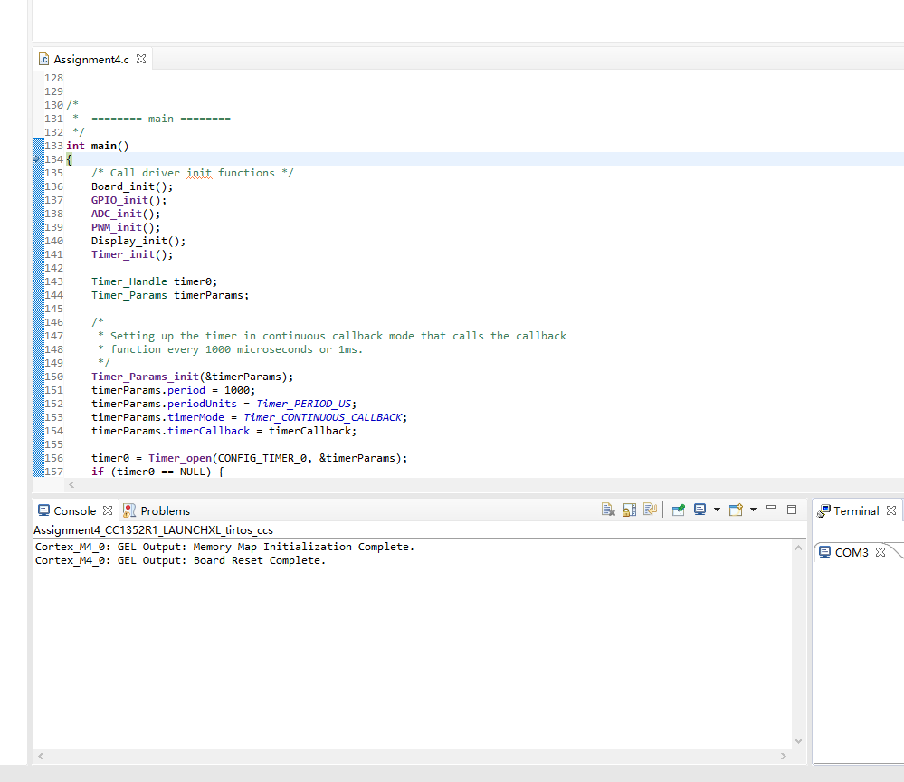

Output:

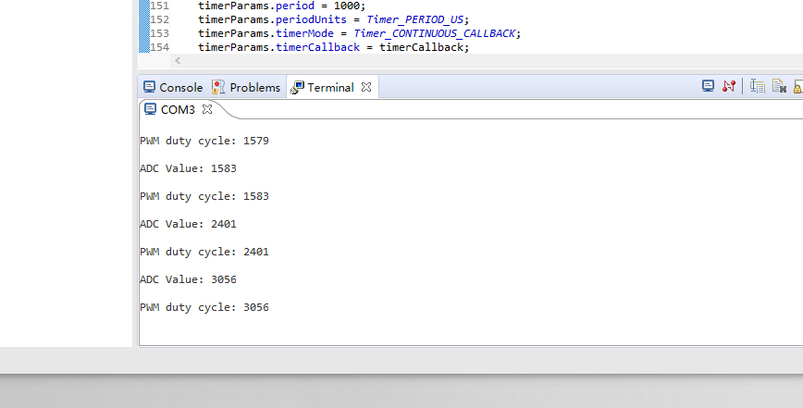



1. Declaration

I understand the Student Academic Misconduct Policy - http://studentconduct.unlv.edu/misconduct/policy.html

“This assignment submission is my own, original work”.

Xianjie Cao