CPE301 – SPRING 2020

Design Assignment 1

Student Name: Xianjie Cao

Student #: 5004222179

Student Email: [caox2@unlv.nevada.edu](mailto:caox2@unlv.nevada.edu)

Primary Github address: <https://github.com/c1029324620/Mocha.git>

Directory: Mocha/DesignAssignments/LAB1/DA1A

1. **COMPONENTS LIST AND CONNECTION BLOCK DIAGRAM w/ PINS**

Atmel Studio 7, Assembly language and Github.

1. **INITIAL/MODIFIED/DEVELOPED CODE OF TASK 1/A**

;

; main.asm

;

; Created: 2/10/2020 9:47:52 PM

; Author : c1029

;

; Replace with your application code

.include "m328pdef.inc"

.org 0x00

.cseg

start:

;initialize the multiplicand with value of 0x5432FFFF

ldi r16, 0xFF

ldi r17, 0xFF

ldi r18, 0x32

ldi r19, 0x54

;initialize the multiplier with value of 0x0010FF99

ldi r20, 0x99

ldi r21, 0xFF

ldi r22, 0x10

ldi r23, 0x00

cpi r20, 0x00 ;if the lowest word is zeron, jump if it is, and borrow from next higher reigers

breq borrow

LP_add:

add r24, r16 ; r24 = r24 + r16

adc r25, r17 ; add with carry

adc r26, r18 ; add with carry

adc r27, r19 ; add with carry

brcc LP_r20 ; if there is no carry, jump to LP_r20, which will decrement the r20 register.

inc r28 ; add the carry to the r28 register

cpi r28, 0x00 ; compare r28 with 0x00, in other word, if r28 become larger than 0xFF or there is carry produced

brne LP_r20 ; jump to LP_r20 if there is no carry

inc r29 ; increment r29 when there is carry

cpi r29, 0x00 ; if a carry is produced

brne LP_r20 ; jump to LP_r20 if there is no carry

inc r30 ; increment r30 when there is carry

cpi r30, 0x00 ; if a carry is produced

brne LP_r20 ; jump if there is no carry

inc r31 ; increment r31 if there is a carry.

LP_r20:

dec r20 ; decrement the r20

brne LP_add ; jump if r20 equal to zero

borrow:

dec r21 ; borrow from r21, and decrement the r21,

cpi r21, 0xFF ; if r21 is equal to 0xFF implies that no more borrow from r21,

brne LP_add ; jump to LP_add

dec r22 ; borrow from r22, and decrement the r22, if it is equal to 0xff, no more borrow are allow

cpi r22, 0xFF

brne LP_add

dec r23 ; no more borrows are allow when r23 is equal to 0xFF

cpi r23, 0xFF

brne LP_add

DONE:

jmp DONE ; program end

1. **DEVELOPED MODIFIED CODE OF TASK 2/A from TASK 1/A**

**Code using ‘MUL’ to verify the result:**

.include "m328pdef.inc"

.org 0x00

.cseg

start:

;initialize the multiplicand with value of 0x5432FFFF

ldi r16, 0xFF

ldi r17, 0xFF

ldi r18, 0x32

ldi r19, 0x54

;initialize the multiplier with value of 0x0010FF99

ldi r20, 0x99

ldi r21, 0xFF

ldi r22, 0x10

ldi r23, 0x00

mul r16, r20 ;r1:r0 = r16 * r20.

mov r24, r0 ;move result into r25:r24

mov r25, r1

mul r17, r20 ;r1:r0 = r16 * r20

add r25, r0 ;combine products

adc r26, r1 ;add with carry

adc r27, r2 ; add zero and with carrry

mul r18, r20 ;r1:r0 = r16 * r20

add r26, r0 ;combine products

adc r27, r1 ;add with carry

adc r28, r2 ;add zero and with carry

mul r19, r20

add r27, r0 ;combine products

adc r28, r1 ;add with carry

adc r29, r2 ;add zero and with carry

mul r16, r21

add r25, r0

adc r26, r1

adc r27, r2 ; adding carry with zero

mul r17, r21

add r26, r0 ;combine products

adc r27, r1

adc r28, r2

mul r18, r21

add r27, r0 ;combine products

adc r28, r1

adc r29, r2

mul r19, r21

add r28, r0 ;combine products

adc r29, r1

adc r30, r2

mul r16, r22

add r26, r0 ;combine products

adc r27, r1

adc r28, r2

mul r17, r22

add r27, r0 ;combine products

adc r28, r1

adc r29, r2

mul r18, r22

add r28, r0 ;combine products

adc r29, r1

adc r30, r2

mul r19, r22

add r29, r0 ;combine products

adc r30, r1

adc r31, r2

mul r16, r23

add r27, r0 ;combine products

adc r28, r1

adc r29, r2

mul r17, r23

add r28, r0 ;combine products

adc r29, r1

adc r30, r2

mul r18, r23

add r29, r0 ;combine products

adc r30, r1

adc r31, r2

mul r19, r23

add r30, r0 ;combine products

adc r31, r1

DONE:

jmp DONE ;program ends

**The C++ code to verify the result:**

#include <iostream>

using namespace std;

int main()

{

long long int x = 0x5432FFFF;

long long int y = 0x0010FF99;

long long int z = x * y;

cout << hex << z << endl;

return 0;

}

1. **SCHEMATICS**

Does not apply.

1. **SCREENSHOTS OF EACH TASK OUTPUT (ATMEL STUDIO OUTPUT)**

Program starts:

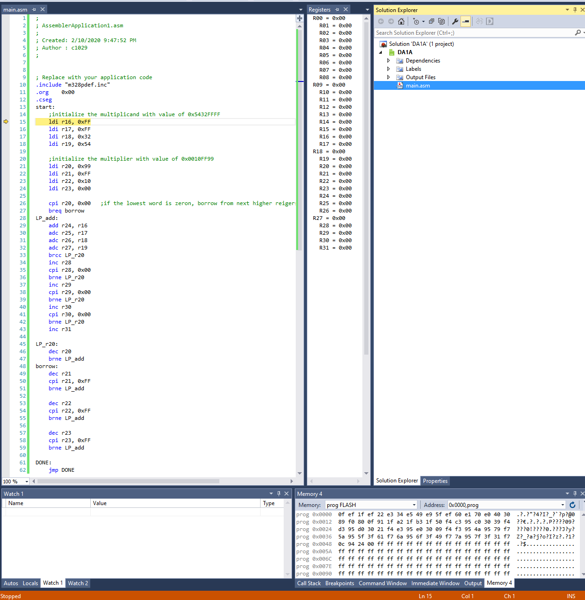

End of the program:

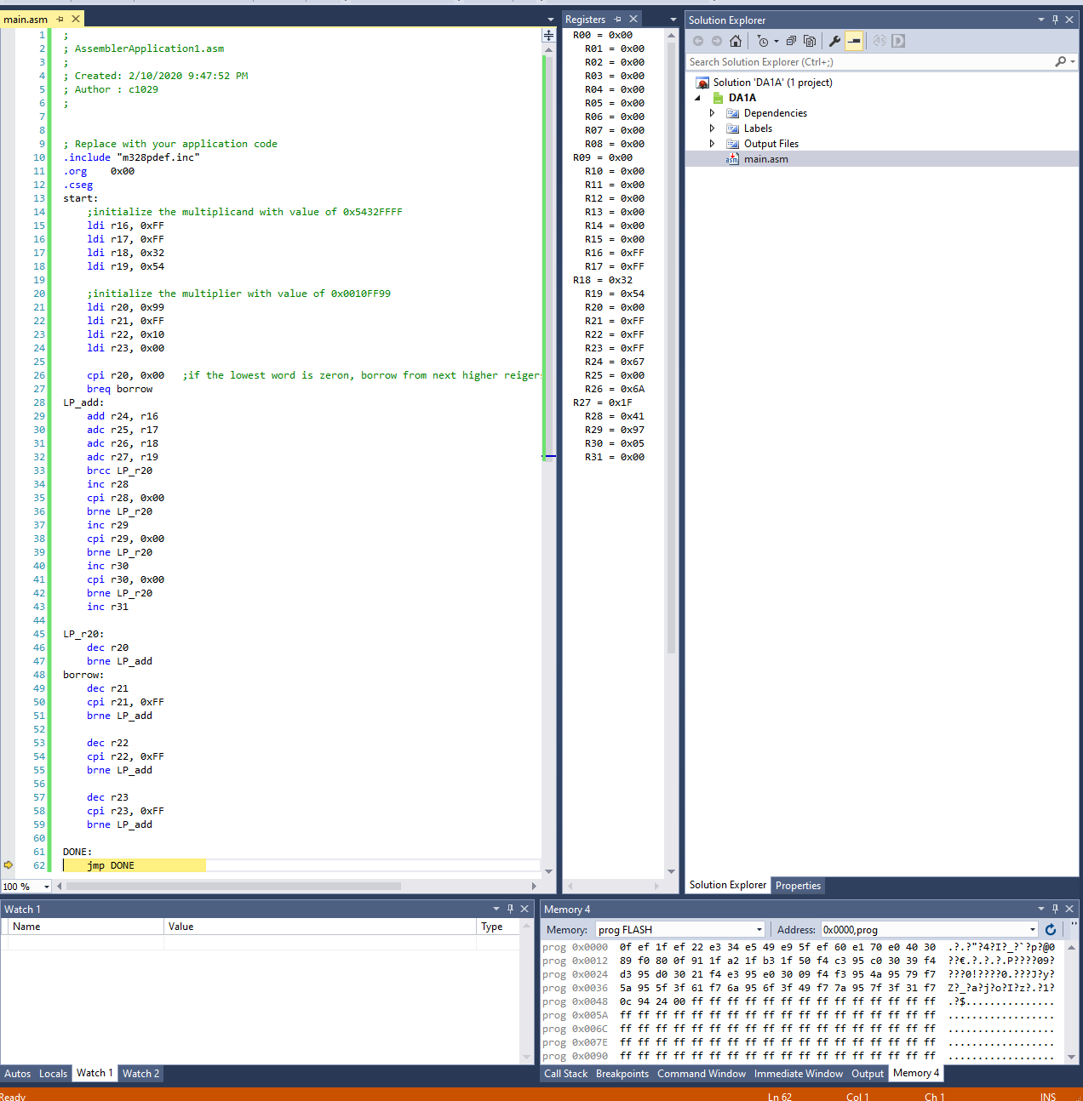

The execution time, clock cycles at 16MHz

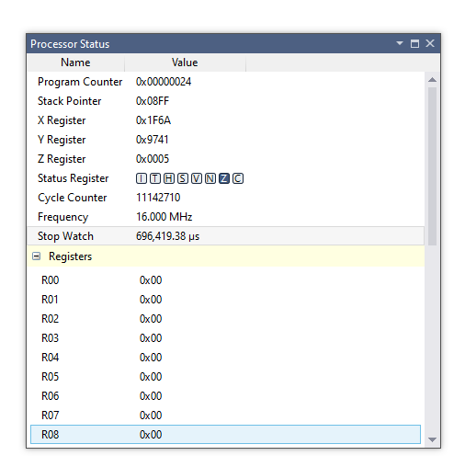

1. **SCREENSHOT OF EACH DEMO (BOARD SETUP)**

Does not applied.

1. **VIDEO LINKS OF EACH DEMO**

<https://youtu.be/OmepHgoZ8pc>

1. **GITHUB LINK OF THIS DA**

[ttps://github.com/c1029324620/Mocha.git](https://github.com/c1029324620/Mocha.git)

**Student Academic Misconduct Policy**

<http://studentconduct.unlv.edu/misconduct/policy.html>

“This assignment submission is my own, original work”.

Xianjie Cao