CPE301 – SPRING 2020

Design Assignment 2B

Student Name: Xianjie Cao

Student #: 5004222179

Student Email: [caox2@unlv.nevada.edu](mailto:caox2@unlv.nevada.edu)

Primary Github address: <https://github.com/c1029324620/Mocha.git>

Directory: Mocha/DesignAssignments/LAB2/DA2B

1. **COMPONENTS LIST AND CONNECTION BLOCK DIAGRAM w/ PINS**

Atmel Studio 7: Simulator, Debugger, and Assembler

Atmega328PB-Xmini PC

Multi-function Shield: Switch, LED

Jump wire

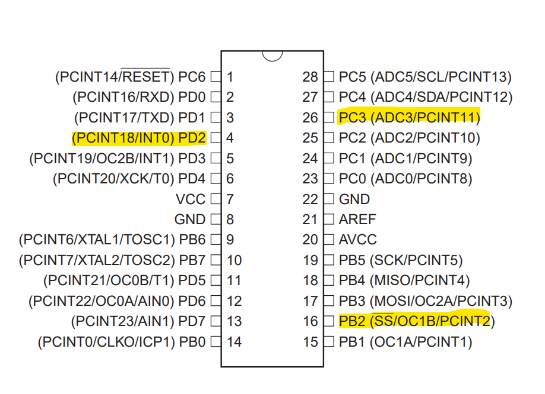

1. **INITIAL/MODIFIED/DEVELOPED CODE OF TASK 1/A**

**Assembly Code for Task 1:**

;

; DA2B.asm

;

; Created: 2/27/2020 11:41:16 AM

; Author : c1029

;

; Replace with your application code

.include <m328pbdef.inc>

.org 0 ;location for reset

jmp MAIN

.org 0x02 ;location for external interrupt 0

jmp EX0_ISR

MAIN:

ldi r20, HIGH(RAMEND)

out SPH, r20

ldi r20, LOW(RAMEND)

out SPL, r20 ;initialize stack

cbi DDRC, 3 ;set PORTC.3 as input

sbi PORTC, 3 ;pull-up activated

ldi r16, 0x04;set PORTB as output

out DDRB, r16 ;set PORTB.2 as output

sbi PORTB, 2 ;initially, set LED off

ldi r20, 0x02 ;make INT0 falling edge triggred

STS EICRA, r20

ldi r20, 1<<INT0 ;enable INT0

out EIMSK, r20 ;set the bit 0 in the external interrupt mask.

sei

HERE:

jmp HERE

EX0_ISR:

cbi PORTB, 2 ;this will turn LED on

delay_2sec: ;delay for 2 sec at 16M Hz

ldi r18, 163

ldi r19, 87

ldi r20, 3

L1: dec r20

brne L1

dec r19

brne L1

dec r18

brne L1

sbi PORTB, 2 ;this will turn LED off again

reti

C Code for Task 1:

/*

* DA2B_C.c

*

* Created: 2/27/2020 12:33:59 PM

* Author : c1029

*/

#define *F_CPU* 16000000UL

#include <avr/io.h>

#include <util//delay.h>

#include <avr/interrupt.h>

int main(void)

{

DDRB |= (1 << 2); //set PORTB.2 as output.

PORTB |= (1 << 2);

DDRC &= (0 << 3); //set PORTC.3 as input.

PORTC |= (1 << 3); //enable pull-up

EICRA = 0x02; //make INT0 falling edge triggered

EIMSK = (1<<INT0); //enable external interrupt 0

sei();

/* Replace with your application code */

while (1)

{

}

}

ISR(INT0_vect)

{

PORTB &= ~(1 << 2); //turn LED on

*_delay_ms*(2000); //for 2 seconds

PORTB |= (1<< 2); //then turn it off

}

1. **DEVELOPED MODIFIED CODE OF TASK 2/A from TASK 1/A**

N/A

1. **SCHEMATICS**

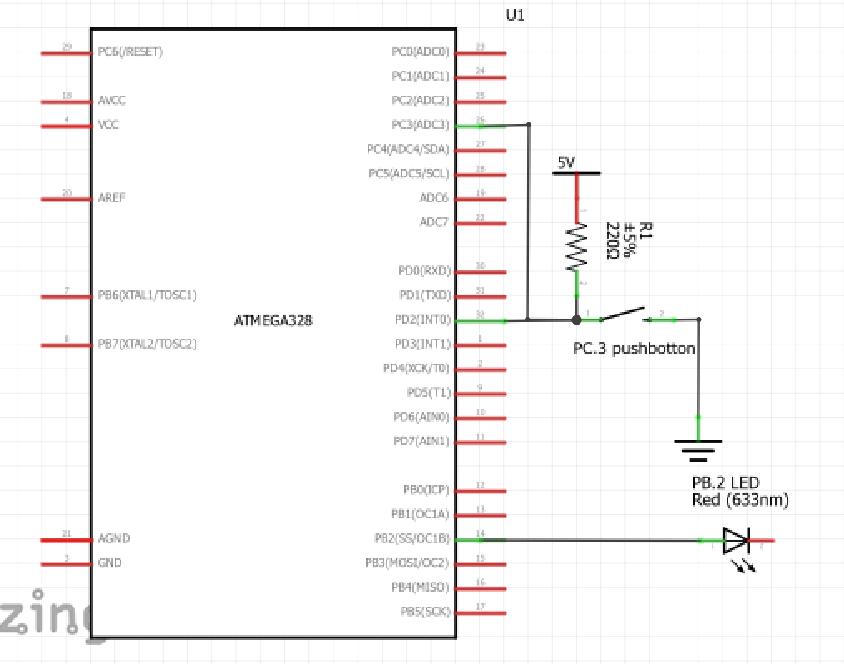

1. **SCREENSHOTS OF EACH TASK OUTPUT (ATMEL STUDIO OUTPUT)**

N/A

1. **SCREENSHOT OF EACH DEMO (BOARD SETUP)**

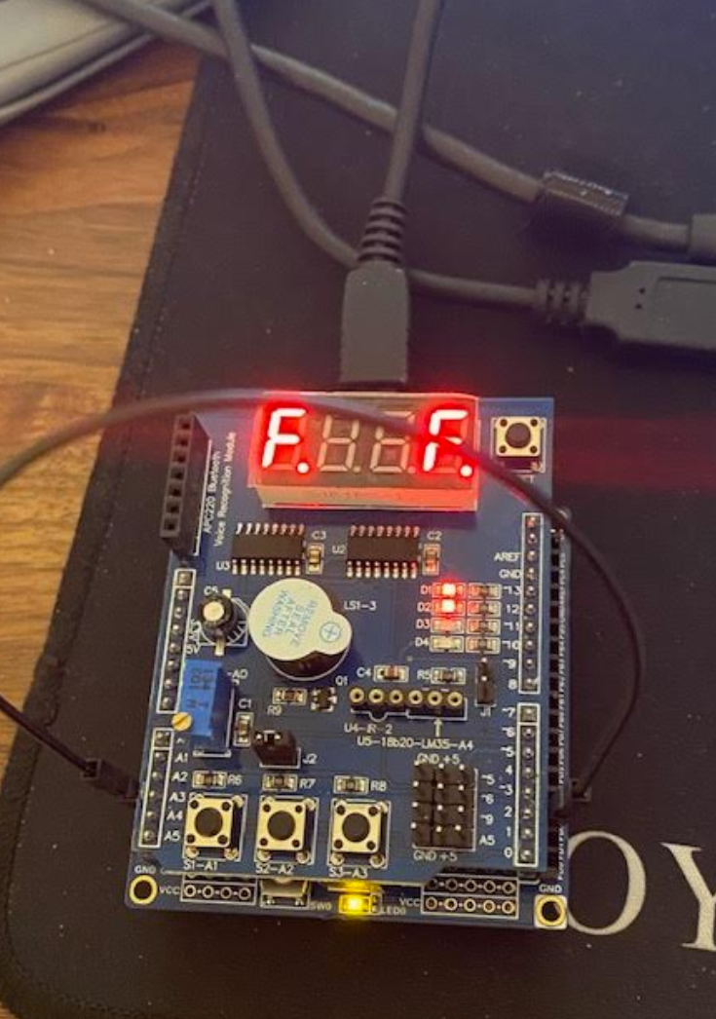 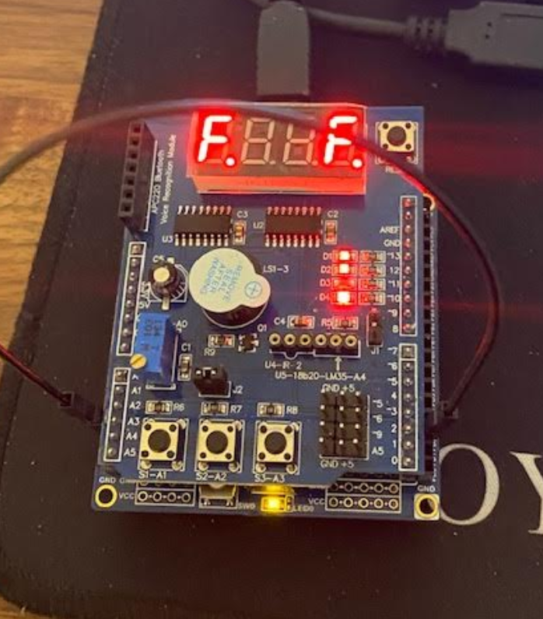

1. **VIDEO LINKS OF EACH DEMO**

Assembly: <https://youtu.be/33MUaCYDHhg>

C: <https://youtu.be/6jQyICiEk1w>

1. **GITHUB LINK OF THIS DA**

<https://github.com/c1029324620/Mocha/tree/master/DesignAssignments/LAB2>

**Student Academic Misconduct Policy**

<http://studentconduct.unlv.edu/misconduct/policy.html>

“This assignment submission is my own, original work”.

Xianjie Cao