CPE301 – SPRING 2020

Design Assignment 3A

Student Name: Xianjie Cao

Student #: 5004222179

Student Email: caox2@unlv.nevada.edu

Primary Github address: <https://github.com/c1029324620/Mocha.git>

Directory: Mocha/DesignAssignments/LAB3/DA3A

1. **COMPONENTS LIST AND CONNECTION BLOCK DIAGRAM w/ PINS**

Atmel Studio 7: Debugger, Simulator and Assembler

Atmega328PB Xmini PC.

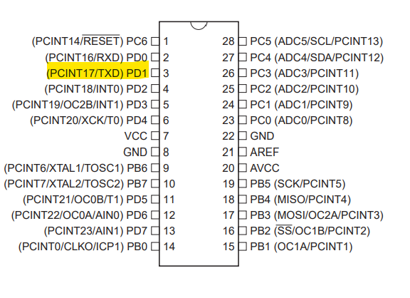

1. **INITIAL/MODIFIED/DEVELOPED CODE OF TASK 1/A**

**Task 1 C code:**

/*

* DA3AT1.c

*

* Created: 3/9/2020 8:21:24 PM

* Author : c1029

*/

#define *F_CPU* 16000000UL

#define BAUD 9600

#include <avr/io.h>

#include <util/setbaud.h>

#include <stdlib.h>

#include <stdio.h>

#include <util\delay.h>

#include <time.h>

void USART_init(void)

{

UBRR0H = *UBRRH_VALUE*;

UBRR0L = *UBRRL_VALUE*;

UCSR0C = _BV(UCSZ01) | _BV(UCSZ00); //8-bit data

UCSR0B = _BV(TXEN0); //enable transmitter

}

//send some data to the serial port

void USART_tx_string(char* data)

{

while((*data !='\0'))

{

while(!(UCSR0A & (1<<UDRE0)));

UDR0 = *data;

data++;

}

}

int main(void)

{

*srand*(*time*(*NULL*)); //random number generator seed

char String[] = "Hello World!!"; //string

char array1[16]; //used for converting integer to string

char array2[16]; //used for converting float to string

USART_init(); //initialized USART

while (1)

{

int rand_num = *rand*(); //assign random integer number

*itoa*(rand_num, array1, 10); //convert to string

float float_point = rand_num * 0.5; //assign random floating point number

*sprintf*(array2,"%f", float_point); //convert to string

//send strings to serial port and print.

USART_tx_string(String);

USART_tx_string(" ");

USART_tx_string(array1);

USART_tx_string(" ");

USART_tx_string(array2);

USART_tx_string("\n");

*_delay_ms*(1000);

}

}

1. **DEVELOPED MODIFIED CODE OF TASK 2/A from TASK 1/A**

**Task 2 C code:**

/*

* DA3AT2.c

*

* Created: 3/9/2020 12:15:24 AM

* Author : c1029

*/

#define *F_CPU* 16000000UL

#define BAUD 9600

#include <avr/io.h>

#include <util/setbaud.h>

#include <stdlib.h>

#include <stdio.h>

#include <util\delay.h>

#include <time.h>

#include <avr/interrupt.h>

volatile *uint8_t* overflow_cnt;

void set_inter()

{

TCCR0A = 0x00; //normal mode

TCCR0B = 0x05; //prescaler 1024

TCNT0 = 0x00;

TIMSK0 = (1<< TOIE0); //enable timer interrupt

sei(); //enable global interrupt

}

void USART_init(void)

{

UBRR0H = *UBRRH_VALUE*;

UBRR0L = *UBRRL_VALUE*;

UCSR0C = _BV(UCSZ01) | _BV(UCSZ00); //8-bit data

UCSR0B = _BV(TXEN0); //enable receiver and transmitter

}

//send some data to the serial port

void USART_tx_string(char* data)

{

while((*data !='\0'))

{

while(!(UCSR0A & (1<<UDRE0)));

UDR0 = *data;

data++;

}

}

int main(void)

{

USART_init(); //initialized USART

set_inter();

*srand*(*time*(*NULL*)); //random number generator seed

char String[] = "Hello World!!"; //string

char array1[16]; //used for converting integer to string

char array2[16]; //used for converting float to string

while (1)

{

if(overflow_cnt > 61) //16MHz / 1024 / 255 = 61, delay of 1 second.

{

int rand_num = *rand*(); //assign random integer number

*itoa*(rand_num, array1, 10); //convert to string

float float_point = rand_num * 0.5; //assign random floating point number

*sprintf*(array2,"%f", float_point); //convert to string

//send strings to serial port and print.

USART_tx_string(String);

USART_tx_string(" ");

USART_tx_string(array1);

USART_tx_string(" ");

USART_tx_string(array2);

USART_tx_string("\n");

overflow_cnt = 0;

}

}

}

ISR(TIMER0_OVF_vect)

{

overflow_cnt++;

}

1. **SCHEMATICS**

N/A

1. **SCREENSHOTS OF EACH TASK OUTPUT (ATMEL STUDIO OUTPUT)**

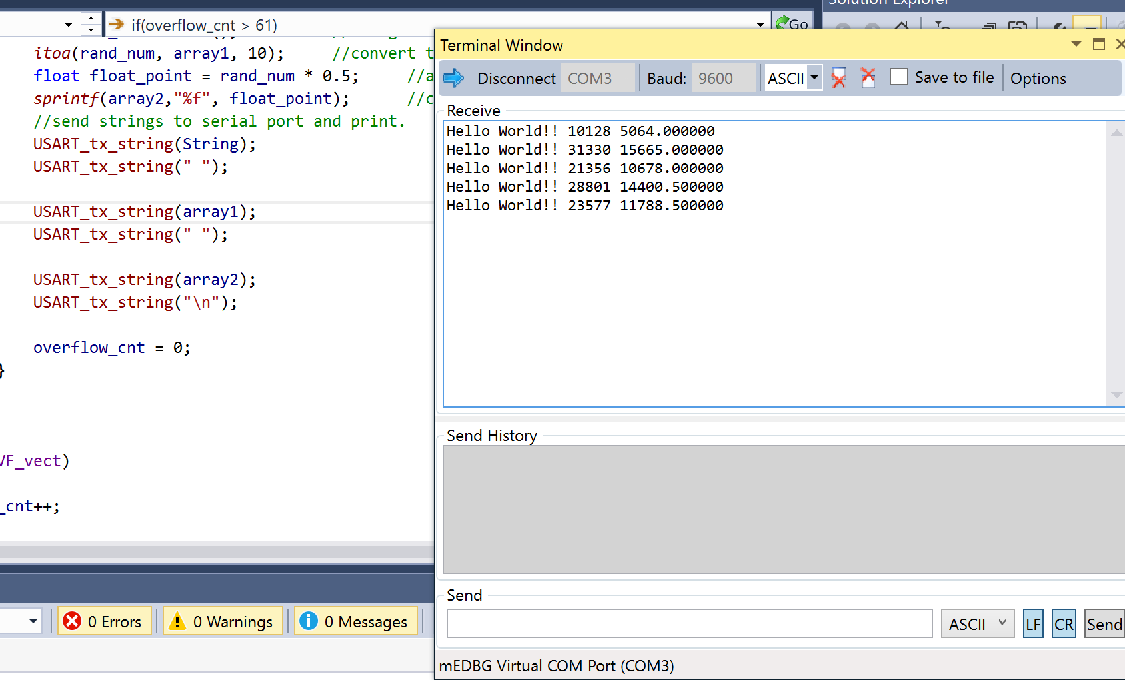

1. **SCREENSHOT OF EACH DEMO (BOARD SETUP)**

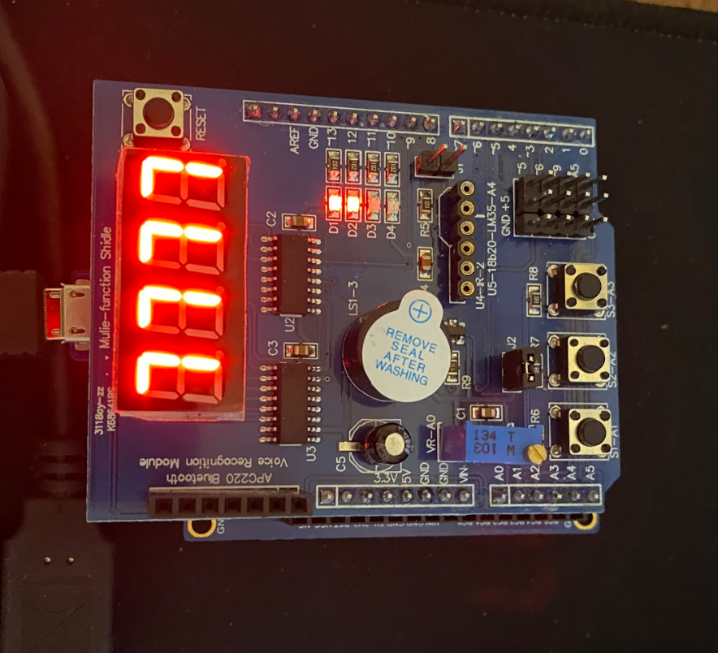

1. **VIDEO LINKS OF EACH DEMO**

Video: <https://youtu.be/hNATh1LkhmQ>

1. **GITHUB LINK OF THIS DA**

<https://github.com/c1029324620/Mocha/tree/master/DesignAssignments/LAB3/DA3A>

**Student Academic Misconduct Policy**

<http://studentconduct.unlv.edu/misconduct/policy.html>

“This assignment submission is my own, original work”.

Xianjie Cao