CPE301 – SPRING 2020

Design Assignment 3B

Student Name: Xianjie Cao

Student #: 5004222179

Student Email: [caox2@unlv.nevada.edu](mailto:caox2@unlv.nevada.edu)

Primary Github address: <https://github.com/c1029324620/Mocha.git>

Directory: Mocha/DesignAssignments/LAB3/DA3B

1. **COMPONENTS LIST AND CONNECTION BLOCK DIAGRAM w/ PINS**

Atmel studio 7: Simulator, Debugger, Assembler and Terminal

Atmega328PB-Xmini PC

LM35

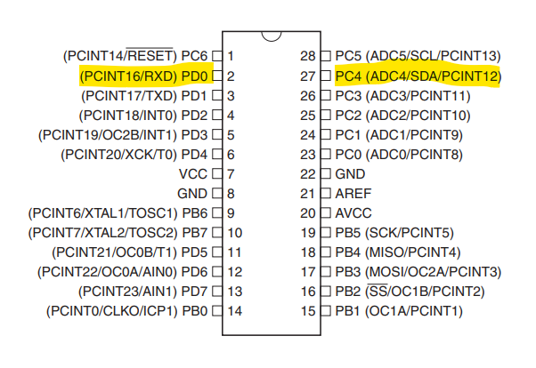

1. **INITIAL/MODIFIED/DEVELOPED CODE OF TASK 1/A**

/*

* DA3BT1.c

*

* Created: 3/13/2020 12:16:44 PM

* Author : c1029

*/

#define *F_CPU* 16000000UL

#define BAUD 9600

#include <avr/io.h>

#include <util/setbaud.h>

#include <avr/interrupt.h>

#include <util/delay.h>

#include <stdio.h>

volatile *uint8_t* overflow_cnt;

volatile *uint8_t* temp;

void USART_init(void)

{

UBRR0H = *UBRRH_VALUE*;

UBRR0L = *UBRRL_VALUE*;

UCSR0C = _BV(UCSZ01) | _BV(UCSZ00); //8-bit data

UCSR0B = _BV(RXEN0) | _BV(TXEN0); //enable transmitter

}

void set_inter()

{

TCCR0A = 0x00; //normal mode

TCCR0B = 0x05; //prescaler 1024

TCNT0 = 0x00;

TIMSK0 = (1<< TOIE0); //enable timer interrupt

sei(); //enable global interrupt

}

void adc_int(void)

{

ADMUX = (0 << REFS1) | (1 << REFS0) | (0 << ADLAR) | (0 << MUX3) | (1 << MUX2) | (0<< MUX1) | (0 << MUX0);

ADCSRA = (1 << ADEN) | (0 << ADSC) | (0 << ADATE) | (0 << ADIF) | (0 << ADIE) | (1<< ADPS2) | (1 << ADPS1) | (1<<ADPS0);

}

void USART_tx_string(char* data)

{

while((*data !='\0'))

{

while(!(UCSR0A & (1<<UDRE0)));

UDR0 = *data;

data++;

}

}

void adc_read(void)

{

ADCSRA |= (1 << ADSC); //enable start conversion

while(ADCSRA & (1<< ADSC)); //wait

temp = ADC; // LM35 value stored in temp.

}

int main(void)

{

/* Replace with your application code */

USART_init();

adc_int();

set_inter();

int celsius;

char array1[20], array2[20];

while (1)

{

if (overflow_cnt == 31)

{

adc_read(); //Call Read Function

celsius = (temp - 32) * 5 / 9; //convert to celsius

*sprintf*(array1,"%i", temp); //convert the number into a string type

*sprintf*(array2, "%i", celsius);

//Prints temperature value

USART_tx_string("Temperature: ");

USART_tx_string(array1);

USART_tx_string(" Fahrenheit or ");

USART_tx_string(array2);

USART_tx_string(" Celsius.");

USART_tx_string("\n");

overflow_cnt = 0;

}

}

}

ISR(TIMER0_OVF_vect)

{

overflow_cnt++;

}

1. **DEVELOPED MODIFIED CODE OF TASK 2/A from TASK 1/A**

N/A

1. **SCHEMATICS**

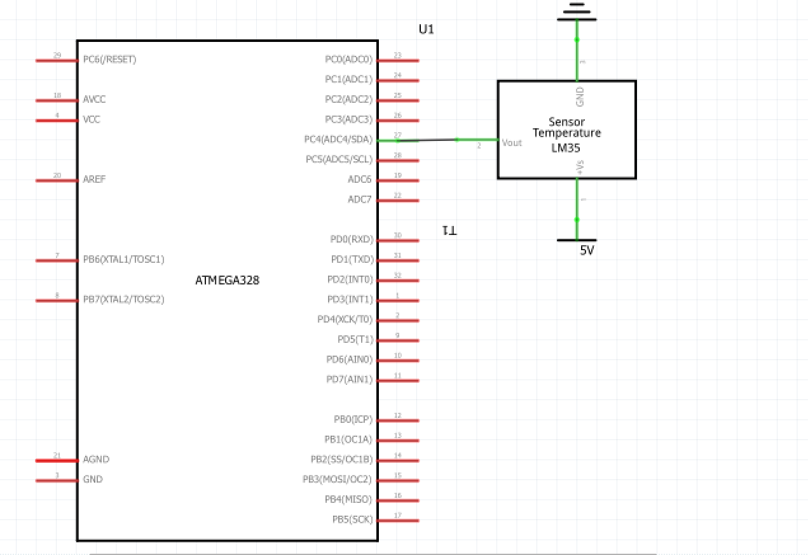

1. **SCREENSHOTS OF EACH TASK OUTPUT (ATMEL STUDIO OUTPUT)**

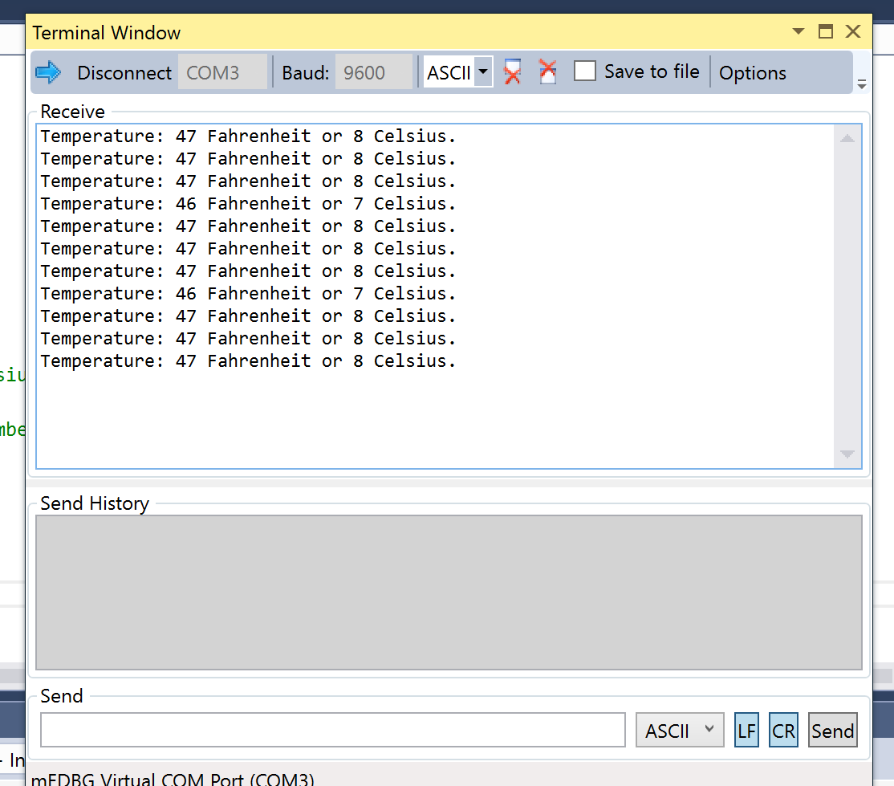

1. **SCREENSHOT OF EACH DEMO (BOARD SETUP)**

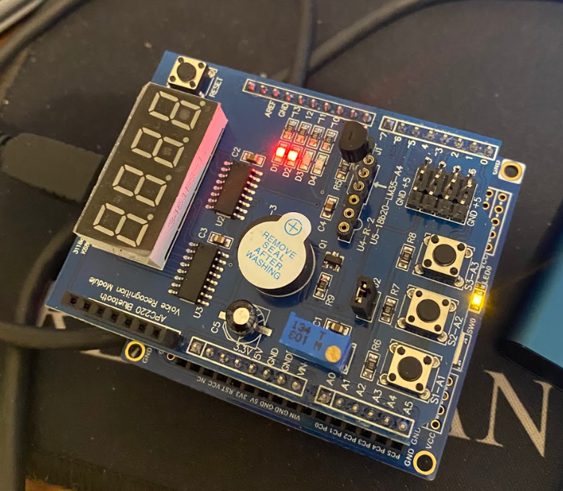

1. **VIDEO LINKS OF EACH DEMO**

Video: <https://youtu.be/Mm9k7M7V9Y8>

1. **GITHUB LINK OF THIS DA**

<https://github.com/c1029324620/Mocha/tree/master/DesignAssignments/LAB3/DA3B>

**Student Academic Misconduct Policy**

<http://studentconduct.unlv.edu/misconduct/policy.html>

“This assignment submission is my own, original work”.

Xianjie Cao