CPE301 – SPRING 2020

Design Assignment 4A

Student Name: Xianjie Cao

Student #: 5004222179

Student Email: [caox2@unlv.nevada.edu](mailto:caox2@unlv.nevada.edu)

Primary Github address: <https://github.com/c1029324620/Mocha.git>

Directory: Mocha/DesignAssignments/LAB4/DA4A

1. **COMPONENTS LIST AND CONNECTION BLOCK DIAGRAM w/ PINS**

Atmel Studio 7: Debugger, simulator and assembler

Atmega328pb Xmini PC

DC Motor

Breadboard

Jump wires

TB6612FNG

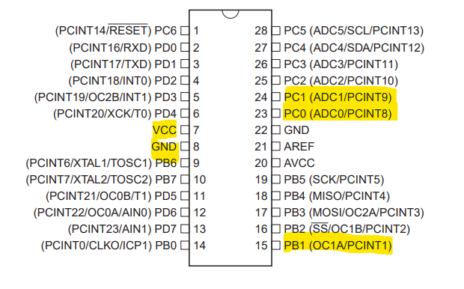

1. **INITIAL/MODIFIED/DEVELOPED CODE OF TASK 1/A**

/*

* DA4A.c

*

* Created: 3/30/2020 12:54:04 PM

* Author : c1029

*/

#define *F_CPU* 16000000UL

#include <avr/io.h>

#include <util/delay.h>

#include <stdio.h>

#include <avr/interrupt.h>

unsigned int adc_value;

void read_adc()

{

ADCSRA |= (1 << ADSC); //enable start conversion

while(ADCSRA & (1<< ADSC)); //wait

adc_value = ADC; // potentiometer value stored in adc_value

}

void init_adc()

{

ADMUX = (0<<REFS1) | //AVref

(1<<REFS0) |

(1<<ADLAR) | //Left justified

(0<<MUX2) | //ADC0 channel 0

(0<<MUX1) |

(0<<MUX0);

ADCSRA = (1<<ADEN) | //Enable ADC

(0<<ADSC) |

(0<<ADATE)|

(0<<ADIF) |

(0<<ADIE) |

(1<<ADPS2)| //prescaler of 128

(1<<ADPS1)|

(1<<ADPS0);

}

int main(void)

{

/* Replace with your application code */

init_adc();

DDRC |= (0<<DDRC1); //pinc.1 as input

PORTC |= (1 << 1); //pull=up resistor

PCICR |= (1<<PCIE1); //pin change interrupt

PCMSK1 |= (1<<PCINT9);

sei();

DDRB |= (1<< DDRB1); //Port B.1 as output

ICR1 = 0xffff;

TCCR1A = (1<<COM1A1) | (1<<COM1B1) | (1<<WGM11); //non-inverting

TCCR1B = (1<< WGM12) | (1<<WGM13); //Fast PWM using ICR1 as TOP

TCCR1B = (1<< CS10); // no prescaler.

while(1)

{

read_adc();

if((adc_value >= 62258) && (adc_value < 65535)) //95% of PWM value

{

OCR1A = 62258;

*_delay_ms*(20);

}

else if((adc_value < 62257) && (adc_value >= 3277))

{

OCR1A = adc_value;

*_delay_ms*(20);

}

else

OCR1A = 0x00; //minimum speed at less than 5% of PWM value.

}

return 0;

}

ISR(PCINT1_vect)

{

DDRC ^=(1<<2);

}

1. **DEVELOPED MODIFIED CODE OF TASK 2/A from TASK 1/A**

N/A

1. **SCHEMATICS**

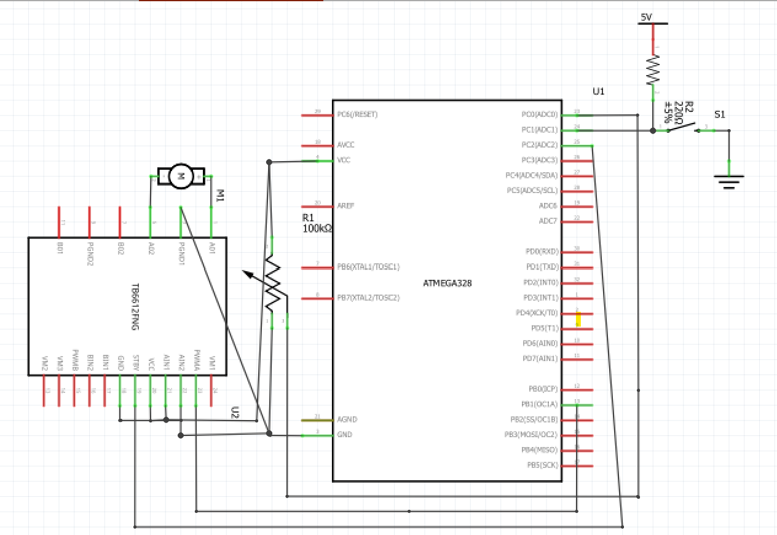

1. **SCREENSHOTS OF EACH TASK OUTPUT (ATMEL STUDIO OUTPUT)**

N/A

1. **SCREENSHOT OF EACH DEMO (BOARD SETUP)**

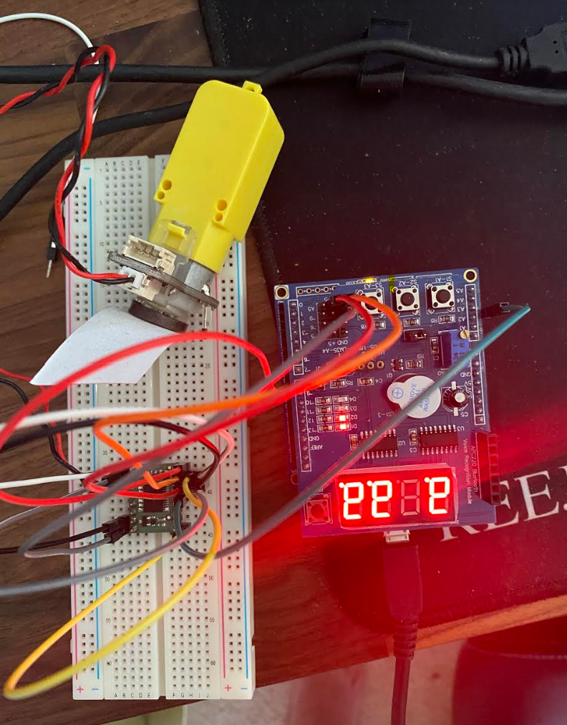

1. **VIDEO LINKS OF EACH DEMO**

<https://youtu.be/EMT-5ujx1WQ>

1. **GITHUB LINK OF THIS DA**

**Student Academic Misconduct Policy**

<http://studentconduct.unlv.edu/misconduct/policy.html>

“This assignment submission is my own, original work”.

Xianjie Cao