CPE301 – SPRING 2020

Design Assignment 6

Student Name: Xianjie Cao

Student #: 5004222179

Student Email: [caox2@unlv.nevada.edu](mailto:caox2@unlv.nevada.edu)

Primary Github address: <https://github.com/c1029324620/Mocha.git>

Directory: Mocha/DesignAssignments/Lab6

1. **COMPONENTS LIST AND CONNECTION BLOCK DIAGRAM w/ PINS**

Atmel Studio 7: Assembler, debugger and simulator

Atmega328pb-Xmini

Jumper wires

Breadboard

MPU6050

Multifunctional Shield

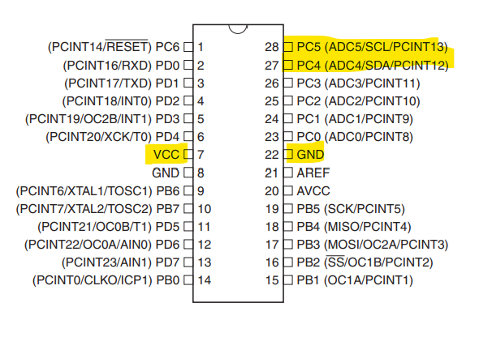

1. **INITIAL/MODIFIED/DEVELOPED CODE OF TASK 1/A**

#define F_CPU 16000000UL /* Define CPU clock Frequency e.g. here its 8MHz */

#include <avr/io.h> /* Include AVR std. library file */

#include <util/delay.h> /* Include delay header file */

#include <inttypes.h> /* Include integer type header file */

#include <stdlib.h> /* Include standard library file */

#include <stdio.h>

#include <math.h> /* Include standard library file */

#include "MPU6050_def.h" /* Include MPU6050 register define file */

#include "i2c_master.h" /* Include I2C Master header file */

#include "uart.h" /* Include USART header file */

float Acc_x,Acc_y,Acc_z,Temperature,Gyro_x,Gyro_y,Gyro_z;

void MPU6050_Init() /* Gyro initialization function */

{

*_delay_ms*(150); /* Power up time >100ms */

I2C_Start_Wait(0xD0); /* Start with device write address */

I2C_Write(SMPLRT_DIV); /* Write to sample rate register */

I2C_Write(0x07); /* 1KHz sample rate */

I2C_Stop();

I2C_Start_Wait(0xD0);

I2C_Write(PWR_MGMT_1); /* Write to power management register */

I2C_Write(0x01); /* X axis gyroscope reference frequency */

I2C_Stop();

I2C_Start_Wait(0xD0);

I2C_Write(CONFIG); /* Write to Configuration register */

I2C_Write(0x00); /* Fs = 8KHz */

I2C_Stop();

I2C_Start_Wait(0xD0);

I2C_Write(GYRO_CONFIG); /* Write to Gyro configuration register */

I2C_Write(0x18); /* Full scale range +/- 2000 degree/C */

I2C_Stop();

I2C_Start_Wait(0xD0);

I2C_Write(INT_ENABLE); /* Write to interrupt enable register */

I2C_Write(0x01);

I2C_Stop();

}

void MPU_Start_Loc()

{

I2C_Start_Wait(0xD0); /* I2C start with device write address */

I2C_Write(ACCEL_XOUT_H); /* Write start location address from where to read */

I2C_Repeated_Start(0xD1); /* I2C start with device read address */

}

void Read_RawValue()

{

MPU_Start_Loc(); /* Read Gyro values */

Acc_x = (((int)I2C_Read_Ack()<<8) | (int)I2C_Read_Ack());

Acc_y = (((int)I2C_Read_Ack()<<8) | (int)I2C_Read_Ack());

Acc_z = (((int)I2C_Read_Ack()<<8) | (int)I2C_Read_Ack());

Temperature = (((int)I2C_Read_Ack()<<8) | (int)I2C_Read_Ack());

Gyro_x = (((int)I2C_Read_Ack()<<8) | (int)I2C_Read_Ack());

Gyro_y = (((int)I2C_Read_Ack()<<8) | (int)I2C_Read_Ack());

Gyro_z = (((int)I2C_Read_Ack()<<8) | (int)I2C_Read_Nack());

I2C_Stop();

}

int main()

{

//Variable Declarations

char buffer[20];

char float_val[10];

float X_a,Y_a,Z_a; //Acceleration Values X-Y-Z

float X_g=0,Y_g=0,Z_g=0; //Gyro Values X-Y-Z

I2C_Init(); //Initialize I2C

MPU6050_Init(); //Initialize MPU6050

USART_Init(9600); //Initialize UART

while(1)

{

Read_RawValue(); //Call Read_RawValue Function

X_a = Acc_x/16384.0; //Acceleration-X

Y_a = Acc_y/16384.0; //Acceleration-Y

Z_a = Acc_z/16384.0; //Acceleration-Z

X_g = Gyro_x/16.4; //Gyro-X

Y_g = Gyro_y/16.4; //Gyro-Y

Z_g = Gyro_z/16.4; //Gyro-Z

//Read/Print Acceleration-X

*dtostrf*( X_a, 3, 2, float_val );

*sprintf*(buffer," Ax = %s g\t",float_val);

USART_SendString(buffer);

//Read/Print Acceleration-Y

*dtostrf*( Y_a, 3, 2, float_val );

*sprintf*(buffer," Ay = %s g\t",float_val);

USART_SendString(buffer);

//Read/Print Acceleration-Z

*dtostrf*( Z_a, 3, 2, float_val );

*sprintf*(buffer," Az = %s g\t",float_val);

USART_SendString(buffer);

//Read/Print Gyro-X

*dtostrf*( X_g, 3, 2, float_val );

*sprintf*(buffer," Gx = %s%c/s\t",float_val,0xF8);

USART_SendString(buffer);

//Read/Print Gyro-Y

*dtostrf*( Y_g, 3, 2, float_val );

*sprintf*(buffer," Gy = %s%c/s\t",float_val,0xF8);

USART_SendString(buffer);

//Read/Print Gyro-Z

*dtostrf*( Z_g, 3, 2, float_val);

*sprintf*(buffer," Gz = %s%c/s\r\n",float_val,0xF8);

USART_SendString(buffer);

*_delay_ms*(1000);

}

}//End Main

1. **DEVELOPED MODIFIED CODE OF TASK 2/A from TASK 1/A**

#define F_CPU 16000000UL /* Define CPU clock Frequency e.g. here its 8MHz */

#include <avr/io.h> /* Include AVR std. library file */

#include <util/delay.h> /* Include delay header file */

#include <inttypes.h> /* Include integer type header file */

#include <stdlib.h> /* Include standard library file */

#include <stdio.h>

#include <math.h> /* Include standard library file */

#include "MPU6050_def.h" /* Include MPU6050 register define file */

#include "i2c_master.h" /* Include I2C Master header file */

#include "uart.h" /* Include USART header file */

float Acc_x,Acc_y,Acc_z,Temperature,Gyro_x,Gyro_y,Gyro_z, pitch, roll;

#define ACCELEROMETER_SENSITIVITY 16384.0

#define GYROSCOPE_SENSITIVITY 16.4

#define dt 0.01 // 10 ms sample rate!

void MPU6050_Init() /* Gyro initialization function */

{

*_delay_ms*(150); /* Power up time >100ms */

I2C_Start_Wait(0xD0); /* Start with device write address */

I2C_Write(SMPLRT_DIV); /* Write to sample rate register */

I2C_Write(0x07); /* 1KHz sample rate */

I2C_Stop();

I2C_Start_Wait(0xD0);

I2C_Write(PWR_MGMT_1); /* Write to power management register */

I2C_Write(0x01); /* X axis gyroscope reference frequency */

I2C_Stop();

I2C_Start_Wait(0xD0);

I2C_Write(CONFIG); /* Write to Configuration register */

I2C_Write(0x00); /* Fs = 8KHz */

I2C_Stop();

I2C_Start_Wait(0xD0);

I2C_Write(GYRO_CONFIG); /* Write to Gyro configuration register */

I2C_Write(0x18); /* Full scale range +/- 2000 degree/C */

I2C_Stop();

I2C_Start_Wait(0xD0);

I2C_Write(INT_ENABLE); /* Write to interrupt enable register */

I2C_Write(0x01);

I2C_Stop();

}

void MPU_Start_Loc()

{

I2C_Start_Wait(0xD0); /* I2C start with device write address */

I2C_Write(ACCEL_XOUT_H); /* Write start location address from where to read */

I2C_Repeated_Start(0xD1); /* I2C start with device read address */

}

void Read_RawValue()

{

MPU_Start_Loc(); /* Read Gyro values */

Acc_x = (((int)I2C_Read_Ack()<<8) | (int)I2C_Read_Ack());

Acc_y = (((int)I2C_Read_Ack()<<8) | (int)I2C_Read_Ack());

Acc_z = (((int)I2C_Read_Ack()<<8) | (int)I2C_Read_Ack());

Temperature = (((int)I2C_Read_Ack()<<8) | (int)I2C_Read_Ack());

Gyro_x = (((int)I2C_Read_Ack()<<8) | (int)I2C_Read_Ack());

Gyro_y = (((int)I2C_Read_Ack()<<8) | (int)I2C_Read_Ack());

Gyro_z = (((int)I2C_Read_Ack()<<8) | (int)I2C_Read_Nack());

I2C_Stop();

}

void getAngle(int Ax, int Ay, int Az)

{

double x = Ax;

double y = Ay;

double z = Az;

pitch = *atan*(x / *sqrt*((y*y) + (z*z))); //pitch calculation

roll = *atan*(y/ *sqrt*((x*x) + (z*z))); //roll calculation

//converting radians into degrees

pitch = pitch * (180.0 / 3.14);

roll = roll * (180.0 / 3.14);

}

void ComplementaryFilter()

{

float pitchAcc, rollAcc;

// Integrate the gyroscope data -> int(angularSpeed) = angle

pitch += ((float)Gyro_x / GYROSCOPE_SENSITIVITY) * dt;

// Angle around the X-axis

roll -= ((float)Gyro_y / GYROSCOPE_SENSITIVITY) * dt;

// Angle around the Y-axis

// Compensate for drift with accelerometer data if !bullshit

// Sensitivity = -2 to 2 G at 16Bit -> 2G = 32768 && 0.5G = 8192

int forceMagnitudeApprox = *abs*(Acc_x) + *abs*(Acc_y) + *abs*(Acc_z);

if (forceMagnitudeApprox > 8192 && forceMagnitudeApprox < 32768)

{

// Turning around the X axis results in a vector on the Y-axis

pitchAcc = *atan2f*((float)Acc_y, (float)Acc_z) * 180 / *M_PI*;

pitch = pitch * 0.98 + pitchAcc * 0.02;

// Turning around the Y axis results in a vector on the X-axis

rollAcc = *atan2f*((float)Acc_x, (float)Acc_z) * 180 / *M_PI*;

roll = roll * 0.98 + rollAcc * 0.02;

}

}

int main()

{

//Variable Declarations

char buffer[20];

char float_val[10];

//float X_a,Y_a,Z_a; //Acceleration Values X-Y-Z

//float X_g=0,Y_g=0,Z_g=0; //Gyro Values X-Y-Z

I2C_Init(); //Initialize I2C

MPU6050_Init(); //Initialize MPU6050

USART_Init(9600); //Initialize UART

//10ms sample

TCCR1B = (1<< CS10); //prescaler of 8

TCNT1 = 0;

while(1)

{

if(TCNT1 == 20000)

{

Read_RawValue(); //Call Read_RawValue Function

/* X_a = Acc_x/16384.0; //Acceleration-X

Y_a = Acc_y/16384.0; //Acceleration-Y

Z_a = Acc_z/16384.0; //Acceleration-Z

X_g = Gyro_x/16.4; //Gyro-X

Y_g = Gyro_y/16.4; //Gyro-Y

Z_g = Gyro_z/16.4; //Gyro-Z*/

getAngle(Acc_x, Acc_y, Acc_z);

ComplementaryFilter();

//Read/Print pitch

*dtostrf*(pitch, 3, 2, float_val );

*sprintf*(buffer," Pitch = %s\t",float_val);

USART_SendString(buffer);

//Read/Print Gyro-Z

*dtostrf*(roll, 3, 2, float_val);

*sprintf*(buffer," Roll = %s\n",float_val);

USART_SendString(buffer);

TCNT1 = 0; //reset timer counter

}

}

}//End Main

1. **SCHEMATICS**

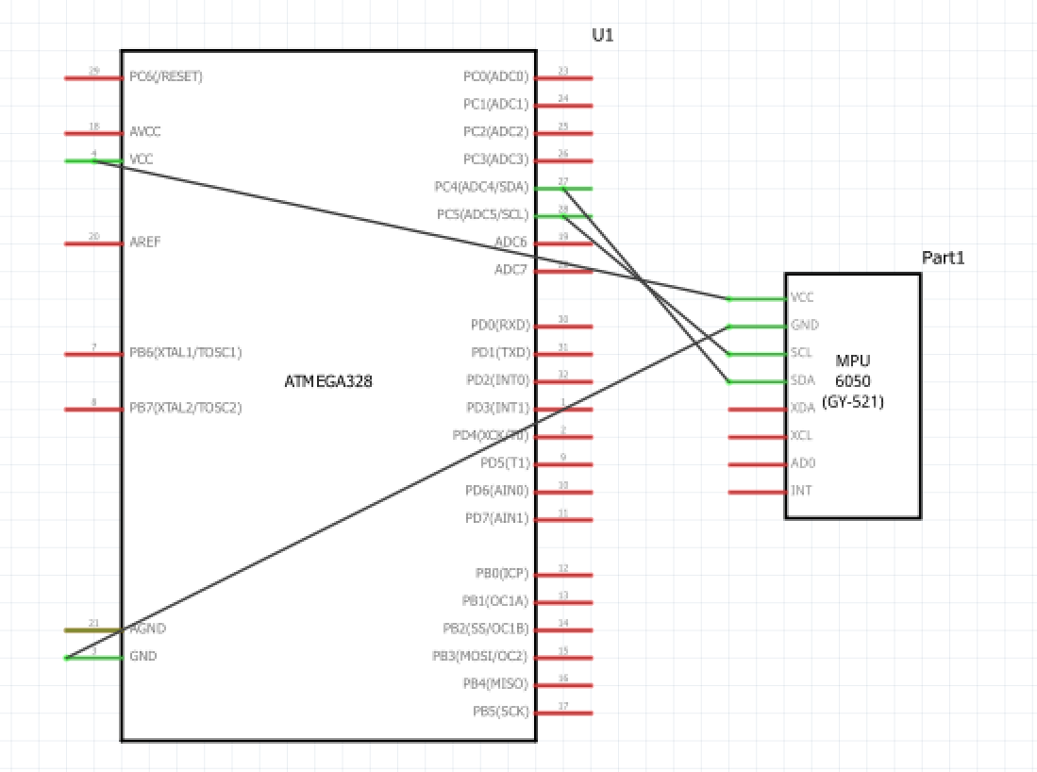

1. **SCREENSHOTS OF EACH TASK OUTPUT (ATMEL STUDIO OUTPUT)**

**Task 1:**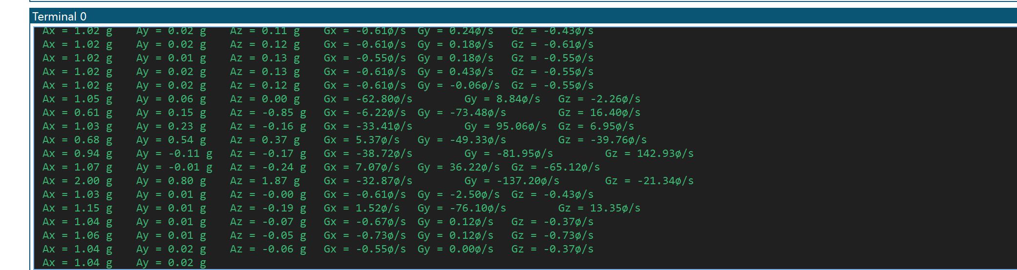

**Task 2:**

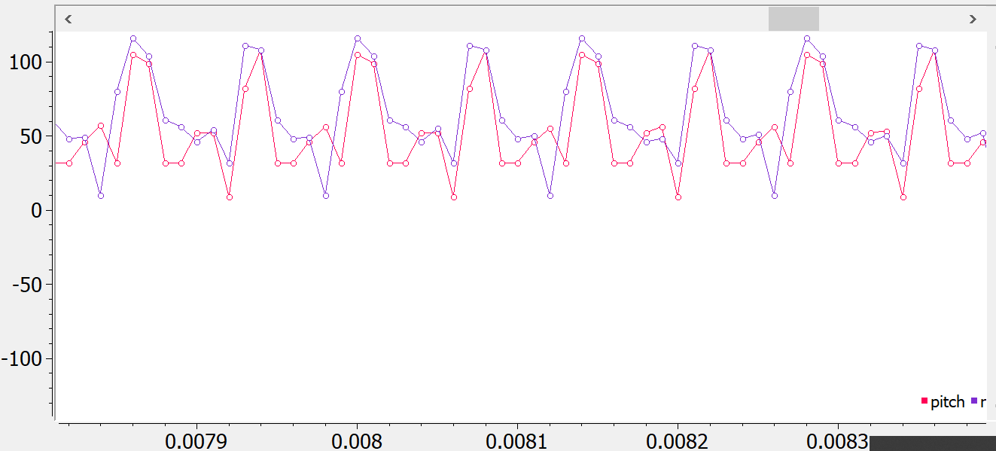

1. **SCREENSHOT OF EACH DEMO (BOARD SETUP)**

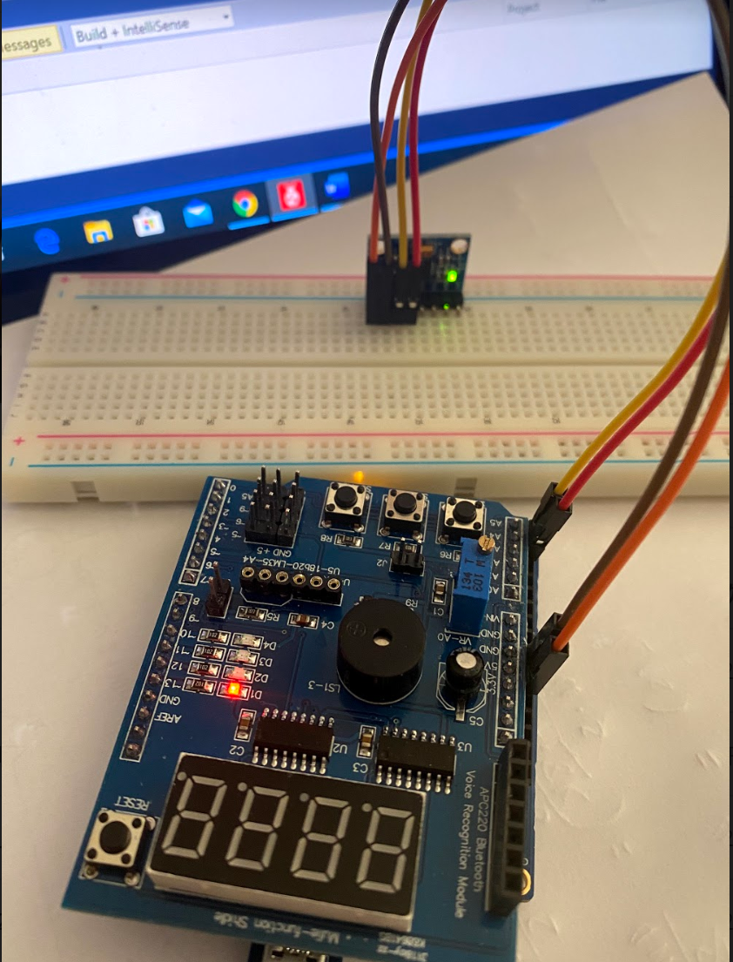

1. **VIDEO LINKS OF EACH DEMO**

Task 1: <https://youtu.be/Uiu1zLGxVh8>

Task 2: <https://youtu.be/01EThdNeow0>

1. **GITHUB LINK OF THIS DA**

<https://github.com/c1029324620/Mocha/tree/master/DesignAssignments/LAB6/DA6>

**Student Academic Misconduct Policy**

<http://studentconduct.unlv.edu/misconduct/policy.html>

“This assignment submission is my own, original work”.

Xianjie Cao