

User Manual

Version 1, updated on October 7, 2017.



What is Collect Earth Online? 2

Part 1: Quick Introduction to Collect Earth Online 3

A. Setting up your account 3

A. Website features 3

B. Report an issue or request new features 3

Part 2: Data Collection 4

A. Select a public project (option 1) 4

B. Select a project from an institution (option 2) 4

C. Enable pop-ups 4

D. Analyze a plot 5

E. Analysis tips 7

Part 3: Institution Set up and Management 8

A. List of Institutions 8

B. Creating a new institution 8

C. Request to join an institution 8

D. Institution management 8

Part 4: Adding a new WMS image source 9

A. Set up a WMS or WMTS feed 9

B. Adding two different years of available imagery 9

Part 5: Project Setup and Management 11

A. Project setup page 11

B. Create a new project 11

C. Setting project area 11

D. Specifying available imagery feed 11

E. Two date imagery to assess landscape changes 12

F. Sample design set up 12

G. Designing plot attributes and labels 12

H. Create the project 13

I. Geo-Dash: create a Google Earth Engine widget 14

B. Project statistics 17

C. Download your data 17

D. Add and manage users 18

E. Validation set construction 18

What is Collect Earth Online?

Collect Earth Online, CEO, is a free and open-source image viewing and interpretation tool, suitable for projects requiring information about land cover and/or land use. CEO enables simultaneous visual interpretations of satellite imagery, providing global coverage from Digital Globe and Bing Maps, a variety of satellite data sources from Google Earth Engine, and the ability to connect to your own Web Map Service (WMS) or Web Map Tile Service (WMTS). The full functionality is implemented online, no desktop installation is necessary.

Collect Earth Online (CEO) is available at <http://ceo.sig-gis.com>.

The manual is broken down into five modules. The first provides a quick overview of the Collect Earth Online platform. The second instructs on how a user can start the photo-interpretation and data collection process. Sections three through five outline how to set up and manage institutions, imagery feeds, and data collection projects.

1. Quick Introduction to Collect Earth Online
   1. Setting up your account
      1. In your browser window, such as Google Chrome, navigate to [**http://ceo.sig-gis.com**](http://ceo.sig-gis.com)**.**
      2. Click on the upper right panel on **Login/Register**.
      3. To set up a new account, click on **Register a new account** and follow the instructions.
      4. Login with your email and password.
      5. If you forget your password, click directly on **Forgot your password?** and follow the instructions.
   2. Website features
      1. You can access the Home, About, Support, and Account pages from the top menu bar.
         1. The **Home** includes information about institutions, published projects, and a map showing locations of existing projects.
         2. The **About** page summarizes information about CEO.
         3. **Support** features Collect Earth Online Tutorials and a Collect Earth Online Demo.
         4. The **Account** page lists information such as user statistics and allows users to update their account settings.
   3. Report an issue or request new features

Under the Collect Earth Online banner at the top of the webpage there is a link to the Github issues page, also available here <https://github.com/openforis/collect-earth-online/issues>. If you discover any of the Collect Earth Online functions are not working properly or would like to suggest an additional feature or functionality be considered, you can use this page to log an issue or suggestion. Once logged, these messages go directly to the Collect Earth Online developer team.

* + 1. To log an issue or request a new CEO feature, simply click on the green **New issue** button in the upper right hand portion of the screen.
    2. You will have to either log in or set up a github account in order to log an issue. By logging in, the development team can contact you in case they need additional information to provide a solution to the issue or feature suggestion.
    3. Type in a title that conveys the topic of the issue or request. Then below, type in a detailed message summarizing the issue you have encountered or the additional functionality you would like to see added into CEO.
    4. Once you have finished providing the details, click the green **Submit new issue** button. This will log your request. Then you can return to the Collect Earth Online webpage and continue your work.
    5. Alternatively, if you are unable to register an account with github, you can ask questions on the OpenForis forum, which is available here <http://www.openforis.org/support>.

1. Data Collection

Several publicly available crowd-sourced mapathon projects are featured in the map window on the home screen. Anyone with an internet connection can log into Collect Earth Online and begin collecting data for these projects. Other projects require users be a member of either an institution or a project. These security levels are pre-determined for each project by the project manager.

* 1. Select a public project (option 1)
     1. You can begin collecting data on these projects by clicking on the map pin. Then clicking on **Get Started** in the pop-up window.

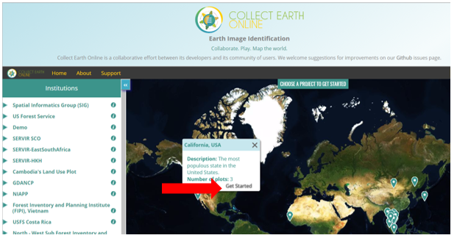

* + 1. This will take you to a screen that has a map of the whole study region, a table with the project data collection statistics, and a number of buttons used for recording data on the right hand side of the screen.
    2. Select the blue **Next Plot** button to begin collecting information.
  1. Select a project from an institution (option 2)
     1. On the left hand side of the home page, click on one of the institutions that you belong to.
     2. A drop down list of available projects opens up. Select the project of interest by clicking on the project name.
     3. This will take you to a screen that has a map of the whole study region, a table with the project data collection statistics, and a number of buttons used for recording data on the right hand side of the screen.
     4. Select the blue **Next Plot** button to begin collecting information.
  2. Enable pop-ups
     1. If it is your first time collecting data with Collect Earth Online or you have switched computers, you will likely need to allow pop-ups from the CEO site.
     2. Check the address bar. If it is marked with a Pop-up blocked icon (see image below), click on the popup blocked warning.

allow pop-ups for CEO

* + - 1. In the popup window that appears, select **Always allow pop-ups from** [**http://ceo.sig-gis.com**](http://ceo.sig-gis.com).
      2. Then select **Done**.
    1. Click **Next Plot** to reload the auxiliary plot information in a new tab.
  1. Analyze a plot
     1. Your sample plot shows up as a red circle or square in the map window. Each sample point is identified with a red circle until it is assigned a label.

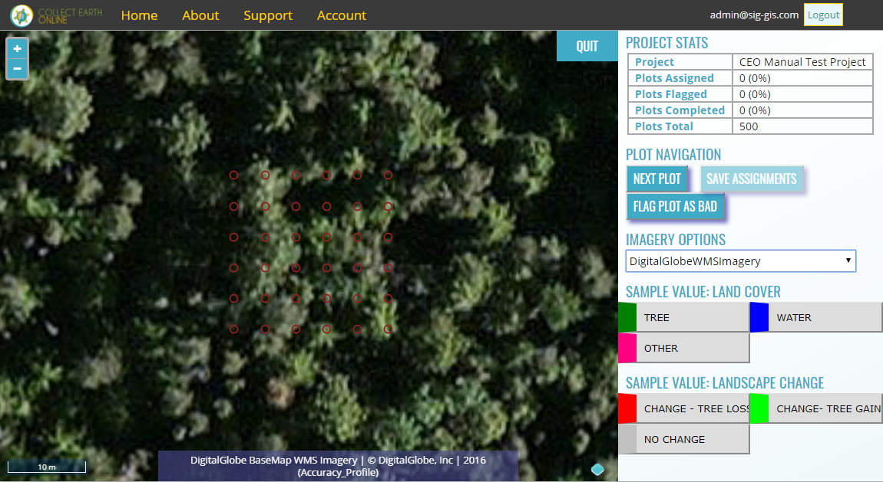

* + 1. You can zoom in and out using the blue + and - buttons in the upper left hand corner of the map window, or simply by scrolling your mouse wheel.
    2. You can view alternative images by selecting the imagery of interest from the drop down list under **Imagery Options** on the right hand panel.
    3. The newly opened popup window also has information to assist in determining the land cover and land use attributes. The Geo-Dash pop-up tab contains information compiled from Google Earth Engine. It can include plots of time series data, such as how NDVI values have varied over time, Landsat image chips, and more.
    4. Select your sample points.
       1. To select a single sample point, click on it with the left mouse key.
       2. To select several sample points, click on them while keeping the Shift key pressed down.
       3. To select all or a larger area of sample points, you can draw a rectangle to select them. Press the Ctrl-key and click in the map window and draw your rectangle.
    5. When your sample points are marked in blue, you can assign them a sample value by clicking on the suitable value in the legend to the left of the map window. The sample points are then marked in the color of the value class.
       1. In the example below, we have selected the sample points located on a tree and classified their attribute Land Cover category as **Tree** (points appear in green color scheme after classification).

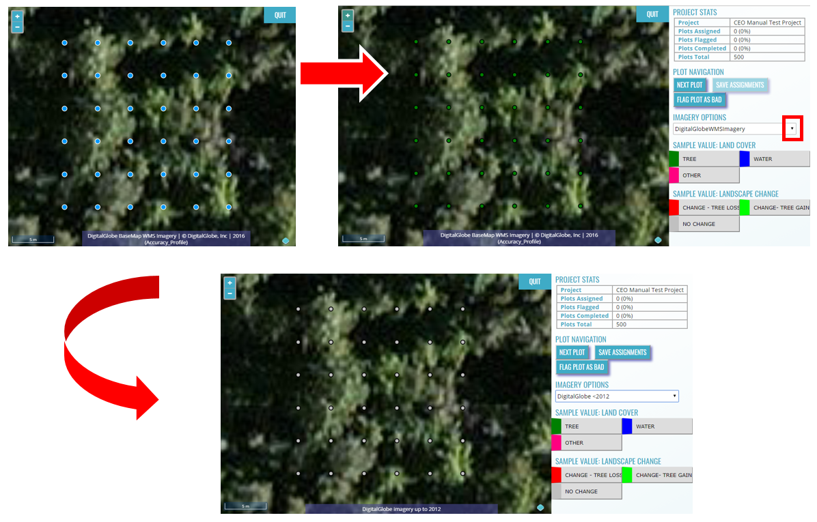

* + 1. After assigning a label to all points for the first attribute, in this example the SAMPLE VALUE: LAND COVER, reselect the points and assign them the secondary attributes (SAMPLE VALUE: LANDSCAPE CHANGE).
       1. To determine landscape change over time, you can toggle between imagery from two different dates. The current imagery layer “DigitalGlobeWMSImagery” has images from 2016.
       2. Click the drop-down menu under IMAGERY OPTIONS and select “DigitalGlobe <2012” to compare imagery from before 2012. The time series information that is presented in the Geo-Dash window is also helpful in determining if change has occurred on the landscape. Make sure you also refer to the second tab, where the Geo-Dash information is presented.
       3. In this case, both images look the same, no change occurred, so we select all points and label them as **no change**.
       4. After assigning point(s) with the secondary label (NO CHANGE), they will change color to grey to match the color scheme of the secondary attribute.
       5. Repeat for all Sample Value categories. In this example there are only two, but it is possible to set up a project with more than two attribute categories.
    2. When all the Sample Values (attributes) of all the sample points of your current plot are classified, click on **SAVE ASSIGNMENTS**. This button is active, appears blue, only when all the points have been labeled.
    3. A pop-up window shows up confirming that the assignments were saved in the database.
       1. Click **OK**.
       2. If SAVE ASSIGNMENTS is still shadowed in light blue, not all sample points are classified yet.
    4. The next plot for analysis shows up automatically.
    5. When all plots are classified, a pop-up window shows up to inform you that all sample plots of your project are analyzed.
  1. Analysis tips
     1. You are able to mark plots as bad if the imagery is not good enough to accurately label the plot attributes.
        1. If the background is completely black, the resolution might be too low for the automatically set zoom level. Alternatively, the plot might be in a large waterbody. Zoom out until you see some more map context to confirm whether the issue is imagery resolution or an oceanic plot.
        2. If the background of a new plot is grey, zoom out a bit to display the imagery.
        3. If the resolution of a plot is too low to distinguish features and classify your points, click on **FLAG PLOT AS BAD**. A pop-up window appears informing you that the plot [number] has been flagged.
        4. Click **OK**.
     2. At any time, you can skip a plot for later analysis by clicking **NEXT PLOT**.
     3. The imagery can be changed by opening the drop-down menu under **IMAGERY OPTIONS** andselecting your imagery of choice. When assessing landscape change, the imagery options in the project should be set up so that you can toggle between imagery from two time periods.
     4. When characterizing landscape change, the information available on the Geo-Dash is especially helpful if imagery is missing for one of the two years. Refer to Landsat plots or NDVI time series on the Geo-DASH for land cover change information.
     5. The **project stats** show the number and percent of plots completed, the number and percent of plots flagged as bad, and the total number of plots. An accuracy score based on the project’s training data will also be available soon.

1. Institution Set up and Management
   1. List of Institutions
      1. A list of all institutions is displayed under **Home**.
      2. By clicking on an institution’s info (i) button, the institution page opens. The logo, website link and description are presented as well as available imagery feeds, such as Web Mapping Services, institution projects and all registered users associated with the institution.
   2. Creating a new institution
      1. If your institution is not yet represented in the system, you can create a new institution by clicking on **Create New Institution** on the left panel of the Home page.

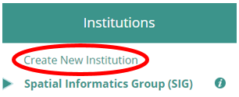

* + 1. Enter your institution’s name, URL, and a brief description. You can upload a logo from your computer by clicking on **Choose File**.

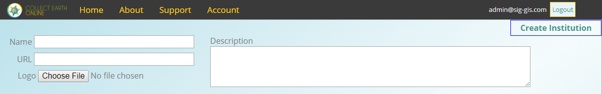

* + 1. Click **Create Institution** after you have completed entering your information.
    2. You can make changes to the institution page later by clicking **Edit Institution**. You can also delete your institution by clicking **Delete Institution**.
  1. Request to join an institution
     1. If your institution has an account and you would like to request to be a member, simply scroll to the institution on the left panel of the Home page.
     2. Click on the institution’s info button, a blue I, and the institution page opens. The list of Users is displayed on the right hand panel, here there is a blue **REQUEST MEMBERSHIP** button. Click on that to be considered to join the institution.
  2. Institution management

If you are one of the administrators for an institution, you can manage three components on the institution page. These include the imagery feeds, the data collection projects, and the users associated with the institution.

* + 1. Go to the institution page and notice the three panels.
       1. **Imagery** lists all available imagery and WMS Feeds. You can add new imagery feeds here as well. Instructions follow in Part 4 on following page.
    2. **Projects** panel lists all projects and allows you to create new projects. This is discussed in Part 5 of the manual.
    3. **Users** panel is where users, institution members, can be viewed and updated. Additionally, you can add a Collect Earth Online member to the institution. Pending affiliation requests can be seen and approved. Users can be invited or banned.
       1. To change the role of any user, use the drop down menu to the right of their email address. Available user roles are Admin and Member.
       2. To restrict the admin capabilities of a user to only one of the institution’s project, you can create a new institution specifically for this user and create the project under this new institution. If the other user(s) do not need admin capabilities, they can simply work on the project as a normal user.

1. Adding a new WMS image source
   1. Set up a WMS or WMTS feed
      1. In order to add a new WMS image source, you need to be logged in as institution administrator
      2. Go to your institution’s page by clicking on the info (i) icon to the right of its name in the **Home** page side bar.
      3. Under the imagery panel, click **Add Imagery**.
      4. Fill out the fields to specify the connection information for your WMS server. Example:
         1. Title: NASASERVIRChipset2002
         2. Attribution: June 2002 Imagery Data Courtesy of DigitalGlobe
         3. GeoServer URL: <http://pyrite.sig-gis.com/geoserver/wms>
         4. GeoServer Layer Name: servir:yr2002
         5. GeoServer Params (as JSON string): {"TILED": true}
      5. Click **Save Changes**.
   2. Adding two different years of available imagery
      1. You can add a second source of the available imagery (such as DigitalGlobe) for a different date and toggle between different years in the data collection mode.
      2. You need to be logged in as institution administrator.
      3. Go to your institution’s page by clicking on the info (i) icon to the right of its name in the **Home** page side bar.
      4. Under the imagery panel, click **Add Imagery**.
      5. Fill out the fields to specify the connection information for the imagery:
         1. Type in a title for the new imagery layer, eg “DigitalGlobe 2012”
         2. Type a short description in the attribution field, eg “DigitalGlobe imagery from 2012”
         3. For GeoServer URL, type: https://services.digitalglobe.com/mapservice/wmsaccess
         4. For GeoServer Layer Name, type “DigitalGlobe:Imagery”
         5. In the GeoServerParams (as JSON string)) field, write:

{VERSION: "1.1.1", CONNECTID: "63f634af-fc31-4d81-9505-b62b4701f8a9", FEATUREPROFILE: "Accuracy_Profile", COVERAGE_CQL_FILTER: "(acquisition_date>'**2012**-01-01')AND(acquisition_date<'**2012**-12-31')"}

The year (2012) is marked in red and bold letters and occurs twice – you need to adjust the four-digit year to your year of choice.

The imagery time can be constrained for any month or date range of choice by adjusting the month and day of the acquisition date instead of only the year.

* + 1. Click **Save Changes**.
    2. You can add several layers for different years of imagery by repeating steps 4-6.
    3. When creating a project, select one of the available imagery layers as default basemap source. You can switch between all of the available imagery layers during analysis.
    4. Navigate to your project on the data collection page to analyze plots. You can now toggle between imagery layers by selecting them in the drop-down menu under **IMAGERY OPTIONS**.

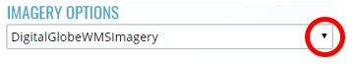

**Note that some years may not contain any imagery**, due to the inherent sparseness of the data collection process within DigitalGlobe’s database. If no imagery for the selected time range appears, try the following:

a) Change the FEATUREPROFILE in the GeoServerParams (as JSON string))

{VERSION: "1.1.1", CONNECTID: "63f634af-fc31-4d81-9505-b62b4701f8a9", **FEATUREPROFILE: "Accuracy_Profile",** **COVERAGE_CQL_FILTER:** "(acquisition_date>'2012-01-01')AND(acquisition_date<'2012-12-31')"}

to other profile options:

* "Cloud_Cover_Profile"
* "Global_Currency_Profile"
* "MyDG_Color_Consumer_Profile"
* "MyDG_Consumer_Profile"

b) Change the **COVERAGE_CQL_FILTER** to a one-sided time constraint:

...COVERAGE_CQL_FILTER: "(acquisition_date<'2012-12-31')"}

1. Project Setup and Management
   1. Project setup page
      1. The project setup page can be viewed by clicking on the info-button next to the institution and clicking **Edit** next to a project name in the project panel.
   2. Create a new project
      1. For setting up a new project, go to your institution page.
      2. Click **Create New Project**. This brings you to the Project Dashboard.

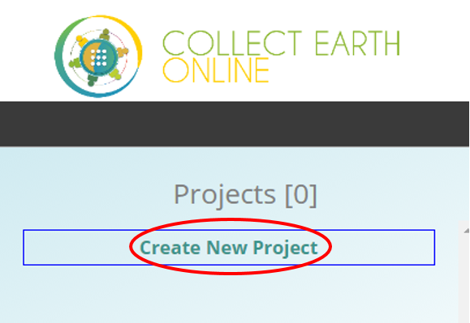

* + 1. Under **Project Info**, enter the project’s name and description.
    2. Project visibility sets the privacy level.
       1. Public: All users can see and edit your project.
       2. Private: Group Admins can see and edit your project.
       3. Institution: Group Members of your institution can see and edit your project.
       4. Invitation: Only invited users can see and edit your project.
  1. Setting project area
     1. In order to select your PROJECT AOI manually by drawing a box, click into the map window. Zoom in/out using the scroll wheel of your mouse, or the + and – boxes in the map window, to locate your area of interest. You can pan the map by clicking on it and dragging the map window. Hold the CRTL-key down and draw a box while keeping the left mouse key pressed down. The coordinate boxes will populate with coordinates once the box is drawn and you let your mouse key go.
  2. Specifying available imagery feed
     1. Select the Project Imagery under **Basemap Source** in the dropdown menu. The map view will display the current selection. You can choose between Digital Globe, Bing maps, and all public and private WMS feeds from your affiliated institution.
     2. When selecting “DigitalGlobe: WMS Imagery”, the **Imagery Year** can be specified in the dropdown menu.
     3. The different options for **Stacking Profile** are described in the box below.

**Stacking Profile Options:** These options set the criteria for selecting which image to display from all available imagery within the selected date range for any given plot location.

Accuracy_Profile: This profile returns high resolution features including those acquired using cameras mounted underneath aircraft and sub-meter satellite imagery.

Cloud_Cover_Profile: This profile returns visible light features (color and panchromatic) with the lowest cloud cover on top.

Global_Currency_Profile: This profile sorts all features (including infrared) chronologically, placing those features acquired most recently on top regardless of any other attribute.

MyDG_Color_Consumer_Profile: This profile is intended to give users the aesthetically best color experience. It provides only visible light color imagery.

* 1. Two date imagery to assess landscape changes

In order to compare land user and cover changes between two years, add one WMS imagery source for both years, and label them accordingly.

* + 1. You will need to first set up the imagery feed for one date period under the institution imagery management panel. Refer to instructions in Part 4, Section B.
    2. When creating the project, select the other time range using your WMS imagery and year of interest as the default imagery layer.
    3. During data collection, the imagery shown underneath the sample points can be switched by using the drop-down menu in order to toggle between the imagery years.
  1. Sample design set up
     1. PLOT DESIGN specifies the type and number of sample plots.
        + 1. *Spatial Distribution* defines the distribution of the sample points. There are three options: simple random, gridded, or uploading an own csv file specifying plot locations.

When selecting **Random**, the number of samples per plot needs to be assigned.

If selecting **Gridded**, the plot spacing parameter (in meters) needs to be selected.

* + - * 1. *Plot shape* can be set as a Circle or a Square. The plot radius (for a circle) or the plot width (for a square) can be chosen.
    1. The SAMPLE DESIGN options allow to specify the spatial distribution of the samples in each plot.
       1. When choosing Random, the sample numbers per plot must be defined.
       2. When choosing Gridded, the sample resolution (in meters) must be specified.
    2. Sample point locations can also be uploaded as a csv file. The coordinates must be in **WGS84 EPSG:4326** format. The first column must contain longitude and the second column latitude. A column header must be given, which can be freely chosen.
  1. Designing plot attributes and labels
     1. You can add collect multiple attributes at each plot. To add an attribute, type a label of the characteristic of interest in the white box to the right of the ADD SAMPLE VALUE GROUP button at the lower right hand section of the interface.
        1. Click the blue button to add it as an attribute.
        2. Repeat until you have entered all the attributes of interest.
     2. Next you will supply a scheme for classifying the sample values is created under **SAMPLE VALUE:** (attribute of interest, e.g., LAND COVER in the image on the following page).
        1. Type the sample class name under **Name**. Try to use names with around 15 characters or less so that the full name is displayed during analysis.
        2. Click on **Color** to choose a unique color for each label.
        3. An optional feature is uploading a reference image, which you can select by clicking on the **Choose File**. Click on the Plus button to save your label and start a new sample class.
        4. A finished sample class appears in the list. It can be removed again by clicking the minus button. After entering the last sample class, you still need to click the Plus button once more to save the final sample class.
        5. Repeat this process until all sample values have the labels of interest. See example image below.

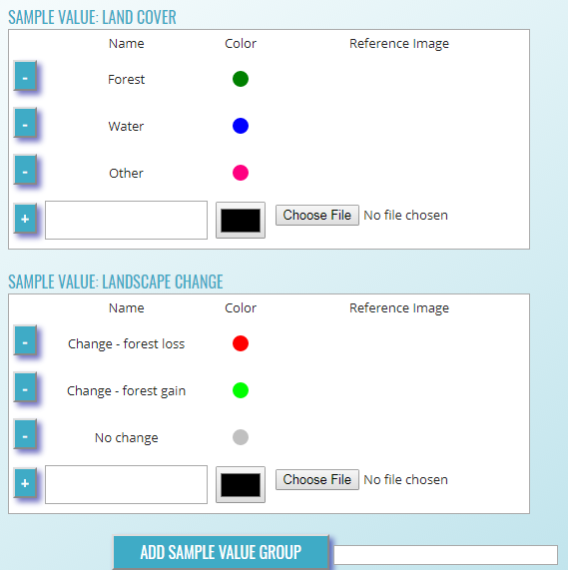

* 1. Create the project
     1. Once the project set up is complete up to this point, click on **CREATE PROJECT**.
        1. A pop-up window will ask ‘Do you REALLY want to create this project?’ Click **OK**.
        2. Now the map box will automatically zoom into your region of interest and draws a red box corresponding to the extent of your sample plots.

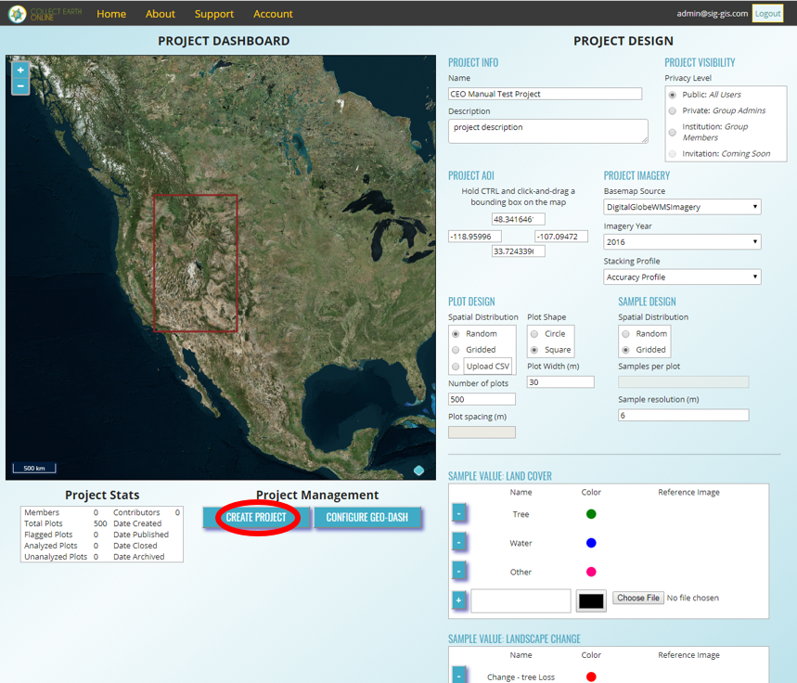

* + 1. Before you can set up the Geo-Dash or begin collecting data you need to next publish the project. Click the **Publish Project** button.
    2. A pop-up window will appear that asks ‘Do you REALLY want to publish this project?’ Click **OK**.
  1. Geo-Dash: create a Google Earth Engine widget

After you have published the project, you can now click on the button to CONFIGURE GEO-DASH. After clicking on that button, a new tab will open in your browser called Geo-Dash. The Geo-Dash tab can be specified to show additional information, such as NDVI time series, to help with classifying land cover characteristics at each plot.

* + 1. In the new tab, click on the blue button, **New Widget**. This will open a pop-up window where you can set up a new widget, such as a time series chart.
    2. In the form field for **Type** you can choose between an image collection, time series graph (e.g., for NDVI), or Statistics (total population, area and elevation) for your new widget.
    3. **Title**: Choose a descriptive title.
    4. **Image Collection**: This is a string format equaling the image collection name for Google Earth Engine.
       - 1. **Landsat**: The most common strings for Landsat are listed below, detailed information can be found on Google Earth Engine help pages. Available composites and the covered time frame are found here: <https://explorer.earthengine.google.com/#search/tag%3A32day>.

For short change intervals, test the **8 day** NDVI composite images and for longer change intervals, explore the **32 day** composites.

You might notice in the 8 day composites for the season unexpectedly low NDVI values. This can be caused by **cloud cover**. If your sample sites is in an area with persistent cloud cover, choose the 32 day composite.

|  |  |  |  |
| --- | --- | --- | --- |
| **Satellite** | **Type** | **Start date** | **Image collection ID** |
| Landsat 8 | NDVI, 32 day | 2013-04-07 | LANDSAT/LC8_L1T_32DAY_NDVI |
| Landsat 8 | NDVI, 8 day | 2013-04-07 | LANDSAT/LC8_L1T_8DAY_NDVI |
| Landsat 7 | NDVI, 32 day | 1999-01-01 | LANDSAT/LE7_L1T_32DAY_NDVI |
| Landsat 7 | NDVI, 8 day | 1999-01-01 | LANDSAT/LE7_L1T_8DAY_NDVI |
| Landsat 8 | NDWI, 32 day | 2013-04-07 | LANDSAT/LC8_L1T_32DAY_NDWI |
| Landsat 8 | NDWI, 8 day | 2013-04-07 | LANDSAT/LC8_L1T_8DAY_NDWI |
| Landsat 7 | NDWI, 32 day | 1999-01-01 | LANDSAT/LE7_L1T_32DAY_NDWI |
| Landsat 7 | NDWI, 8 day | 1999-01-01 | LANDSAT/LE7_L1T_8DAY_NDWI |

* + - * 1. The image collection ID for Sentinel-2 is COPERNICUS/S2 (covering 2015-06-23 to present) and for Sentinel-1 is COPERNICUS/S1_GRD (covering 2015-10-03 to present).
    1. For **Dates, s**elect the start and stop dates from the calendar or write them directly into the field using the format YYYY-MM-DD. If the end date is longer than the period of record, only the available data will be displayed.
    2. **Bands**: The bands are specific to each image collection. The image collections of derived products, such as NDVI or NDWI, only have one band. Therefore the band field can be left blank. For products with multiple bands of information, refer to their metadata. Refer to the Google Earth Engine data archive, available here <https://code.earthengine.google.com/datasets/>.
       - 1. For example, for **Sentinel-2** the bands are:

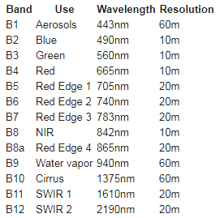

(from <https://explorer.earthengine.google.com/#detail/COPERNICUS%2FS2>)

* + 1. **Columns:** A number up to 12 specifies how wide the widget will be. 4 will create a square, larger numbers a rectangle. If not filled out, the widget will be a square.

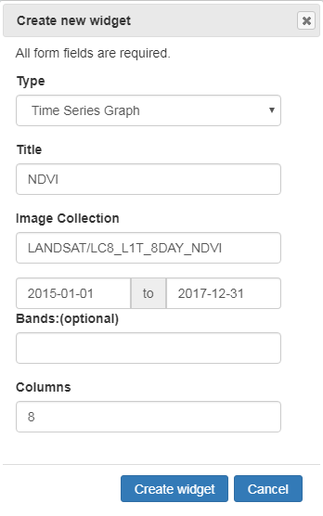

* + - 1. After setting the **NDVI** widget up, click **Create** widget.
      2. To see the changes in your new widget, you need to classify a plot to re-open the GEO-DASH window again.

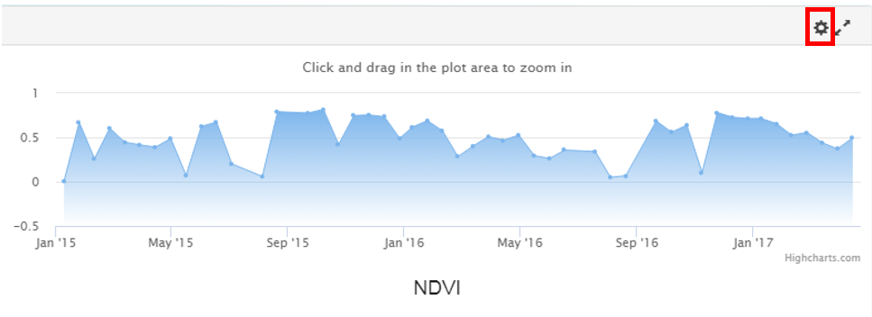

* + - 1. For editing or deleting you widget, click on the wheel icon.
  1. Project statistics
     1. You can see a project’s setup by going to **Home** and clicking on your institution name. A drop-down menu lists the projects. Click **Edit** on the project of interest to see the PROJECT DASHBOARD and PROJECT DESIGN.
     2. The **Project Stats** arelisted under the PROJECT DASHBOARD. It gives an overview over members, contributors, the points classified, plots flagged as bad, and the date the project was created, published and closed.
     3. The **Project Stats** are alsoshown when starting data collection, featuring the percent of assigned, flagged as well as completed plots and total plot number.

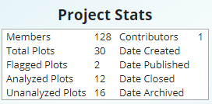

* 1. Download your data
     1. Click on the **Home** page on your institution to open the listed projects. Click **Edit** next to the project to get to the PROJECT DASHBOARD. Under Project Management, click on
        1. **DOWNLOAD PLOT DATA** to download your data as a plot summary in a csv file format.
        2. **DOWNLOAD SAMPLE DATA** will prepare a download of your raw data, where information for each point within each plot is stored in its own row.
     2. The csv file will download with the following structure. Note the columns will vary depending on which download structure you have selected.
        1. *PLOT_ID* stands for the sample number.
        2. SAMPLE_ID is only available if you selected the Download Sample Data button. Each sample ID represents the unique point within the plot.
        3. *CENTER_LON* and *CENTER_LAT* are the geographic coordinates of the center of your sample, which has *RADIUS_M*.
        4. *FLAGGED* will say FALSE for a sample where data was collected or not analyzed yet, while TRUE means the quality of the background map was too bad to label the samples (due to clouds or poor image resolution).
        5. *ANALYSES* will show 1 for plots that are analyzed, and 0 stands for not analyzed. If more than one person assigned a label to a plot, this column will indicate the number of analysts that have assessed the plot.
        6. USER_ID includes the user id of the person that classified the plot.
        7. *SAMPLE_POINTS* stand for the number of samples in each plot.
        8. *USER_ASSIGNMENTS* is the unique (numeric) ID of the user that collected the information for any given plot.
        9. *FOREST, WATER* and *OTHER columns* indicate the fractional coverage of each value, or land cover label, per plot, listed as a percent.
     3. Data downloaded from CEO will be in WGS84 EPSG:4326 format.
  2. Add and manage users
     1. The administrator of an institution can add and manage its users. Go to **Home** and select your institution.
     2. To add a user, enter the user’s email address in the **Users** tab and click **ADD USER.**
     3. A pop-up window notifies you that the user [email address] has been given the role ‘member’. Click **OK**.
     4. The user’s email address appears now in the Users panel. Using the drop-down menu, the role can be changed from **Member** to **Admin** or **Remove** to remove the user from the list.
  3. Validation set construction
     1. Coming soon