Project Name : AwesomeQA
Module Name : User Registration
Requirement ID : Req001_AwesomeQA_Regs
Base URL :
https://awesomeqa.com/ui/index.php?route=account/register
Description:
The user should be able to perform registration in awesomeqa registration page and get the valid credentials to login post to that.

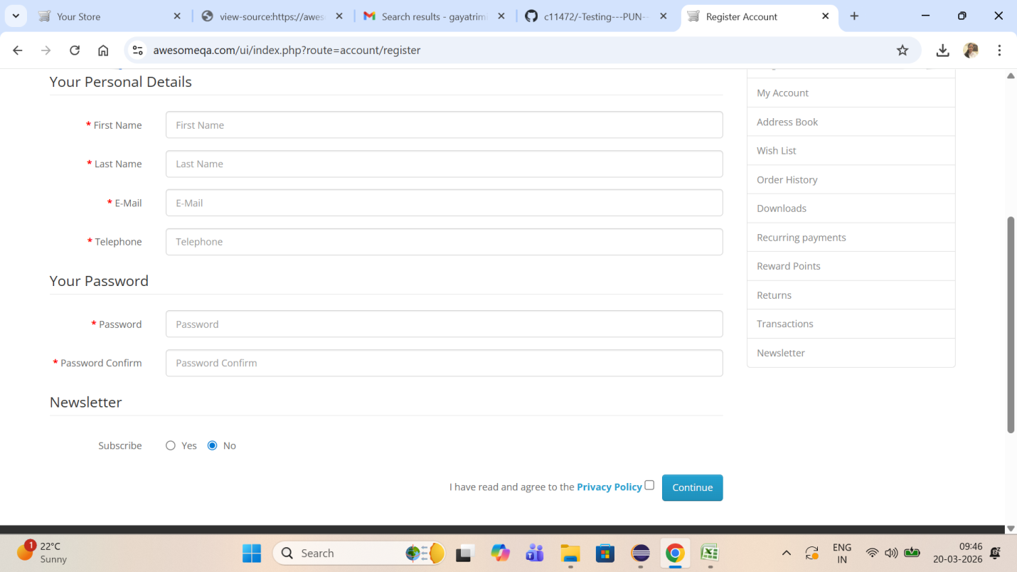
First Name:
- First name should be within 20 characters
- No special symbols and numbers allowed
Last Name:
- Last name should be within 15 characters
- No special symbols and numbers allowed
Email:
- Email should have a valid domain
- Email id must be within 30 in size
Telephone Number:
- Starts with 91
- 10 digits
Password:
- Mixture of at least one Upper case , One lower case , one special symbol , one number
- Size max – 10
Confirmed Password:
- Same as password
Subscribe : Yes or No radio button
Privacy Policy : Mandatory – check box
Continue:
By clicking on continue button the user can register successfully.

