Scenario-1
Use any login form and automate for the below users to login and update the status respectively using TestNG @DataProvider
email | password | status
gayatrimis2@gmail.com | gayatrimis2@gmail.com | Pass
Testuser34 | C1453 | Fail

Scenario-2:
Open google search page and enter the search string as “ Java Complete Reference “.
Automate the below steps
2.1 Count all the options available
2.2 Extract all the options and display in console
2.3 Click on the third option to be searched

Reference page :

Test Xpath :
/html/body/div[1]/div[3]/form/div[1]/div[1]/div[2]/div[4]/div[2]/div[1]/div/ul/li

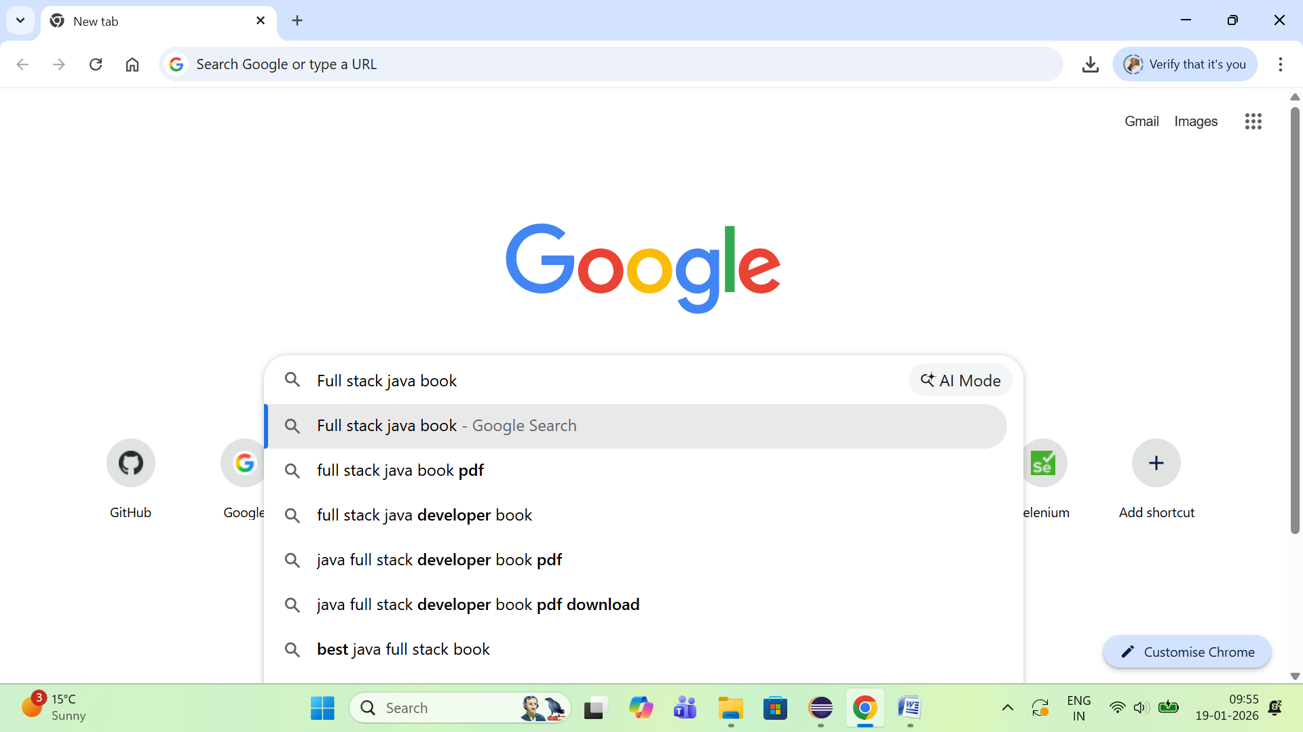

Scenario-3:
Web Table automation .

https://www.w3schools.com/html/html_tables.asp
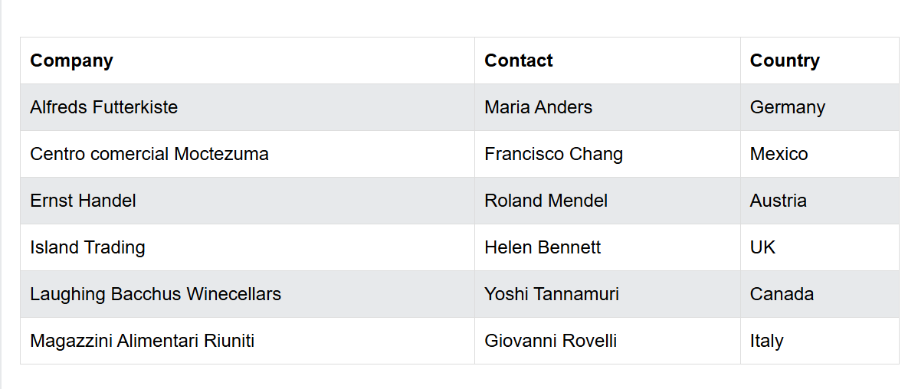

Xpath for webTable
//table[@id='customers']//tr --- including headers
//table[@id='customers']//tr/th --- headers
//table[@id='customers']//tr/td
Specific row:
//table[@id='customers']//tr[3]
//table[@id='customers']//tr[2]/td[3] – specific data
3.1 Extract all the data from the table including column names
3.2 Validate the column names are correct or not
3.3 Extract only table rows except columns
3.4 Count the number of rows available in the table
3.5 Count the number of columns available in the table
3.6 Check if the country India is present in the table or not
3.7 Extract a specific value and validate.

Note :
- Nested table scenarios
- Multiple tables based scenarios

WebElements to automate :
1.Dropdown List
2. Alert Handling
3. Drag and Drop
4. Frames
5. Actions documentation

Scenario-4:
Topic : Select class
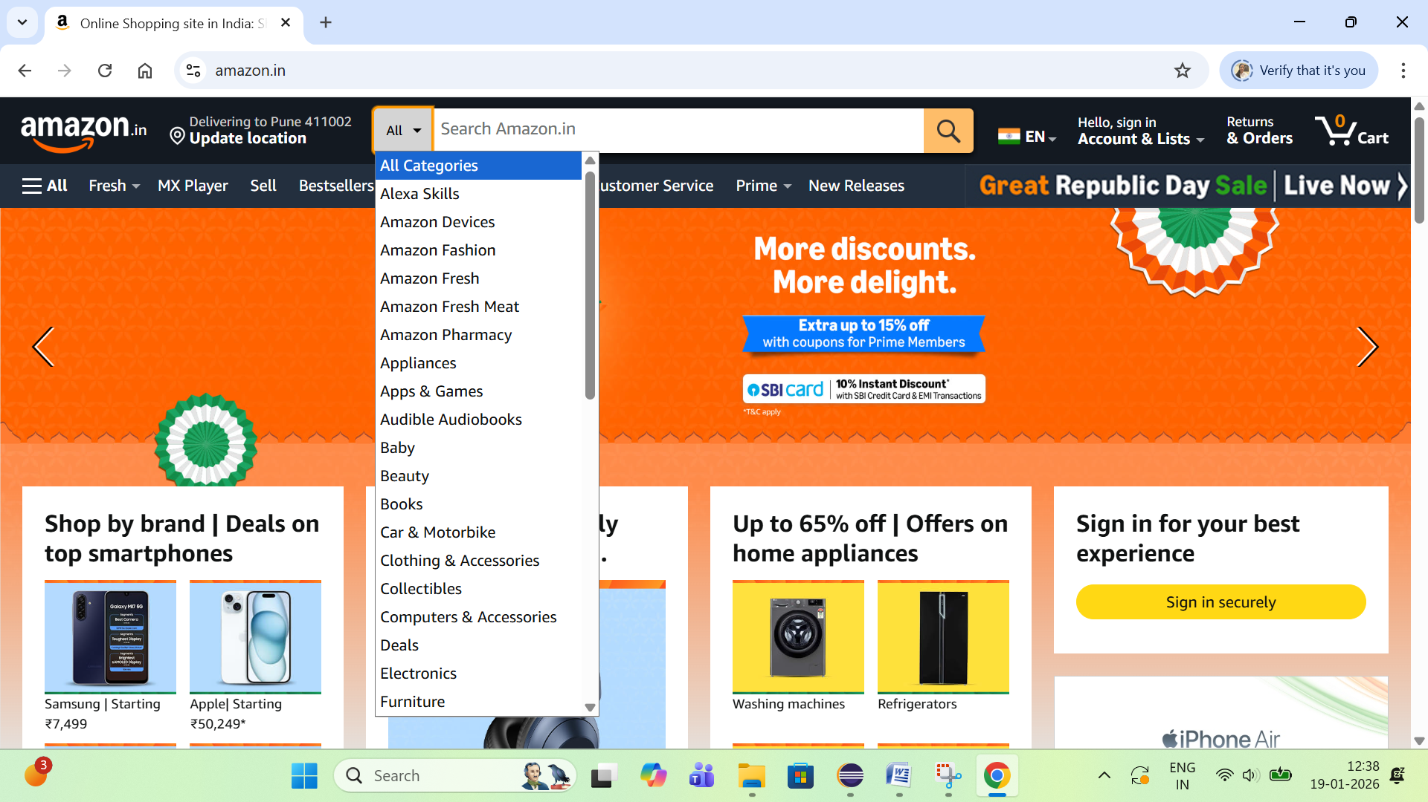
4.1 : get all the options present in dropdown and validate whether a specific options is present or not.
4.2: Select the third option present in dropdown list
Sel.SelectByIndex(3);
4.3: Select the option “Baby” from the list
Sel.SelectByVisibleText(“Baby”);

Scenario-5:
Alert Interface :

Reference screen :
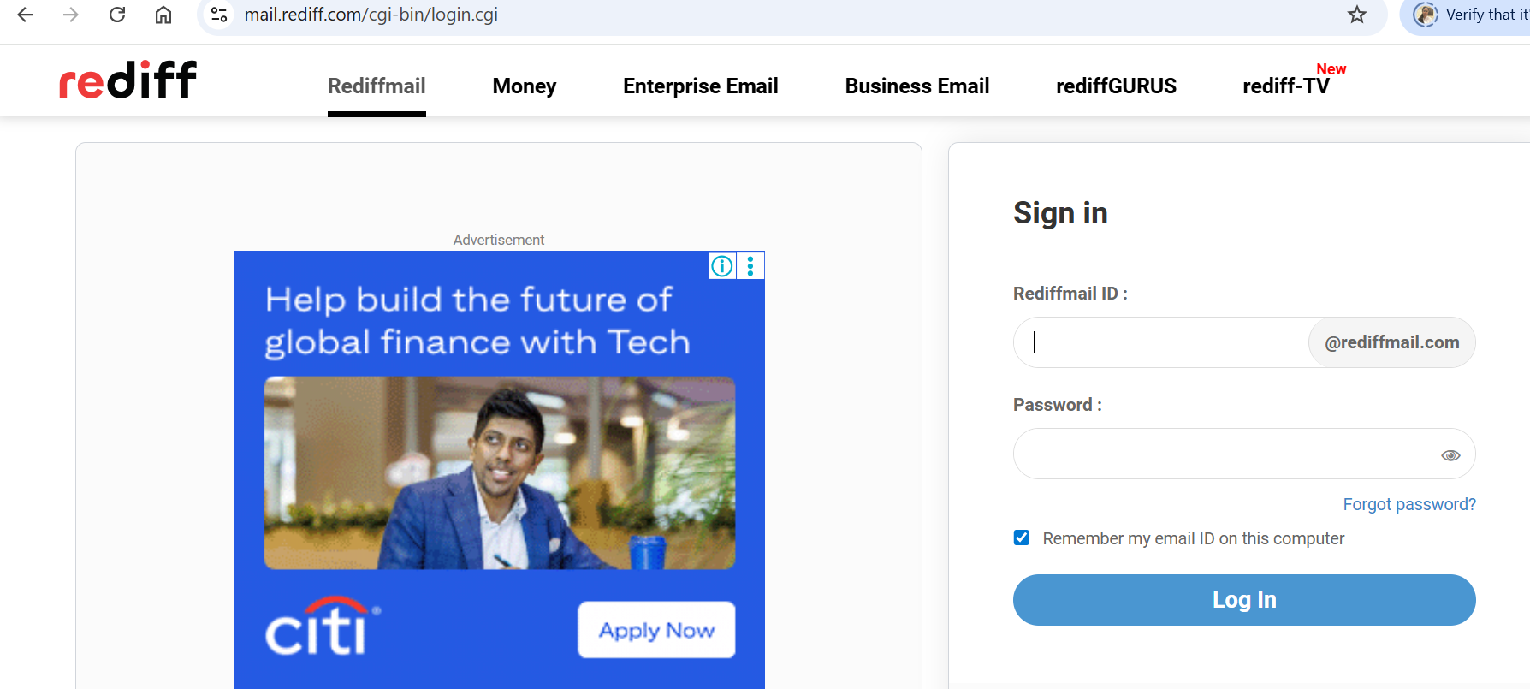
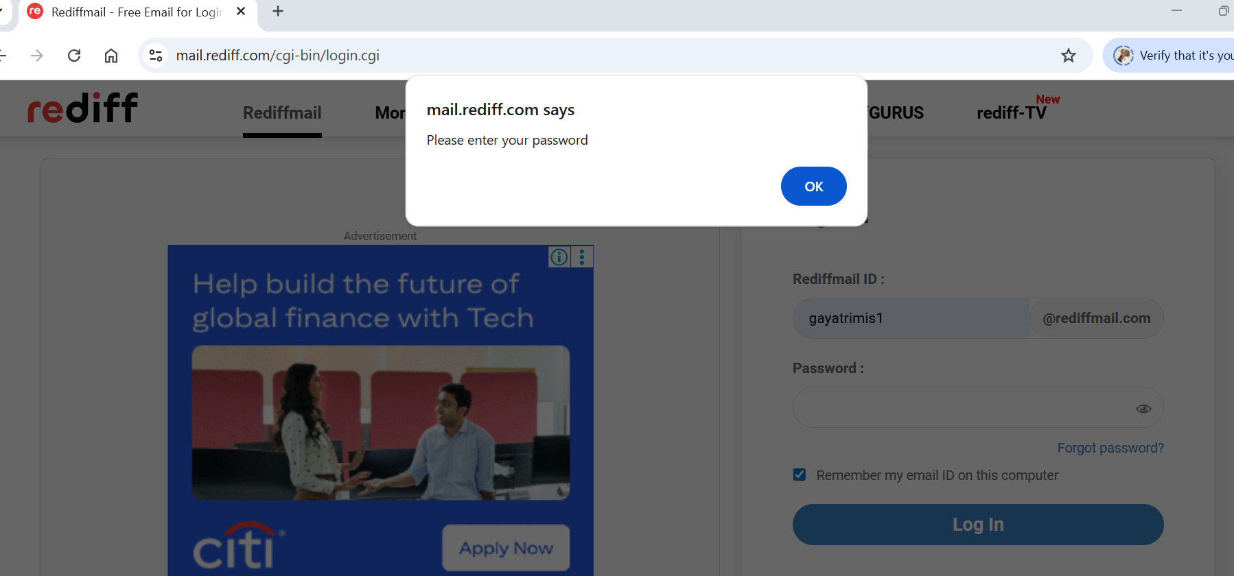

Steps:
- Launch the rediff login form
- Enter the user name
- Click on login
- Handel the alert
- Enter the password

