Topics :
SendKeys method to send the test data
WenElement
TagName
findElement
FindElements
Web scrapping using getText
WebElements methods – click ,clear,sendKeys
List implements in web scrapping

Day-2 :

Scenario-1:
Automate the test case for Login Scenario in awesomeqa.com/ui app using both valid and invalid test data.

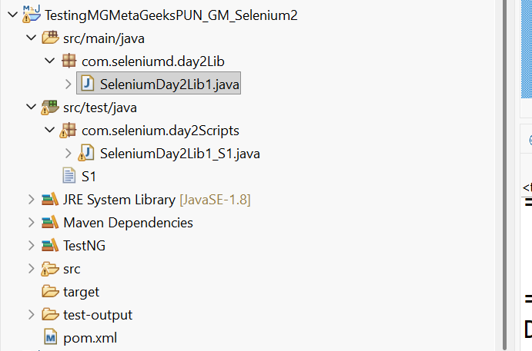

Library:
package com.seleniumd.day2Lib;

import org.openqa.selenium.By;
import org.openqa.selenium.WebDriver;
import org.openqa.selenium.WebElement;
import org.openqa.selenium.interactions.Actions;

public class SeleniumDay2Lib1 {
WebDriver driver;
// init method
public void init(WebDriver driver) {
this.driver=driver;

}

public String Launch_OcartLogin() {

driver.get("https://awesomeqa.com/ui/index.php?route=account/login");
String LoginPageTitle=driver.getTitle();
return LoginPageTitle;
}

public String Perform_Login_Valid(String email,String password) throws InterruptedException {

driver.findElement(By.xpath("//input[@id='input-email']")).sendKeys(email);
//driver.findElement(By.xpath("//input[@id='input-email']")).sendKeys("gayatrimis2@gmail.com");

driver.findElement(By.xpath("//input[@id='input-password']"))
.sendKeys(password);
driver.findElement(By.xpath("//input[@type='submit']")).click();
String confirmation_message=driver
.findElement(By.xpath("//h2[contains(text(),'My Orders')]"))
.getText();
Thread.sleep(4000);
Actions act = new Actions(driver);
WebElement el =
driver.findElement(By.xpath("//*[@id='top-links']/ul/li[2]/a/i"));
act.moveToElement(el).click().build().perform();
//driver.findElement(By.xpath("")).click();

Thread.sleep(20000);
// click on Logout
WebElement el1 =
driver.findElement(By.xpath("(//a[contains(text(),'Logout')])[1]"));
el1.click();
Thread.sleep(3000);

return confirmation_message;

}

public String Perform_Login_Invalid(String email1,String password1) throws InterruptedException {
/*WebElement el_continue = driver.findElement(By.xpath("//*[contains(text(),'Continue')]"));
Thread.sleep(2000);
el_continue.click();*/

WebElement el_AccountLink = driver.findElement(By.xpath("(//a[contains(text(),'Account')])[2]"));
el_AccountLink.click();
driver.findElement(By.xpath("//input[@id='input-email']")).sendKeys(email1);
//driver.findElement(By.xpath("//input[@id='input-email']")).sendKeys("gayatrimis2@gmail.com");

driver.findElement(By.xpath("//input[@id='input-password']")).sendKeys(password1);
driver.findElement(By.xpath("//input[@type='submit']")).click();
Thread.sleep(3000);
WebElement errmsg = driver.findElement(By.xpath("//*[@id='account-login']/div[1]"));
Thread.sleep(2000);
String confirmation_error_message=errmsg .getText();
return confirmation_error_message;
}
}

TestNG Script:
package com.selenium.day2Scripts;

import org.openqa.selenium.By;
import org.openqa.selenium.WebDriver;
import org.openqa.selenium.WebElement;
import org.openqa.selenium.chrome.ChromeDriver;
import org.openqa.selenium.interactions.Actions;
import org.testng.annotations.Test;

import com.seleniumd.day2Lib.SeleniumDay2Lib1;

import junit.framework.Assert;

public class SeleniumDay2Lib1_S1 {

WebDriver driver = new ChromeDriver();
// Class objects
SeleniumDay2Lib1 sd2lib = new SeleniumDay2Lib1();
//Expected Data
String ExpStr="My Orders";
String ExpError = "Warning: No match for E-Mail Address and/or Password.";

@Test(priority=1)
public void Test_Launch() throws InterruptedException {
sd2lib.init(driver);
sd2lib.Launch_OcartLogin();
Thread.sleep(3000);

}

@Test(priority=2)
public void Test_Login_Validate() throws InterruptedException {

String ActStr=sd2lib.Perform_Login_Valid("gayatrimis2@gmail.com"
,"gayatrimis2@gmail.com");//passing test data during method call
Assert.assertEquals(ExpStr, ActStr);

}

@Test(priority=3)
public void Test_LoginInvalid_Validate() throws InterruptedException {

String ActError = sd2lib.Perform_Login_Invalid("c344", "5573");// invalid data

Assert.assertEquals(ExpError, ActError);
}

}

Scenario-2:
Launch awesomeqa.com/ui application in chrome browser.
Count how many links are available in the home page.
Display all the link names in console using webscrapping.
Library:
//Count all the links and extract the names

public List Count_links_From_HomePage() throws InterruptedException {
List <WebElement> Links = driver.findElements(By.tagName("a"));
int LinkCounts= Links.size();

Thread.sleep(3000);
for(int i=1;i<LinkCounts;i++) {
String Link_names= Links.get(i).getText();
Thread.sleep(200);
System.out.println(Link_names);

}

return Links;
}

TestNG Script:
package com.AccessSeleniumDay1_Lib;

import java.util.Arrays;
import java.util.List;

import org.openqa.selenium.WebDriver;
import org.openqa.selenium.chrome.ChromeDriver;
import org.testng.annotations.Test;

import com.seleniumay1.lib.SeleniumDay1_CommonMethods;
import com.seleniumay1.lib.SeleniumDay1_Lib;

import junit.framework.Assert;

public class Awesome_TC_01 {
// create the browser instance
WebDriver driver=new ChromeDriver();

//Expected List

List ExpList = Arrays.asList("bbsr","urrtt");

//Object for Lib class
SeleniumDay1_CommonMethods pg0 = new SeleniumDay1_CommonMethods();
SeleniumDay1_Lib pg1 = new SeleniumDay1_Lib();

//Expected Test Data
String Exp_HomePgTitleIs="Your Store";

@Test(priority=1)
public void InvokeApp_Awesome() {
pg0.init0(driver);
pg0.Maximize_Browser_Window();
pg0.Delete_Cookeies_From_BrowserWindow();
pg1.init(driver);
pg1.InvokeAwesomeQaApp();
// String HomePgTitleIs = pg1.AwesomeHome_PageTitle();
// System.out.println("HomePgTitleIs" + " " + HomePgTitleIs);
}

@Test(priority=2)
public void Fetch_And_Validate_Title() {
String HomePgTitleIs = pg1.AwesomeHome_PageTitle();
System.out.println("HomePgTitleIs" + " " + HomePgTitleIs);

// Assertion for validating page title

Assert.assertEquals(HomePgTitleIs, Exp_HomePgTitleIs);
}

@Test(priority=3)
public void Count_Links_Test() throws InterruptedException {
List lstData=pg1.Count_links_From_HomePage();
//System.out.println("Total number of links : " + " " +cnt);
Assert.assertEquals(ExpList, lstData);

}

}

