Screen -1:

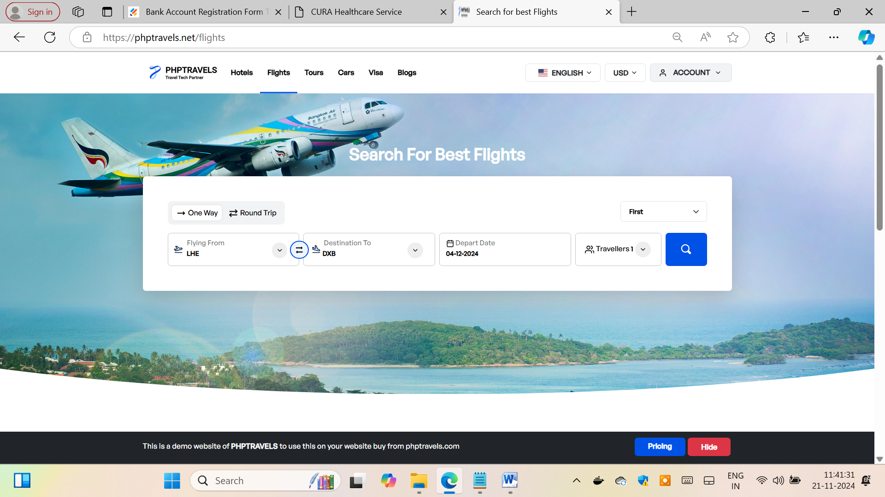

7 days ---

Search Fligt:

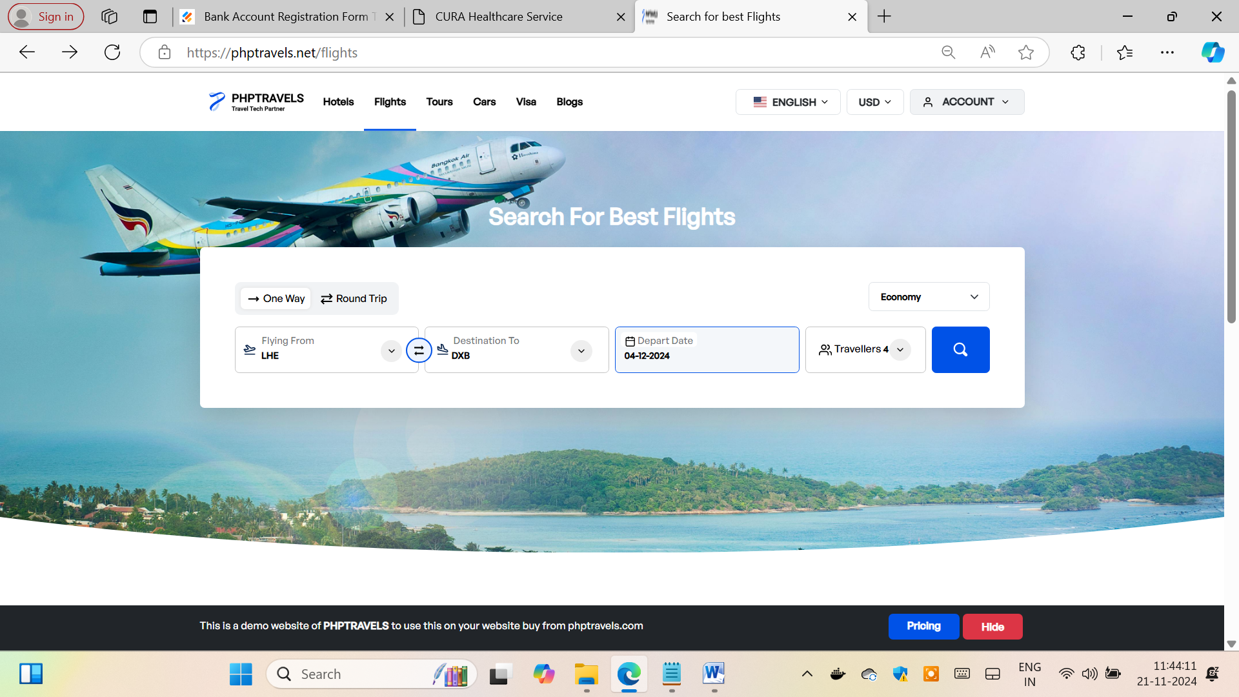

Expected :

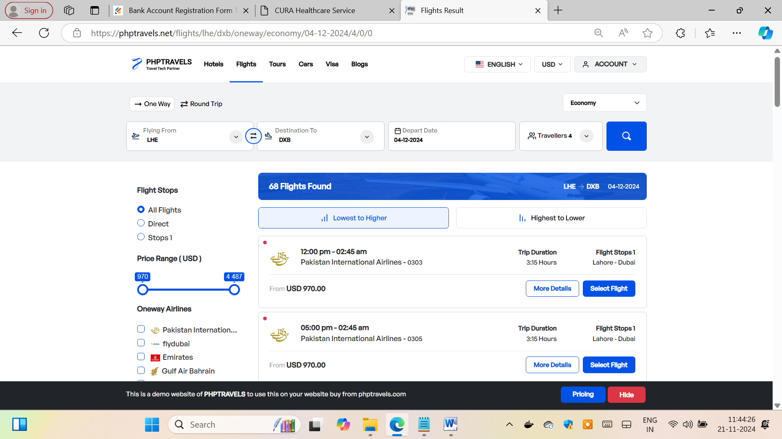

FirstName : Length 15

Should have only characters

LastName : Length 15

Should have only characters

DOB:

Day Range- 1 to 31

Month ---- 01 to 12

Year ----

Note the person should be more than 18 and less than 90.

Test Design :

User Stories

Test Scenarios

Test Cases

Steps

Test data