TagName

Img

A

Input

Select

Table

Scenario-1 – day2

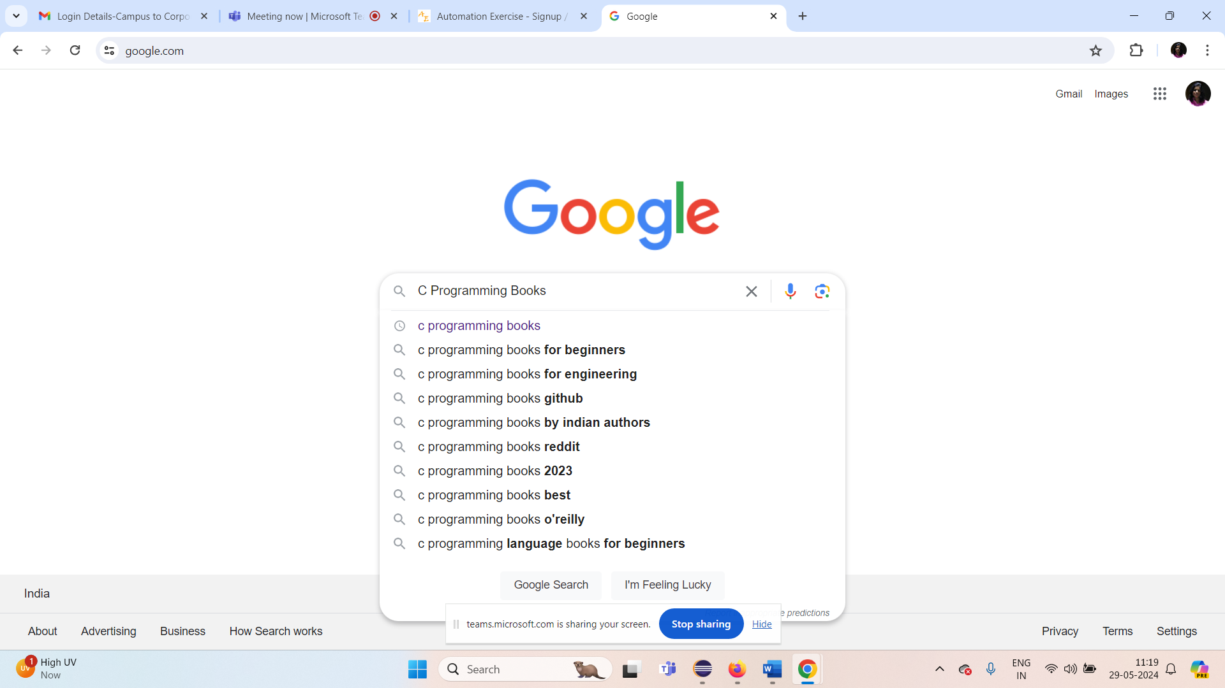

Get all the search options available … and count then display them in console.

findElements

List/ ArrayList ---- Locator

Customizing Xpath

lxp + I + rxp

WebElement

Scenario-3 :

Alert handling

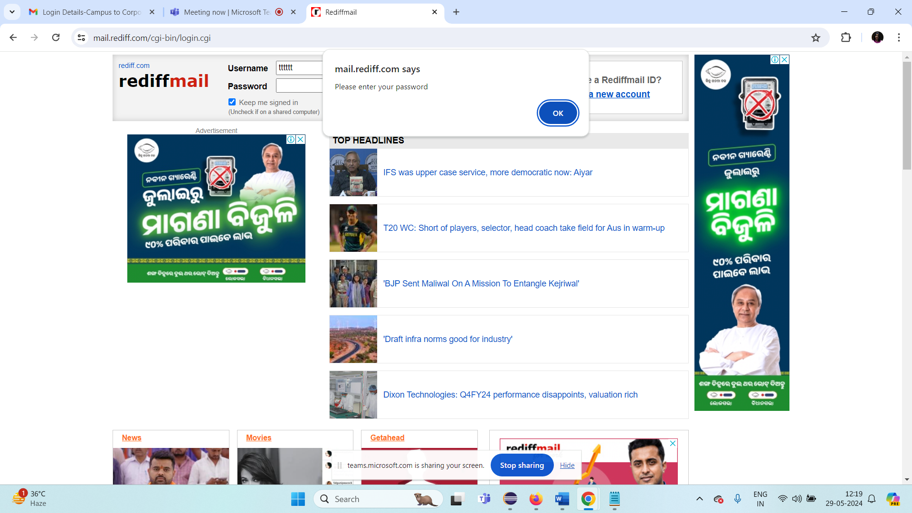

Webdriver wd = new FirefoxDriver();

FirefoxDriver implements WebDriver{

}

ChromeDriver implements WebDriver{

}

Edgedriver implements WebDriver{

}

Scenario-4:d.swtich

Working with frame

method – wd.switchTo().frame(!);

wd.switchTo().parentFrame();

library

Day-3

1. Drag and drop
2. WebTable automation
3. Scrolling automation
4. Java Script Executor