Basic sample project structure :
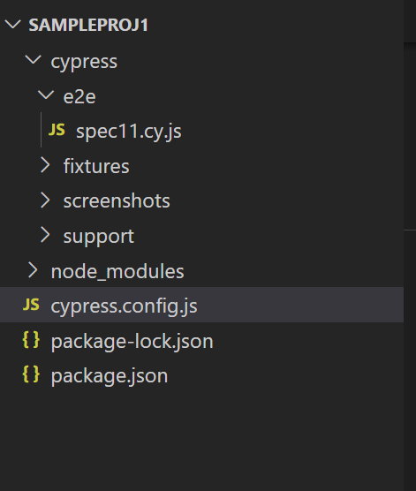
Spec11.cy.js:
/// <reference types="cypress"/>
describe('second test suite',() =>{

it('google test',function(){
cy.visit('https://www.google.com/')

})
})

Cypressconfi.js:
const { defineConfig } = require('cypress')
module.exports = defineConfig({
viewportHeight: 1080,
viewportWidth: 1920,
video: false,
e2e: {
baseUrl: 'https://www.google.com',
excludeSpecPattern: ['**/1-getting-started','**/2-advanced-examples'],
specPattern: 'cypress/e2e/**/*.cy.{js,jsx,ts,tsx}',
setupNodeEvents(on,config){

}

},
})

Open terminal
npx cypress open
Run the specification file
Or
npx cypress run –spec <relativepath>

