Working in GIT :

- Download Git SCM for windows.
I downloaded Git-2.37.3-64-bit.
Source Link : https://git-scm.com/download/win
- Copy the exe file to local drive from downloads to D:\Softwaresupdate\Git_SCM_Windows
- Install the setup… go with all default settings .
- After installation you can see gitbas like below screen
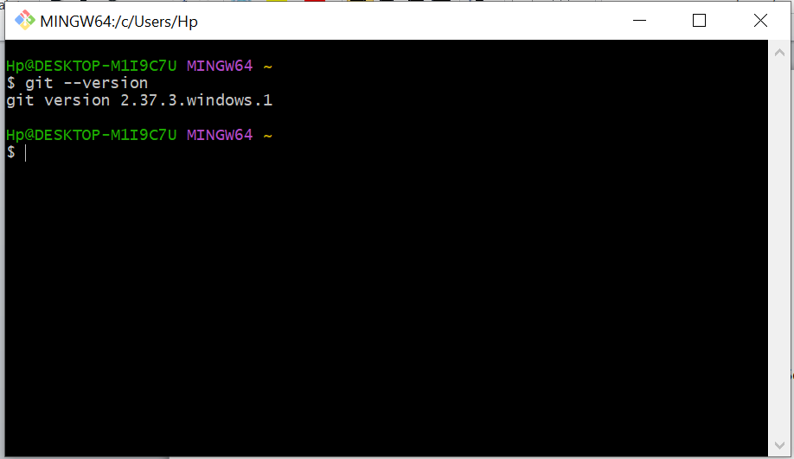
- Command to know the git version installed.
git - -version
You can see the git version installed as above screen o/p.
- To see the help command
git help config
or
git config –help
Click on enter
O/p is to see what config command does
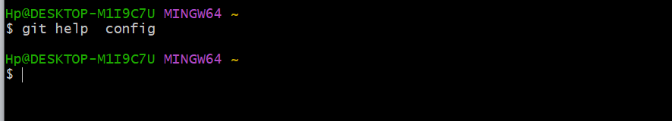

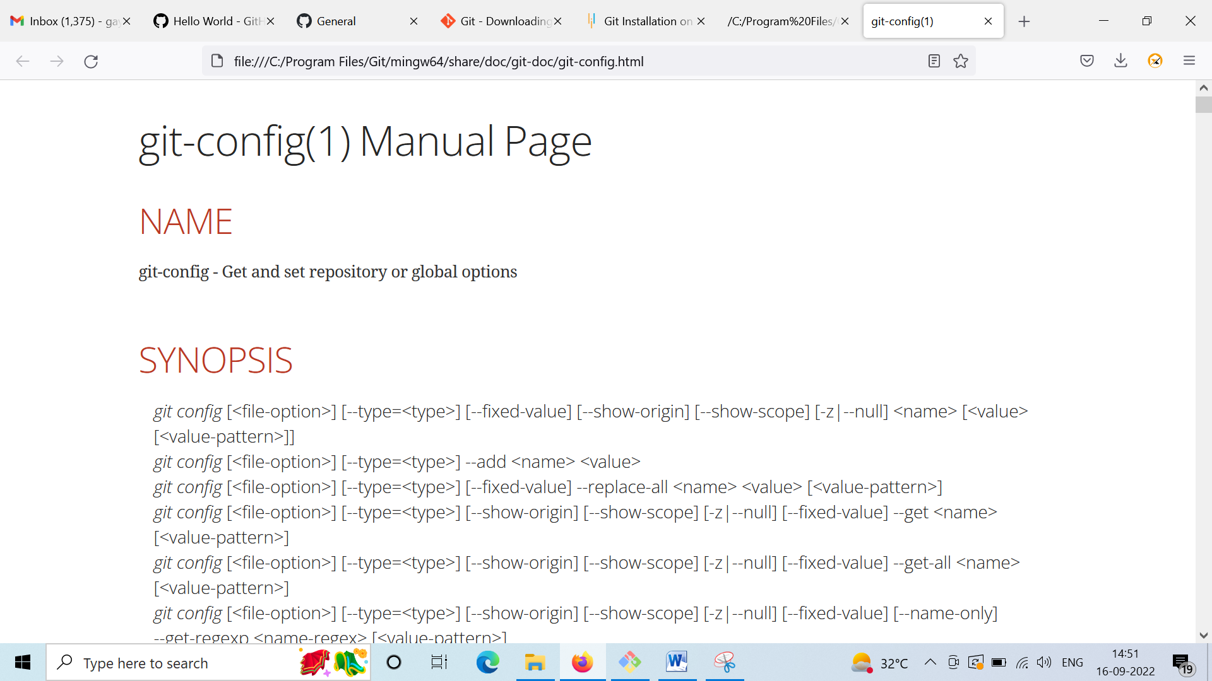

- Command to clear the screen

clear

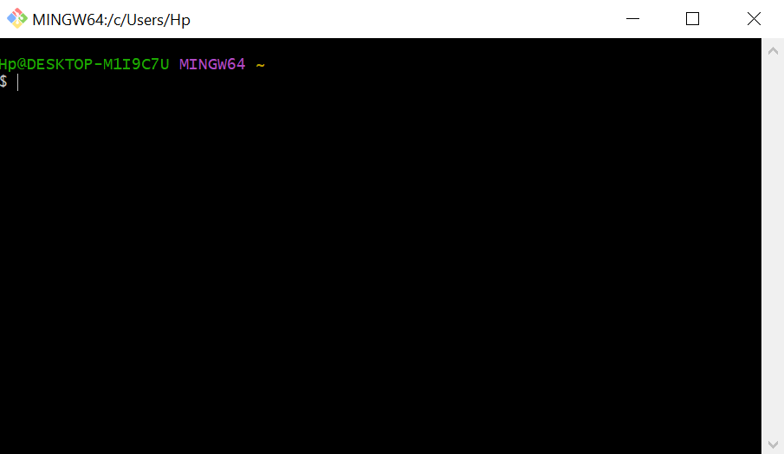

- Creating a local directory in your system
mkdir <directory name>

mkdir tutorial_git

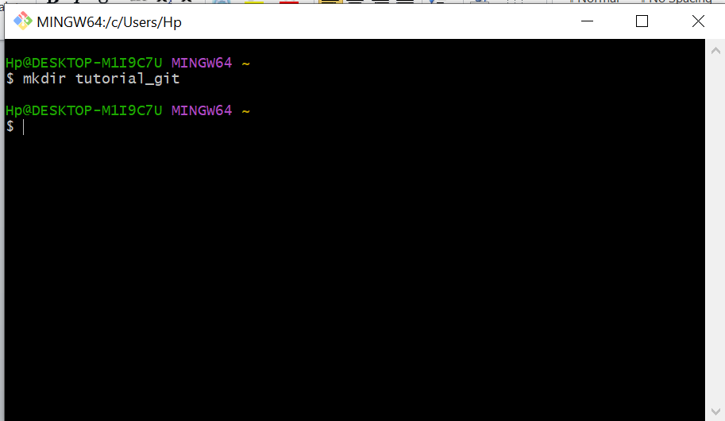

Move into the newly created directory
cd tutorial_git

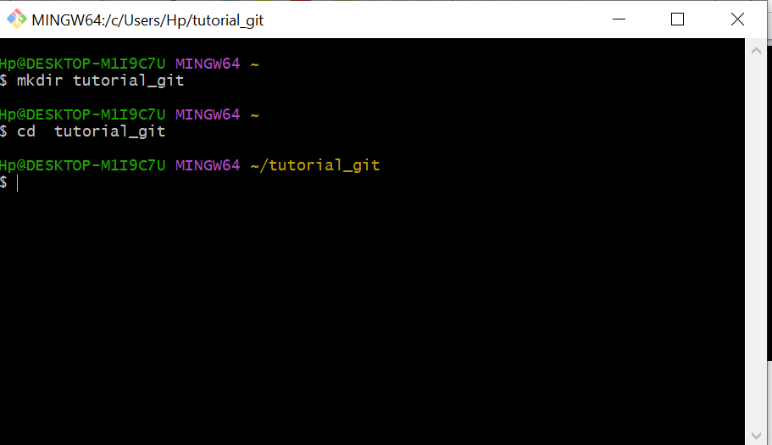

- Initialize the newly created directory

git init

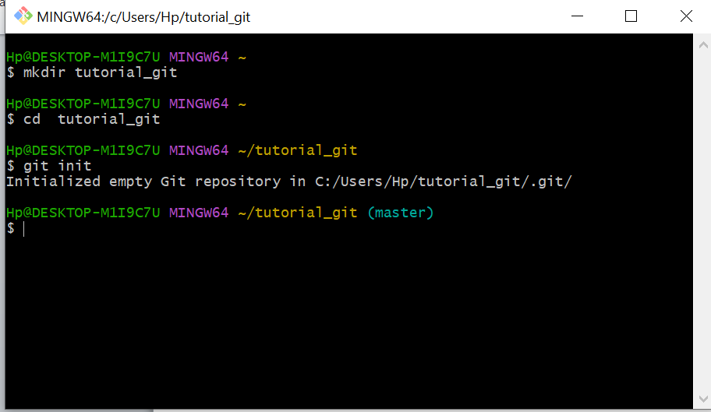

You can see the directory path as above screen image.

Traverse the path physically and check whether the folder is created.

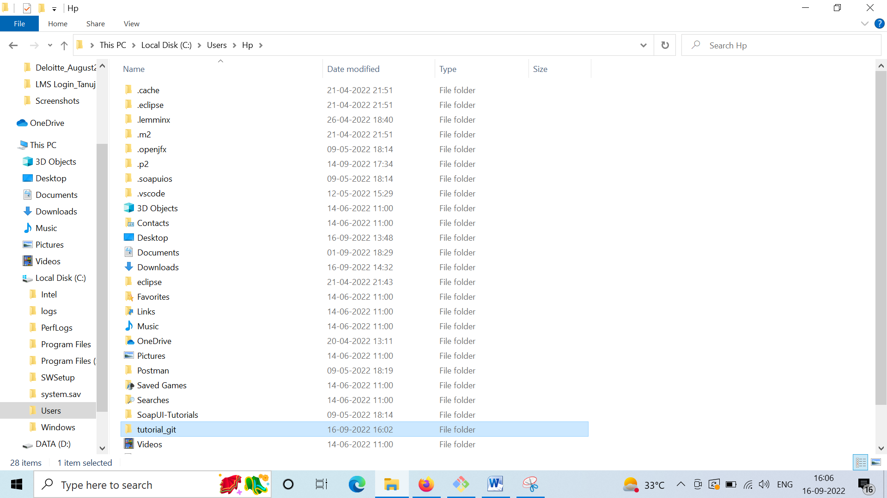

As you can see the tutorial_git folder which is an empty folder.

Add a file to the folder.

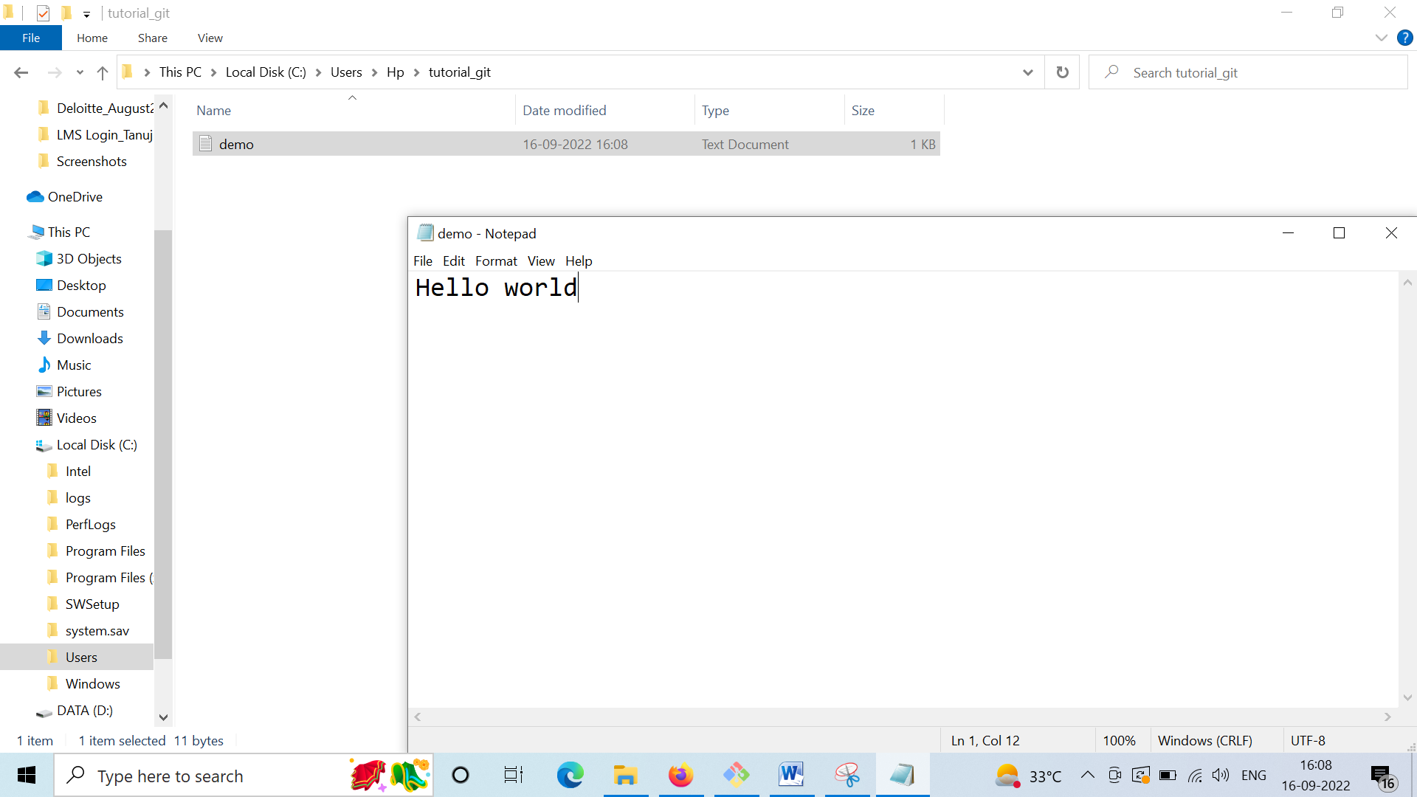

Demo.txt

Check the status command in gitbass

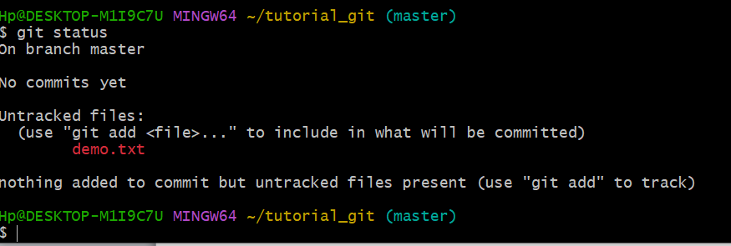

Add the file to the current directory using git add command

git add demo.txt

o/p
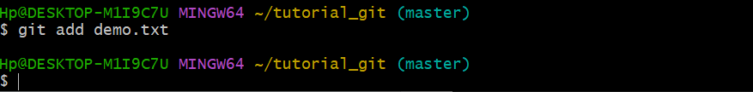

Execute commit command

git commit -m “the demo.txt committed”

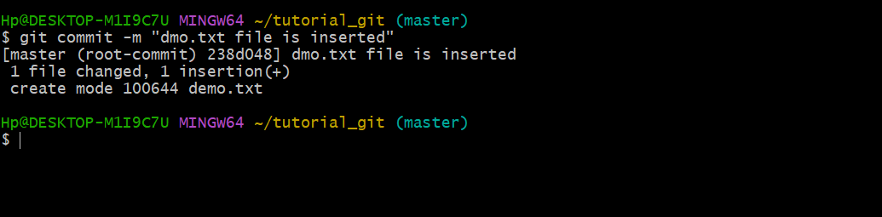

Add another word document

Keep the file in place.
git add GITDocument.doc

git commit -m “This is the initial draft fro git commands”

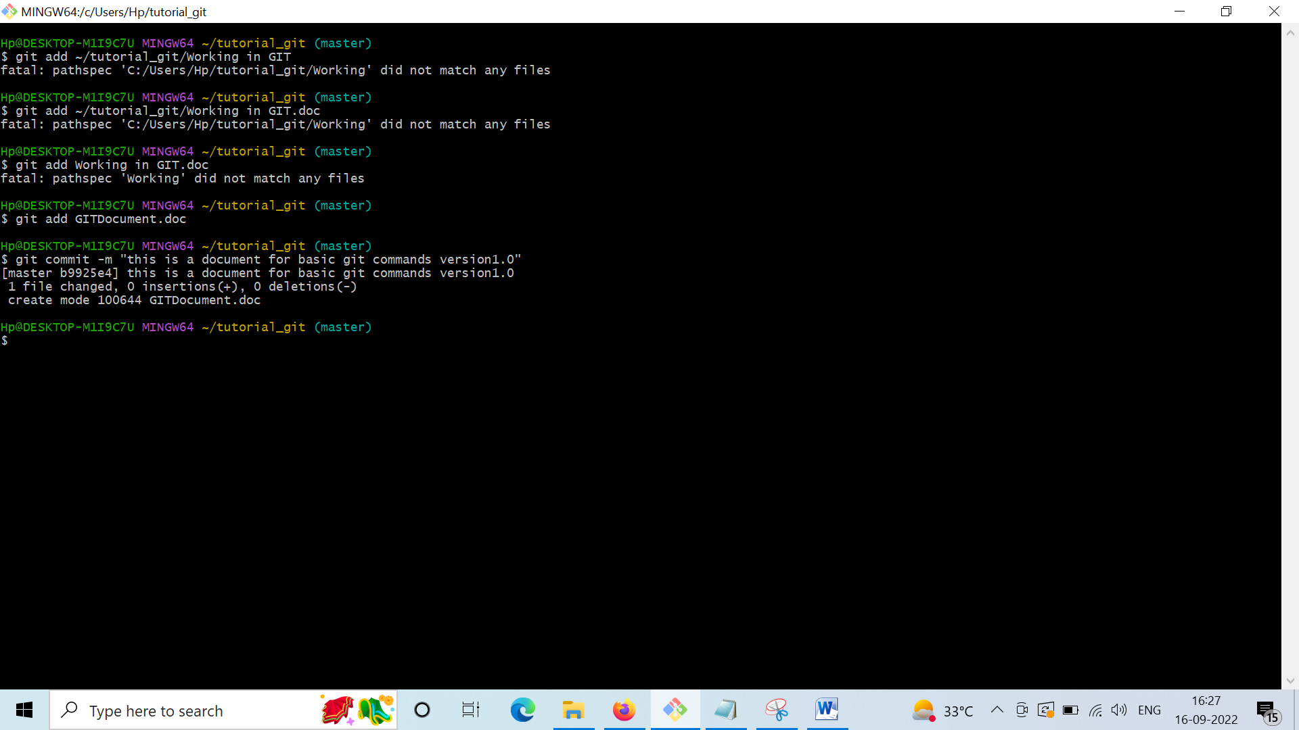

Link a git to the github account :

git config --global user.username gayatrimis1@gmail.com -github

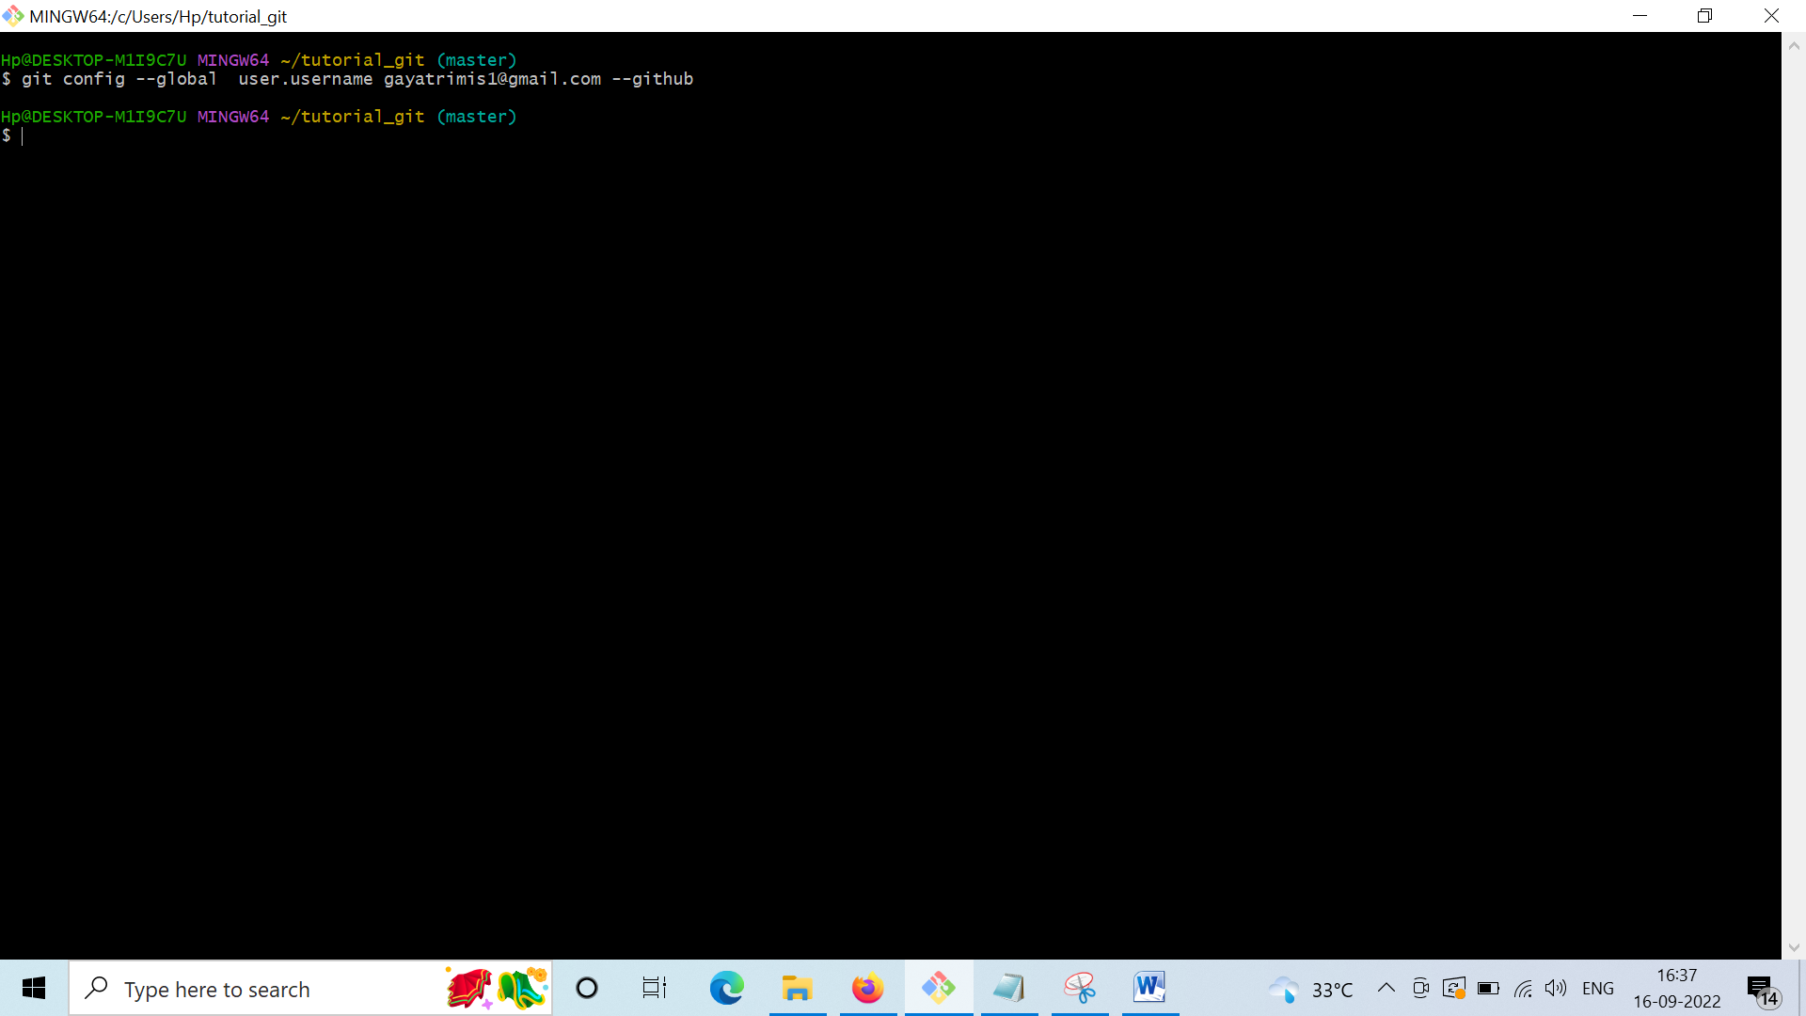

Now open the github and create a new repository in github.

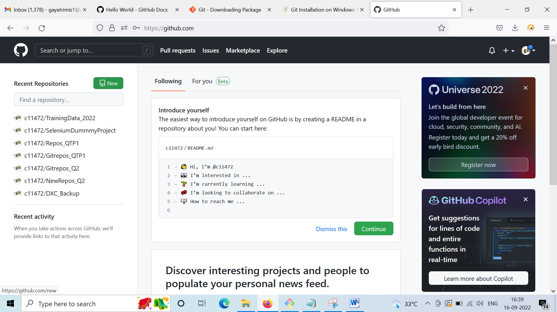

Click on New to create a repository.
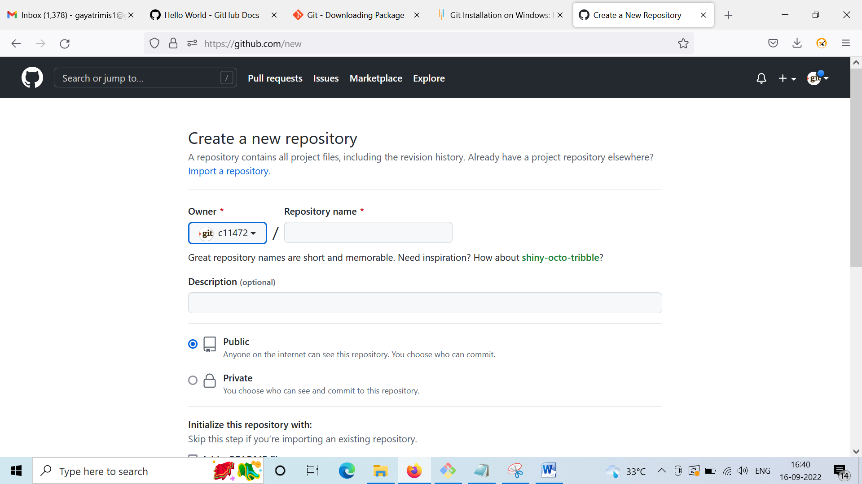
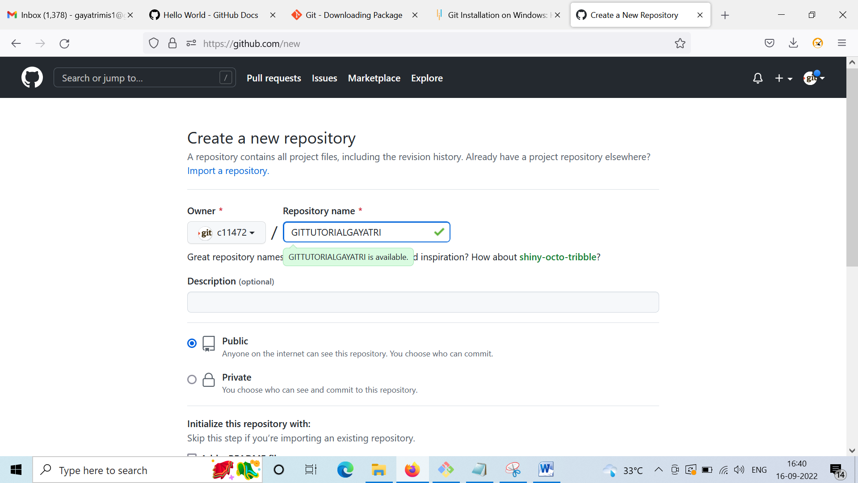

Click on Create to create repository.

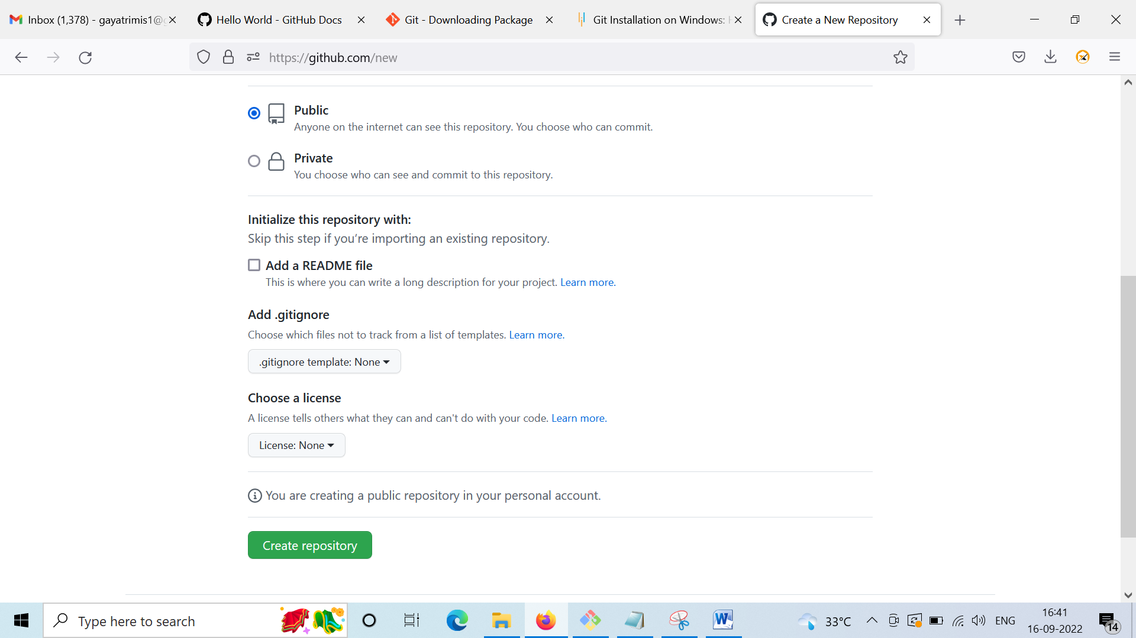

The repository will be created.
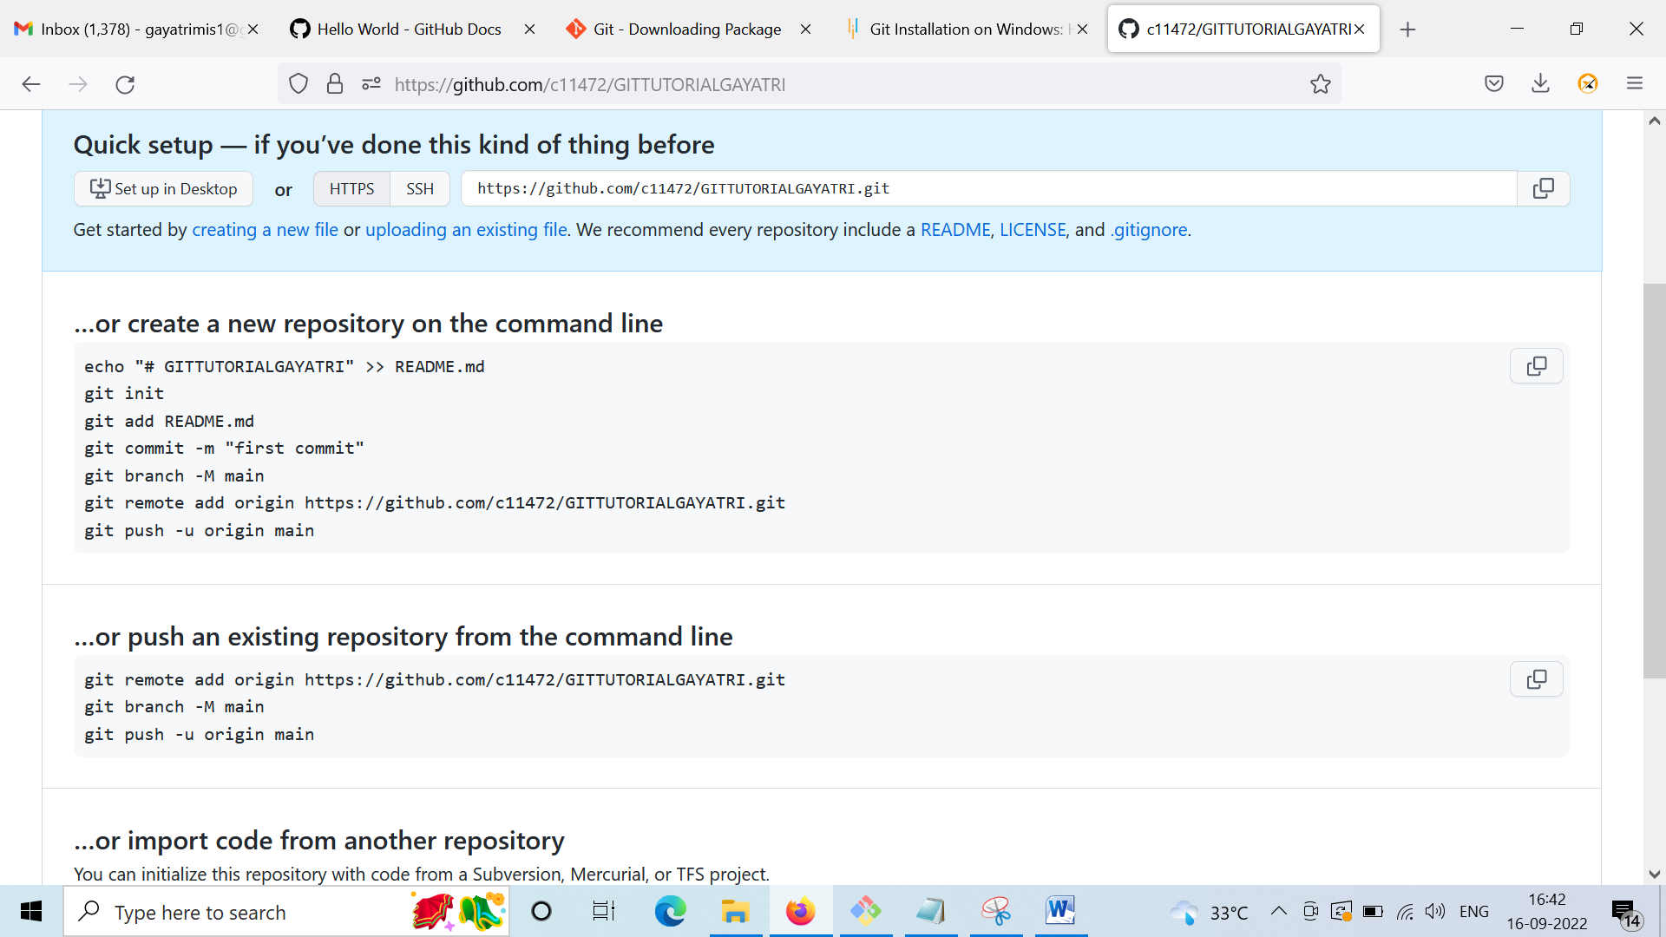

To link the remote repository in git ..

Copy the https / ssh link

Go to gitbass

Execute the command
git remote add origin <link>

git remote add origin https://github.com/c11472/GITTUTORIALGAYATRI.git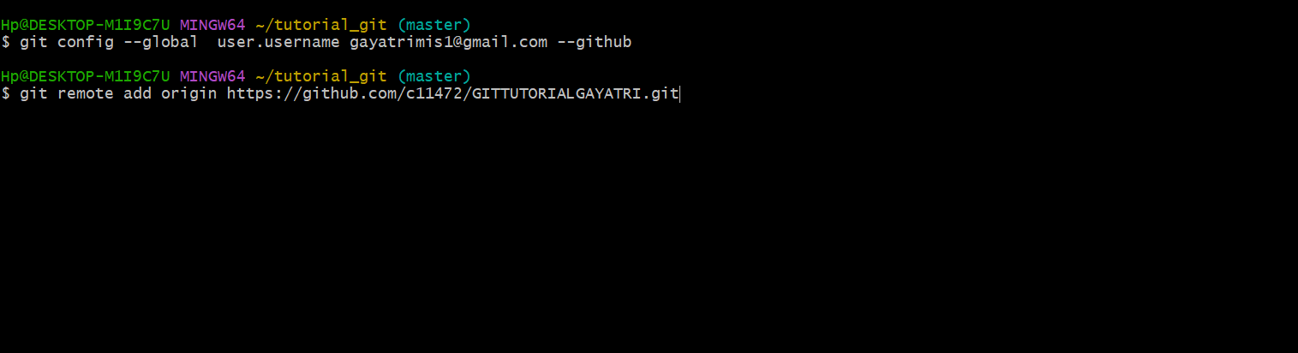

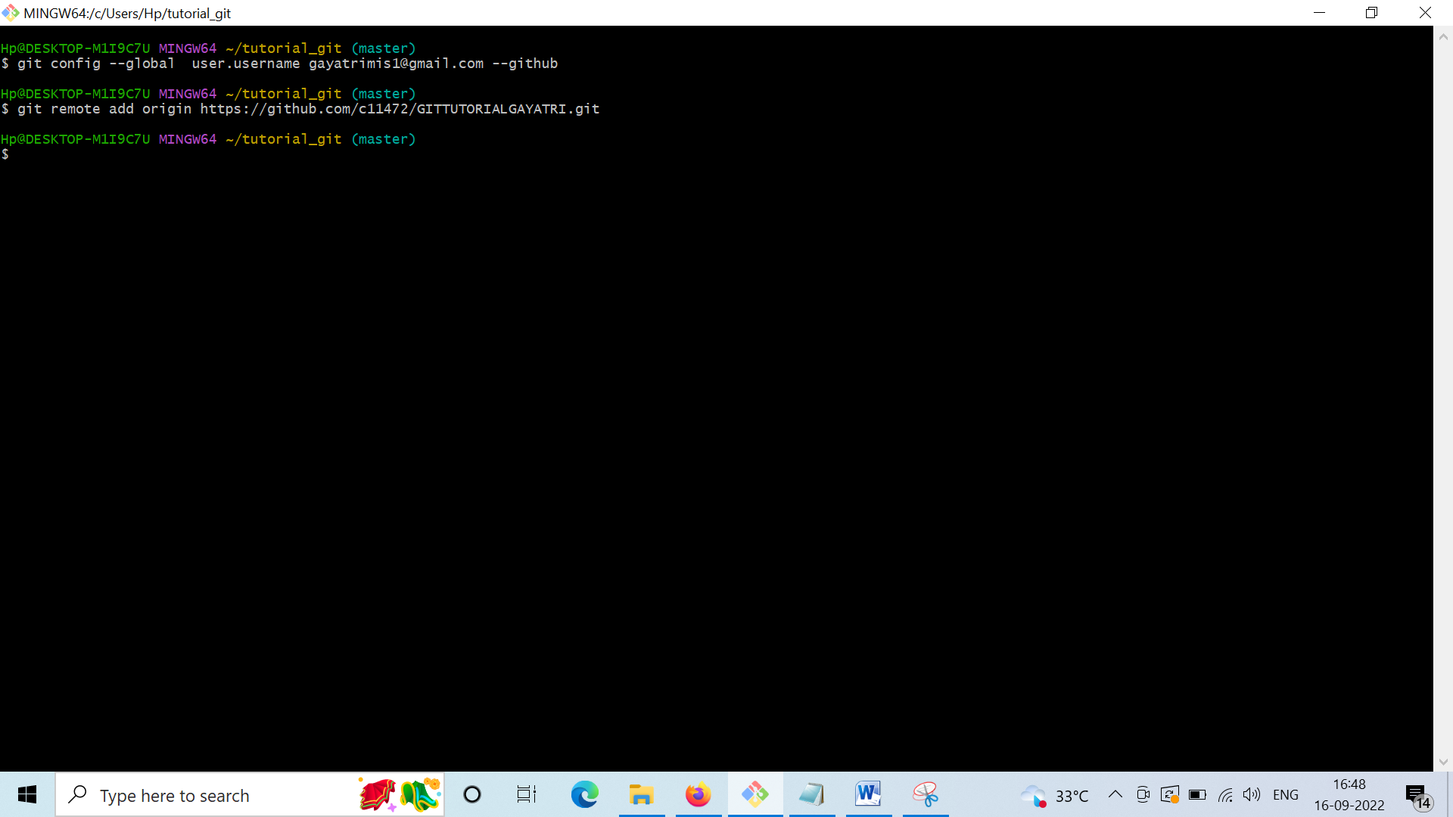

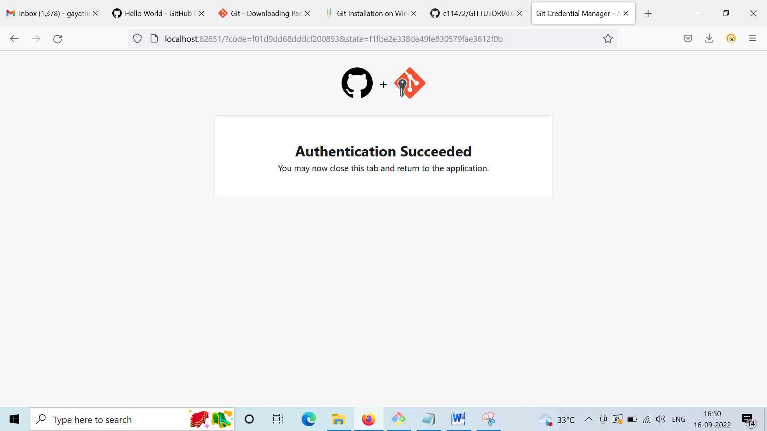

Check the repository in Github now.

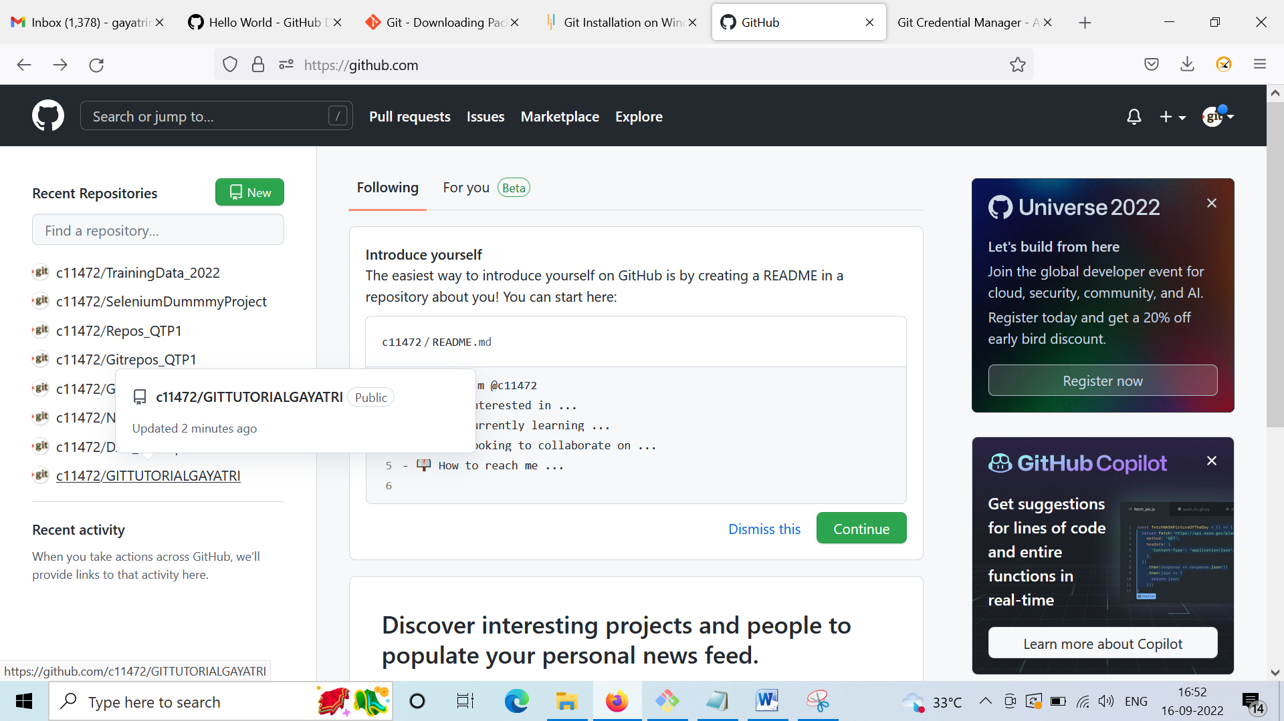

This repository got two files ..from origin

