BDD Components
- Featurefile --- .feature
- Stepsdefinitions file --- .java
- Testrunner – junit file --- template – shared--- .java
- Properties file – src/test/java – source folder

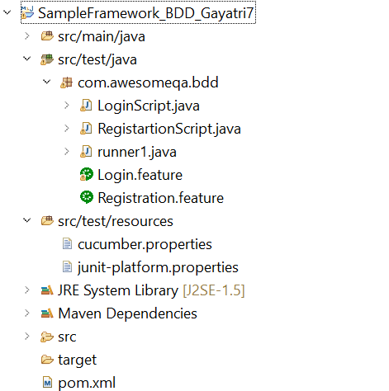
Login.feature
Feature: Addtiton test in calculator
@testadd
Scenario: awesomeqa login
Given The user is in login page
When the user enters the email

LoginScript.java //stepsdefinition

public class LoginScript {

//input[@id="input-email"]
//input[@id="input-password"]
//*[@value="Login"]

// configure WebDriver
WebDriver wd;
@Given("The user is in login page")
public void loginpage() {
wd=new FirefoxDriver();
wd.get("https://awesomeqa.com/ui/index.php?route=account/login");
}
@When("the user enters the email")
public void comparetest() {
wd.findElement(By.xpath("//*[@id=\"input-email\"]")).sendKeys("test123");}}
Login.feature
runner1.java
import static org.junit.Assert.*;
import org.junit.Test;
import org.junit.runner.RunWith;
import io.cucumber.junit.Cucumber;
@RunWith(Cucumber.class)
public class runner1 {
}

Dependencies:
<dependency>
<groupId>org.seleniumhq.selenium</groupId>
<artifactId>selenium-java</artifactId>
<version>4.9.0</version>
</dependency>
<dependency>
<groupId>junit</groupId>
<artifactId>junit</artifactId>
<version>3.8.1</version>
<scope>test</scope>
</dependency>
<!-- https://mvnrepository.com/artifact/io.cucumber/cucumber-java -->
<dependency>
<groupId>junit</groupId>
<artifactId>junit</artifactId>
<version>4.13</version>
<scope>test</scope>
</dependency>
<dependency>
<groupId>io.cucumber</groupId>
<artifactId>cucumber-java</artifactId>
<version>6.11.0</version>
</dependency>
<dependency>
<groupId>io.cucumber</groupId>
<artifactId>cucumber-junit</artifactId>
<version>6.11.0</version>
</dependency>

