**To get the maximum between three numbers**

**Algorithm**

1. **Start**.
2. **Input**: Three numbers a, b, and c.
3. **Compare**:
   * If a >= b and a >= c, then a is the maximum number.
   * Else, if b >= a and b >= c, then b is the maximum number.
   * Else, c is the maximum number.
4. **Output**: Print the maximum number.
5. **End**.

Pseudo Code :

BEGIN

// Step 1: Input three numbers

INPUT a, b, c

// Step 2: Compare the numbers

IF a >= b AND a >= c THEN

max = a

ELSE IF b >= a AND b >= c THEN

max = b

ELSE

max = c

END IF

// Step 3: Output the maximum value

PRINT "The maximum value is:", max

END

Flow Chart :

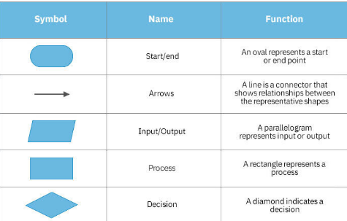

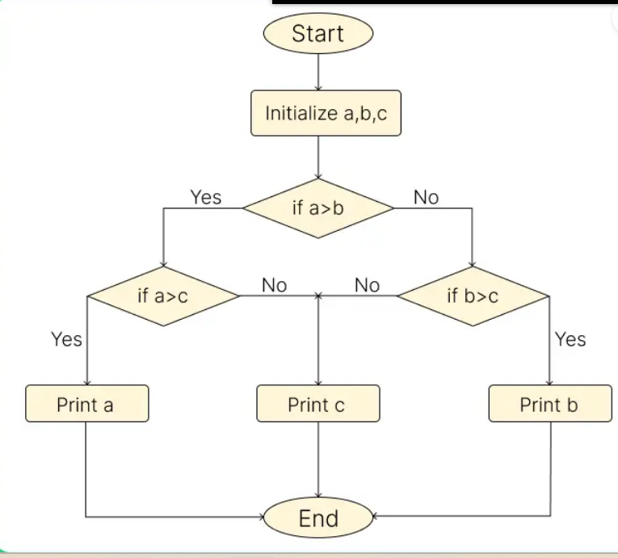

**Scenario-1**

**To get the average of the numbers present in a single dimensional array .**

**int num[] = {12,78,56,67,5,2} ; // 36.6 or 37**

**Scenario - 2**

**Write an algorithm to get the factorial of the input number .**

**5**

**5*4*3*2*1 = 120**