V & V Model :
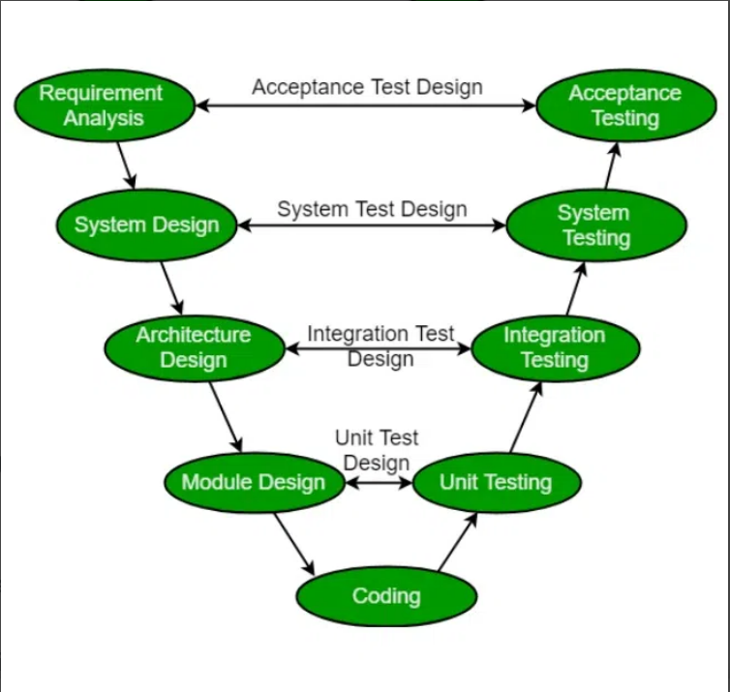

Waterfall Model :
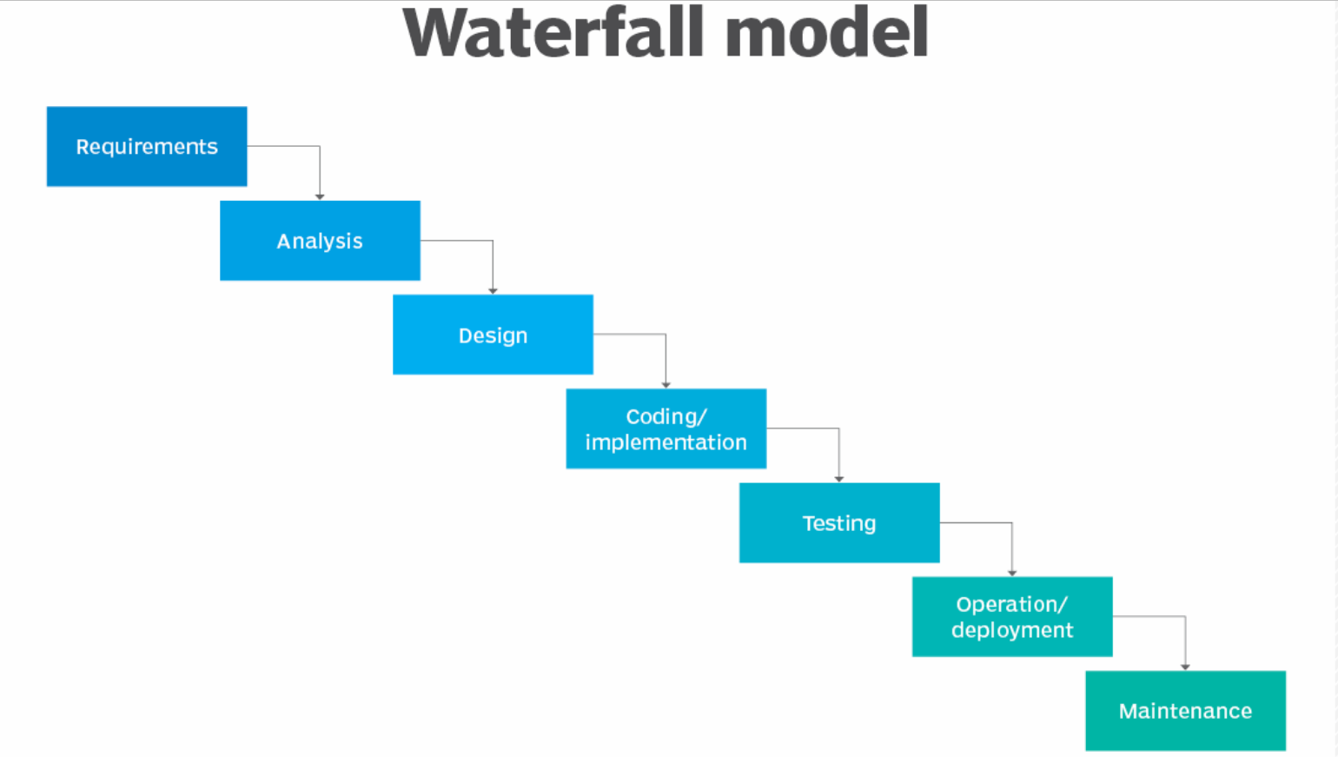

Phases in waterfall model :
Phase-1 : Requirement Gathering And Documentation
Phase-2 : Analysis
Phase -3 : Design
Phase-4 : Coding
Phase-5 : Testing
Phase – 6 : deployment
Phase – 7: Maintenance
Challenges in waterfall model :
- Making changes are difficult
- Does not focus on end user or client -> Creating a value in customer prospective
- The testing phase is delayed until most of the project is completed
- Measuring the progress within the changes is difficult
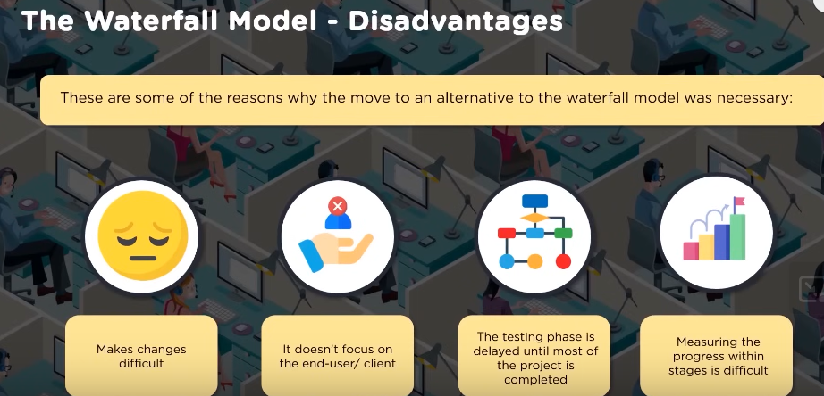

Basic meaning of Agile .
Go faster
Be flexible
Respond to changes --- Address the change request from the client immediately
Agile introduced in 2001

Agile manifesto are the set of principles used in project management and development :
- It enables team to deliver values to their customer in ease.
- Agile team delivers work in small but usable increments…. Incremental model
- Evaluation of requirements, plans and responds takes place continuously so it allows team to respond the changes quickly.
Agile manifesto created in Feb 2001

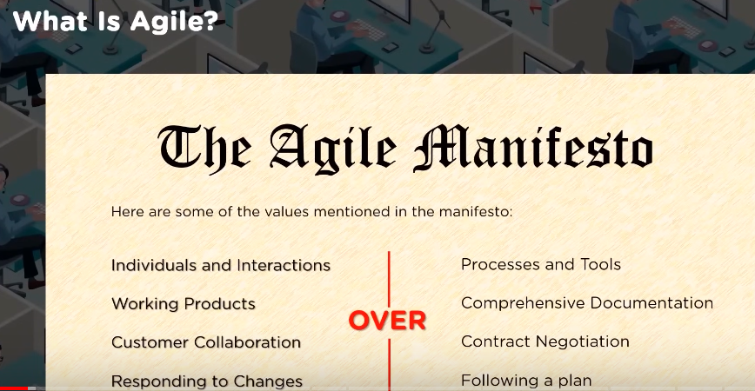

Agile Principle :
- Customer satisfaction: One needs to certifies the customer through early and quick delivery of the product.
- Welcome to change :Change need to be addressed in the late of the development process.
- Deliver frequently : To ensure the software is delivered frequently focusing on shorter timescale.
- Work together : Developers and business individuals needs to work together through the course of project.
Involvement of customer , supplier and the team must work together.
- Motivated Team : Project need to be build around motivated individuals , they must trusted to get the job done.
- Face to face : Face to face conversation is the most efficient way of interaction / communication. Feedback.
- Working software : Working software is the primary measure of progress.
Deliverable has to come regularly in terms of work product/ working piece .
- Constant Pace : Agile process must be based on sustainable development.
Left to right …
- Good Design : Agility can be improved by technical excellence and good design.
Insights towards – product , technologies , capability and skills.
Small piece design become quicker.
- Simplicity : The amount of work that is not being done to be minimized.
Focus on only those what is requiring to be done.
- Self Organization : Diversified team members come together , discuss together , take ownership to accomplish the result.
Self organized team provides the best architecture , requirement and design.
Blaming scenario will not be there.
- Reflect and adjust : Effectiveness can be improved by the team who regularly reflecting on it.
Benefits of agile :
- Large amount of interaction between client and the project team.
- Improve transparency to client in every phases of the project.
- Delivery of the output is predictable and can sometime be earlier than expected.
- The cost of the project is predictable and follow rigid schedule.
- It allows the changes to refine and re prioritize the product backlog.
PO:
Product Details List / Product Backlog
Complete List of activities which has to be down .
[ATM access in same bank ] --- chunk3
ATM access in different bank
Balance enquiry
Amt withdraw
Amt Deposit
Change pin number
Call customer care
Get the details log of transaction

- The client can provide the priority of features and allowing team to ensure maximum project value.
User stories
Epics
- By focusing on needs of users team can deliver the values to the customer.
- Project is broken into smaller units with high quality of development , testing and collaboration.
Agile Methodologies :
XP – Extreme Programming
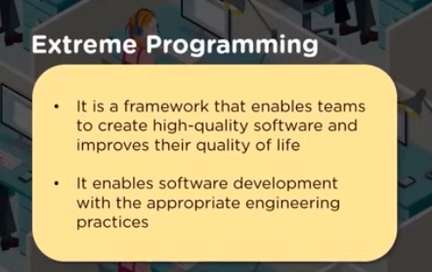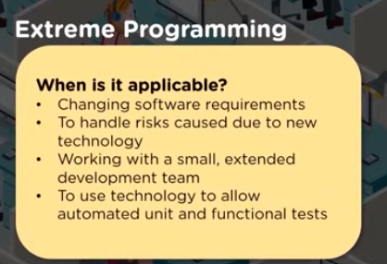

Kanban :
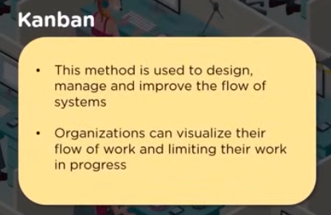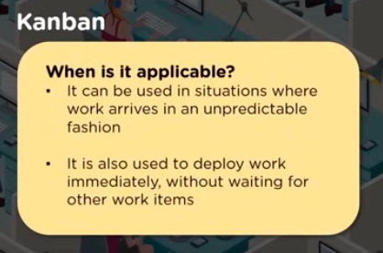
Minutes of meeting -> Action items -> Next meeting pending
Kanban board :
Our name with assigned task which will be visible to us .
It is a pool system because people pool the work from it and complete.
Example of Kanban board :
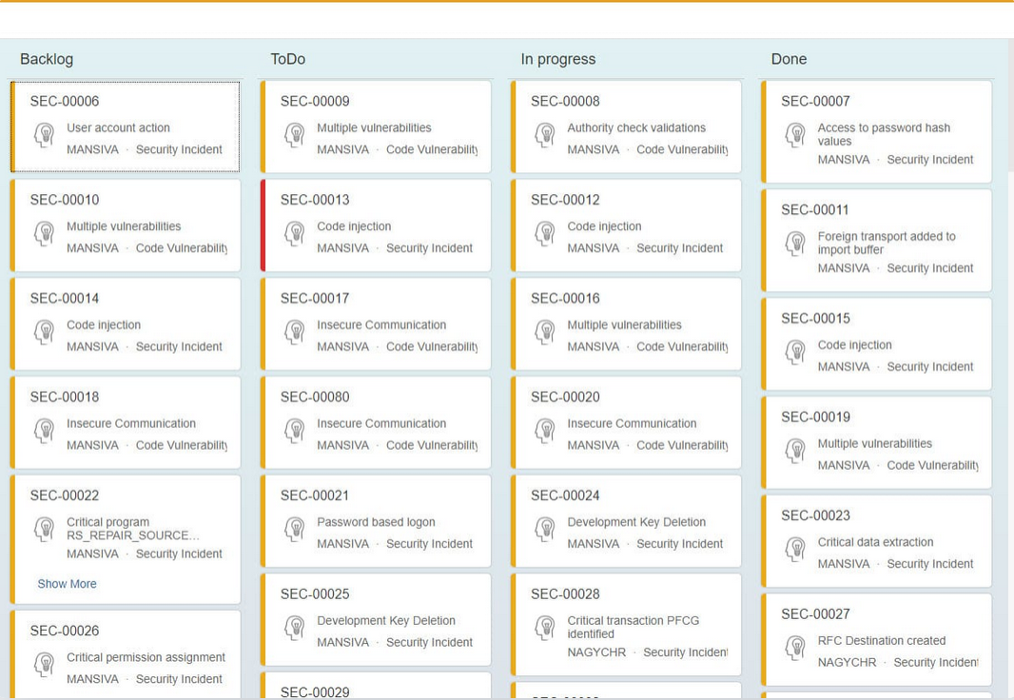

Lean:
Waste minimization.
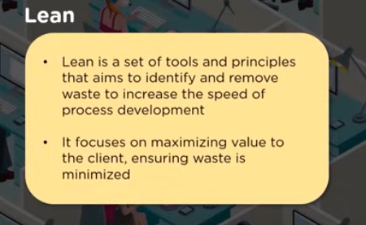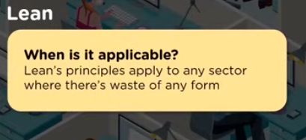
Bottle neck must be eliminated.
Non valuing activities must be eliminated.

Scrum :
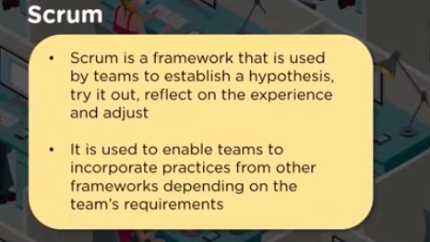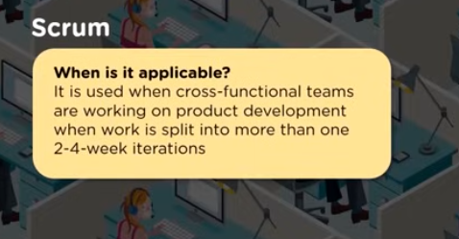
Sprint - 2
Dt 12.10.2024--- 6 hours
Dt 13.10.2024 ---6 hours

Dt 14.10.2024 ------ 6 hours

Task-2

Product Backlog access atm using valid pin to withdraw amt

Small time box iterations .
These iterations are called as sprints.
Task-3
Accomplishing the result.
Provide the flexibility.
Able to move faster.

Crystal :
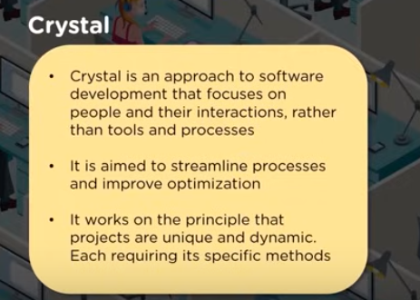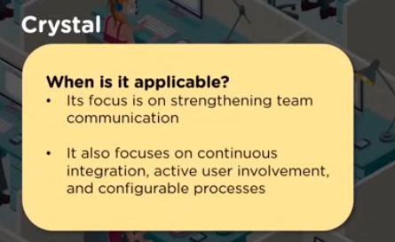

Safe Agile : This is a scaled scenario for more complex project.

