Topics Covered 1.5 Days
++++++++++++++++++++++++++++++++

Day-1 :

1. understanding software components
2. Software Development Life Cycle Phases // provide analogy wtr a case study / domain
3. Models - Waterfall Model // Graphical explanation [ pros and cons analysis]
4. Models- V & V Model // Graphical explanation
5. Comparison between V & V waterfall // analytical comparison [pros and cons analysis]
6. Requirement Analysis // analogy ----
6.1. Design Phase - High Level Design // provide analogy
7. Design Phase - Low Level Design //provide analogy
8. Implementation Phase
9. Deployment Phase
10. Maintenance Phase // analogy
11. Different Environments ---

++++++++++++++++++++++++++++++++

Day-2 :

1. Recap of day-1 content
2. What is testing ?
3. Why testing is important ?
4. What is Quality ?
5. What are the Quality Attributes ?
6. What is difference between Quality and Testing
7. Domain Based Testing / Domain Driven testing
8. Levels of testing baselevel understanding
8.1 : Unit Testing--- approaches + Junit
8.2 : Integration Testing --- approaches
8.3 : System Testing (p)
8.4: Acceptance Testing (p)

9. Cause of defects --- Testing Environment ----
9.1 : Cost of the software defect

10. Issue : Error , Defect , failure wrt Environments // analogies

++++++++++++++++++++++++++++++++

Sample Requirement :

[ABC Bank]
The employees of abc bank can login and maintain their official time-sheet , sal doc,holidays list and other important process components .

- Login
- Logout
- Time stamp capture for login time and logout time
- View Holiday List
[Quality Check ]

ABC BaNK ----→ [DepProducts] --→
[Abcbankeportal.com] ------ [Functionalities]
a

[Quality attributes ]
Critical functionalities must work
Securities
Compatibilities
Performance
Usability

Quality is the responsibility of all … < ---- Agility

[DepProducts ]
Verification with the Requirement and Quality attributes
+
Validation

Before Execution ----- When the app is in initial stage of development
Validation ---- When the app is available to test

-----Standards --- testing

Development Activities:
- Write the code ----- unit testing ---- junit , testNG
- Create the Database---- Testing ---- DCT --- Data centric testing
- Design the pages- web pages ---- Designers --- Static page ---- HTML + CSS --- Test
- Integrate the module
- Testing -----
QA Test Engineers ----- Dedicated test the application end to end

System Design Documents---
HLD
LLD
Requirement Document / Functional Doc

Software Development Life Cycle :
Phase-1 :
PLANNING ----- Project Plan Document
Phase-2:
ANALYSIS --- Understanding -----HLD
PHASE-3:
DESIGN ----- Design Documents ---- HLD / LLD [Deliverable]
[Login]
App code
Data table
Static page

HLD :
Ready with module specifications and architecture
LLD:
Code
Database
Page designs
+++++++++++++++++++++++++++++++++++++++++++++++++++++++++

Development Environment
Design Phase of SDLC
1.Create the class templates ---- A
2.Create the method library with all required method templates A
3.Writing the method definition---- B
4. Creating table using mysql --- empty table----A
5. Inserting records into the table --- records will be there ---- B
6. completing validations in code----B

Public Class Login_Users{
//blank

}
Opt A: HLD
Opt B:LLD

PHASE-4:
IMPLEMENTATION
Work on the critical features localhost
http://localhost:port

PHASE-5
INTEGARTION [ Registration(M1) , login(M2)] --- Developers
PHASE-6
TESTING
http://localhost:port {Testing Environment]
So many test cycles will be maintained

PHASE-7:

Deployment [ Production environment]
MAINTENANCE
Requirements Gathering

Design – System Design

Implementation

[resources will be idle till implementation phases
Testing
[Expenshive to fix the defects ]
Deployment
Duration to complete the project will be more
Maintenance

System Testing
Req
Design
Acceptance Test
IntegrationTesting
HLD
Module Design
Unit Testing
Coding

Bugs related to different environment

Development Environment --------------- Error
Testing Environment ----------- Defect
Production Env ------------ Failures

[Issues]
Difference between the expected result and actual result
Scenarios:
- Addition method does not have the return type sum Error
- The bank employee is unable to download the salary slip from
Abceportal.com > SalrySleep Module by clicking on download. Failure
- The system engineer has logged in using valid credentials and is unable to is unable to download the salary slip . [ Defect]
- Referential integrity has not been achieved in the existing Database design [Error]
- UI interface is not matching with the design document wrt color , alignments and font size . [Error /Defect / Failure]
- Error 2. Defect 3. Failure
Abceportal.com > SalrySleep Module by clicking on download.
SDET --- manual testers ----- [QA]
Quality :

- Measures how well the products or service meets the customer expectation
- Attributes : Functional , performance , security ,
- , Usability, UI based ……….Domain specific quality attributes
Performance :
Load ==== Test----→ Loadrunner , Jmeter
Stress Test
Functional --→ manual testing , Automation Testing using Selenium WebDriver+Frameworks and design pattern to create your automation ttest suite , compatibility testing -> Selenium Grid
Android app --- [bigbasket ]
View the items
View price
View item details ----1 minutes to load the page / 200 millisecs
Tag to pin code to check the item is available

Tag location [ private --- 1user or vendor ] [public]
Place orders
Track orders
Getting order id
Invoice
Payment receipt
Address change
- Ensures customer satisfaction
Scenarios :
Scenario-1:
In ABCBank 100 employees at a time must able to login successfully within 1 minutes [Performance] [Load Testing]

Scenario-2:
In ABCBank app the employee must be able to login using valid username and password. [security] [functionality]
Scenario-3:
ABCBankapp must not save any sensitive data in cookies or hidden file while accessing. [security]
Scenario-4:
ABCBank app DOM is not accessible except home page to end users. [security]

Scenario-5:
ABCBank app can be invoked and used in parallel using different browsers [Browser-Compatibility]
Scenario-6:
ABCBank does not save the user name and password in cookies
Scenario-7:
All major features of ABCBank app must work as expected in different operating systems Windows , Linux , Mac [OS-compatibility]

Cause of s/w defects:
The user is unable to login in Awesomeqa application using valid credentials.
Identify the possible cause of defect.
- Integration issue
- Implantation issue
- Page Design
- Maintenance
- Security
- Validation
- UI Based Issue
- Network issue
- Performance issue
- Requirements
- Functionality
- DB server
- Compatibility issue
- Usability
- Deployment
- Not connected to correct data source from app code
- The correct method has not been called in app code

Software Testing Definition :
- Testing is a process to evaluate the application.
- Testing is a process which must be followed to detect the defects in the application.
- Testing is a process of verification and validation.
- Testing can be static .
- Testing can be dynamic.
Quality and Testing

SDET – Software Development Engineers in Test

What is module integration?

What is Unit Testing ? Junit for unit testing
Developers
Approaches :
Code coverage
Path coverage
Decision Coverage
Loop Coverage
Condition Coverage
Branch Coverage
Integration Testing :
Developers
Top Down Integration
Bottom Up Integration
Critical part first Integration
Big Bang Integration

System testing ---- QA test Engineers
Acceptance Testing ---- Customers and Testers other stakeholders

.
Day-3:

Topics :
- Generic Testing Process
- STLC – Software Testing Then

STLC :
Testing Lifecycle .
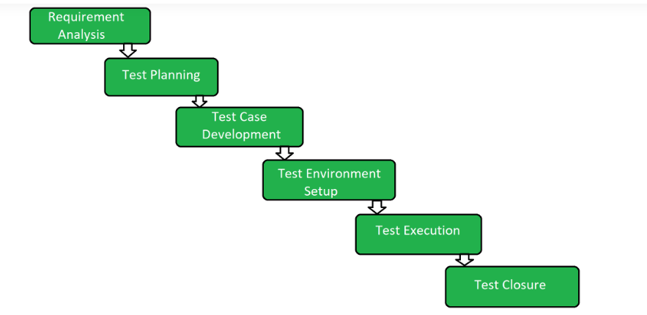

P1:Test Requirement Analysis
P2:Test Planning
P3:Test Design -------------------- Test cases / Test Scenarios / Test Data
- Pre req : Requirement Document
- Test Scenarios ------ User Registration
- Test scenarios must be converted to test cases
Valid condition
Invalid condition
Null condition
Unit level test cases
Objective – To achieve the optimum test coverage wrt all the conditions

- Each test cases will have the test data / input data

Templates --- Test case template
P4:Test Environment Setup
P5:Test Automation

Test case steps are getting converted to test scripts .\
Java class + selenium API

P6:Test Exceution
Maunual Test case execution [s]
Execute the test script

P7:Defect Tracking [ defect log]
P8:Test Closure [Test coverage details , Test execution report , RTM ……other coverage matrices ]

Project Requirement Document

Requirement Specifications / Functional Document / System Requirement Document

Test Plan ---- TestPlan Review Checklist
Requirement Doc --- Requirement Review Check List
Test Design ----- Test Case Design Review Check List
Test Execution
Test Data
RTM
Defect Report---- Defect Reiew Check List

Review --- Pear Member / Manager
Document – Baseline

