INSTALLATION TEST
Prerequisite :
Install nodejs

Steps – Angular
cd appang
npm install –g @angular/cli

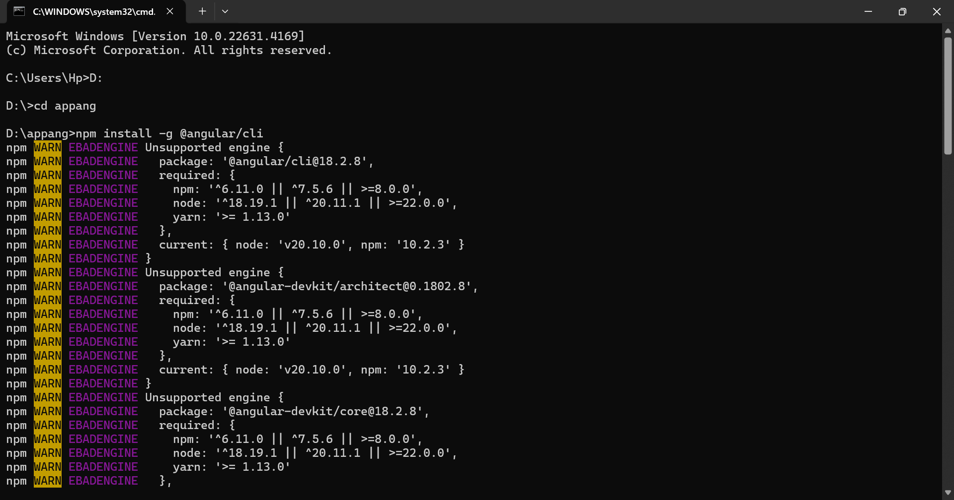

ng new myapp
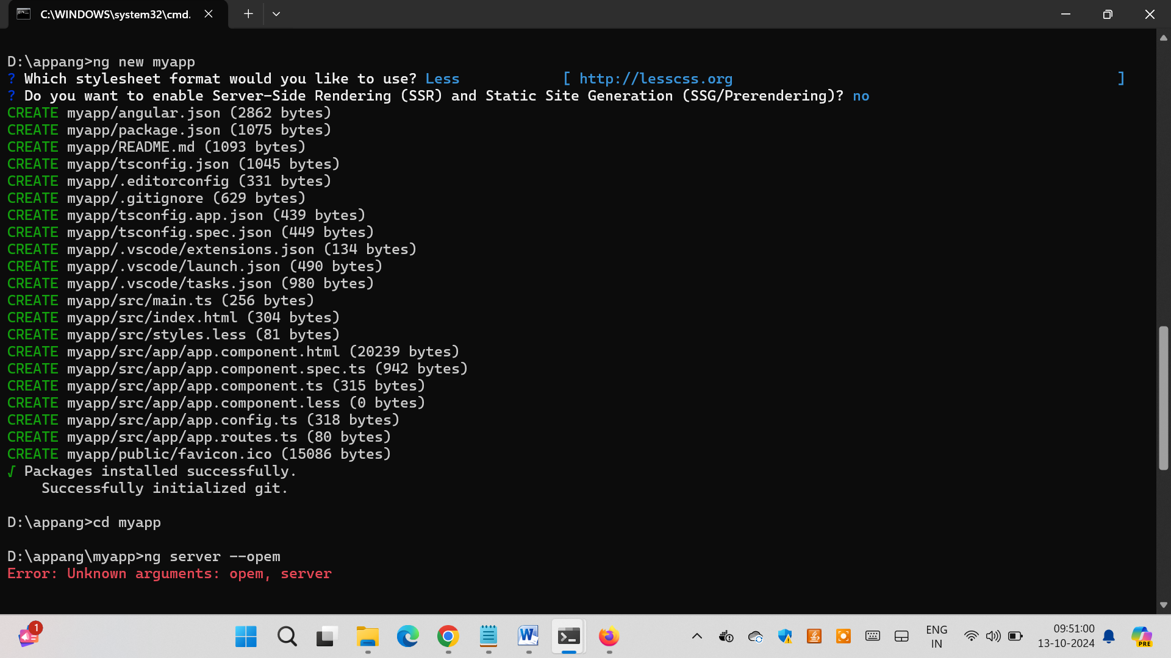

cd myapp
ng serve –open
